Supplementary Figures
Supplementary Figure 1. Location of study region in Jiangxi Province. Red pentagram represents the study site.

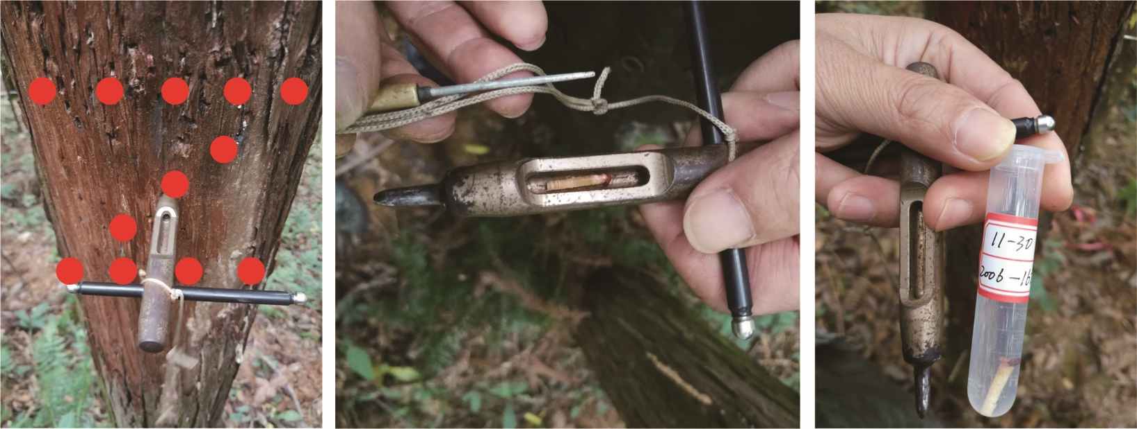
(A)
(C)
(B)
Supplementary Figure 2. The micro-sampling process in the field. (A): the sampling site on the tree stem following the Z-shape; (B): the sampled wood core which is 15 mm long and 2 mm in diameter; (C): wood core fixed in FAA (formalin-ethanol-acetic acid solution).

(B)
(A)
Supplementary Figure 3. Phases of wood cell development in Chinese fir. (A): section stained with safranin and fast green. (B): section with polarized light. CC represents the cambial cells, EC represents the enlarging cells, TC represents the wall-thickening cells, MC represents the mature cells.

