Supplementary Information

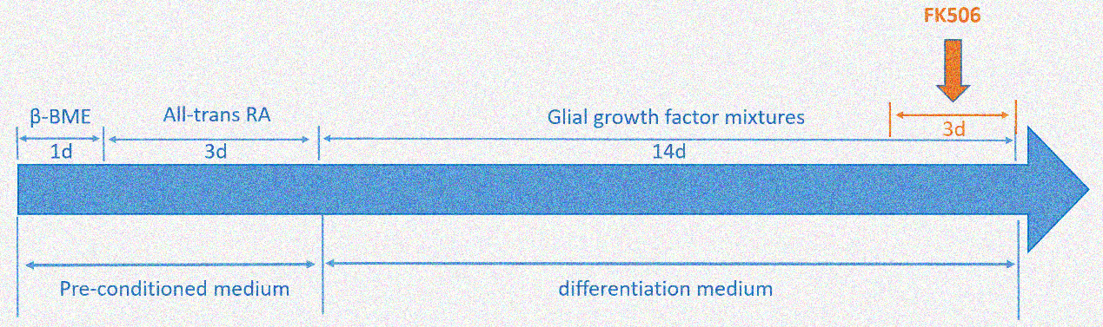
Figure S1. A schematic representation which summarizes the induction process of ADSCs differentiation toward Schwann cell lineage.

4 ℃
-20℃
37℃
Figure S2. The storage and use of Matrigel at different temperature. Matrigel is stored at -20℃ in the form of frozen cube. At 2-8 ℃, matrigel is thawed and suited for cell suspension. When it is above 10 ℃, matrigel starts to polymerize and forms into solid gel.

