Supplementary Material

Supplementary Table

Supplementary Table 1
Table S1. Details of study treatments and post-progression therapies
 | SBRT-IO  N=16 | Matched TACE  N=48
Median sessions of TACE, range | NA | 2 (1–16)
Median number of cycles of nivolumab, range | 10 (1 – 20) | NA
SBRT dose  Median, range  27.5 Gy in 5 fractions, n  30 Gy in 5 fractions, n  32.5 Gy in 5 fractions, n  35 Gy in 5 fractions, n*  37.5 Gy in 5 fractions, n* | 35 Gy (27.5–37.5 Gy)  1  1  2  7  5 | NA
Post-progression therapy, n  Multiple lines of systemic therapies  Sorafenib  SIRT | 1  1  0  0 | 6  0  5  1
Abbreviations: SBRT-IO, combined stereotactic body radiotherapy and immunotherapy; TACE, transarterial chemoembolisation; SIRT, selective internal radiotherapy; NA, not applicable.
* One patient with two lesions and one patient with three lesions received 35Gy in 5 fractions. One patient with two lesions and two patients with three lesions received the same SBRT dosage (37.5Gy in 5 fractions) (i.e. total 7 patients with 10 lesions received 35Gy in 5 fractions; total 5 patients with 10 lesions received 37.5Gy in 5 fractions).

Supplementary Figures

Supplementary Figure 1
Figure S1. Kaplan-Meier curves of (A) PFS and (B) OS in patients of the TACE arm of different time periods
Fig. S1A. Kaplan-Meier curves of PFS
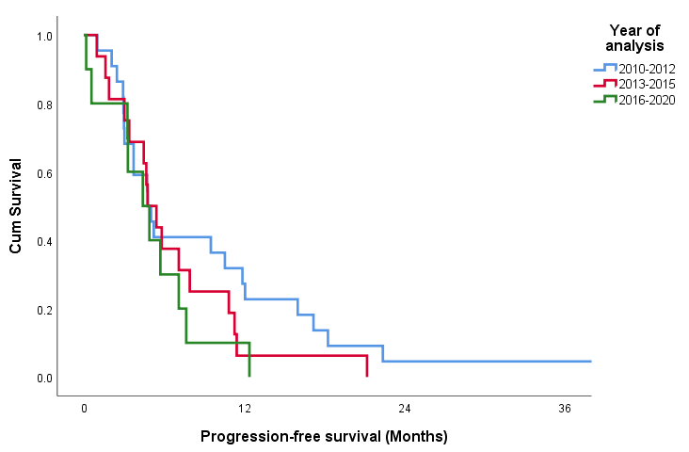

Fig. S1B. Kaplan-Meier curves of OS
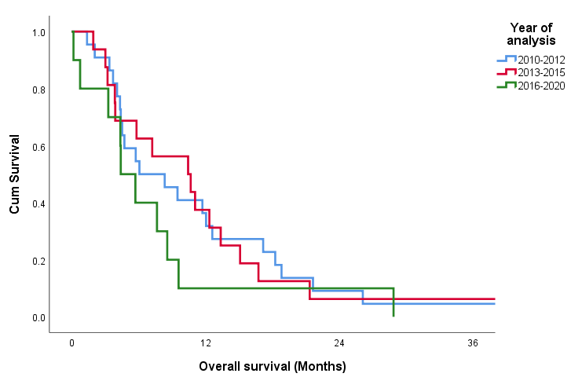
Time period | N | PFS (months)  Median, range | P value | OS (months)  Median, range | P value
2010–2012 | 22 | 5.03 (0.99–42.18) | 0.314 | 7.23 (1.38–57.23) | 0.448
2013–2015 | 16 | 4.73 (0.95–21.19) |  | 7.23 (1.94–51.02)
2016–2020 | 10 | 4.65 (0.16–12.39) |  | 5.06 (0.16–28.88)
Abbreviations: TACE, transarterial chemoembolisation; N, number of patients; PFS, progression-free survival; OS, overall survival

Supplementary Figure 2
Figure S2. 69 years old female presented with bi-lobed HCC. The largest lesion (12cm) was irradiated with SBRT (32.5Gy in 5 fractions) followed by 10 cycles of immune checkpoint inhibitors, achieved complete response in both the irradiated lesion and out-of-field lesions.
A1 | 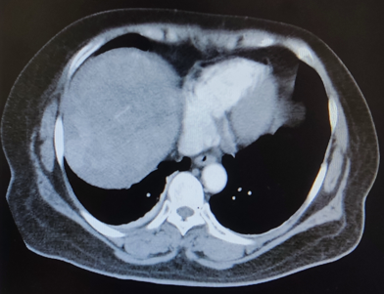 |  |  | B1 | 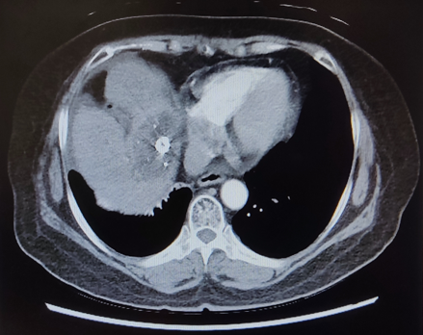
A2 | 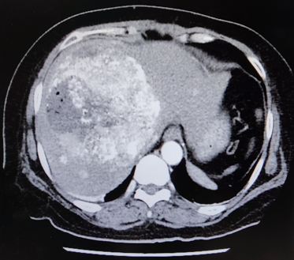 |  |  | B2 | 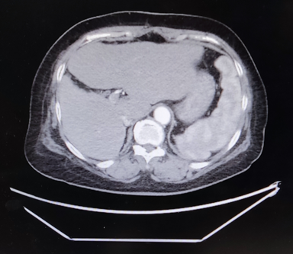
C | 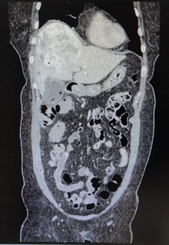 | D | 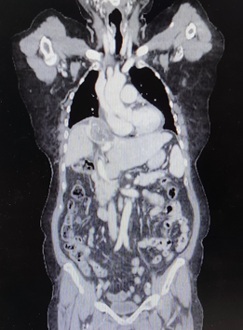 |  |  | E | 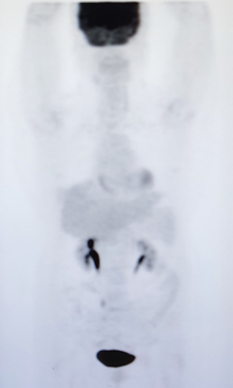
- (1) Arterial phase (2) Axial contrast CT image before SBRT-IO showing bi-lobed HCC
- (1) Arterial phase (2) Axial contrast CT at 20-month follow-up time after SBRT-IO showing complete response of tumours
- Coronal contrast CT image before SBRT-IO
- Coronal contrast CT image at 20-month follow-up time after SBRT-IO
- Coronal PET/CT image at 20-month follow-up time after SBRT-IO
Abbreviations: HCC, hepatocellular carcinoma; SBRT, stereotactic body radiotherapy; CR, complete response; N, number of lesions

