Supplementary Material

Supplementary Figures and Tables

Supplementary Figures
Supplementary Figure 1. ¹H NMR (A), ¹³C NMR (B), DEPT135 (C), 1H-1H COSY (D), HSQC (E), HMBC (F), NOESY (G) and HRMS (H) of N6 (3,3′-(3-Trifluoromethyl-4-chlorobenzylidene)-bis-(4-hydroxycoumarin).
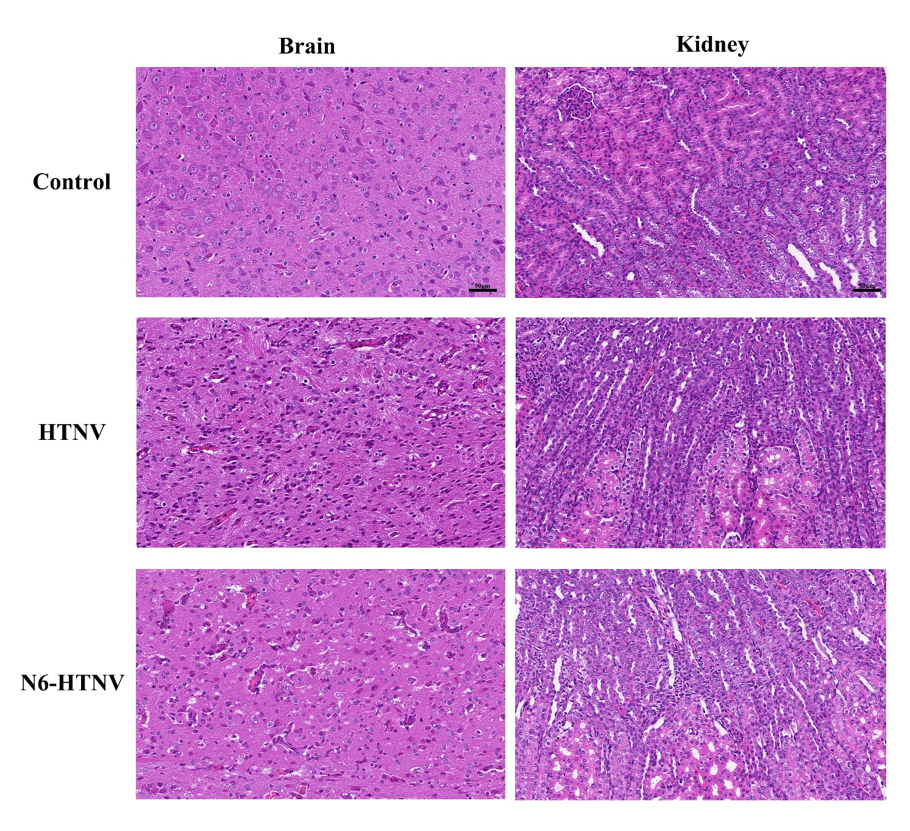
Supplementary Figure 2. Morphologies of the brain and kidney were examined with H&E staining in mice from the control, HTNV, and N6-HTNV groups. After the treatment of compound N6, there was no obvious pathological change in the brain and kidney of HTNV-infected mice comparing to the control animal model. Scale bars represent 50 μm.

