(A)
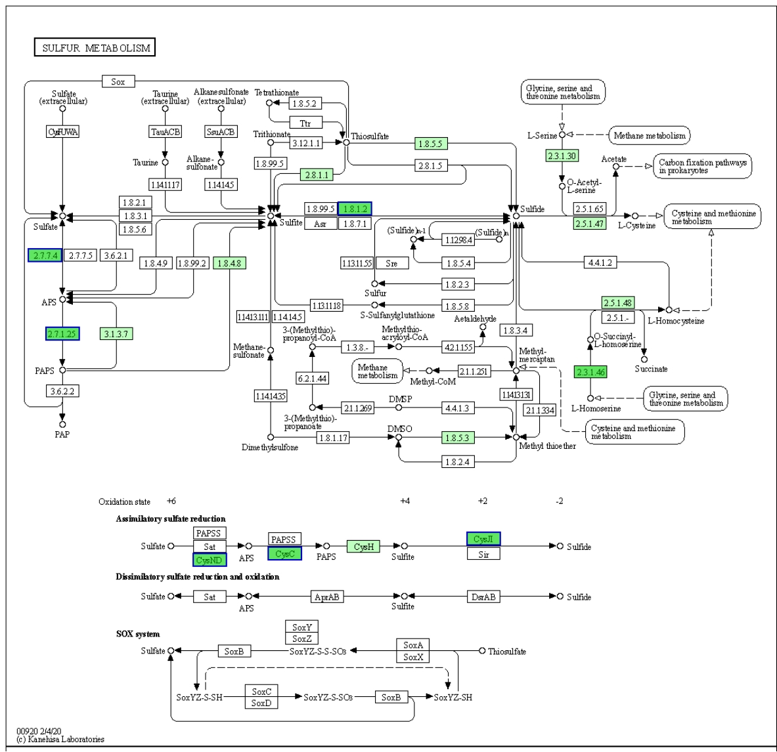

(B)
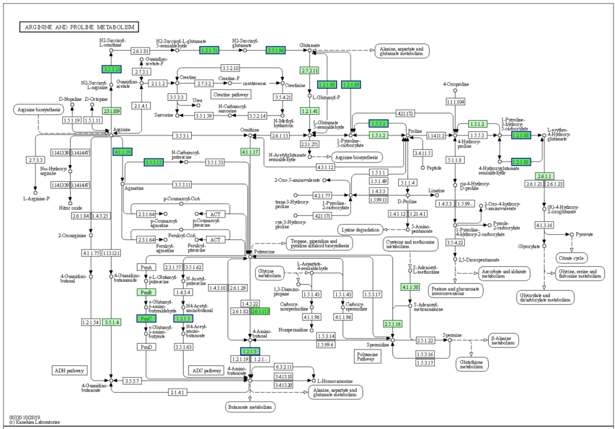

(C)
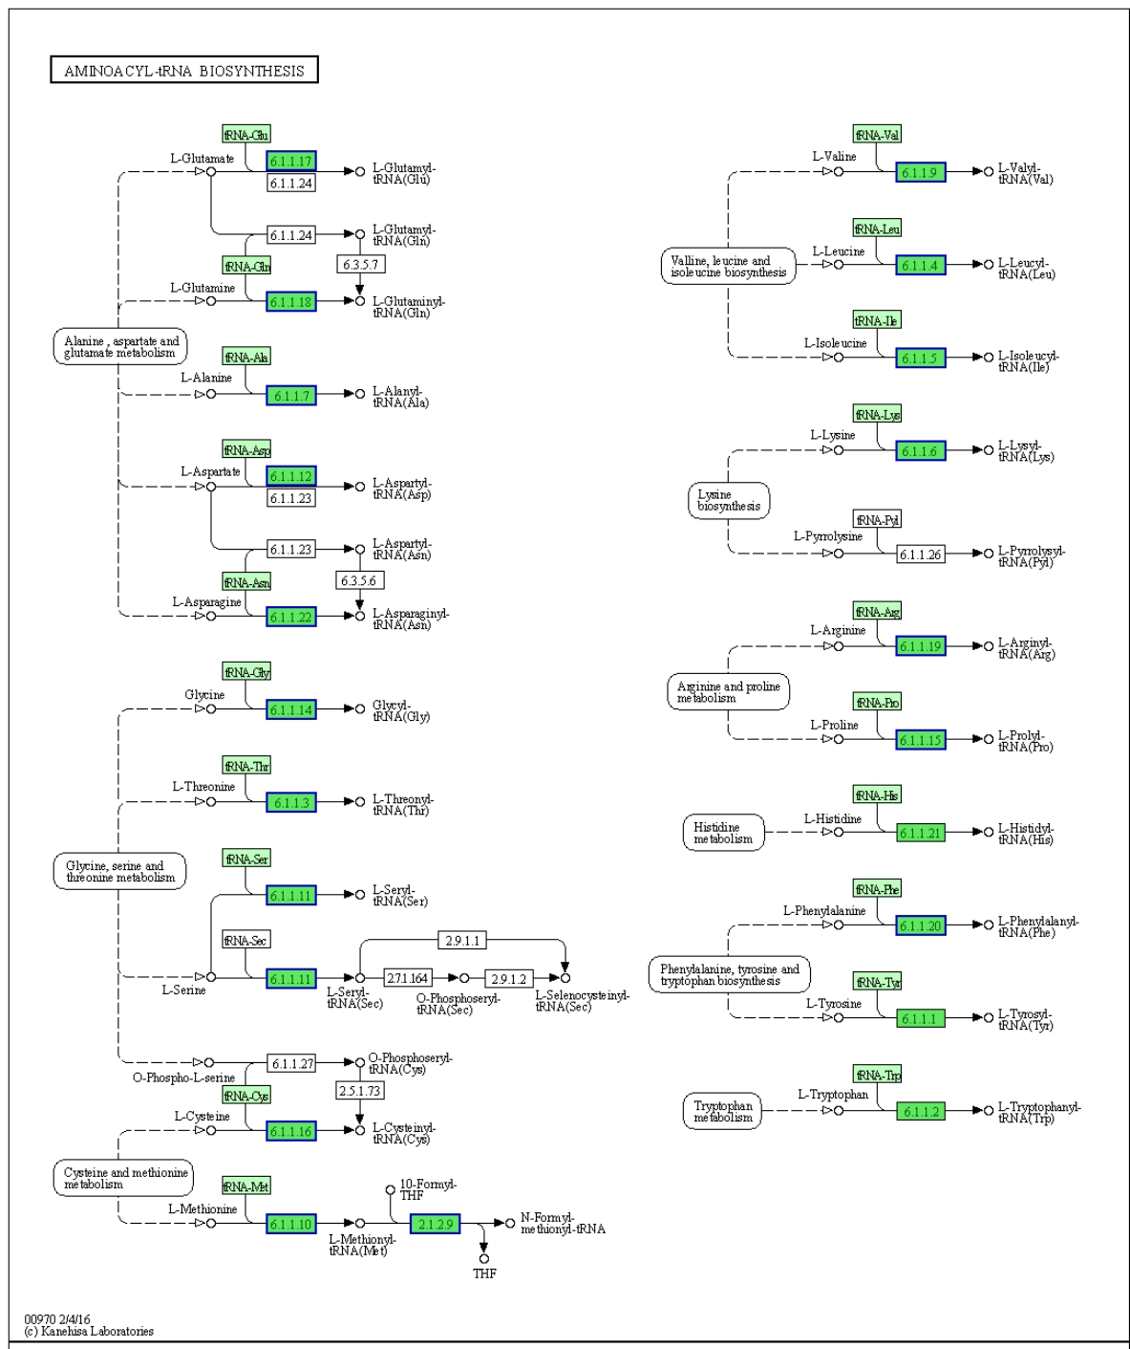
Supplementary Figure 1. KEGG pathway of sulfur metabolism (A); arginine and proline metabolism (B); and aminoacyl-tRNA biosynthesis (C) in intracellular differentially expressed proteins. Deep green: protein enriched to the pathway; light green: species enriched to the pathway; red ring or blue ring: protein set.

(A)
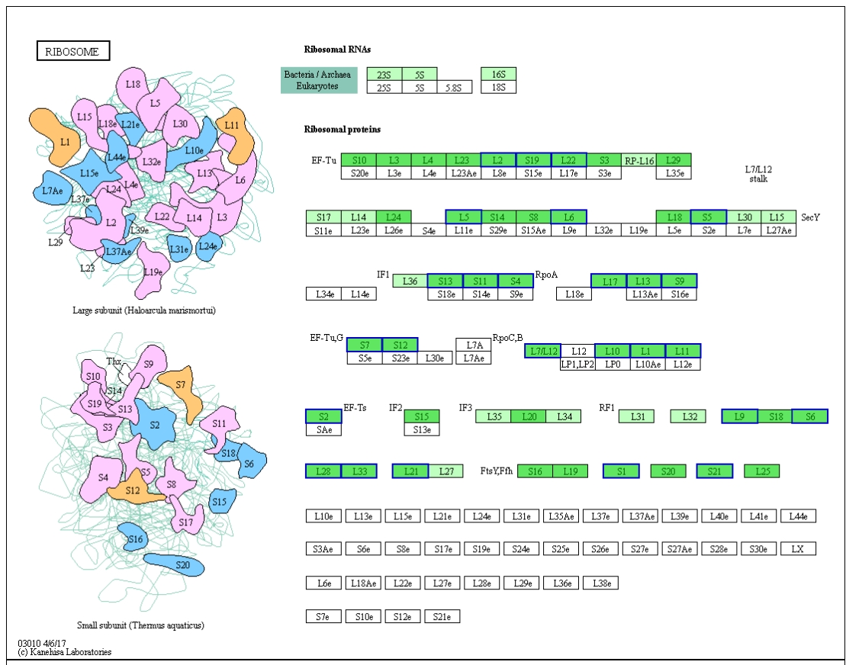

(B)
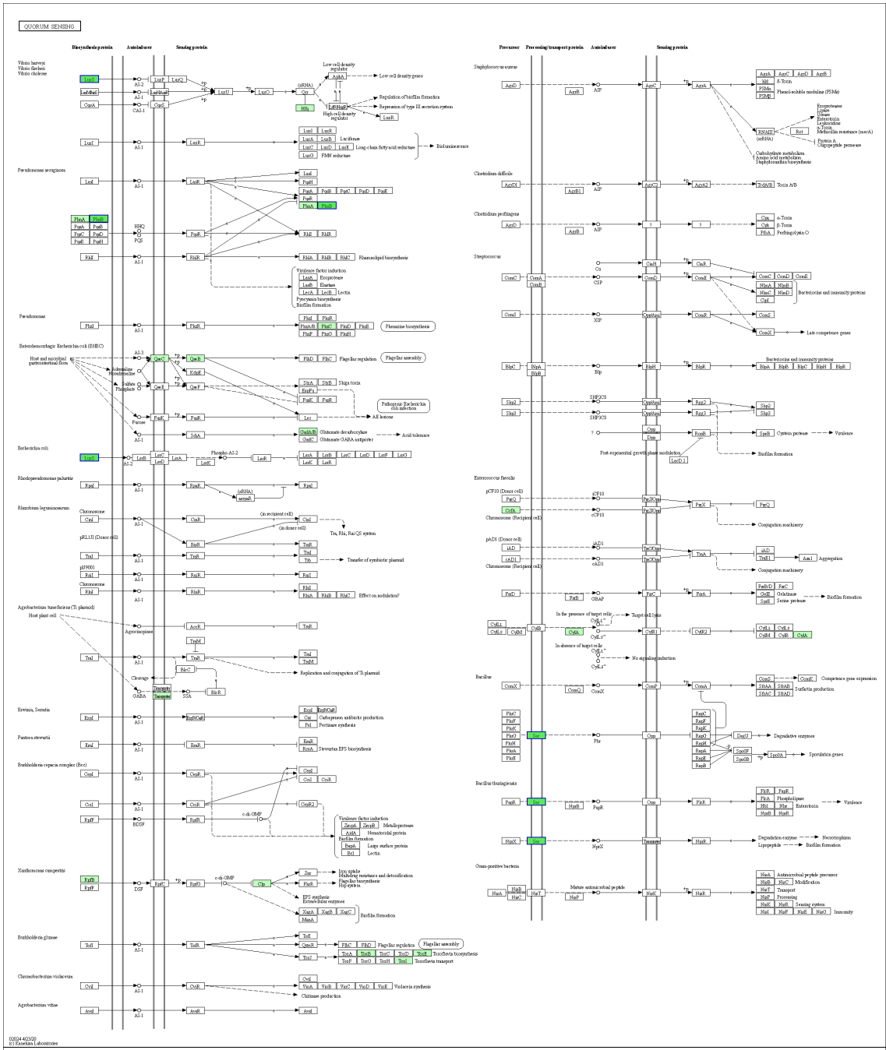

(C)
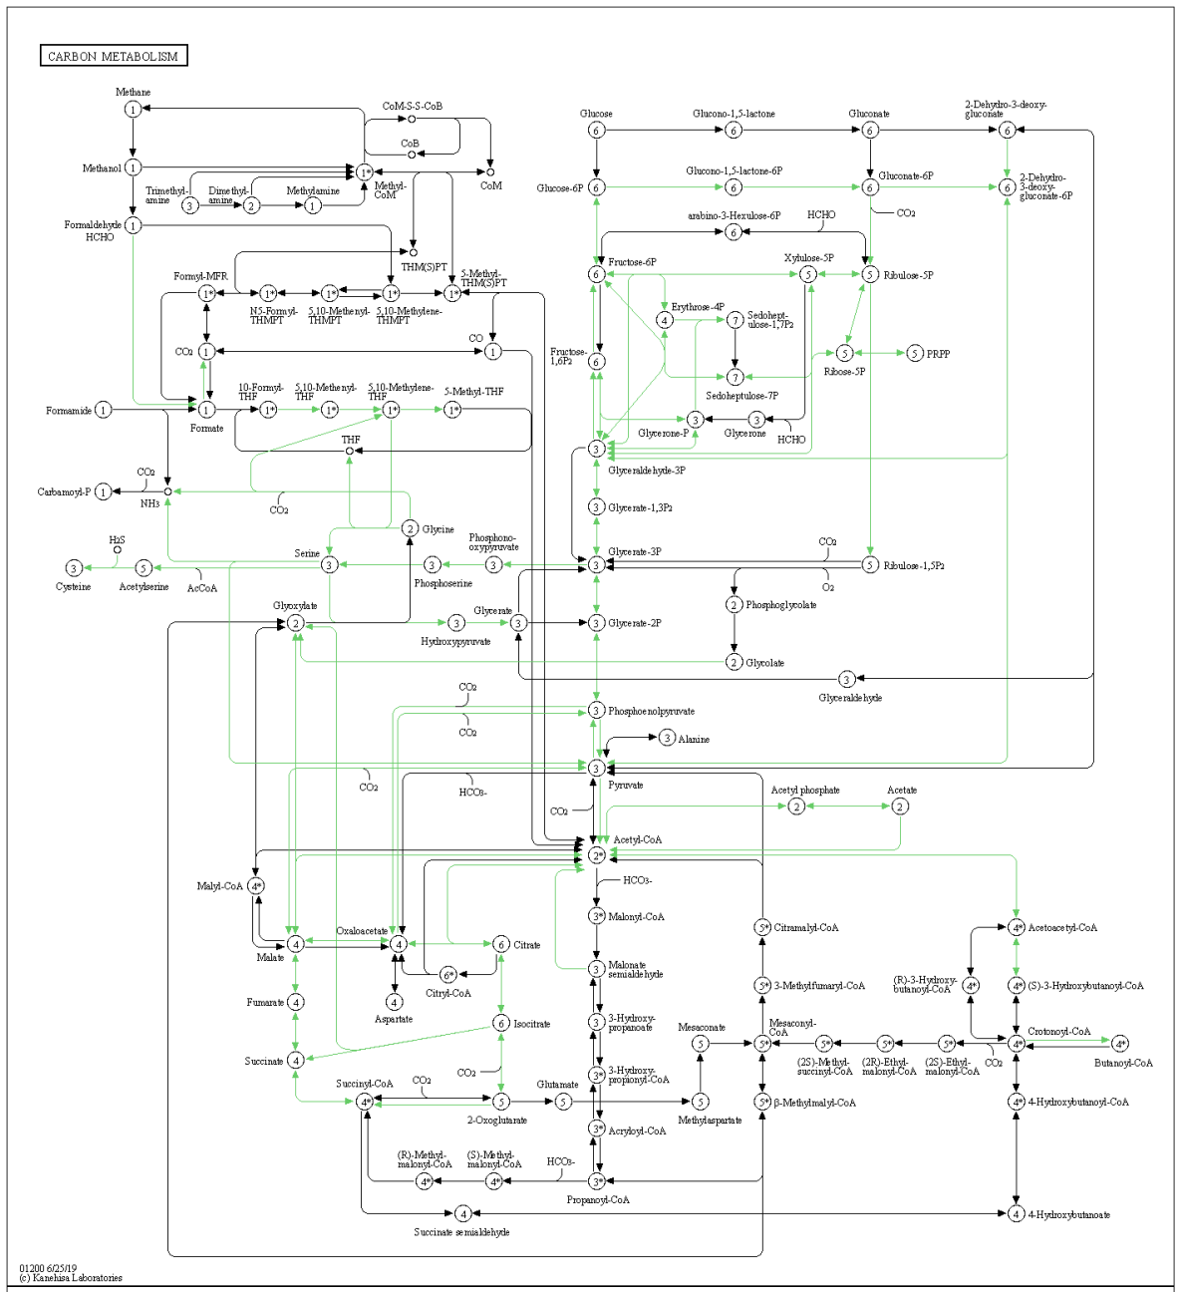
Supplementary Figure 2. KEGG pathway of ribosome (A); quorum sensing (B); and Carbon metabolism (C) in extracellular differentially expressed proteins. Deep green: protein enriched to the pathway; light green: species enriched to the pathway; red ring or blue ring: protein set.

