Table S1: clustering coefficient analysis results
Cluster | A | B | C | D | E
Whole | 0.4227±0.0816 | 0.4295±0.0693 | 0.3813±0.0775 | 0.3610±0.0886 | 0.3367±0.0949
Cortical | 0.3368±0.1752 | 0.3558±0.1564 | 0.3261±0.1661 | 0.2936±0.1497 | 0.2475±0.1491
Deep area | 0.3637±0.1064 | 0.3868±0.1036 | 0.3999±0.1016 | 0.4248±0.1099 | 0.4409±0.0949

Table S2: Characteristic path length analysis results
Path length | A | B | C | D | E
Whole | 1.8842±0.4194 | 1.9086±0.4714 | 1.9053±0.4670 | 1.8662±0.4161 | 1.8601±0.3919
Cortical | 1.5802±0.2881 | 1.6195±0.3005 | 1.6329±0.2973 | 1.6608±0.2761 | 1.6185±0.2465
Deep area | 1.9228±0.4662 | 1.9299±0.4829 | 1.9159±0.4540 | 1.8907±0.4297 | 1.8852±0.4251

Table S3: Efficiency analysis results
efficiency | A |  | B | C | D | E
Whole |  | 0.6087±0.1112 | 0.6043±0.1181 | 0.6077±0.1140 | 0.6140±0.1064 | 0.6128±0.1072
Cortical |  | 0.5066±0.1865 | 0.5007±0.1890 | 0.5079±0.1915 | 0.5140±0.1920 | 0.5152±0.1850
Deep area |  | 0.5947±0.1264 | 0.5882±0.1357 | 0.5873±0.1309 | 0.5968±0.1268 | 0.5953±0.1282

Table S4: Modularity analysis results

Modularity | A | B | C | D | E
Whole | 0.2658±0.1019 | 0.2818±0.1156 | 0.2556±0.1056 | 0.2323±0.0969 | 0.2201±0.0919
Cortical | 0.2610±0.0712 | 0.2915±0.0716 | 0.2400±0.0905 | 0.2019±0.0709 | 0.1945±0.0698
Deep area | 0.2615±0.0903 | 0.2705±0.0987 | 0.2550±0.0958 | 0.2954±0.0863 | 0.3295±0.0910

 | Frontal  (L) | Frontal  (R) | Temporal  (L) | Temporal  (R) | Parietal  (L) | Parietal  (R) | Occipital  (L) | Occipital  (R) | Angular  (L) | Angular  (R)
A | 7.67 | 6.29 | 10.81 | 9.62 | 9.80 | 8.22 | 10.82 | 9.72 | 10.28 | 9.51
B | 8.11 | 8.43 | 10.57 | 9.87 | 9.15 | 7.67 | 10.97 | 10.41 | 9.53 | 8.61
C | 8.50 | 8.65 | 10.31 | 10.50 | 7.75 | 8.62 | 10.70 | 9.91 | 8.73 | 9.79
D | 8.99 | 8.66 | 11.38 | 9.69 | 9.92 | 8.77 | 11.12 | 9.71 | 8.84 | 10.51
E | 8.42 | 8.17 | 11.89 | 9.20 | 10.07 | 7.94 | 11.00 | 9.21 | 7.10 | 11.32
Table S5(a): The change in degree of cortical area during anesthesia recovery

Table S5(b):The change in degree of deep areas during anesthesia recovery
L | Hippocampus | Cingulum | amygdala | Entorhinal | fusiform | SMP | lingual | cuneus | calcarine | Interior frontal | insular
A | 7.97 | 9.12 | 10.99 | 7.40 | 10.54 | 9.12 | 7.86 | 10.03 | 8.79 | 9.90 | 8.14
B | 7.80 | 10.13 | 11.13 | 7.64 | 10.83 | 8.30 | 8.12 | 9.53 | 10.06 | 8.41 | 7.84
C | 10.21 | 9.50 | 11.16 | 9.00 | 10.81 | 8.44 | 8.45 | 9.28 | 10.41 | 8.25 | 8.15
D | 8.95 | 9.85 | 10.69 | 8.72 | 10.80 | 7.08 | 8.96 | 10.27 | 9.54 | 8.41 | 9.10
E | 8.30 | 10.10 | 11.15 | 10.67 | 10.47 | 8.01 | 8.05 | 9.59 | 9.61 | 7.08 | 9.43
R | Hippocampus | Cingulum | amygdala | Entorhinal | fusiform | SMP | lingual | cuneus | calcarine | Interior frontal | insular
A | 9.16 | 9.85 | 11.84 | 7.97 | 7.47 | 9.10 | 10.46 | 9.86 | 10.33 | 9.35 | 9.52
B | 9.42 | 9.00 | 11.15 | 7.39 | 9.20 | 9.07 | 10.07 | 10.48 | 9.56 | 8.17 | 10.88
C | 9.52 | 8.20 | 11.32 | 8.49 | 9.36 | 7.56 | 8.90 | 8.50 | 9.08 | 8.55 | 10.90
D | 7.27 | 9.16 | 10.18 | 7.57 | 9.19 | 8.39 | 9.83 | 8.69 | 9.40 | 9.40 | 8.48
E | 9.74 | 8.18 | 11.68 | 8.31 | 8.55 | 9.34 | 9.66 | 7.88 | 11.12 | 6.86 | 9.40

Table S6(a): Change in Betweenness centrality of cortical area:
 | Frontal  (L) | Frontal  (R) | Temporal  (L) | Temporal  (R) | Parietal  (L) | Parietal  (R) | Occipital  (L) | Occipital  (R) | Angular  (L) | Angular  (R)
A | 20.15 | 14.37 | 33.56 | 24.12 | 35.57 | 25.86 | 21.34 | 23.12 | 36.16 | 29.23
B | 25.03 | 23.15 | 25.62 | 22.51 | 32.71 | 29.66 | 25.87 | 24.28 | 32.03 | 32.76
C | 26.67 | 29.51 | 24.37 | 37.73 | 22.12 | 29.14 | 21.67 | 26.41 | 28.62 | 31.73
D | 25.82 | 21.06 | 38.31 | 32.86 | 29.79 | 22.42 | 30.68 | 33.20 | 24.49 | 36.41
E | 26.18 | 20.22 | 41.08 | 26.09 | 34.25 | 21.44 | 31.04 | 30.87 | 12.71 | 43.60

L | Hippocampus | Cingulum | amygdala | Entorhinal | fusiform | SMP | lingual | cuneus | calcarine | Interior frontal | insular
A | 23.45 | 26.38 | 34.09 | 18.88 | 24.94 | 28.91 | 15.56 | 40.54 | 27.09 | 33.55 | 23.52
B | 20.53 | 41.70 | 29.96 | 16.49 | 30.31 | 26.45 | 27.43 | 38.35 | 38.99 | 31.77 | 17.75
C | 39.12 | 35.24 | 34.76 | 31.95 | 27.94 | 21.29 | 21.35 | 29.51 | 37.00 | 23.28 | 28.67
D | 23.34 | 34.52 | 35.15 | 24.89 | 33.23 | 15.16 | 25.39 | 33.23 | 31.43 | 25.12 | 30.57
E | 25.07 | 35.75 | 39.58 | 38.55 | 28.85 | 17.91 | 20.57 | 29.70 | 34.31 | 16.97 | 28.53
R | Hippocampus | Cingulum | amygdala | Entorhinal | fusiform | SMP | lingual | cuneus | calcarine | Interior frontal | insular
A | 36.07 | 33.49 | 48.76 | 21.39 | 17.80 | 27.34 | 40.97 | 28.64 | 39.37 | 32.53 | 27.67
B | 36.74 | 22.46 | 38.31 | 19.36 | 32.20 | 28.68 | 30.19 | 39.79 | 31.14 | 26.21 | 29.54
C | 30.42 | 22.47 | 31.25 | 26.26 | 41.11 | 17.30 | 26.54 | 28.67 | 26.72 | 31.51 | 43.61
D | 22.56 | 25.13 | 37.32 | 20.40 | 29.35 | 24.66 | 29.70 | 25.48 | 28.32 | 32.06 | 23.19
E | 26.71 | 17.18 | 39.66 | 26.36 | 21.53 | 25.33 | 28.23 | 18.60 | 36.65 | 11.67 | 37.14
Table S6(b): Change in Betweenness centrality of deep areas

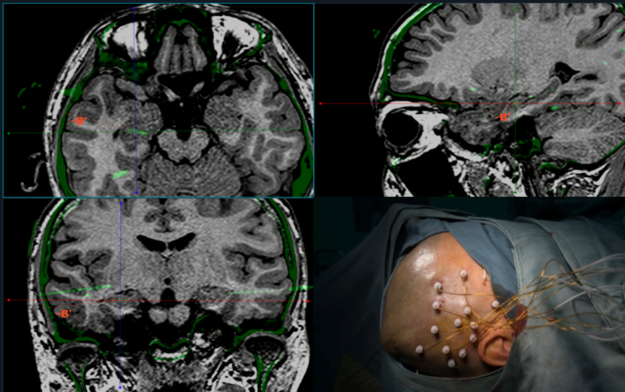
Figure S1. Different position of cortical and deep areas observed

