Supplementary Material

Supplementary Tables
Supplementary Table 1:
Environmental data collected at a high frequency over several months by data loggers at the Norwegian sampling site (Røvik) at two stations in the Thau Lagoon close to the French sampling site (Trombetta2019, Messiaen2020). The table lists the datalogger IDs, country, location, date and time of recordings, the measurement and its value. Measurments include temperature in °C, light intensity in Lux and PAR (µmol m⁻² s⁻¹), and Salinity in ‰.
Uploaded on figshare: 10.6084/m9.figshare.14955492

Supplementary Table 2: Measured and calculated parameters from the OJIP protocol of PAM measurements of each seagrass leaf. The following parameters are provided: Bckg: Background; F₀: F_{50μs}, fluorescence intensity at 50 μs; F_{J} = fluorescence intensity at J-step (at 2 ms); Fi: fluorescence intensity at i-step (at 60 ms); F_{M}: maximal fluorescence intensity; F_{V}: F_{M} - F₀ (maximal variable fluorescence); V_{J}: (F_{J} - F₀) / (F_{M} - F₀); V_{i}:(F_{i} - F₀₎ / (F_{M} - F₀₎; F_{M} / F₀; F_{V} / F₀; F_{v} / F_{M}; M₀ or (dV/dt)₀: TR₀ / RC - ET₀ / RC = 4 (F₃₀₀ - F₀₎ / (F_{M} - F₀); Area: Area between fluorescence curve and F_{M} (background subtracted); Fix Area: Area below the fluorescence curve between F_{40μs} and F_{1s} (background subtracted); S_{M}: Area / (F_{M} - F₀) (multiple turn-over); S_{S}: the smallest S_{M} turn-over (single turn-over); N: S_{M} . M₀ . (1 / V_{J}) turn-over number Q_{A}; Phi_P₀: 1 – (F₀ / F_{M}) (or F_{V} / F_{M}); Psi_₀: 1 – V_{J}; Phi_E₀: (1 – (F₀ / F_{M)}) . Psi_₀; Phi_D₀: 1 – Phi_P₀ – (F₀ / F_{M}); Phi_Pav = Phi_P₀ (S_{M} / t_{FM}) with t_{FM}: time to reach F_{M} (in ms); ABS / RC: M₀ . (1 / V_{J}) . (1 / Phi_P₀); TR₀ / RC: M₀ . (1 / V_{J}); ET₀ / RC: M₀ . (1 / V_{J}) . Psi_₀; DI₀ / RC:(ABS / RC) – (TR₀ / RC).
Uploaded on figshare: 10.6084/m9.figshare.14958810

Supplementary Table 3: Read counts. Read counts for 21,069 genes and 48 libraries. Gene IDs are listed in the first column, the mean coverage for each gene across all samples in the second column, and counts for all samples in the subsequent columns.
Uploaded on figshare: 10.6084/m9.figshare.14958837

Supplementary Table 4: Regularized log transformed read counts for 48 libraries at 13,932 genes with mean coverage >5. Gene IDs are listed in the first column, rlog values for all samples in the subsequent columns.
Uploaded on figshare: 10.6084/m9.figshare.14958867

Supplementary Table 5: Number of reads per library. Listed are the numbers of raw reads, trimmed reads, reads that mapped uniquely to nuclear DNA and organellar DNA of Z. marina, and reads that mapped to nuclear and organellar exons.
Uploaded on figshare: 10.6084/m9.figshare.14958936

Supplementary Table 6: Genes showing significant differences in gene expression between summer and winter. Columns specify the: 1. Population; 2. Upregulated.in, whether the gene was upregulated during summer or winter; 3. GeneID, the gene ID based on the Zostera marina genome annotation; 4. baseMean, the mean of normalized counts for all samples; 5. log2FoldChange, the log2 fold difference in normalized expression between samples taken at day and night (values > 1 indicate higher expression at day); 6. lfcSE, the standard error of the log2 fold difference; 7. stat, the Wald test statistic for differential expression; 8. pvalue, the p-value; 9. padj, the p-value adjusted by the Benjamini-Hochberg method to control for false discovery rate; 10. description, the gene description; 11. GO.labels, the associated Gene Ontology terms; 12. KO.Term, the associated KEGG Ontology terms.
Uploaded on figshare: 10.6084/m9.figshare.14958957

Supplementary Table 7: Genes showing significant differences in gene expression between day and night. Columns specify the: 1. Population; 2. Season, 3. Upregulated.in, whether the gene was upregulated during day or night; 4. GeneID, the gene ID based on the Zostera marina genome annotation; 5. baseMean, the mean of normalized counts for all samples; 6. log2FoldChange, the log2 fold difference in normalized expression between samples taken at day and night (values > 1 indicate higher expression at day); 7. lfcSE, the standard error of the log2 fold difference; 8. stat, the Wald test statistic for differential expression; 9. pvalue, the p-value; 10. padj, the p-value adjusted by the Benjamini-Hochberg method to control for false discovery rate; 11. description, the gene description; 12. GO.labels, the associated Gene Ontology terms; 13. KO.Term, the associated KEGG Ontology terms.
Uploaded on figshare: 10.6084/m9.figshare.14958990

Supplementary Table 8: KEGG metabolic pathways enriched with genes that were differentially expressed between day and night or between winter and summer in the French and/or Norwegian population of Zostera marina.
Uploaded on figshare: 10.6084/m9.figshare.14959008

Supplementary Figures
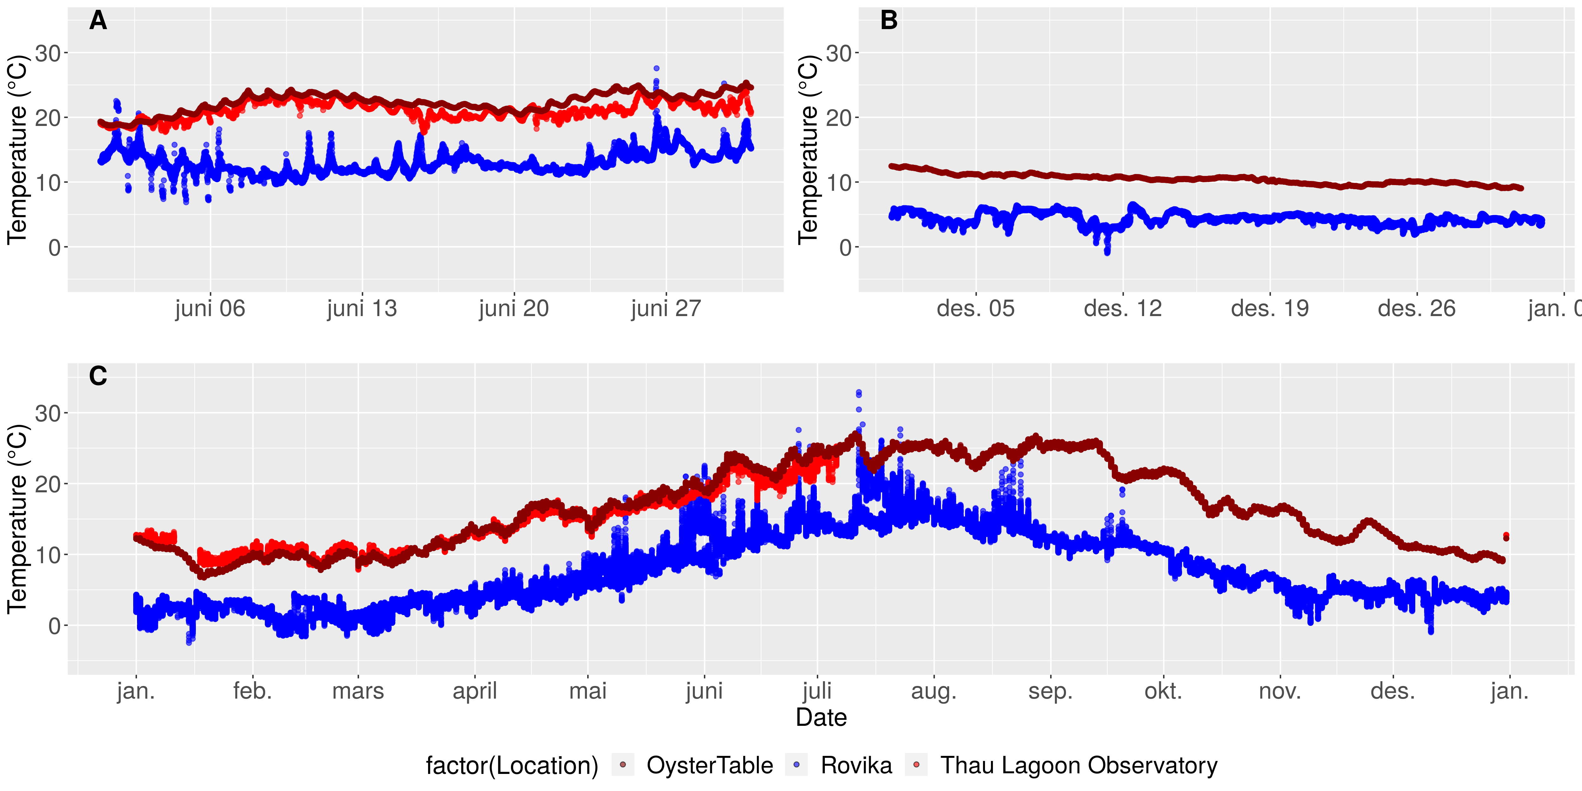
Supplementary Figure 1. Temperatures in June (a), December (b), and over the entire year (c) at the Norwegian sampling site (blue) and at two observatory stations in the Thau Lagoon close to the French sampling site (red, dark red).
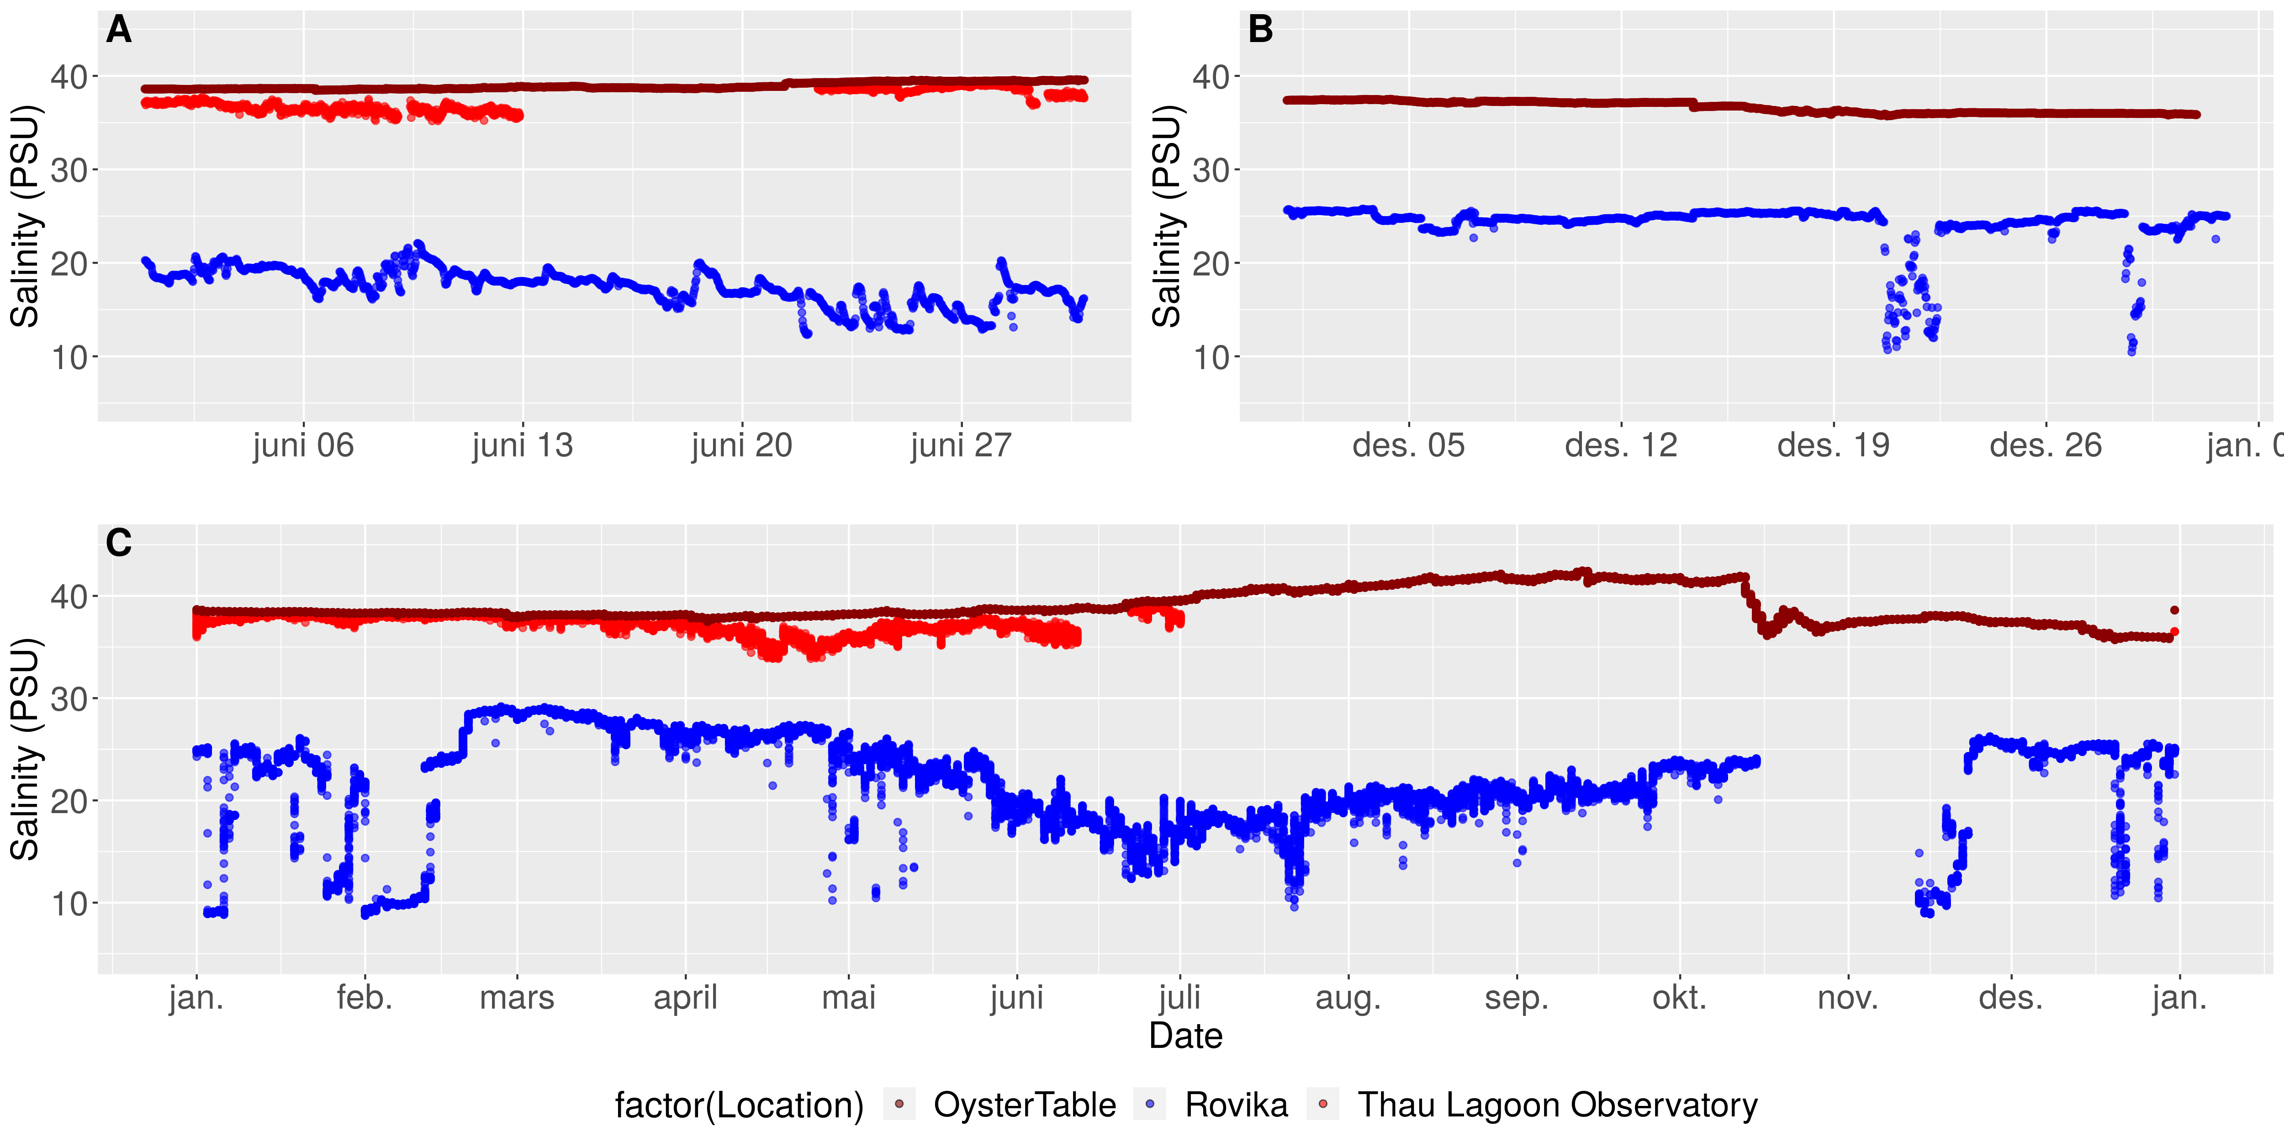
Supplementary Figure 2. Salinity levels in June (a), December (b), and over the entire year (c) at the Norwegian sampling site (blue) and at two observatory stations in the Thau Lagoon close to the French sampling site (red, dark red).
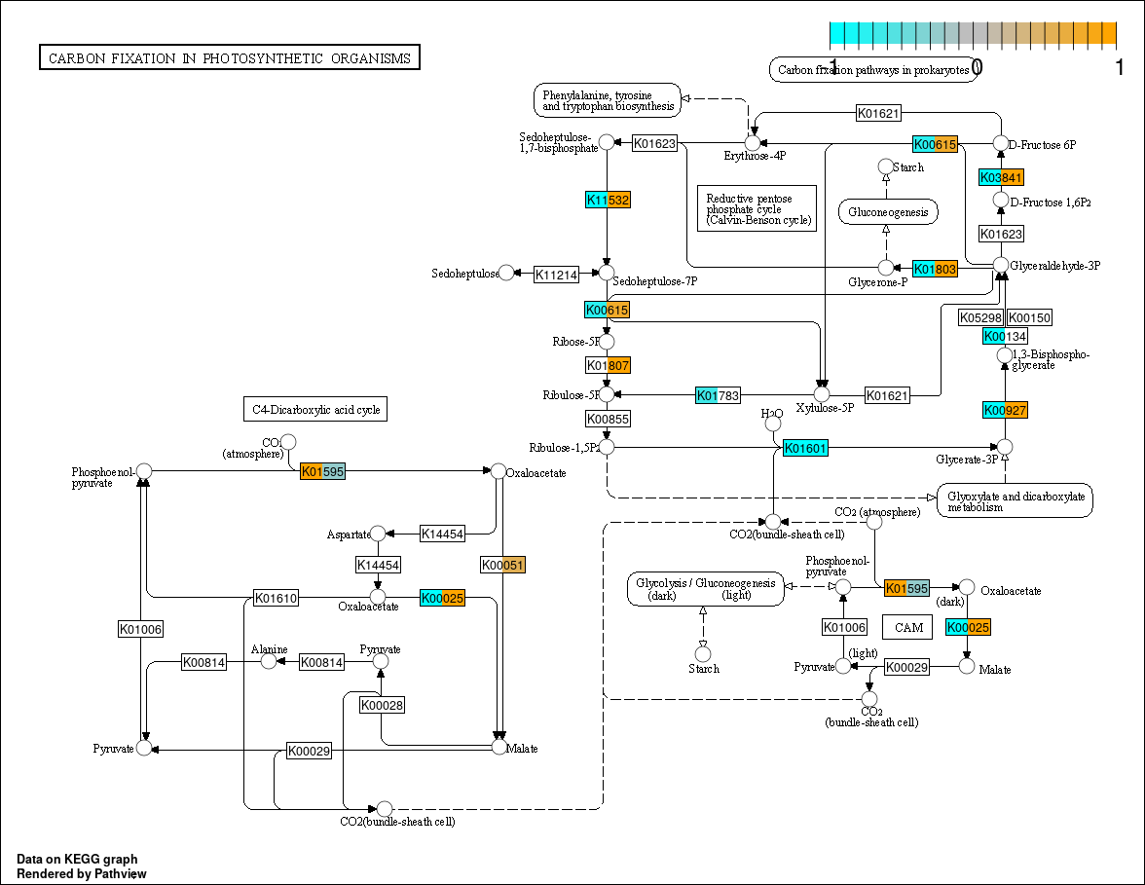
Supplementary Figure 3. Carbon fixation pathway showing seasonal expression changes (log2-fold, values <-1 or >1 are set to these limits) in gene functions (KEGG orthologies) that were significantly higher expressed in summer (orange) or winter (cyan) samples. Insignificant seasonal expression differences are shown in white. If several genes referred to the same KEGG orthology (KO) term, their average diurnal log2 fold change is shown. Each KO-term is partitioned into two sections corresponding to 1) French and 2) Norwegian samples.
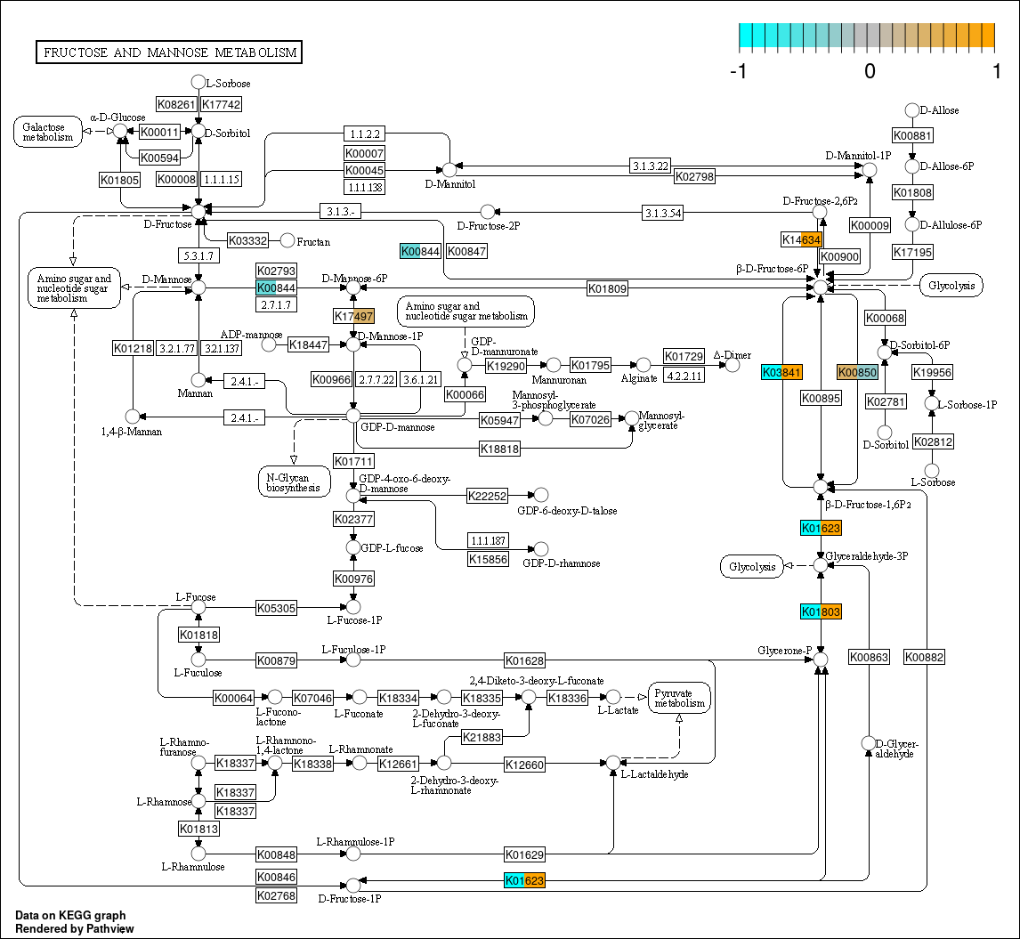
Supplementary Figure 4. Fructose and mannose metabolism pathway showing seasonal expression changes (log2-fold, values <-1 or >1 are set to these limits) in gene functions (KEGG orthologies) that were significantly higher expressed in summer (orange) or winter (cyan) samples. Insignificant seasonal expression differences are shown in white. If several genes referred to the same KEGG orthology (KO) term, their average diurnal log2 fold change is shown. Each KO-term is partitioned into two sections corresponding to 1) French and 2) Norwegian samples.
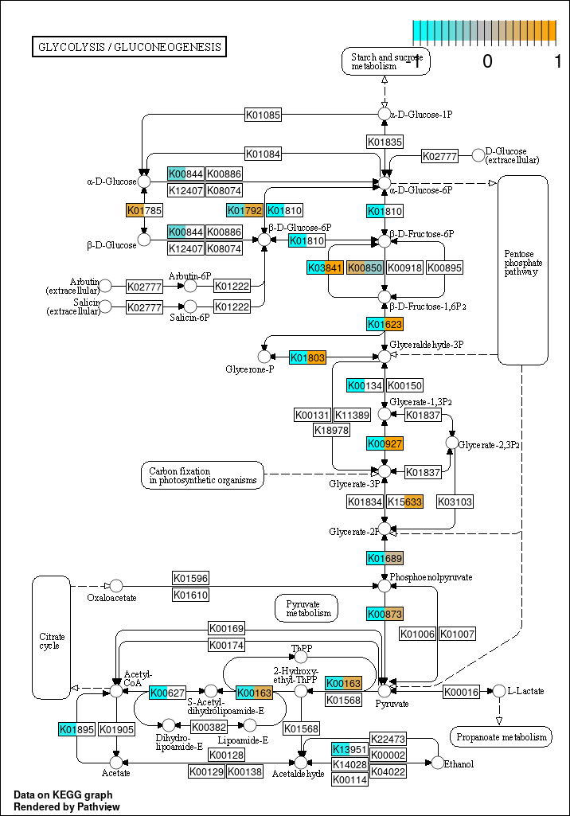
Supplementary Figure 5. Glycolisis/gluconeogenesis pathway showing seasonal expression changes (log2-fold, values <-1 or >1 are set to these limits) in gene functions (KEGG orthologies) that were significantly higher expressed in summer (orange) or winter (cyan) samples. Insignificant seasonal expression differences are shown in white. If several genes referred to the same KEGG orthology (KO) term, their average diurnal log2 fold change is shown. Each KO-term is partitioned into two sections corresponding to 1) French and 2) Norwegian samples.
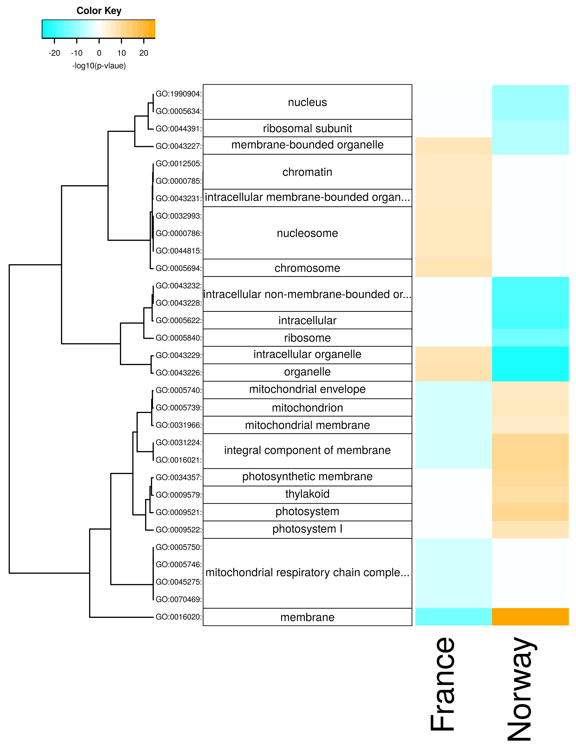
Supplementary Figure 6. Seasonal changes in cellular components. Enriched components are shown for each population with positive -log10(p-values) for genes upregulated in summer (orange) and with negative -log10(p-values) for genes upregulated in winter (cyan).
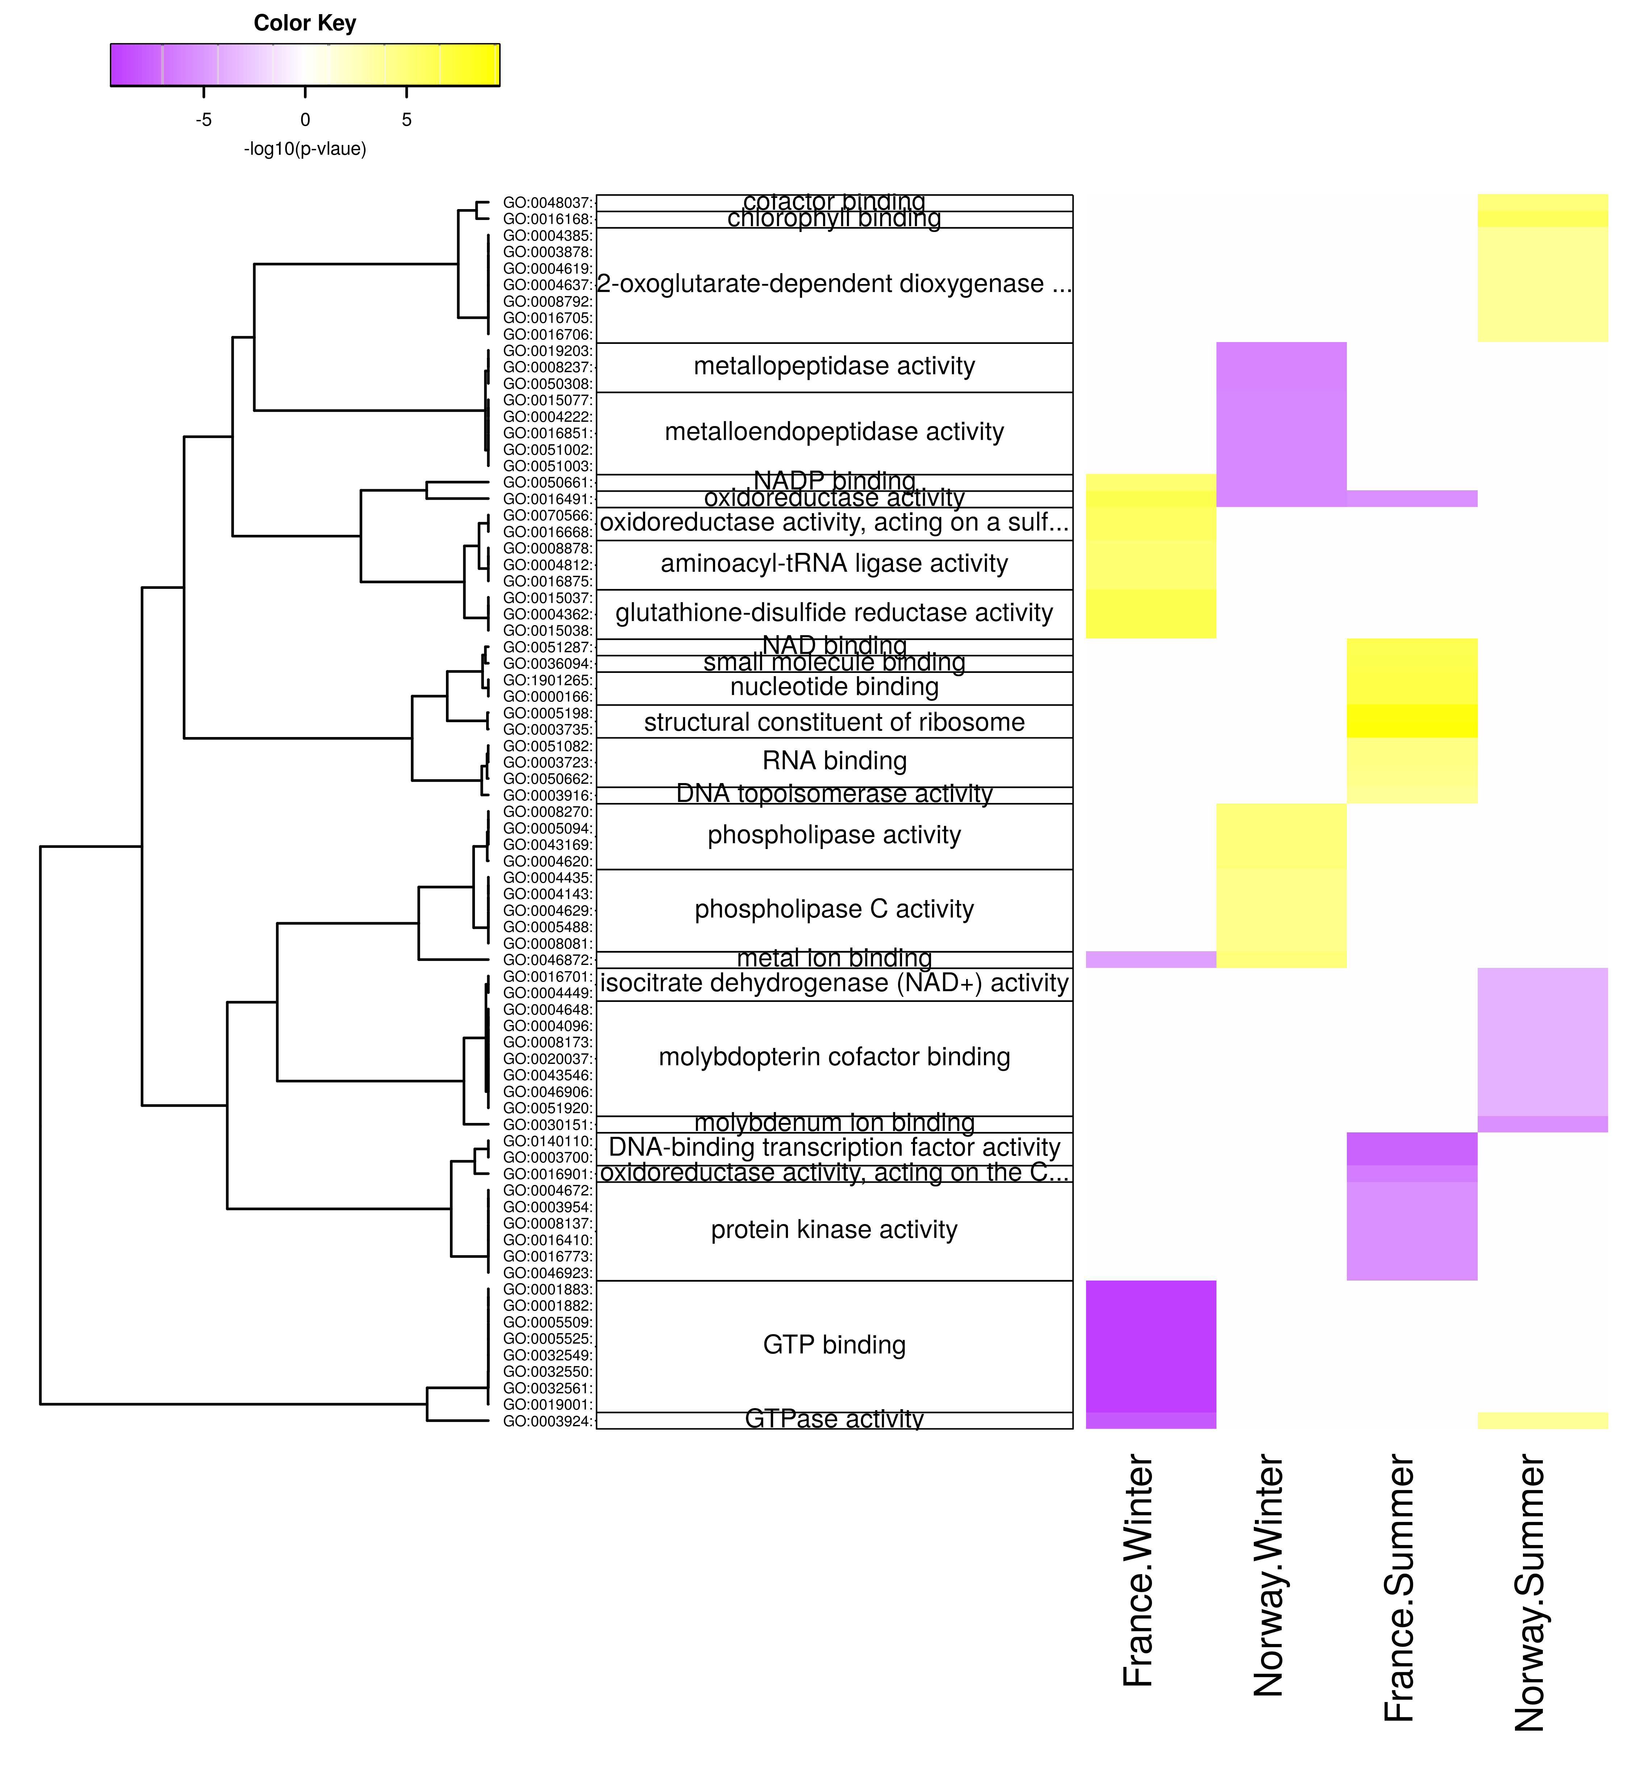
Supplementary Figure 7. Diurnal changes in molecular functions. Enriched functions are shown for each population x season with positive -log10(p-values) for genes upregulated at day (yellow) and with negative -log10(p-values) for genes upregulated at night (violet).
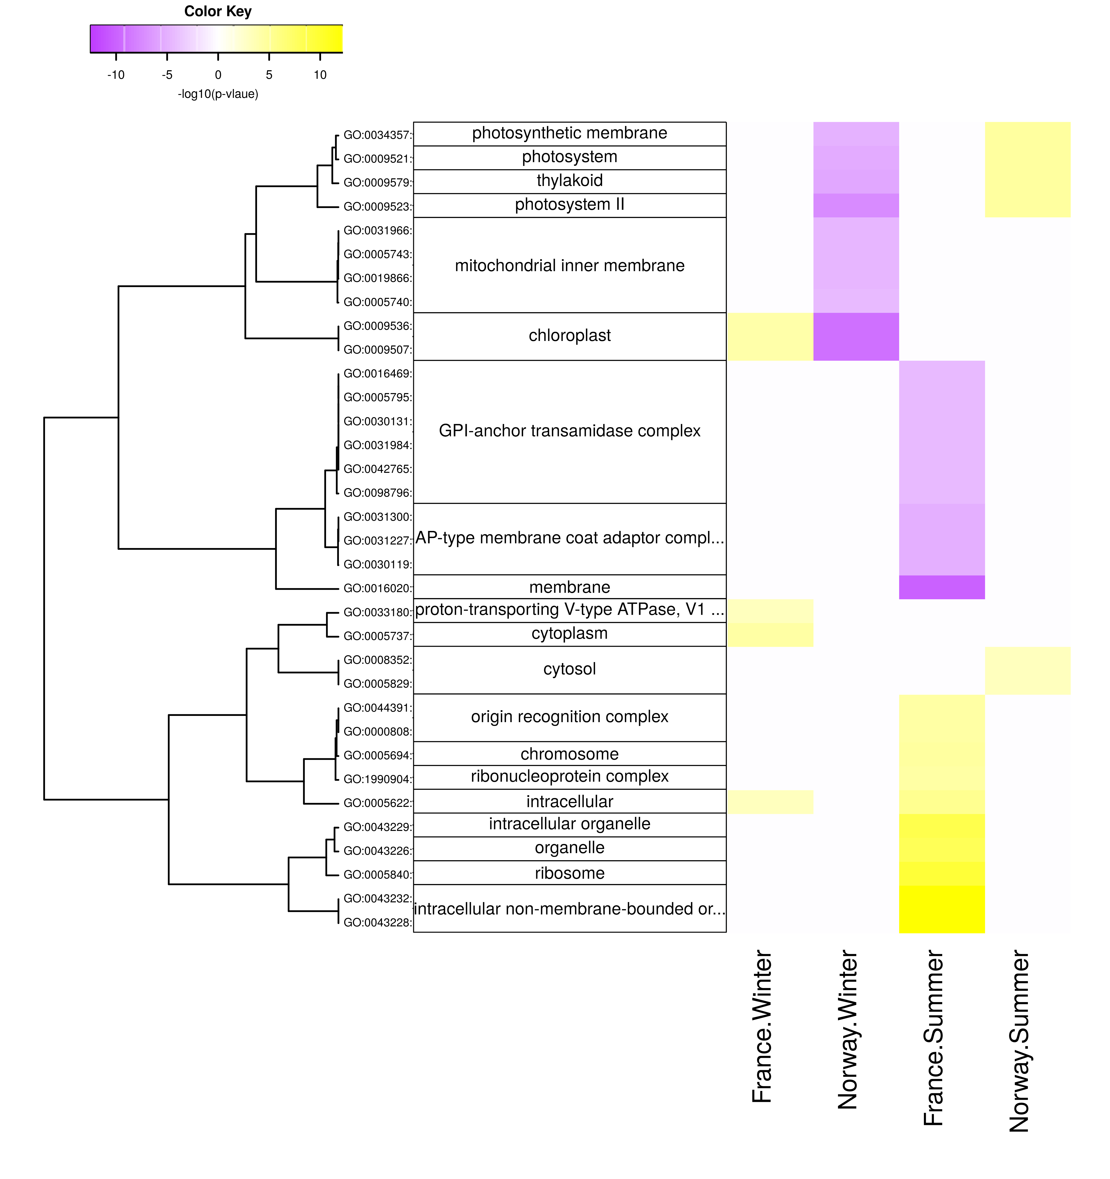
Supplementary Figure 8. Diurnal changes in cellular components. Enriched components are shown for each population x season with positive -log10(p-values) for genes upregulated at day (yellow) and with negative -log10(p-values) for genes upregulated at night (violet).
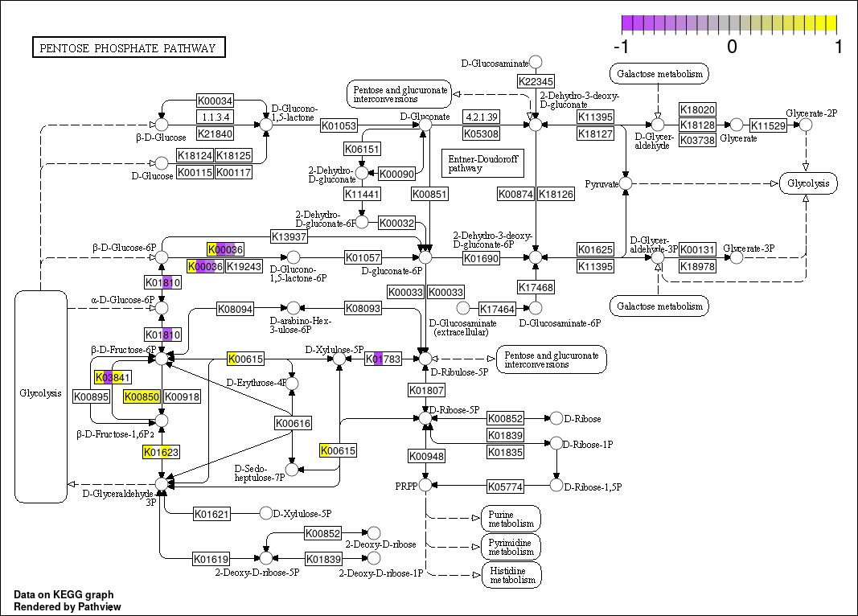
Supplementary Figure 9. Pentose phosphate pathway showing diurnal expression changes (log2-fold, values <-1 or >1 are set to these limits) in gene functions (KEGG orthologies) that were significantly higher expressed in day (yellow) or night (violet) samples. Insignificant expression differences between day and night are shown in white. If several genes referred to the same KEGG orthology (KO) term, their average diurnal log2 fold change is shown. Each KO-term is sliced into four pieces corresponding to 1) French winter samples, 2) Norwegian winter samples, 3) French summer samples, and 4) Norwegian summer samples.
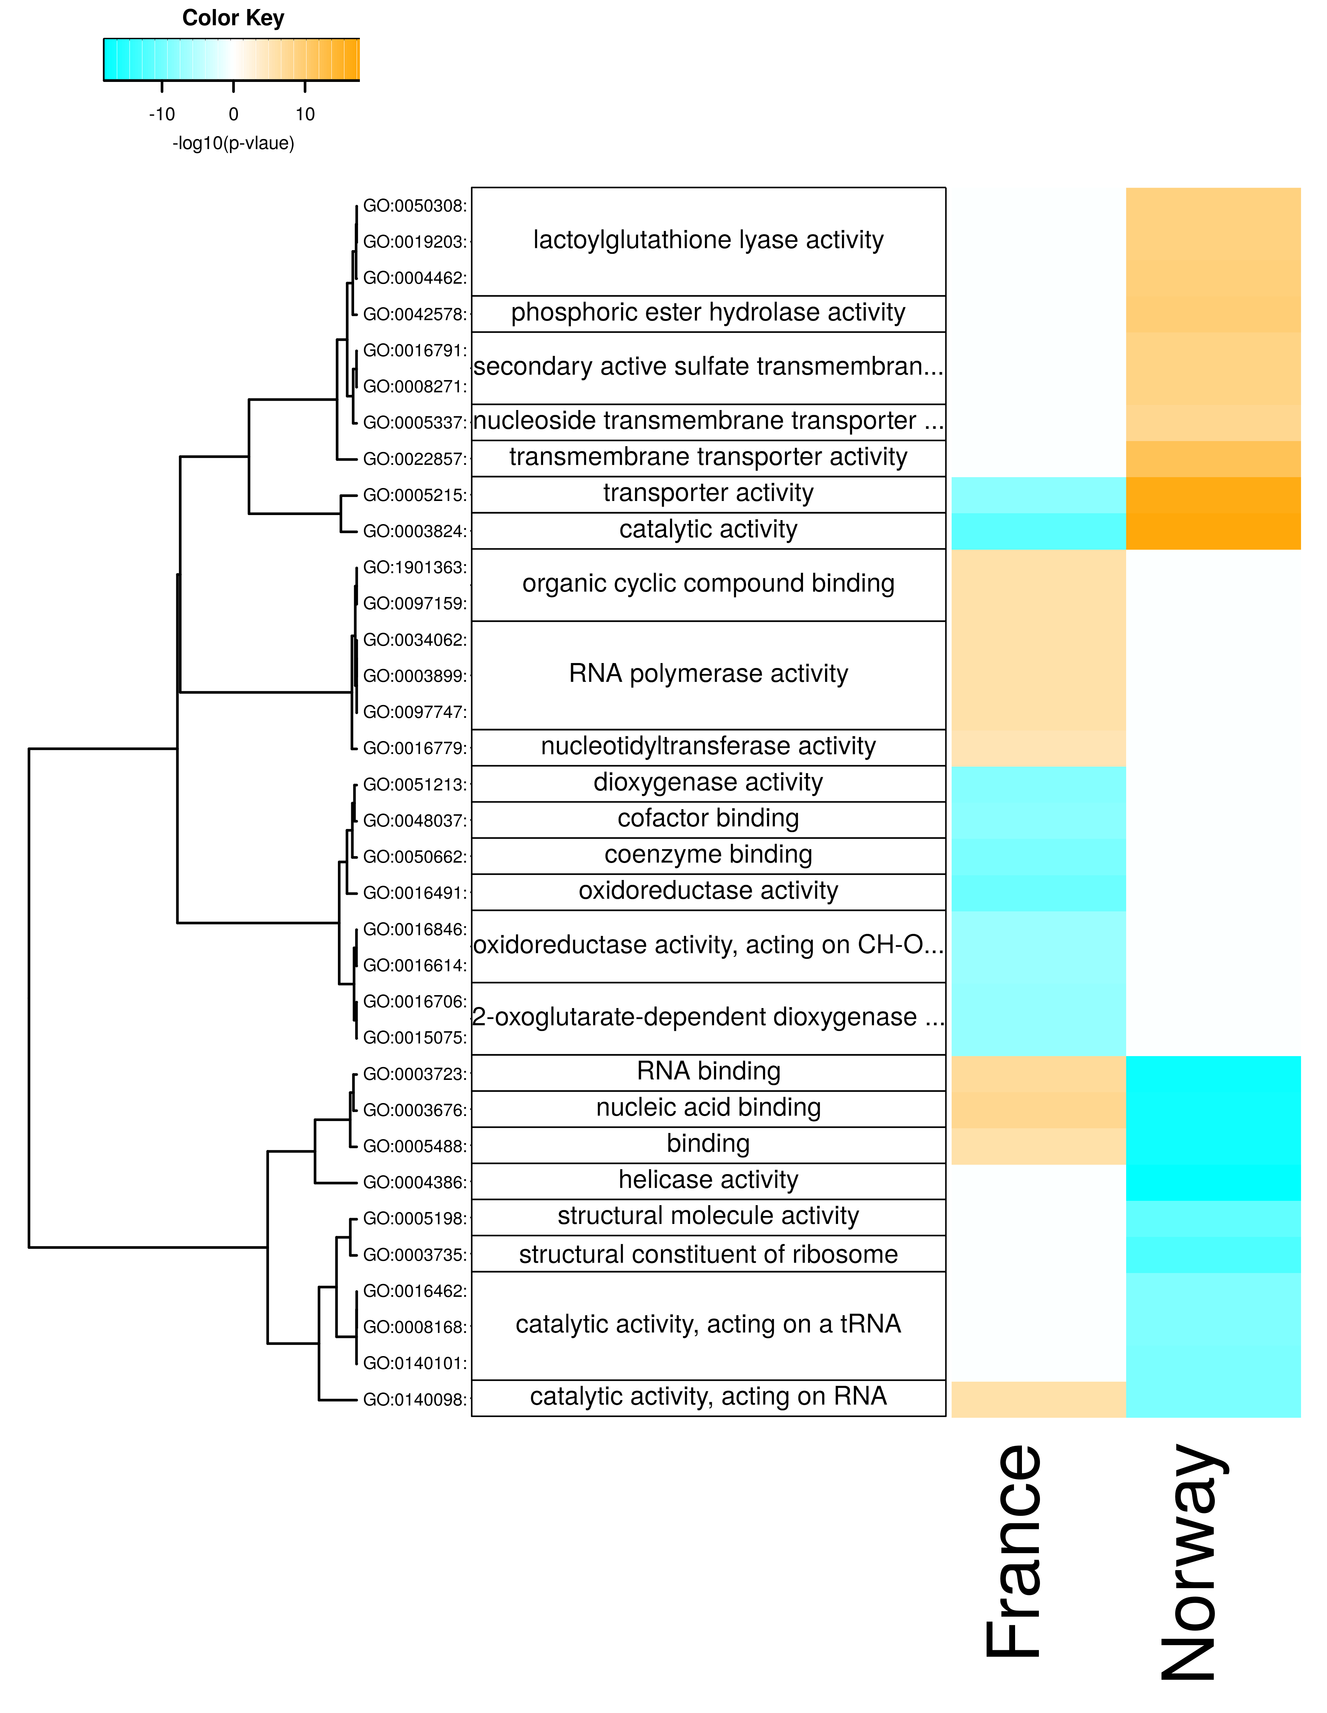
Supplementary Figure 10. Seasonal changes in molecular functions. Enriched functions are shown for each population with positive -log10(p-values) for genes upregulated in summer (orange) and with negative -log10(p-values) for genes upregulated in winter (cyan).
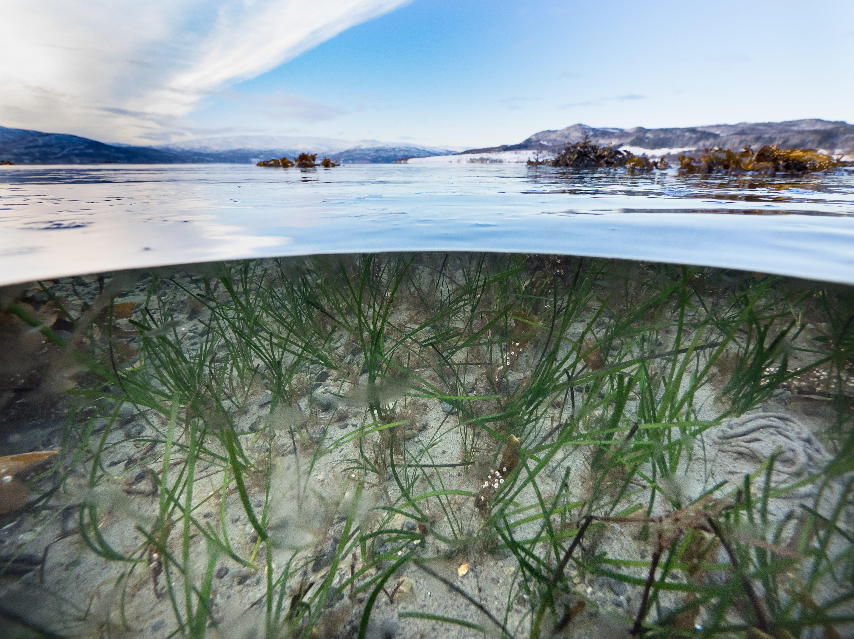
Supplementary Figure 11.
Eelgrass (Zostera marina) plants at our Norwegian sampling site (Røvik, 67°16’06.2" N, 15°15’38.4" E). The picture was taken on February 12th, 2016. The presence of fresh green leaves suggests that the plants had grown new shoots during the dark winter period.

