Supplementary Material

Supplementary Data
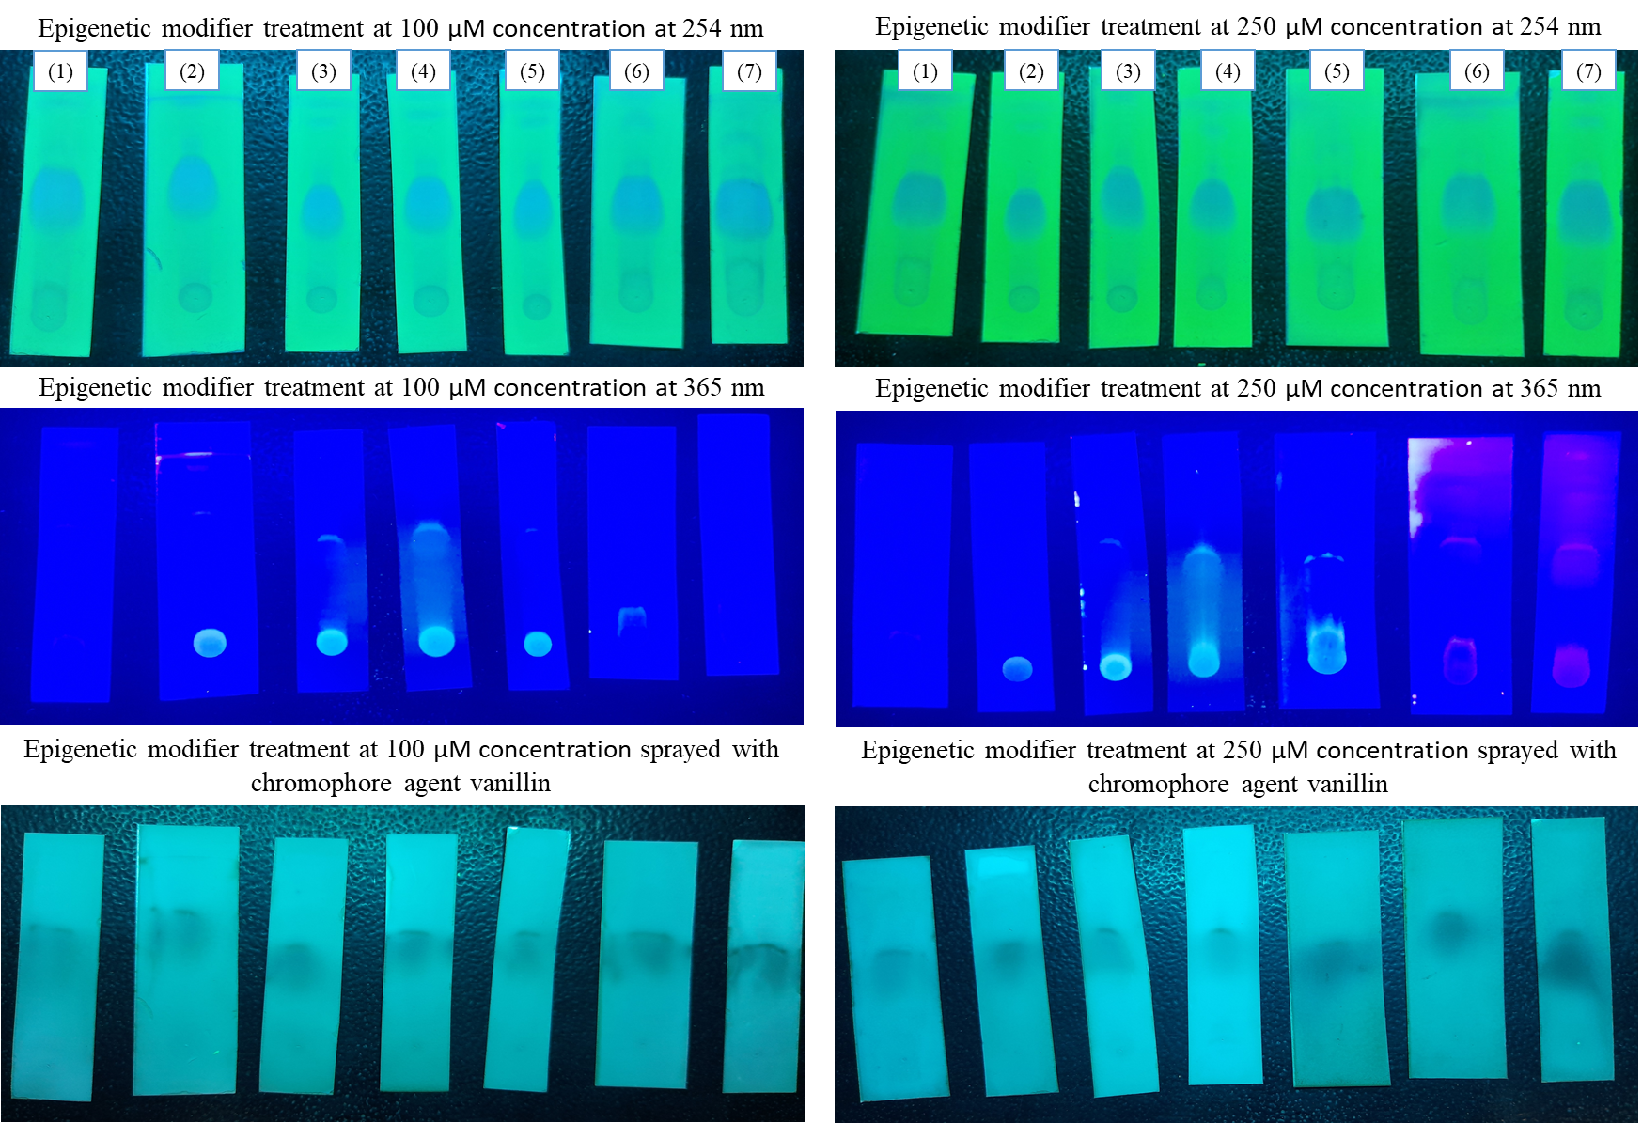
Figure S1. Comparative analysis of the TLC profiles produced by the strain with and without the epigenetic modifier treatment (1), 5-azacytidine (2), Valproic acid (3), Hydralazine Hydrochloride (4), Sodium butyrate (5), Quercetin (6) and SAHA (7).
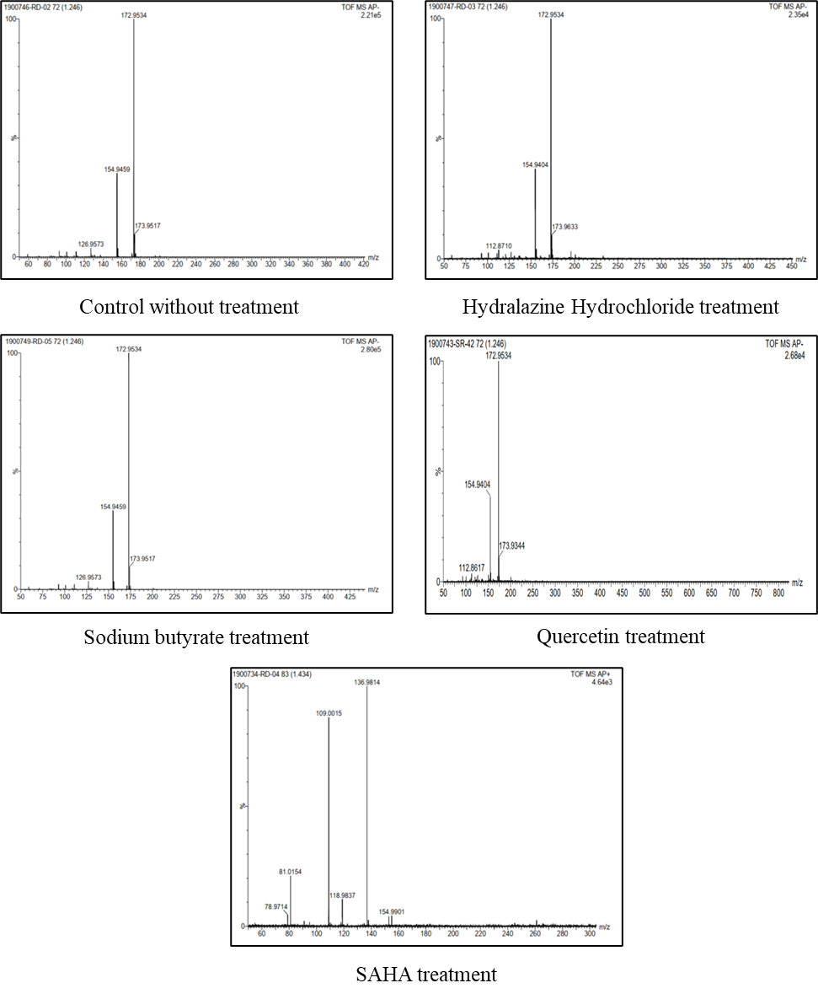
Figure S2: LCMS analysis of treatments showing phomalactone (m/z: 154).
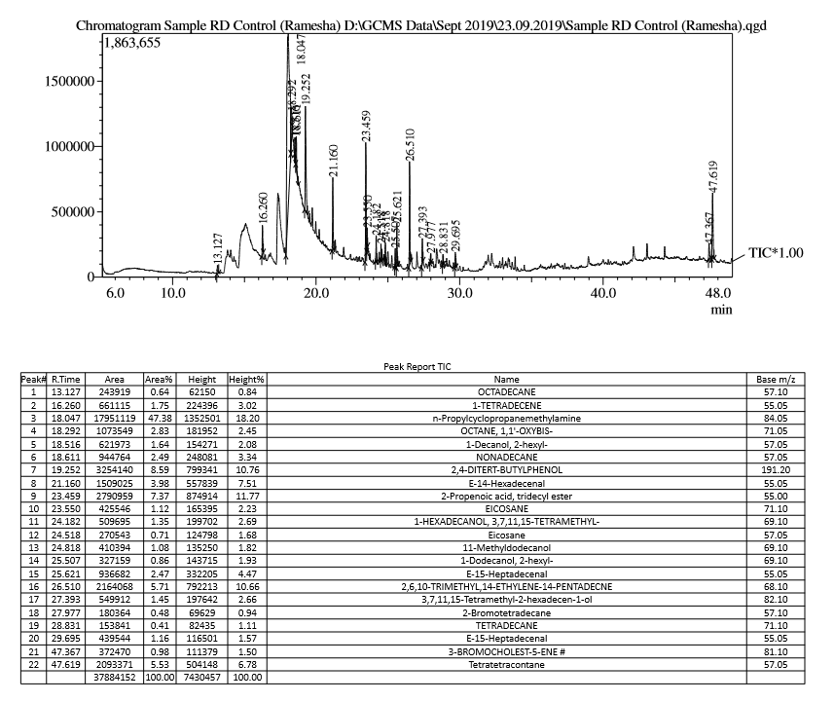
Figure S3. GCMS Data of Control crude extract without treatment
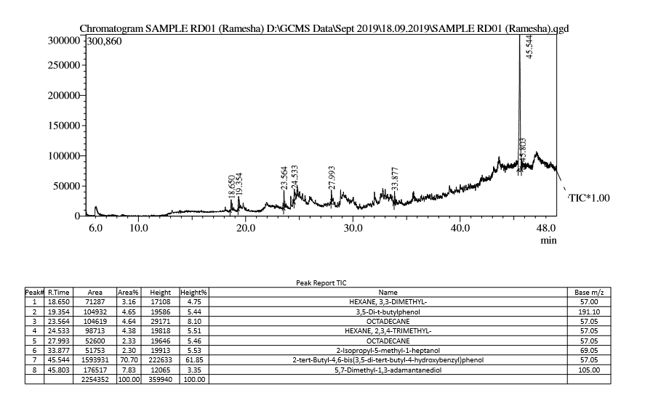
Figure S4. GCMS data of 5-Azacytidine treatment
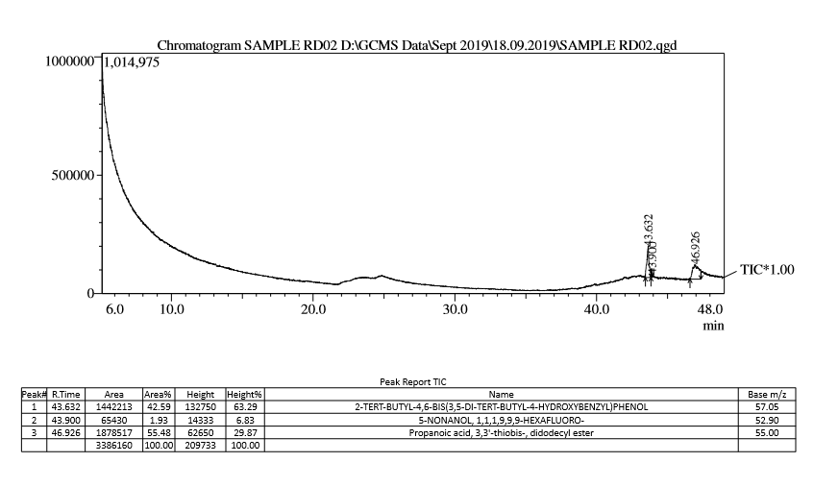
Figure S5. GCMS data of Valproic acid treatment
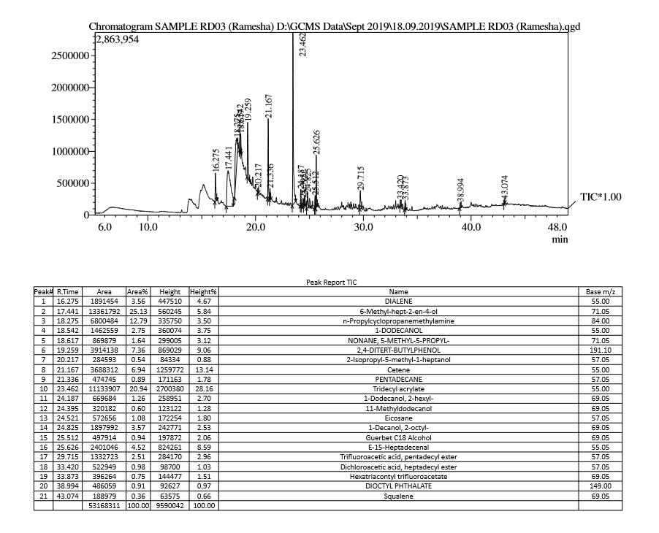
Figure S6. GCMS data of Hydralazine hydrochloride treatment
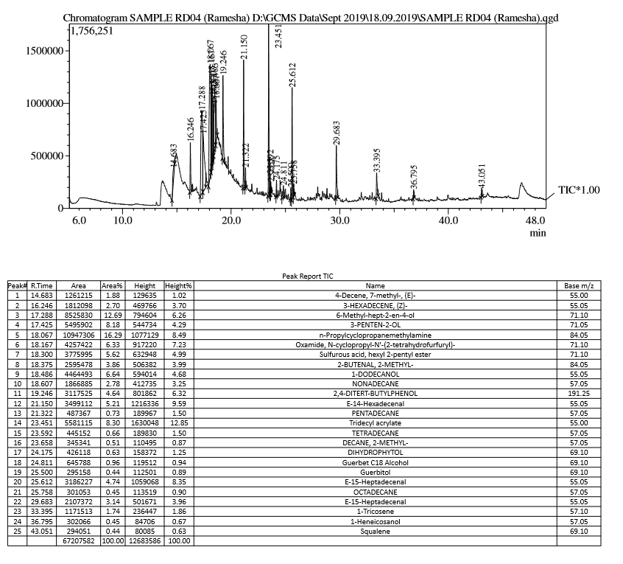
Figure S7. GCMS data of Sodium butyrate treatment
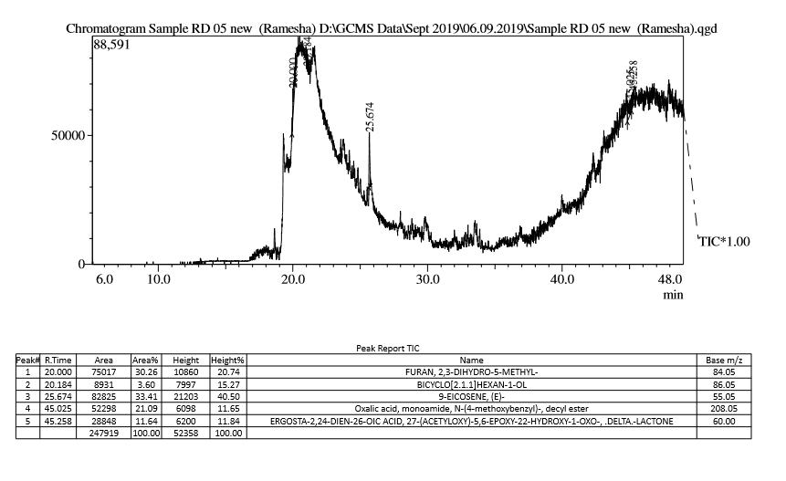
Figure S8. GCMS data of Quercetin treatment
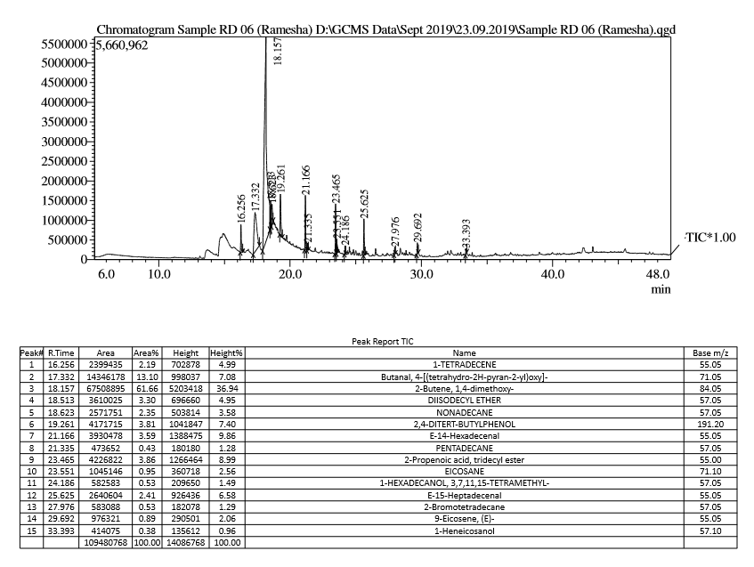
Figure S9. GCMS data of SAHA treatment

Table S1. Number of peaks detected in HPLC profiles of the total metabolites of Nigrospora sphaerica at wavelength of 254nm from different treatments
Peak no. | Retention Time | Control | 5-azacytidine | Valproic acid | Hydralazine Hydrochloride | Sodium butyrate | Quercitin | SAHA
 |  | (Peak Area) | (Peak Area) | (Peak Area) | (Peak Area) | (Peak Area) | (Peak Area) | (Peak Area)
1 | 2.1 | 0 | 0 | 0 | 0 | 10278 | 30182 | 9850
2 | 2.2 | 51226 | 0 | 0 | 0 | 0 | 0 | 0
3 | 2.3 | 0 | 0 | 0 | 0 | 42678 | 80296 | 45871
4 | 2.4 | 0 | 0 | 0 | 167987 | 0 | 0 | 0
5 | 2.5 | 41091 | 93109 | 0 | 0 | 32448 | 65575 | 49559
6 | 2.8 | 0 | 0 | 0 | 0 | 57559 | 108057 | 167155
7 | 2.9 | 0 | 278406 | 0 | 0 | 0 | 0 | 0
8 | 3.0 | 20310377 | 0 | 0 | 0 | 2086152 | 1367324 | 1992990
9 | 3.1 | 0 | 0 | 0 | 15954884 | 0 | 0 | 0
10 | 3.2 | 0 | 2212928 | 0 | 11772237 | 1266280 | 1510219 | 1346813
11 | 3.5 | 78922 | 0 | 0 | 0 | 0 | 0 | 0
12 | 3.7 | 0 | 336629 | 0 | 0 | 0 | 7546 | 159678
13 | 3.8 | 0 | 0 | 0 | 0 | 404356 | 156345 | 0
14 | 3.9 | 0 | 478379 | 0 | 0 | 0 | 0 | 320309
15 | 4.0 | 806189 | 0 | 361746 | 0 | 0 | 103232 | 0
16 | 4.1 | 0 | 485952 | 0 | 1509254 | 0 | 0 | 0
17 | 4.4 | 6711 | 0 | 0 | 2544 | 0 | 0 | 0
18 | 4.5 | 0 | 143503 | 0 | 0 | 43713 | 45864 | 58565
19 | 4.7 | 6350 | 49004 | 4206 | 15560 | 40009 | 21755 | 69261
20 | 4.9 | 0 | 0 | 0 | 14289 | 0 | 0 | 0
21 | 5.0 | 0 | 30489 | 0 | 0 | 0 | 17085 | 0
22 | 5.3 | 27015 | 0 | 0 | 18683 | 0 | 33864 | 60526
23 | 5.4 | 0 | 60330 | 8681 | 0 | 38639 | 0 | 0
24 | 5.8 | 0 | 360436 | 13676 | 0 | 0 | 0 | 0
25 | 5.9 | 28064 | 0 | 0 | 0 | 0 | 0 | 0
26 | 6.0 | 0 | 0 | 0 | 41598 | 0 | 0 | 0
27 | 6.1 | 0 | 0 | 0 | 0 | 34596 | 22033 | 39806
28 | 6.4 | 26761 | 0 | 0 | 0 | 0 | 0 | 0
29 | 6.5 | 0 | 0 | 0 | 27615 | 0 | 0 | 0
30 | 6.8 | 0 | 0 | 13759 | 0 | 0 | 0 | 0
31 | 6.9 | 0 | 0 | 0 | 0 | 0 | 8079 | 16341
32 | 7.0 | 57927 | 0 | 0 | 94688 | 12600 | 0 | 0
33 | 7.1 | 0 | 43347 | 0 | 0 | 0 | 0 | 0
34 | 7.3 | 0 | 0 | 0 | 0 | 2962 | 1653 | 4575
35 | 7.5 | 0 | 0 | 0 | 0 | 3500 | 0 | 4573
36 | 7.6 | 20624 | 0 | 12428 | 0 | 0 | 0 | 0
37 | 7.7 | 0 | 0 | 0 | 31615 | 0 | 0 | 0
38 | 7.8 | 0 | 181192 | 0 | 0 | 0 | 0 | 0
39 | 7.9 | 15143 | 0 | 5521 | 23716 | 3918 | 0 | 3117
40 | 8.2 | 8366 | 0 | 0 | 0 | 0 | 0 | 0
41 | 8.3 | 0 | 0 | 0 | 19903 | 0 | 0 | 0
42 | 8.5 | 0 | 0 | 6924 | 0 | 0 | 0 | 0
43 | 8.6 | 5623 | 0 | 0 | 0 | 0 | 0 | 0
44 | 8.7 | 0 | 0 | 0 | 19099 | 0 | 0 | 0
45 | 8.9 | 0 | 2165 | 0 | 0 | 0 | 0 | 0
46 | 9.0 | 0 | 0 | 0 | 17929 | 0 | 0 | 0
47 | 9.1 | 12491 | 0 | 0 | 0 | 0 | 0 | 0
48 | 9.2 | 0 | 0 | 3129 | 0 | 0 | 0 | 0
49 | 9.4 | 0 | 0 | 5102 | 0 | 0 | 0 | 0
50 | 9.5 | 4016 | 0 | 0 | 0 | 0 | 0 | 0
51 | 9.6 | 0 | 5869 | 0 | 0 | 42303 | 35051 | 23522
52 | 9.9 | 0 | 0 | 0 | 1675 | 0 | 0 | 0
53 | 10.1 | 0 | 0 | 0 | 0 | 5335 | 3471 | 4560
54 | 10.2 | 0 | 7784 | 0 | 0 | 0 | 0 | 0
55 | 10.5 | 121062 | 0 | 0 | 0 | 0 | 0 | 0
56 | 10.6 | 0 | 0 | 289461 | 181031 | 0 | 0 | 0
57 | 11.2 | 9291 | 0 | 0 | 0 | 0 | 0 | 0
58 | 11.3 | 0 | 0 | 1397 | 34793 | 0 | 0 | 0
59 | 11.9 | 725846 | 0 | 0 | 0 | 0 | 0 | 0
60 | 12.1 | 0 | 0 | 7158 | 106064 | 0 | 0 | 0
61 | 12.4 | 0 | 0 | 0 | 0 | 2443 | 2476 | 2313
62 | 12.7 | 0 | 21860 | 0 | 0 | 0 | 0 | 0
63 | 12.8 | 0 | 0 | 0 | 13897 | 0 | 0 | 0
64 | 13.6 | 0 | 0 | 0 | 4574 | 0 | 0 | 0
65 | 13.7 | 0 | 0 | 0 | 2857 | 0 | 0 | 0
66 | 14.1 | 0 | 0 | 0 | 4671 | 0 | 0 | 0
67 | 14.7 | 1206 | 0 | 0 | 0 | 0 | 0 | 0
68 | 14.8 | 0 | 2324 | 0 | 0 | 0 | 0 | 0
69 | 15.3 | 4836 | 0 | 0 | 0 | 0 | 0 | 0
70 | 15.5 | 0 | 0 | 3073 | 0 | 0 | 0 | 0
71 | 15.9 | 0 | 0 | 7291 | 0 | 0 | 0 | 0
72 | 16.0 | 0 | 0 | 0 | 4042 | 0 | 0 | 0
73 | 18.2 | 3977 | 0 | 0 | 0 | 0 | 0 | 0
74 | 18.3 | 3802 | 0 | 0 | 0 | 0 | 0 | 0
75 | 20.1 | 0 | 1305 | 0 | 0 | 0 | 0 | 0
76 | 20.3 | 30942 | 0 | 0 | 0 | 0 | 0 | 0
77 | 22.2 | 0 | 0 | 0 | 0 | 0 | 0 | 4525
78 | 22.3 | 0 | 0 | 0 | 0 | 0 | 5864 | 0
79 | 22.4 | 0 | 0 | 0 | 0 | 3380 | 0 | 0
80 | 23.5 | 0 | 0 | 0 | 5255 | 0 | 0 | 0
81 | 25.5 | 6201 | 0 | 0 | 0 | 0 | 0 | 0
82 | 25.6 | 2185 | 0 | 0 | 0 | 0 | 0 | 0
83 | 25.7 | 7108 | 0 | 0 | 0 | 0 | 0 | 0
84 | 26.0 | 0 | 36156 | 0 | 0 | 0 | 0 | 0
85 | 27.5 | 4929 | 0 | 0 | 0 | 0 | 0 | 0
86 | 28.9 | 0 | 0 | 0 | 24561 | 0 | 0 | 0

Table S2. GCMS analysis for detection of VOCs
Sl No. | Control | 5-Azacytidine | Valproic acid | Hydralazine Hydrochloride | Sodium butyrate | Quercetin | SAHA
1 | octadecane | hexane, 3,3-dimethyl- | 2-tert-butyl-4,6-bis(3,5-di-tert-butyl-4-hydroxybenzyl) phenol | dialene | 4-decene, 7-methyl-, (e)- | furan, 2,3-dihydro-5-methyl- | 1-tetradecene
2 | 1-tetradecene | 3,5-di-t-butylphenol | 5-nonanol, 1,1,1,9,9,9-hexafluoro- | 6-methyl-hept-2-en-4-ol | 3-hexadecene, (z)- | bicyclo[2.1.1]hexan-1-ol | butanal, 4-[(tetrahydro-2h-pyran-2-yl) oxy]-
3 | phomalactone | octadecane | propanoic acid, 3,3'-thiobis-, didodecyl ester | phomalactone | 6-methyl-hept-2-en-4-ol | 9-eicosene, (e)- | 2-butene, 1,4-dimethoxy-
4 | octane, 1,1'-oxybis- | hexane, 2,3,4-trimethyl- |  | 1-dodecanol | 3-penten-2-ol | oxalic acid, monoamide, n-(4-methoxybenzyl)-, decyl ester | diisodecyl ether
5 | 1-decanol, 2-hexyl- | 2-isopropyl-5-methyl-1-heptanol |  | nonane, 5-methyl-5-propyl- | phomalactone | ergosta-2,24-dien-26-oic acid, 27-(acetyloxy)-5,6-epoxy-22-hydroxy-1-oxo-, .delta.-lactone | nonadecane
6 | nonadecane | 2-tert-butyl-4,6-bis(3,5-di-tert-butyl-4-hydroxybenzyl) phenol |  | 2,4-ditert-butylphenol | oxamide, n-cyclopropyl-n'-(2-tetrahydrofurfuryl)- |  | 2,4-ditert-butylphenol
7 | 2,4-ditert-butylphenol | 5,7-dimethyl-1,3-adamantanediol |  | 2-isopropyl-5-methyl-1-heptanol | sulfurous acid, hexyl 2-pentyl ester |  | e-14-hexadecenal
8 | e-14-hexadecenal |  |  | cetene | 2-butenal, 2-methyl- |  | pentadecane
9 | 2-propenoic acid, tridecyl ester |  |  | pentadecane | 1-dodecanol |  | 2-propenoic acid, tridecyl ester
10 | eicosane |  |  | tridecyl acrylate | nonadecane |  | eicosane
11 | 1-hexadecanol, 3,7,11,15-tetramethyl- |  |  | 1-dodecanol, 2-hexyl- | 2,4-ditert-butylphenol |  | 1-hexadecanol, 3,7,11,15-tetramethyl-
12 | 11-methyldodecanol |  |  | 11-methyldodecanol | e-14-hexadecenal |  | e-15-heptadecenal
13 | 1-dodecanol, 2-hexyl- |  |  | eicosane | pentadecane |  | 2-bromotetradecane
14 | e-15-heptadecenal |  |  | 1-decanol, 2-octyl- | tridecyl acrylate |  | 9-eicosene, (e)-
15 | 2,6,10-trimethyl,14-ethylene-14-pentadecne |  |  | guerbet c18 alcohol | tetradecane |  | 1-heneicosanol
16 | 3,7,11,15-tetramethyl-2-hexadecen-1-ol |  |  | e-15-heptadecenal | decane, 2-methyl-
17 | 2-bromotetradecane |  |  | triﬂuoroace9c acid, pentadecyl ester | dihydrophytol
18 | tetradecane |  |  | dichloroace9c acid, heptadecyl ester | guerbet c18 alcohol
19 | e-15-heptadecenal |  |  | hexatriacontyl triﬂuoroacetate | guerbitol
20 | 3-bromocholest-5-ene # |  |  | dioctyl phthalate | e-15-heptadecenal
21 | tetratetracontane |  |  | squalene | octadecane
22 |  |  |  |  | 1-tricosene
23 |  |  |  |  | 1-heneicosanol
24 |  |  |  |  | squalene

Table S3. Antibacterial activity of Epigenetic Modifiers treated crude extracts by disc diffusion method
Sl. No. | Test Organism | Gentamicin | Epigenetic Modifiers treated crude extracts (Zone of inhibition in mm)
 |  | In mm | Control | 5-Azacytidine | Valproic acid | Hydralazine Hydrochloride | Sodium butyrate | Quercetin | SAHA
1. | Escherichia coli | 24 ± 0.33 | 8 ± 0.33 | 8 ± 0.33 | 14 ± 0.33 | 15 ± 0.00 | 15 ± 0.33 | 15 ± 0.33 | 15 ± 0.00
2. | Staphylococcus aureus | 22 ± 0.33 | 15 ± 0.00 | 6 ± 0.00 | 7 ± 0.33 | 14 ± 0.33 | 16 ± 0.66 | 16 ± 0.00 | 16 ± 0.33

