Appendix

Table S1 Primers used for validation
Gene ID | Gene Name | Primers (5' to 3')
transcript_90 | myosin heavy chain type 1a | GGTGAACCGCACTTTGA
 |  | CTGGCTGACTTGGCTTT
transcript_91 | myosin heavy chain type 1b | CGCAACTTGGAACACGATA
 |  | CGCCCTCGGACTCATACTT

Table S2 DEPs statistics of SG40 vs. FG40
ID | Annotation | Species | log2FC | regulated
transcript_50 | myosin heavy chain type a | Marsupenaeus japonicus | 0.81 | up
transcript_5822 | actin 1a | Fenneropenaeus chinensis | 0.56 | up
transcript_2192 | heat shock protein 21 | Macrobrachium rosenbergii | 0.53 | up
transcript_1516 | glycerol-3-phosphate dehydrogenase | Nasonia vitripennis | 0.52 | up
transcript_4523 | LOC103524650 | Diaphorina citri | 0.52 | up
transcript_3934 | sarcoplasmic calcium-binding protein | Litopenaeus vannamei | 0.51 | up
transcript_4029 | actin 1 | Fenneropenaeus chinensis | 0.50 | up
transcript_2405 | glucose-6-phosphate isomerase | Spodoptera exigua | 0.44 | up
transcript_6139 | phosphorylase b kinase regulatory subunit alpha-like isoform 2 | Megachile rotundata | 0.44 | up
transcript_15197 | skeletal muscle actin 6 | Homarus americanus | 0.42 | up
transcript_15574 | Coiled-coil domain-containing protein 47 | Stegodyphus mimosarum | 0.40 | up
transcript_3182 | triose-phosphate isomerase | Litopenaeus vannamei | 0.37 | up
transcript_10217 | phosphorylase b kinase regulatory subunit beta | Zootermopsis nevadensis | 0.32 | up
transcript_3403 | 2,3-bisphosphoglycerate-dependent phosphoglycerate mutase | Daphnia pulex | 0.31 | up
transcript_3624 | fructose 1,6-bisphosphatase | Marsupenaeus japonicus | 0.30 | up
transcript_1085 | mediator of RNA polymerase II transcription subunit 31 | Solenopsis invicta | 0.29 | up
transcript_2330 | AaeL_AAEL000536 | Aedes aegypti | 0.27 | up
transcript_1312 | nucleotide excision repair protein | Marsupenaeus japonicus | 0.24 | up
transcript_353 | calcineurin subunit A | Eriocheir sinensis | 0.23 | up
transcript_10625 | Myosin light chain kinase | Toxocara canis | 0.23 | up
transcript_1536 | protein lethal (2) essential for life-like | Megachile rotundata | 0.23 | up
transcript_10565 | Cytoplasmic dynein 1 light intermediate chain 2 | Zootermopsis nevadensis | 0.23 | up
transcript_4213 | LOTGIDRAFT_232738 | Lottia gigantea | 0.23 | up
transcript_12761 | 2-oxoglutarate dehydrogenase | Culex quinquefasciatus | 0.20 | up
transcript_4302 | DJ-1 protein | Litopenaeus vannamei | 0.18 | up
transcript_4936 | ubiquitin | Procambarus clarkii | 0.14 | up
transcript_14792 | DAPPUDRAFT_320916 | Daphnia pulex | 0.14 | up
transcript_1495 | SINV_80052 | Solenopsis invicta | 0.13 | up
transcript_516 | EH domain-containing protein 1-like | Daphnia pulex | -0.08 | down
transcript_6604 | actin 2 | Penaeus monodon | -0.09 | down
transcript_2268 | cyclophilin A | Litopenaeus vannamei | -0.12 | down
transcript_4790 | ribosomal protein L10a | Fenneropenaeus merguiensis | -0.17 | down
transcript_10514 | 14-3-3 epsilon-like | Litopenaeus vannamei | -0.19 | down
transcript_2496 | proliferation-associated protein 2G4-like | Megachile rotundata | -0.21 | down
transcript_4729 | heat shock protein 10 | Scylla paramamosain | -0.21 | down
transcript_5905 | Shootin-1 | Zootermopsis nevadensis | -0.25 | down
transcript_12151 | Tubulin beta-2 chain | Homarus americanus | -0.29 | down
transcript_4902 | NADH dehydrogenase [ubiquinone] 1 beta subcomplex subunit 9 | Zootermopsis nevadensis | -0.30 | down
transcript_4982 | ribosomal protein L24 | Marsupenaeus japonicus | -0.31 | down
transcript_10357 | histone H1-delta-like | Aplysia californica | -0.35 | down
transcript_5097 | ribosomal protein S25 | Ixodes scapularis | -0.35 | down
transcript_4971 | 60s ribosomal protein l27a | Ascaris suum | -0.36 | down
transcript_11264 | clottable protein | Marsupenaeus japonicus | -0.40 | down
transcript_5111 | ribosomal protein L44 | Procambarus clarkii | -0.43 | down
transcript_4483 | sarcoplasmic calcium-binding protein, beta chain | Penaeus sp. | -0.49 | down
transcript_4129 | T265_13221 | Opisthorchis viverrini | -0.52 | down
transcript_10746 | myosin heavy chain type 2 | Penaeus monodon | -0.54 | down
transcript_11623 | myosin heavy chain type b | Marsupenaeus japonicus | -0.66 | down
transcript_6703 | GM19733 | Drosophila sechellia | -0.69 | down
transcript_10737 | actin 2 | Penaeus monodon | -0.81 | down
transcript_91 | myosin heavy chain type 1b | Litopenaeus vannamei | -0.95 | down
transcript_90 | myosin heavy chain type 1a | Litopenaeus vannamei | -1.00 | down

Table S3 DEPs statistics of SG70 vs. FG70
ID | Annotation | Species | log2FC | regulated
transcript_7770 | cactus protein | Litopenaeus vannamei | 0.75 | up
transcript_2449 | pyruvate kinase 3 | Litopenaeus vannamei | 0.48 | up
transcript_1516 | glycerol-3-phosphate dehydrogenase | Nasonia vitripennis | 0.41 | up
transcript_11514 | glycogen debranching enzyme isoform X2 | Microplitis demolitor | 0.40 | up
transcript_2405 | glucose-6-phosphate isomerase | Spodoptera exigua | 0.29 | up
transcript_1121 | YQE_04268 | Dendroctonus ponderosae | 0.28 | up
transcript_4212 | COP9 signalosome complex subunit 7a | Zootermopsis nevadensis | 0.22 | up
transcript_5955 | Deoxyribonuclease tatD | Lepeophtheirus salmonis | 0.15 | up
transcript_2268 | cyclophilin A | Litopenaeus vannamei | -0.11 | down
transcript_1118 | GTP-binding protein CG1354-like | Bombus terrestris | -0.12 | down
transcript_2070 | Phosphoglycolate phosphatase | Cerapachys biroi | -0.14 | down
transcript_9510 | protein ROP | Pediculus humanus corporis | -0.16 | down
transcript_4776 | prefoldin subunit 4-like | Aplysia californica | -0.18 | down
transcript_1590 | BRAFLDRAFT_122807 | Branchiostoma floridae | -0.18 | down
transcript_935 | integrin | Litopenaeus vannamei | -0.19 | down
transcript_12360 | Protein transport protein Sec24B | Cerapachys biroi | -0.19 | down
transcript_4552 | prefoldin | Ixodes scapularis | -0.19 | down
transcript_12753 | DAPPUDRAFT_41019 | Daphnia pulex | -0.20 | down
transcript_352 | 10-formyltetrahydrofolate dehydrogenase | Zootermopsis nevadensis | -0.20 | down
transcript_2759 | eukaryotic initiation factor 4A | Litopenaeus vannamei | -0.21 | down
transcript_4915 | ribosomal protein L11 | Triatoma infestans | -0.21 | down
transcript_4802 | ribosomal protein L14 | Lysiphlebus testaceipes | -0.21 | down
transcript_4440 | proteasome subunit beta type-1 | Tribolium castaneum | -0.23 | down
transcript_1982 | BRAFLDRAFT_285686 | Branchiostoma floridae | -0.25 | down
transcript_13573 | Tyrosine-protein kinase CSK | Stegodyphus mimosarum | -0.25 | down
transcript_15296 | DAPPUDRAFT_189511 | Daphnia pulex | -0.25 | down
transcript_9605 | patatin-like phospholipase domain-containing protein 2-like isoform X2 | Ceratitis capitata | -0.26 | down
transcript_9952 | H+ transporting ATP synthase O subunit | Antheraea yamamai | -0.26 | down
transcript_2496 | proliferation-associated protein 2G4-like | Megachile rotundata | -0.26 | down
transcript_894 | DAPPUDRAFT_321849 | Daphnia pulex | -0.26 | down
transcript_9625 | myosin heavy chain type b | Marsupenaeus japonicus | -0.27 | down
transcript_2525 | DAPPUDRAFT_306997 | Daphnia pulex | -0.27 | down
transcript_12854 | tropomodulin isoform X6 | Tribolium castaneum | -0.28 | down
transcript_3589 | rRNA 2&apos;-O-methyltransferase fibrillarin | Zootermopsis nevadensis | -0.28 | down
transcript_4691 | BRAFLDRAFT_59133 | Branchiostoma floridae | -0.29 | down
transcript_5223 | 40S ribosomal protein S28-like | Strongylocentrotus purpuratus | -0.29 | down
transcript_516 | EH domain-containing protein 1-like | Daphnia pulex | -0.30 | down
transcript_10954 | LIM and senescent cell antigen-like-containing domain protein 1-like isoform X1 | Ceratitis capitata | -0.31 | down
transcript_10514 | 14-3-3 epsilon-like | Litopenaeus vannamei | -0.31 | down
transcript_4939 | ribosomal protein S17 | Branchiostoma belcheri | -0.31 | down
transcript_1029 | glycosyl-phosphatidylinositol-linked carbonic anhydrase | Litopenaeus vannamei | -0.32 | down
transcript_2651 | Protein msta, isoform A | Zootermopsis nevadensis | -0.32 | down
transcript_2202 | DAPPUDRAFT_309332 | Daphnia pulex | -0.32 | down
transcript_2531 | COP9 signalosome complex subunit 2 | Nasonia vitripennis | -0.33 | down
transcript_8699 | DAPPUDRAFT_305817 | Daphnia pulex | -0.36 | down
transcript_3099 | CAPTEDRAFT_177589 | Capitella teleta | -0.36 | down
transcript_14551 | 25-kDa subunit RNA polymerase | Ornithodoros parkeri | -0.36 | down
transcript_422 | Eukaryotic translation initiation factor 5-like | Daphnia pulex | -0.36 | down
transcript_1989 | BRAFLDRAFT_270056 | Branchiostoma floridae | -0.36 | down
transcript_10484 | ribosomal protein S18 | Procambarus clarkii | -0.38 | down
transcript_3286 | bifunctional methylenetetrahydrofolate dehydrogenase/cyclohydrolase, mitochondrial | Acyrthosiphon pisum | -0.38 | down
transcript_9552 | TOM1-like protein 2 | Zootermopsis nevadensis | -0.39 | down
transcript_2785 | TNF superfamily ligand Eiger homologue | Marsupenaeus japonicus | -0.41 | down
transcript_2463 | UMP-CMP kinase | Zootermopsis nevadensis | -0.41 | down
transcript_4248 | ribosomal protein rpl6 | Glycera tridactyla | -0.41 | down
transcript_13987 | ubiquitin-conjugating enzyme E2 b | Eriocheir sinensis | -0.42 | down
transcript_53 | myosin heavy chain type 1 | Litopenaeus vannamei | -0.42 | down
transcript_11202 | protein OPI10 homolog | Apis mellifera | -0.44 | down
transcript_4729 | heat shock protein 10 | Scylla paramamosain | -0.44 | down
transcript_2025 | vacuolar protein-sorting-associated protein 25-like | Saccoglossus kowalevskii | -0.46 | down
transcript_91 | myosin heavy chain type 1b | Litopenaeus vannamei | -0.50 | down
transcript_10921 | DAPPUDRAFT_222043 | Daphnia pulex | -0.52 | down
transcript_1831 | beta-tubulin | Mythimna separata | -0.52 | down
transcript_12024 | muscle M-line assembly protein unc-89 isoform X2 | Acromyrmex echinatior | -0.55 | down
transcript_4982 | ribosomal protein L24 | Marsupenaeus japonicus | -0.60 | down
transcript_1980 | -- | -- | -0.70 | down
transcript_4833 | crustacyanin subunit C | Fenneropenaeus merguiensis | -0.82 | down
transcript_90 | myosin heavy chain type 1a | Litopenaeus vannamei | -0.84 | down
transcript_2418 | DAPPUDRAFT_302108 | Daphnia pulex | -1.17 | down
transcript_141 | paramyosin | Papilio xuthus | -1.49 | down

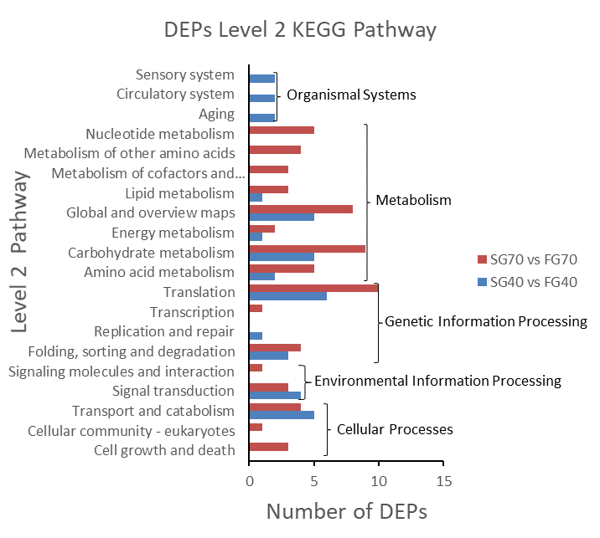
Fig. S1. Level 2 KEGG pathway analysis of DEPs in M. japonicus.

