Supplementary Table 1 : Summary of alpha-diversity of the rhizosphere microbiome among different wheat genotypes.
 | Genotype | Shannon Index
 |  | P28ª | P35a^{b} | P35b^{c} | P160^{d}
 | Eltan | 3.75 ± 1.77 | 5.22 ± 0.48 | 5.76 ± 0.50 | 5.55 ± 0.20
 | Hill81 | 5.93 ± 0.27 | 5.49 ± 0.29 | 6.03 ± 0.53 | 5.59 ± 0.28
 | Lewjain | 5.64 ± 0.25 | 5.58 ± 0.24 | 6.10 ± 0.31 | 5.68 ± 0.13
 | Madsen | 4.60 ± 1.35 | 5.51 ± 0.26 | 5.96 ± 0.24 | 5.68 ± 0.27
 | PI561725 | 5.92 ± 0.22 | 5.65 ± 0.27 | 5.93 ± 0.47 | 5.29 ± 0.49
 | PI561727 | 4.980 ± 1.41 | 5.42 ± 0.30 | 5.75 ± 0.42 | 5.28 ± 0.32
ª Three 28-day cycles
^{b} Three 35-day cycles (Trial 1)
^{c} Three 35-day cycles (Trial 2)
^{d} Three 160-day cycles

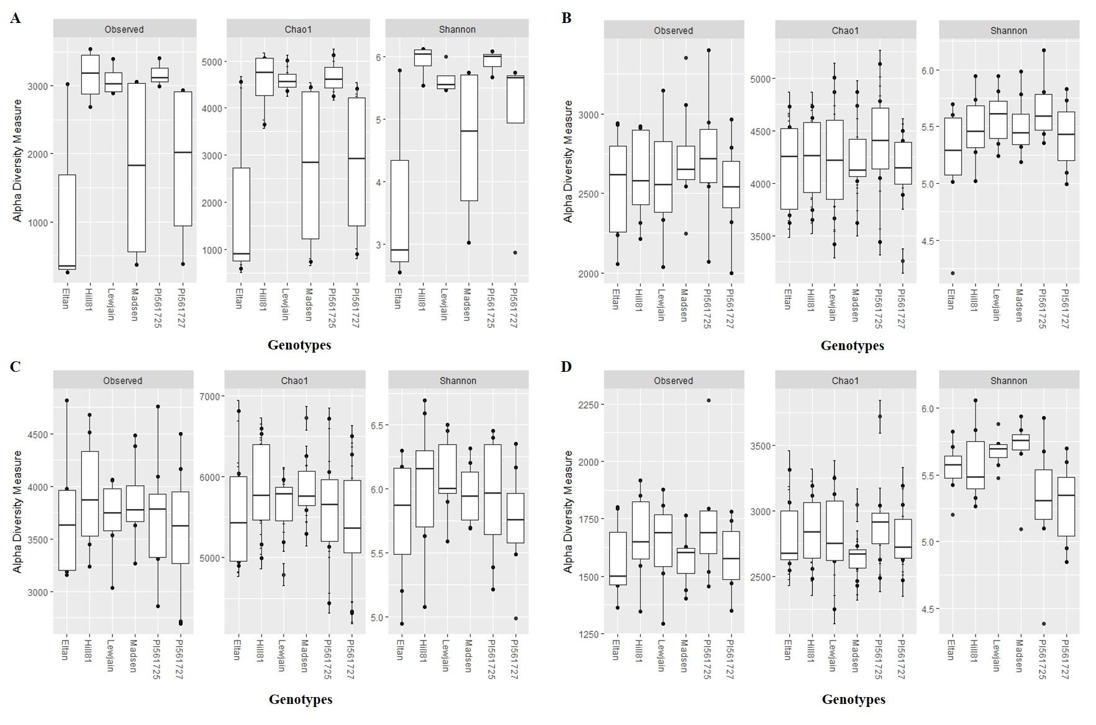
Supplementary Figure 1 : Alpha diversity of the rhizosphere microbiome of six winter wheat genotypes. (A-D) 28-, 35- (Trial 1), 35- (Trial 2), and 160-day cycle.

Supplementary Table 2 : PERMANOVA pair-wise tests between the rhizosphere microbiome of six winter wheat genotypes and across experiments based on Bray-Curtis similarity (P-value at 999 permutations).

a. 35-Day Cycles Trial 1 (P35a)
Genotype | Eltan | Hill81 | Lewjain | Madsen | PI561725
Hill81 | 0.088
Lewjain | 0.038 | 0.456
Madsen | 0.090 | 0.262 | 0.333
PI561725 | 0.066 | 0.160 | 0.306 | 0.143
PI561727 | 0.067 | 0.145 | 0.158 | 0.516 | 0.279
b. 35-Day Cycles Trial 2 (P35b)
Genotype | Eltan | Hill81 | Lewjain | Madsen | PI561725
Hill81 | 0.039
Lewjain | 0.052 | 0.092
Madsen | 0.081 | 0.286 | 0.191
PI561725 | 0.067 | 0.242 | 0.150 | 0.269
PI561727 | 0.169 | 0.165 | 0.064 | 0.317 | 0.300
c. 160-day Cycles (P160)
Genotype | Eltan | Hill81 | Lewjain | Madsen | PI561725
Hill81 | 0.620
Lewjain | 0.120 | 0.248
Madsen | 0.091 | 0.384 | 0.120
PI561725 | 0.013 | 0.011 | 0.013 | 0.006
PI561727 | 0.030 | 0.030 | 0.009 | 0.011 | 0.400
d. Growth chamber and field experiment
Experiments | Field | P28 | P35a | P35b
P28 | 0.001
P35a | 0.001 | 0.001
P35b | 0.001 | 0.001 | 0.001
P160 | 0.001 | 0.001 | 0.001 | 0.001

Supplementary Table 3 : Bray-Curtis similarity between the rhizosphere microbiome of six winter wheat genotypes and across experiments.

a. 35-Day Cycles Trial 1 (P35a)
Genotype | Eltan | Hill81 | Lewjain | Madsen | PI561725 | PI561727
Hill81 | 66.97
Lewjain | 68.00 | 70.08
Madsen | 67.47 | 69.24 | 70.13
PI561725 | 68.23 | 69.34 | 70.54 | 69.43
PI561727 | 68.28 | 69.25 | 70.29 | 70.34 | 70.47 | 70.74
b. 35-Day Cycles Trial 2 (P35b)
Genotype | Eltan | Hill81 | Lewjain | Madsen | PI561725 | PI561727
Hill81 | 64.74
Lewjain | 65.46 | 65.40
Madsen | 67.52 | 67.59 | 67.91
PI561725 | 66.38 | 66.71 | 66.92 | 69.10
PI561727 | 66.43 | 65.87 | 65.58 | 68.63 | 67.56 | 66.49
c. 160-day Cycles (P160)
Genotype | Eltan | Hill81 | Lewjain | Madsen | PI561725 | PI561727
Hill81 | 65.61
Lewjain | 64.15 | 64.30
Madsen | 66.00 | 66.77 | 66.39
PI561725 | 60.28 | 60.19 | 57.31 | 59.72
PI561727 | 61.91 | 61.73 | 58.07 | 61.18 | 65.71 | 65.11
d. Growth chamber and field experiment
Experiments | Field | P28 | P35a | P35b
P28 | 31.79
P35a | 33.01 | 41.16
P35b | 33.45 | 38.52 | 42.49
P160 | 31.92 | 39.02 | 41.83 | 41.24

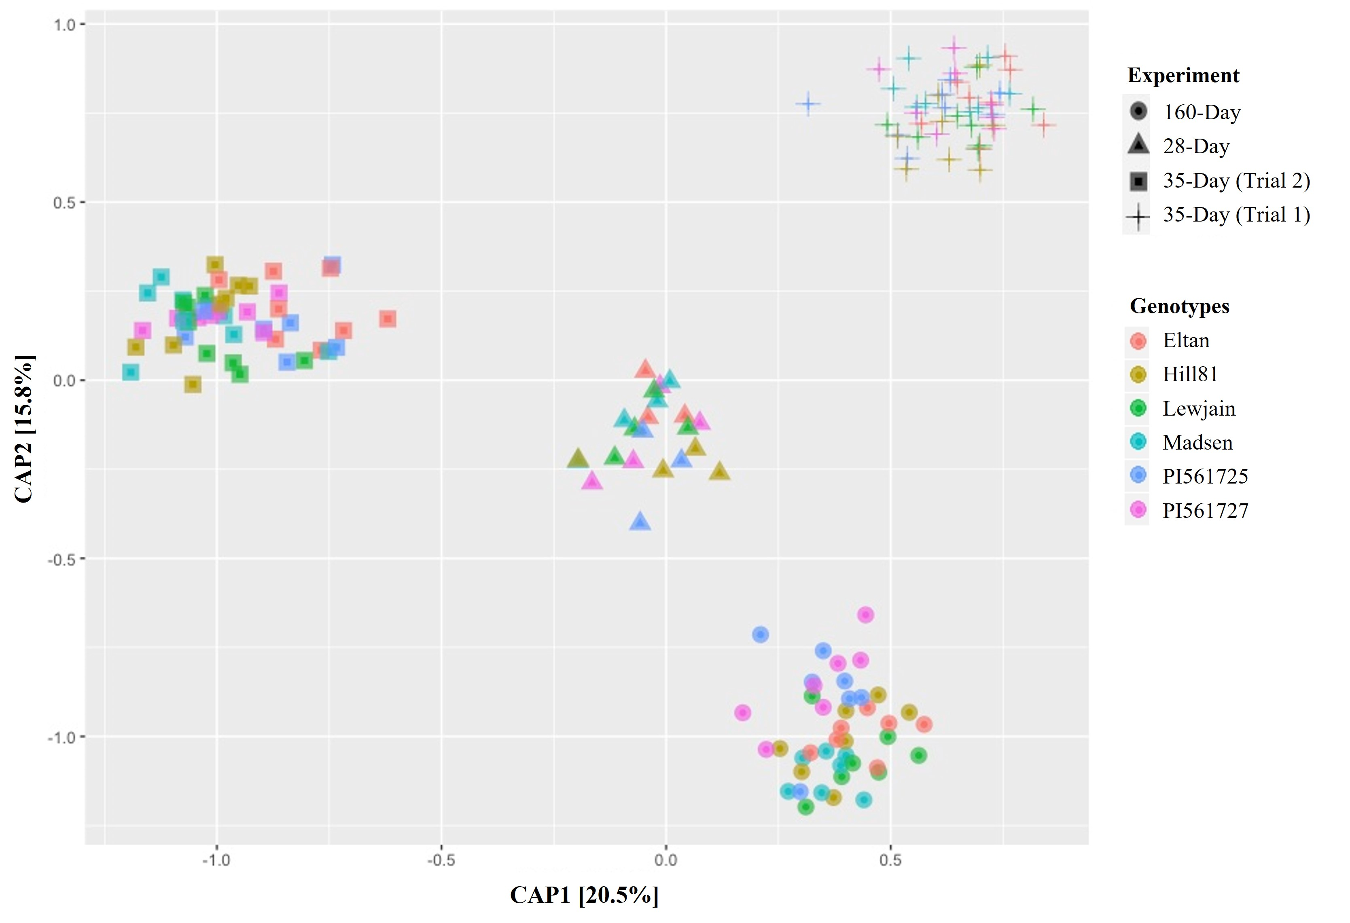
Supplementary Figure 2: CAP plot of Bray-Curtis distances among bacterial communities of six winter wheat genotypes grown in Pullman soil across different growth chamber cycling lengths. Different shapes represent different cycling experiments while different wheat genotypes are represented by different colors.
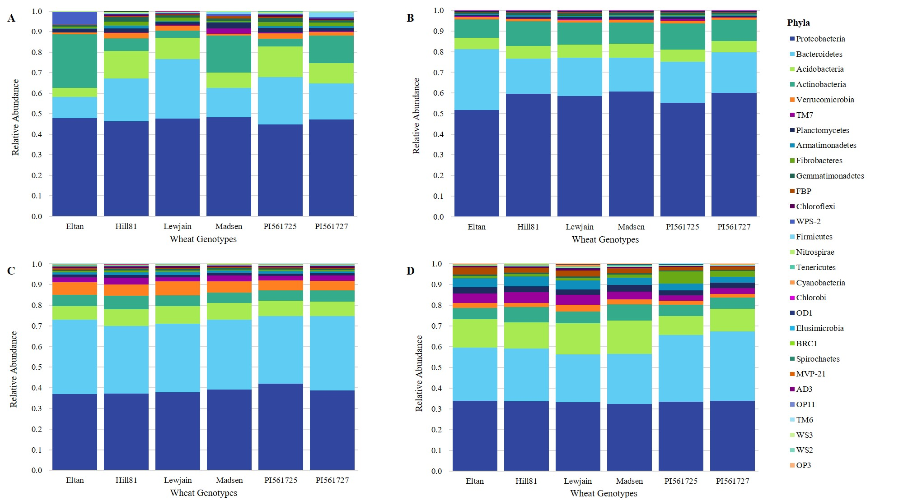
Supplementary Figure 3: Most abundant bacterial taxa of six winter wheat genotypes grown in Pullman soil under different growth chamber cycling lengths. (A-D) 28-, 35- (Trial 1), 35- (Trial 2), 160-day cycle. Most abundant bacterial phyla after filtering out OTUs with <0.001 relative abundance.
Supplementary Table 4 : Percent abundance of phyla of the most abundant bacterial taxa in the six winter wheat varieties among growth chamber experiment.

Dataset | Phyla* | Eltan | Hill81 | Lewjain | Madsen | PI561725 | PI561727 | Rank
P28 | Proteobacteria | 47.8 | 46.3 | 47.6 | 48.4 | 44.9 | 47.1 | 1
P28 | Bacteroidetes | 10.3 | 20.8 | 29.0 | 14.3 | 23.1 | 17.7 | 2
P28 | Actinobacteria | 26.1 | 6.0 | 3.4 | 18.0 | 3.8 | 13.5 | 3
P28 | Acidobacteria | 4.4 | 13.6 | 10.4 | 7.4 | 14.9 | 9.8 | 4
P28 | Planctomycetes | 1.7 | 2.1 | 1.3 | 2.9 | 2.2 | 1.6 | 5
P28 | Verrucomicrobia | 0.8 | 2.6 | 2.5 | 0.9 | 2.5 | 1.9 | 6
P28 | Fibrobacteres | 0.9 | 2.1 | 1.6 | 0.6 | 2.1 | 1.8 | 7
P28 | WPS-2 | 6.3 | 0.4 | 0.2 | 0.9 | 0.4 | 0.6 | 8
P28 | Gemmatimonadetes | 0.6 | 2.1 | 1.2 | 1.0 | 2.0 | 1.1 | 9
P28 | Firmicutes | 0.1 | 0.4 | 0.4 | 1.1 | 0.5 | 2.6 | 10
P28 | TM7 | 0.1 | 0.3 | 0.3 | 2.6 | 0.4 | 0.3 | 11
P28 | Armatimonadetes | 0.2 | 1.1 | 0.6 | 0.4 | 0.9 | 0.8 | 12
P28 | Chloroflexi | 0.1 | 0.8 | 0.4 | 0.2 | 0.8 | 0.7 | 13
P28 | FBP | 0.2 | 0.5 | 0.4 | 1.1 | 0.5 | 0.2 | 14
P28 | Nitrospirae | 0.1 | 0.5 | 0.3 | 0.2 | 0.6 | 0.3 | 15
P28 | Chlorobi | 0.1 | 0.1 | 0.1 | 0.1 | 0.1 | 0.1 | 16
P28 | Elusimicrobia | 0.0 | 0.1 | 0.0 | 0.0 | 0.1 | 0.0 | 17
P28 | BRC1 | 0.0 | 0.0 | 0.0 | 0.0 | 0.1 | 0.0 | 18
P28 | Cyanobacteria | 0.0 | 0.0 | 0.1 | 0.0 | 0.0 | 0.0 | 19
P28 | OD1 | 0.0 | 0.0 | 0.0 | 0.0 | 0.0 | 0.0 | 20
P28 | Tenericutes | 0.0 | 0.1 | 0.0 | 0.0 | 0.0 | 0.0 | 21
P28 | AD3 | 0.0 | 0.0 | 0.0 | 0.0 | 0.0 | 0.0 | 22
P35a | Proteobacteria | 51.7 | 59.5 | 58.4 | 60.7 | 55.1 | 60.0 | 1
P35a | Bacteroidetes | 29.5 | 17.0 | 18.6 | 16.3 | 20.0 | 19.7 | 2
P35a | Actinobacteria | 8.9 | 12.1 | 10.7 | 10.3 | 12.6 | 10.2 | 3
P35a | Acidobacteria | 5.4 | 6.2 | 6.4 | 6.9 | 6.0 | 5.5 | 4
P35a | Verrucomicrobia | 1.2 | 1.1 | 1.2 | 1.2 | 1.4 | 1.0 | 5
P35a | Gemmatimonadetes | 0.9 | 1.3 | 1.4 | 1.3 | 1.1 | 0.9 | 6
P35a | Planctomycetes | 0.7 | 0.9 | 0.9 | 1.2 | 1.1 | 0.7 | 7
P35a | Armatimonadetes | 0.4 | 0.5 | 0.6 | 0.5 | 0.5 | 0.5 | 8
P35a | TM7 | 0.3 | 0.3 | 0.5 | 0.4 | 0.7 | 0.3 | 9
P35a | Chloroflexi | 0.3 | 0.3 | 0.3 | 0.3 | 0.4 | 0.3 | 10
P35a | FBP | 0.2 | 0.2 | 0.4 | 0.3 | 0.2 | 0.3 | 11

Supplementary Table 4 continued…
Dataset | Phyla* | Eltan | Hill81 | Lewjain | Madsen | PI561725 | PI561727 | Rank
P35a | Firmicutes | 0.1 | 0.2 | 0.2 | 0.2 | 0.2 | 0.2 | 12
P35a | Fibrobacteres | 0.1 | 0.2 | 0.1 | 0.1 | 0.3 | 0.1 | 13
P35a | Nitrospirae | 0.1 | 0.1 | 0.1 | 0.1 | 0.1 | 0.1 | 14
P35a | WPS-2 | 0.1 | 0.1 | 0.1 | 0.1 | 0.1 | 0.1 | 15
P35a | Chlorobi | 0.0 | 0.0 | 0.0 | 0.0 | 0.0 | 0.0 | 16
P35a | Elusimicrobia | 0.0 | 0.0 | 0.0 | 0.0 | 0.0 | 0.0 | 17
P35a | BRC1 | 0.0 | 0.0 | 0.0 | 0.0 | 0.0 | 0.0 | 18
P35a | OD1 | 0.0 | 0.0 | 0.0 | 0.0 | 0.0 | 0.0 | 19
P35a | Cyanobacteria | 0.0 | 0.0 | 0.0 | 0.0 | 0.0 | 0.0 | 20
P35b | Proteobacteria | 37.0 | 37.2 | 37.9 | 39.2 | 42.0 | 38.7 | 1
P35b | Bacteroidetes | 36.0 | 32.7 | 33.2 | 33.9 | 32.7 | 36.0 | 2
P35b | Acidobacteria | 6.6 | 8.0 | 8.5 | 7.9 | 7.5 | 7.0 | 3
P35b | Verrucomicrobia | 6.1 | 5.5 | 6.8 | 5.5 | 4.9 | 4.7 | 4
P35b | Actinobacteria | 5.5 | 6.6 | 5.3 | 5.1 | 4.9 | 5.5 | 5
P35b | TM7 | 2.3 | 3.3 | 1.9 | 2.7 | 2.1 | 2.5 | 6
P35b | Armatimonadetes | 1.1 | 1.3 | 1.5 | 1.2 | 1.2 | 1.0 | 7
P35b | Planctomycetes | 1.3 | 1.4 | 1.2 | 1.2 | 1.2 | 1.0 | 8
P35b | Chloroflexi | 0.9 | 1.0 | 1.0 | 0.7 | 0.8 | 0.9 | 9
P35b | Gemmatimonadetes | 0.5 | 0.8 | 0.8 | 0.7 | 0.7 | 0.6 | 10
P35b | Fibrobacteres | 0.7 | 0.8 | 0.7 | 0.5 | 0.7 | 0.6 | 11
P35b | FBP | 0.7 | 0.3 | 0.4 | 0.5 | 0.3 | 0.5 | 12
P35b | Tenericutes | 0.7 | 0.4 | 0.3 | 0.2 | 0.4 | 0.4 | 13
P35b | Cyanobacteria | 0.3 | 0.2 | 0.1 | 0.2 | 0.2 | 0.3 | 14
P35b | Firmicutes | 0.1 | 0.1 | 0.3 | 0.1 | 0.1 | 0.1 | 15
P35b | Nitrospirae | 0.1 | 0.1 | 0.1 | 0.1 | 0.1 | 0.1 | 16
P35b | Spirochaetes | 0.0 | 0.1 | 0.1 | 0.0 | 0.0 | 0.0 | 17
P35b | Chlorobi | 0.0 | 0.1 | 0.1 | 0.0 | 0.0 | 0.0 | 18
P35b | WPS-2 | 0.0 | 0.0 | 0.0 | 0.0 | 0.0 | 0.0 | 19
P35b | OD1 | 0.0 | 0.0 | 0.0 | 0.0 | 0.0 | 0.0 | 20
P35b | Elusimicrobia | 0.0 | 0.0 | 0.0 | 0.0 | 0.0 | 0.0 | 21
P35b | BRC1 | 0.0 | 0.0 | 0.0 | 0.0 | 0.0 | 0.0 | 22
P160 | Proteobacteria | 34.0 | 33.7 | 33.2 | 32.4 | 33.4 | 33.9 | 1
P160 | Bacteroidetes | 25.5 | 25.5 | 23.0 | 24.2 | 32.2 | 33.4 | 2
P160 | Acidobacteria | 13.7 | 12.7 | 15.1 | 16.0 | 9.3 | 11.0 | 3

Supplementary Table 4 continued…
Dataset | Phyla* | Eltan | Hill81 | Lewjain | Madsen | PI561725 | PI561727 | Rank
P160 | Actinobacteria | 5.5 | 7.3 | 5.8 | 7.9 | 5.4 | 5.4 | 4
P160 | TM7 | 4.6 | 5.2 | 4.8 | 3.7 | 2.5 | 2.7 | 5
P160 | Armatimonadetes | 4.4 | 4.7 | 4.2 | 3.5 | 3.1 | 2.9 | 6
P160 | Planctomycetes | 3.0 | 2.9 | 2.7 | 3.2 | 2.6 | 2.6 | 7
P160 | FBP | 3.5 | 2.4 | 3.0 | 2.2 | 1.7 | 1.6 | 8
P160 | Verrucomicrobia | 2.4 | 2.0 | 3.2 | 2.5 | 1.9 | 1.8 | 9
P160 | Fibrobacteres | 1.0 | 1.1 | 1.2 | 1.6 | 5.9 | 2.7 | 10
P160 | Chloroflexi | 0.6 | 0.7 | 0.9 | 0.8 | 0.4 | 0.4 | 11
P160 | Gemmatimonadetes | 0.6 | 0.6 | 0.7 | 0.7 | 0.5 | 0.5 | 12
P160 | Tenericutes | 0.4 | 0.3 | 0.5 | 0.5 | 0.1 | 0.1 | 13
P160 | Nitrospirae | 0.2 | 0.2 | 0.3 | 0.2 | 0.3 | 0.3 | 14
P160 | Cyanobacteria | 0.1 | 0.2 | 0.8 | 0.1 | 0.1 | 0.1 | 15
P160 | Firmicutes | 0.1 | 0.2 | 0.2 | 0.2 | 0.3 | 0.3 | 16
P160 | OD1 | 0.1 | 0.1 | 0.1 | 0.1 | 0.2 | 0.1 | 17
P160 | Chlorobi | 0.0 | 0.1 | 0.1 | 0.1 | 0.1 | 0.1 | 18
P160 | MVP-21 | 0.0 | 0.0 | 0.1 | 0.1 | 0.0 | 0.0 | 19
P160 | WPS-2 | 0.0 | 0.0 | 0.0 | 0.0 | 0.0 | 0.0 | 20
P160 | Elusimicrobia | 0.0 | 0.0 | 0.0 | 0.0 | 0.0 | 0.0 | 21
P160 | BRC1 | 0.0 | 0.0 | 0.0 | 0.0 | 0.0 | 0.0 | 22
* Phyla of merged OTUs after filtering out OTUs with < 0.001 relative abundance

Supplementary Table 5 : Top 50 differentially abundant OTUs across six winter wheat varieties in four growth chamber cycling experiments

Dataset | OTUs | Adj. P-Value* | Comparison | Family | Scientific Name
P160 | DENOVO30 | 9.26E-03 | lower in PI561725 & PI561727 than Lewjain | A4b | Unidentified
P160 | DENOVO81 | 8.88E-03 | lower in PI561727 & PI561725 than Eltan, Lewjain, Madsen, Hill81 | Actinospicaceae | Unidentified
P160 | DENOVO121 | 9.19E-03 | lower in PI561727 & PI561725 than Madsen; lower in PI561725 than Hill81 | Actinosynnemataceae | Unidentified
P160 | REF6743 | 8.82E-04 | lower in PI561725 & PI561727 than Eltan, Lewjain, Madsen, Hill81 | Anaeroplasmataceae | Asteroleplasma sp.
P160 | DENOVO2959 | 6.84E-04 | lower in PI561727 & PI561725 than Eltan, Lewjain, Madsen, Hill81 | Anaeroplasmataceae | Asteroleplasma sp.
P160 | DENOVO2719 | 1.11E-02 | lower in PI561727 & PI561725 than Eltan, Lewjain, Hill81; lower in PI561725 than Madsen | Anaeroplasmataceae | Asteroleplasma sp.
P160 | REF4888 | 4.03E-03 | higher in PI561727 & PI561725 than Eltan, Lewjain, Madsen | Caulobacteraceae | Caulobacter sp.
P160 | REF416 | 4.65E-03 | lower in PI561725 & PI561727 than Lewjain, Madsen | Chitinophagaceae | Unidentified
P160 | REF3713 | 1.09E-02 | lower in PI561725 & PI561727 than Eltan, Lewjain, Madsen, Hill81 | Chitinophagaceae | Unidentified
P160 | REF3149 | 8.77E-03 | lower in PI561727 than Lewjain, Madsen | Chitinophagaceae | Unidentified
P160 | DENOVO2329 | 1.31E-02 | lower in PI561727 than Lewjain, Madsen | Chthoniobacteraceae | Unidentified
P160 | DENOVO125 | 1.39E-02 | lower in PI561725 than Eltan, Lewjain | Chthoniobacteraceae | Chthoniobacter sp.
P160 | REF4717 | 2.99E-03 | higher in PI561727 & PI561725 than Eltan, Lewjain, Madsen, Hill81 | Comamonadaceae | Variovorax paradoxus
P160 | REF1650 | 1.08E-02 | lower in PI561727 & PI561725 than Hill81, Lewjain, Madsen | Comamonadaceae | Unidentified
P160 | DENOVO123 | 1.25E-02 | lower in PI561727 & PI561725 than Lewjain | Cytophagaceae | Unidentified

Supplementary Table 5 continued…
Dataset | OTUs | Adj. P-Value* | Comparison | Family | Scientific Name
P160 | REF6894 | 1.39E-02 | higher in Lewjain than PI561725, PI561727; lower in PI561725 than Eltan, Hill81 | Ellin6075 | Unidentified
P160 | REF5534 | 2.75E-03 | higher in Lewjain than PI561725 | Ellin6075 | Unidentified
P160 | REF5326 | 5.47E-03 | higher in Lewjain than PI561725, PI561727 | Ellin6075 | Unidentified
P160 | REF5260 | 7.97E-04 | higher in Lewjain than PI561725, PI561727 | Ellin6075 | Unidentified
P160 | REF4374 | 1.33E-02 | lower in PI561727 & PI561725 than Lewjain; lower in PI561725 than Eltan, Madsen | Ellin6075 | Unidentified
P160 | REF3567 | 1.00E-02 | higher in Lewjain than PI561727, Eltan, Hill81, PI561725; higher in Madsen than PI561725, PI561727; lower in PI561725 than Eltan | Ellin6075 | Unidentified
P160 | DENOVO3101 | 4.16E-03 | lower in PI561725 than Eltan | Fimbriimonadaceae | Fimbriimonas sp.
P160 | REF1644 | 9.54E-03 | lower in Madsen than PI561725 | Hyphomicrobiaceae | Rhodoplanes sp.
P160 | REF3099 | 8.51E-03 | higher in PI561725 than Lewjain, Madsen, Hill81; higher in PI561727 & PI561725 than Eltan | Koribacteraceae | Candidatus Koribacter sp.
P160 | REF2862 | 9.54E-03 | higher in Madsen than PI561725 | Nocardioidaceae | Kribbella sp.
P160 | REF3578 | 3.25E-05 | higher in PI561725 & PI561727 than Eltan, Lewjain, Madsen, Hill81 | Oxalobacteraceae | Janthinobacterium sp.
P160 | REF7627 | 5.75E-03 | higher in Lewjain than PI561725, PI561727 | Pirellulaceae | Unidentified
P160 | REF4027 | 3.00E-03 | higher in PI561725 & PI561727 than Eltan, Lewjain, Madsen | Rhizobiaceae | Unidentified
P160 | REF8018 | 3.07E-03 | higher in PI561725 & PI561727 than Eltan, Lewjain, Madsen, Hill81 | Sphingobacteriaceae | Unidentified
P160 | REF603 | 8.22E-04 | higher in PI561725 & PI561727 than Eltan, Hill81, Lewjain, Madsen | Sphingobacteriaceae | Unidentified
P160 | REF3283 | 9.50E-03 | higher in PI561727 & PI561725 than Lewjain, Madsen, Eltan, Hill81 | Sphingobacteriaceae | Unidentified

Supplementary Table 5 continued…
Dataset | OTUs | Adj. P-Value* | Comparison | Family | Scientific Name
P160 | DENOVO4 | 1.29E-02 | lower in PI561725 than Eltan, Lewjain, Madsen; lower in PI561725 than Hill81 | Sphingobacteriaceae | Unidentified
P160 | DENOVO3719 | 8.13E-03 | lower in PI561725 than Eltan, Lewjain | Sphingobacteriaceae | Unidentified
P160 | DENOVO266 | 1.32E-02 | lower in PI561727 & PI561725 than Eltan, Madsen, Lewjain, Hill81 | Sphingobacteriaceae | Unidentified
P160 | DENOVO2423 | 1.05E-02 | higher in PI561725 than Eltan, Madsen, Lewjain, Hill81; higher in PI561727 than Eltan | Sphingobacteriaceae | Unidentified
P160 | DENOVO11 | 1.40E-02 | higher in PI561725 than Eltan, Hill81, Lewjain, Madsen; higher in PI561727 than Eltan, Lewjain | Sphingobacteriaceae | Unidentified
P160 | REF6706 | 6.05E-03 | higher in Lewjain than PI561725, PI561727 | Sphingomonadaceae | Sphingomonas sp.
P160 | REF2226 | 9.60E-03 | lower in PI561725 & PI561727 than Lewjain, Eltan, Madsen, Hill81 | Sphingomonadaceae | Kaistobacter sp.
P160 | REF2166 | 1.09E-02 | lower in PI561725 than Hill81, Lewjain, Madsen, Eltan | Sphingomonadaceae | Sphingomonas wittichii
P160 | REF12 | 6.48E-04 | higher in Lewjain than PI561725, Hill81, PI561727 | Sphingomonadaceae | Kaistobacter sp.
P160 | REF4774 | 1.31E-02 | higher in PI561725 than Eltan | Streptomycetaceae | Streptomyces sp.
P160 | REF4166 | 1.09E-02 | higher in PI561725 & PI561727 than Eltan, Lewjain, Madsen | Streptomycetaceae | Streptomyces sp.
P160 | REF961 | 6.81E-03 | higher in PI561725 than Hill81, Lewjain, Madsen, Eltan | Unidentified | Unidentified
P160 | REF8474 | 1.08E-02 | higher in PI561725 than Eltan, Madsen, Lewjain, PI561727, Hill81 | Unidentified | Unidentified
P160 | REF4342 | 4.80E-03 | lower in PI561727 & PI561725 than Lewjain, Madsen, Hill81; lower in PI561725 than Eltan | Unidentified | Unidentified
P160 | REF2943 | 9.99E-03 | lower in Madsen than Eltan, PI561725, PI561727 | Unidentified | Unidentified

Supplementary Table 5 continued…
Dataset | OTUs | Adj. P-Value* | Comparison | Family | Scientific Name
P160 | DENOVO66 | 9.65E-03 | higher in PI561727 & PI561725 than Eltan, Lewjain, Madsen; higher in PI561727 than Hill81 | Unidentified | Unidentified
P160 | DENOVO4008 | 8.97E-03 | higher in PI561725 than Hill81, PI561727, Eltan, Lewjain, Madsen | Unidentified | Unidentified
P160 | DENOVO21 | 1.27E-02 | lower in PI561727 than Madsen | Unidentified | Unidentified
P160 | REF8601 | 1.34E-02 | higher in Lewjain than PI561725 | Xanthomonadaceae | Pseudoxanthomonas mexicana
P35a | REF8481 | 3.58E-02 | higher in Madsen than PI561725 | Acidobacteriaceae | Unidentified
P35a | REF5301 | 3.42E-02 | higher in Madsen than PI561725 | Acidobacteriaceae | Unidentified
P35a | DENOVO442 | 5.98E-02 | higher in Madsen than PI561725 | Acidobacteriaceae | Unidentified
P35a | REF982 | 5.35E-02 | higher in Eltan than Hill81, PI561727 | Bradyrhizobiaceae | Bradyrhizobium sp.
P35a | REF2556 | 6.22E-02 | higher in Madsen than PI561725 | Burkholderiaceae | Burkholderia sp.
P35a | REF5075 | 3.81E-02 | lower in PI561725 than Eltan | Caulobacteraceae | Mycoplana sp.
P35a | REF994 | 4.30E-02 | higher in Eltan than Hill81, Lewjain, Madsen, PI561725 | Chitinophagaceae | Chitinophaga sp.
P35a | REF6907 | 1.96E-02 | higher in Eltan than Hill81, Lewjain, Madsen, PI561725 | Chitinophagaceae | Chitinophaga arvensicola
P35a | REF591 | 1.78E-02 | higher in Eltan than Hill81, Lewjain, Madsen | Chitinophagaceae | Unidentified
P35a | REF5077 | 3.73E-03 | higher in Eltan than Hill81 | Chitinophagaceae | Chitinophaga sp.
P35a | DENOVO799 | 4.35E-02 | higher in PI561725 than Eltan | Chitinophagaceae | Flavisolibacter sp.
P35a | DENOVO787 | 4.19E-02 | higher in Eltan than Hill81, Madsen, PI561725 | Chitinophagaceae | Chitinophaga sp.
P35a | DENOVO2591 | 4.04E-02 | higher in Eltan than Hill81, Lewjain, Madsen | Chitinophagaceae | Chitinophaga arvensicola
P35a | DENOVO1885 | 1.69E-02 | higher in Eltan than Hill81, PI561725 | Chitinophagaceae | Chitinophaga sp.
P35a | DENOVO1204 | 1.87E-02 | higher in Eltan than Hill81 | Chitinophagaceae | Chitinophaga arvensicola
P35a | REF254 | 6.41E-02 | higher in Eltan than Hill81, PI561725, PI561727 | Chthoniobacteraceae | Unidentified
P35a | REF1824 | 3.58E-02 | higher in Madsen than PI561725 | Comamonadaceae | Variovorax sp.
P35a | REF363 | 2.82E-02 | higher in Eltan than Hill81, Madsen; higher in PI561727 than Madsen | Hyphomicrobiaceae | Devosia sp.
Supplementary Table 5 continued…
Dataset | OTUs | Adj. P-Value* | Comparison | Family | Scientific Name
P35a | REF1968 | 3.43E-02 | higher in Hill81 than Eltan | Koribacteraceae | Candidatus Koribacter sp.
P35a | REF4277 | 1.83E-02 | higher in PI561727 than Lewjain | Moraxellaceae | Unidentified
P35a | REF317 | 3.62E-02 | higher in Eltan than Lewjain, Madsen, PI561727 | Mycobacteriaceae | Mycobacterium sp.
P35a | DENOVO299 | 1.34E-02 | higher in Eltan than Lewjain, Madsen | Mycobacteriaceae | Mycobacterium sp.
P35a | REF3941 | 1.66E-02 | higher in Eltan than Hill81, Madsen, PI561725;  higher in Lewjain than PI561727 | Nocardioidaceae | Nocardioides sp.
P35a | DENOVO2076 | 3.49E-02 | higher in PI561725 than Eltan | Nocardioidaceae | Unidentified
P35a | REF4070 | 4.54E-02 | higher in PI561725 than Eltan | Oxalobacteraceae | Janthinobacterium sp.
P35a | REF3578 | 5.80E-02 | higher in PI561725, Hill81 than Eltan | Oxalobacteraceae | Janthinobacterium sp.
P35a | REF2162 | 5.00E-02 | higher in PI561727 than Lewjain | Oxalobacteraceae | Unidentified
P35a | REF1729 | 1.57E-02 | higher in Madsen than PI561725 | Oxalobacteraceae | Unidentified
P35a | REF8227 | 3.77E-02 | higher in PI561725 than Madsen | Rhizobiaceae | Rhizobium sp.
P35a | REF7236 | 3.71E-02 | higher in PI561727 than Lewjain | Rhizobiaceae | Unidentified
P35a | REF4529 | 3.71E-02 | higher in PI561727 than Lewjain | Rhizobiaceae | Rhizobium sp.
P35a | REF4514 | 8.68E-03 | higher in Eltan than PI561727 | Rhizobiaceae | Rhizobium sp.
P35a | REF6072 | 4.54E-02 | higher in PI561725 than Eltan | Sphingobacteriaceae | Unidentified
P35a | REF520 | 6.40E-02 | lower in PI561727 than Lewjain | Sphingobacteriaceae | Sphingobacterium multivorum
P35a | REF3842 | 4.40E-02 | lower in Hill81 than Eltan | Sphingobacteriaceae | Unidentified
P35a | REF3136 | 4.31E-02 | lower in Madsen than Eltan, Hill81, PI561725 | Sphingobacteriaceae | Unidentified
P35a | DENOVO457 | 4.48E-02 | higher in Eltan than Hill81, Madsen | Sphingobacteriaceae | Unidentified
P35a | DENOVO4 | 1.15E-02 | lower in Hill81 than Eltan | Sphingobacteriaceae | Unidentified
P35a | DENOVO18 | 2.55E-02 | lower in Hill81 than Eltan, PI561725, Lewjain;  lower in Madsen than Eltan | Sphingobacteriaceae | Pedobacter sp.
P35a | REF6703 | 5.45E-02 | lower in PI561725 than Eltan | Sphingomonadaceae | Sphingomonas sp.
P35a | REF890 | 1.54E-02 | higher in PI561725 & PI561727 than Lewjain, Madsen | Streptomycetaceae | Unidentified
P35a | REF5601 | 2.05E-02 | higher in PI561725 than Eltan, Madsen | Unidentified | Unidentified
Supplementary Table 5 continued…
Dataset | OTUs | Adj. P-Value* | Comparison | Family | Scientific Name
P35a | REF115 | 3.99E-02 | higher in PI561725 than Eltan, Madsen | Unidentified | Unidentified
P35a | DENOVO98 | 6.33E-02 | lower in Hill81 than Eltan | Unidentified | Unidentified
P35a | REF4467 | 5.09E-02 | higher in Hill81 than Eltan, PI561725, Lewjain, Madsen, PI561727 | Weeksellaceae | Chryseobacterium sp.
P35a | REF8806 | 1.83E-02 | lower in PI561727 than Lewjain | Xanthomonadaceae | Luteimonas sp.
P35a | REF4425 | 6.21E-02 | lower in PI561727 than Eltan | Xanthomonadaceae | Stenotrophomonas sp.
P35a | REF1794 | 5.77E-02 | lower in Lewjain than Eltan, PI561727 | Xanthomonadaceae | Luteibacter rhizovicinus
P35a | DENOVO42 | 5.78E-02 | lower in Lewjain than Eltan, PI561727 | Xanthomonadaceae | Luteibacter rhizovicinus
P35a | DENOVO1486 | 5.60E-02 | Lewjain than Eltan, PI561727 | Xanthomonadaceae | Unidentified
P35b | REF8284 | 4.37E-02 | lower in Eltan than Hill81, Madsen | Bradyrhizobiaceae | Balneimonas sp.
P35b | REF5019 | 4.86E-02 | higher in PI561725 than Lewjain | Burkholderiaceae | Burkholderia sp.
P35b | REF2457 | 2.21E-02 | higher in PI561725 than Hill81 | Burkholderiaceae | Burkholderia sp.
P35b | DENOVO37 | 3.60E-02 | higher in PI561725 than Lewjain | Burkholderiaceae | Burkholderia sp.
P35b | REF5685 | 4.98E-02 | higher in Lewjain than Eltan | Chitinophagaceae | Flavisolibacter sp.
P35b | REF1576 | 3.60E-02 | higher in Lewjain than PI561725 | Chitinophagaceae | Unidentified
P35b | DENOVO312 | 4.98E-02 | lower in Lewjain than Eltan | Chthoniobacteraceae | Unidentified
P35b | REF5854 | 4.12E-02 | lower in Hill81 than Eltan | Cytophagaceae | Dyadobacter sp.
P35b | DENOVO256 | 5.71E-02 | lower in Hill81 than Eltan | Cytophagaceae | Dyadobacter sp.
P35b | DENOVO321 | 1.40E-02 | higher in Lewjain than Eltan, PI561725 | Ellin517 | Unidentified
P35b | REF5687 | 3.42E-02 | higher in Eltan, Lewjain than Hill81 | Flavobacteriaceae | Flavobacterium sp.
P35b | REF1157 | 5.89E-02 | higher in Eltan than Hill81 | Microbacteriaceae | Microbacterium sp.
P35b | DENOVO36 | 3.68E-02 | higher in Eltan than Hill81, Lewjain | Microbacteriaceae | Microbacterium sp.
P35b | REF6840 | 5.23E-02 | higher in Lewjain than Hill81 | Opitutaceae | Opitutus sp.
P35b | REF4338 | 6.01E-02 | higher in Lewjain than PI561725, PI561727 | Opitutaceae | Opitutus sp.
P35b | DENOVO35 | 1.87E-02 | higher in Lewjain than Hill81 | Opitutaceae | Opitutus sp.
P35b | REF6555 | 1.53E-02 | higher in PI561725 than Eltan; higher in PI561725, Lewjain than Hill81 | Oxalobacteraceae | Janthinobacterium sp.
Supplementary Table 5 continued…
Dataset | OTUs | Adj. P-Value* | Comparison | Family | Scientific Name
P35b | REF5409 | 2.32E-02 | higher in PI561725 than Eltan | Oxalobacteraceae | Janthinobacterium sp.
P35b | REF409 | 5.22E-02 | higher in PI561725, Madsen than Eltan | Oxalobacteraceae | Unidentified
P35b | REF377 | 2.49E-02 | higher in Lewjain than Eltan | Oxalobacteraceae | Unidentified
P35b | REF2162 | 3.05E-02 | higher in PI561725, Eltan than Hill81; higher in Eltan than Lewjain, Madsen | Oxalobacteraceae | Unidentified
P35b | REF2754 | 4.74E-02 | higher in PI561727 than Madsen | Paenibacillaceae | Paenibacillus sp.
P35b | REF8663 | 2.80E-02 | lower in PI561727 than Madsen | Promicromonosporaceae | Promicromonospora sp.
P35b | REF3938 | 2.42E-02 | higher in PI561727 than Madsen, Hill81 | Pseudomonadaceae | Pseudomonas sp.
P35b | REF7639 | 2.09E-02 | higher in Lewjain than Eltan, PI561727, Hill81, PI561725 | Rhizobiaceae | Agrobacterium sp.
P35b | DENOVO1260 | 2.38E-02 | lower in Hill81 than Eltan | Rhizobiaceae | Unidentified
P35b | REF7915 | 3.82E-02 | higher in Hill81 than Lewjain | Sphingobacteriaceae | Unidentified
P35b | REF7655 | 5.07E-02 | higher in Eltan than Madsen, PI561725 | Sphingobacteriaceae | Pedobacter sp.
P35b | REF7015 | 4.35E-02 | higher in PI561725 than Hill81 | Sphingobacteriaceae | Unidentified
P35b | REF4083 | 5.60E-02 | higher in PI561725 than Hill81 | Sphingobacteriaceae | Unidentified
P35b | REF359 | 3.99E-02 | higher in Lewjain than Eltan, PI561727 | Sphingobacteriaceae | Pedobacter sp.
P35b | REF1367 | 3.71E-02 | higher in Lewjain than Hill81, PI561725 | Sphingobacteriaceae | Pedobacter sp.
P35b | DENOVO558 | 3.82E-02 | higher in Lewjain than Hill81 | Sphingobacteriaceae | Pedobacter sp.
P35b | DENOVO131 | 5.02E-02 | lower in Lewjain than Eltan, Hill81 | Sphingobacteriaceae | Unidentified
P35b | REF8789 | 2.83E-02 | higher in PI561725 than Hill81, Eltan | Sphingomonadaceae | Novosphingobium sp.
P35b | REF6703 | 5.07E-02 | higher in PI561725 than Eltan | Sphingomonadaceae | Sphingomonas sp.
P35b | REF6605 | 2.32E-02 | higher in PI561725 than Eltan | Sphingomonadaceae | Sphingomonas sp.
P35b | REF7887 | 5.24E-02 | higher in Eltan than Hill81, Lewjain, Madsen | Unidentified | Unidentified
P35b | REF760 | 1.87E-02 | higher in PI561727 than Madsen; higher in Eltan than Hill81, Madsen | Unidentified | Unidentified
P35b | REF1850 | 3.52E-02 | higher in Hill81 than Eltan, PI561725, Lewjain | Unidentified | Unidentified
Supplementary Table 5 continued…
Dataset | OTUs | Adj. P-Value* | Comparison | Family | Scientific Name
P35b | DENOVO66 | 5.60E-02 | higher in Hill81 than PI561725 | Unidentified | Unidentified
P35b | DENOVO398 | 3.61E-02 | lower in Hill81 than Eltan | Unidentified | Unidentified
P35b | DENOVO24 | 6.25E-02 | higher in Eltan than Hill81, PI561725 | Unidentified | Unidentified
P35b | DENOVO207 | 1.49E-02 | higher in Eltan than Hill81, Lewjain, PI561725 | Unidentified | Unidentified
P35b | DENOVO194 | 2.67E-02 | higher in Eltan than Hill81, Lewjain, PI561725 | Unidentified | Unidentified
P35b | REF6068 | 5.97E-02 | lower in Lewjain than Hill81 | Verrucomicrobiaceae | Unidentified
P35b | REF4103 | 3.69E-02 | higher in Lewjain than Hill81 | Verrucomicrobiaceae | Unidentified
P35b | REF8806 | 2.80E-02 | lower in PI561727 than Madsen | Xanthomonadaceae | Luteimonas sp.
P35b | REF6400 | 1.56E-02 | higher in Eltan than Hill81, PI561725 | Xanthomonadaceae | Luteimonas sp.
P35b | DENOVO2000 | 5.45E-02 | higher in Eltan than Hill81, PI561725 | Xanthomonadaceae | Unidentified
*Benjamini–Hochberg adjusted p-value

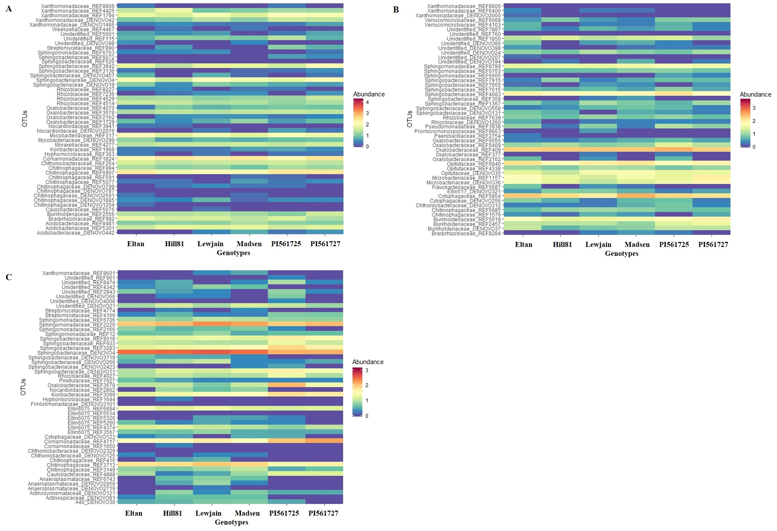Supplementary Figure 4: Differential abundance of top 50 bacterial OTUs across six winter wheat genotypes grown in Pullman soil under different growth chamber cycling lengths. (A) 35- day cycles (Trial 1), (B) 35-day cycles (Trial 2), (C) 160-day cycles. Heatmap is based on normalized log(x+1) transformed counts and generated using DESeq2.
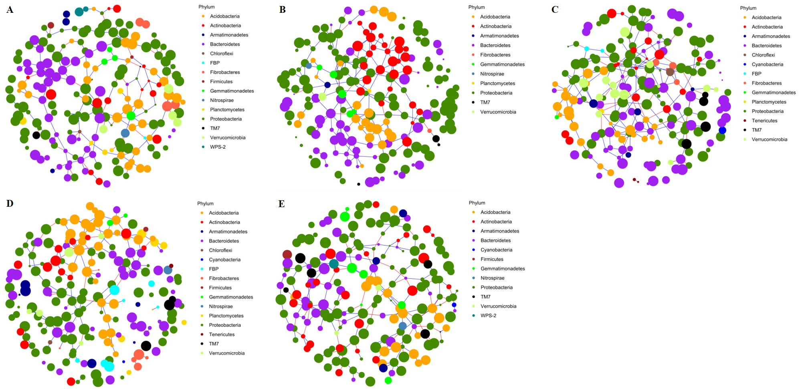
Supplementary Figure 5: Network analysis of rhizosphere bacteriome by cycle length and from the field. Sparse inverse covariance estimation network for (A-D) 28-, 35- (Trial 1), 35- (Trial 2), 160-day growth chamber cycle, (E) 2-year field cycling (Mahoney et al., 2017). Network generated after edge filtering using relative abundance of top 205 taxa as determined in SPIEC-EASI (SParse InversE Covariance Estimation for Ecological Association Inference).
Supplementary Table 6: Edge parameters of ecological networks estimated by SPEIC-EASI.

a. Edges before filtering
Edges | P28 | P35a | P35b | P160 | 2 Year Field
Positive Edges | 312 | 440 | 438 | 336 | 283
Negative Edges | 124 | 157 | 192 | 165 | 176
Total Edges | 436 | 597 | 630 | 501 | 459
% Positive | 71.56 | 73.70 | 69.52 | 67.07 | 61.66
b. Edges After Filtering ª
Edges | P28 | P35a | P35b | P160 | 2 Year Field
Positive Edges | 167 | 216 | 197 | 141 | 149
Negative Edges | 52 | 23 | 49 | 32 | 80
Total Edges | 219 | 239 | 246 | 173 | 229
% Positive | 76.26 | 90.38 | 80.08 | 81.50 | 65.07
ª Edges with an absolute weight <0.1 were removed

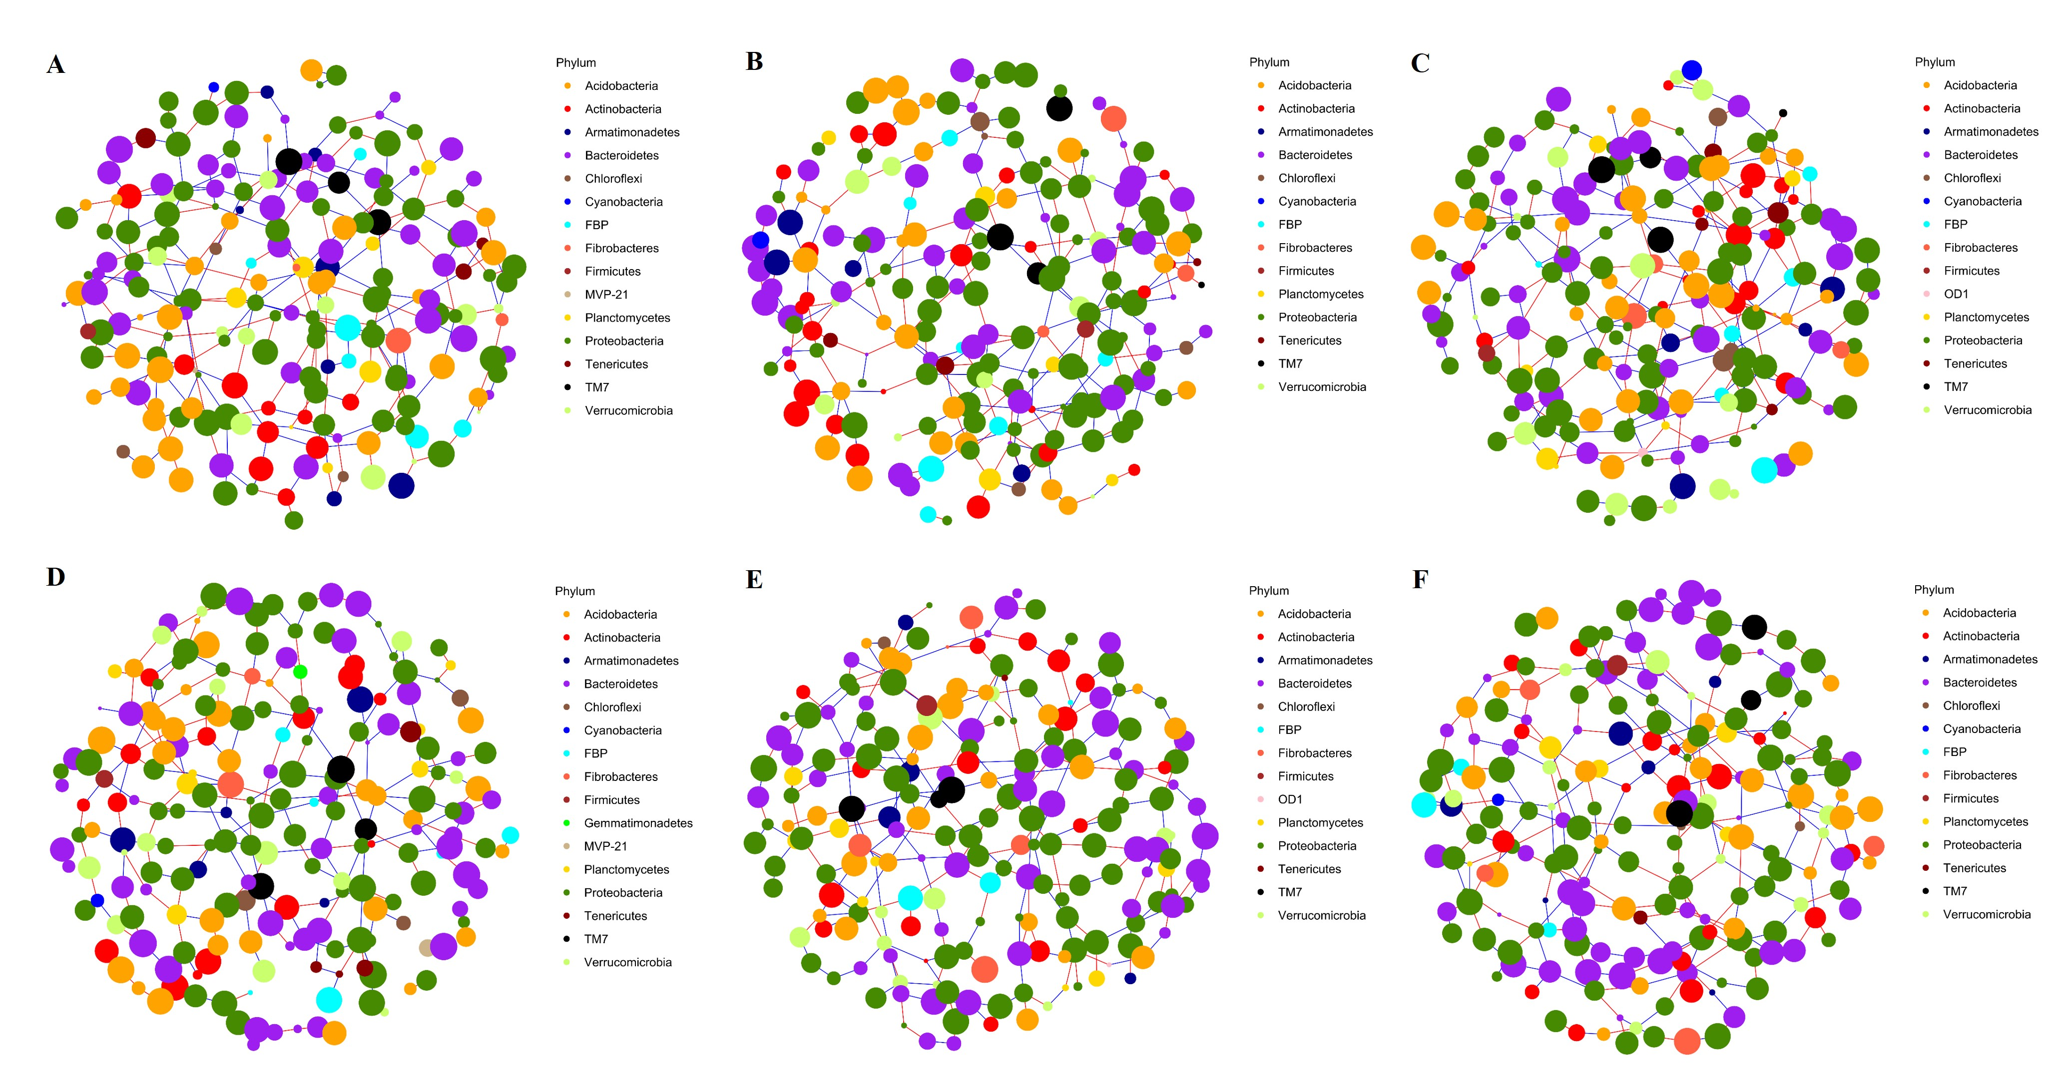
Supplementary Figure 6: Network analysis of differentially abundant taxa in the rhizosphere bacteriome by genotype after 160 days of growth. Sparse inverse covariance estimation network for (A) Eltan (B) Hill81 (C) Lewjain (D) Madsen (E) PI561725 (F) PI561727. Network generated after edge filtering using relative abundance of top 205 taxa as determined in SPIEC-EASI (SParse InversE Covariance Estimation for Ecological Association Inference).
Supplementary Table 7: Summary of edge parameters and roles of ecological networks estimated by SPEIC-EASI from the 160-day cycling experiment using differentially abundant OTUs.

a. Edges before filtering
Edges | Eltan | Hill81 | Lewjain | Madsen | PI561725 | PI561727
Positive Edges | 219 | 216 | 205 | 205 | 225 | 215
Negative Edges | 192 | 191 | 188 | 172 | 178 | 195
Total Edges | 411 | 407 | 393 | 377 | 403 | 410
% Positive | 53.28 | 53.07 | 52.16 | 54.38 | 55.83 | 52.44
b. Edges After Filtering ª
Edges | Eltan | Hill81 | Lewjain | Madsen | PI561725 | PI561727
Positive Edges | 135 | 135 | 129 | 127 | 141 | 127
Negative Edges | 109 | 105 | 119 | 104 | 106 | 119
Total Edges | 244 | 240 | 248 | 231 | 247 | 246
% Positive | 55.33 | 56.25 | 52.02 | 54.98 | 57.09 | 51.63
c. Modules and Network Roles ^{b}
Module/ Roles | Eltan | Hill81 | Lewjain | Madsen | PI561725 | PI561727
Module | 11 | 10 | 11 | 10 | 10 | 10
Connector | 37 | 37 | 30 | 32 | 40 | 30
Module Hub | 0 | 0 | 2 | 0 | 1 | 0
Peripheral Hub | 1 | 2 | 3 | 2 | 2 | 1
Network Hub | 0 | 0 | 0 | 0 | 0 | 0
Peripheral | 0 | 0 | 0 | 0 | 114 | 132
Ultra-Peripheral | 165 | 166 | 170 | 171 | 48 | 42
Kinless | 2 | 0 | 0 | 0 | 0 | 0
ª Edges with an absolute weight <0.1 were removed
^{b} Network modules determined using rnetcarto in R and roles described by Guimerà and Amaral (2005) and modification by Olesen et al., (2007)

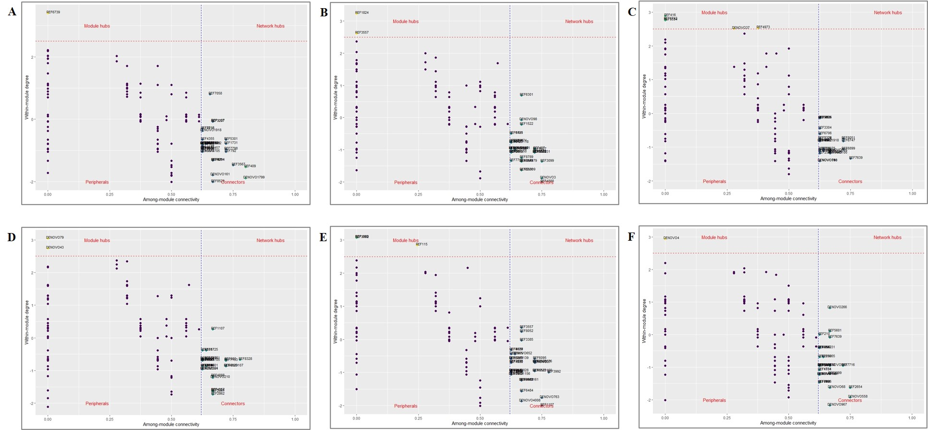
Supplementary Figure 7: Network roles of differentially abundant taxa in the rhizosphere bacteriome of each genotype after 160 days of growth. Bacterial taxa roles in covariance network of (A) Eltan (B) Hill81 (C) Lewjain (D) Madsen (E) PI561725 (F) PI561727. Network roles of top 205 taxa determined based on criteria described by Guimera and Amaral (2005) through rnetcarto package in R.

Supplementary Table 8 : Differentially abundant OTUs correlated with shoot length, shoot weight and root disease score in suppression assays.

A. Inoculated
OTUs | Family | Shoot Length |  |  |  |  |  | Shoot Weight |  |  |  |  |  | Disease Score
 |  | P-value ª | Corr. Coeff. ^{b} | r² |  |  | P-value ª |  | Corr. Coeff. ^{b} | r² |  |  | P-value ^{c} |  | Corr. Coeff. ^{d} | r²
REF3578 | Oxalobacteraceae | 0.014 | 0.386 | 0.127 |  |  | 0.045 |  | 0.315 | 0.076 |  |  | 0.036 |  | -0.328 | 0.130
REF4717 | Comamonadaceae | 0.006 | 0.429 | 0.163 |  |  | 0.049 |  | 0.309 | 0.073 |  |  | 0.008 |  | -0.406 | 0.140
REF1650 | Comamonadaceae | 0.002 | -0.485 | 0.215 |  |  | 0.066 |  | -0.289 | 0.060 |  |  | 0.046 |  | 0.313 | 0.063
REF2166 | Sphingomonadaceae | 0.256 | -0.184 | 0.008 |  |  | 0.335 |  | -0.154 | -0.001 |  |  | 0.027 |  | 0.344 | 0.091
REF8601 | Xanthomonadaceae | 0.462 | -0.120 | -0.012 |  |  | 0.365 |  | -0.145 | -0.004 |  |  | 0.030 |  | 0.340 | 0.009
REF4166 | Streptomycetaceae | 0.008 | 0.412 | 0.148 |  |  | 0.018 |  | 0.367 | 0.112 |  |  | 0.097 |  | -0.263 | 0.061
REF603 | Sphingobacteriaceae | 0.010 | 0.402 | 0.139 |  |  | 0.160 |  | 0.224 | 0.026 |  |  | 0.332 |  | -0.155 | 0.078
REF8018 | Sphingobacteriaceae | 0.018 | 0.371 | 0.115 |  |  | 0.085 |  | 0.272 | 0.050 |  |  | 0.099 |  | -0.261 | 0.053
REF3283 | Sphingobacteriaceae | 0.037 | 0.331 | 0.086 |  |  | 0.107 |  | 0.256 | 0.041 |  |  | 0.287 |  | -0.170 | 0.044
REF3099 | Koribacteraceae | 0.001 | 0.511 | 0.242 |  |  | 0.002 |  | 0.460 | 0.191 |  |  | 0.067 |  | -0.289 | 0.097
DENOVO2423 | Sphingobacteriaceae | 0.049 | 0.313 | 0.074 |  |  | 0.113 |  | 0.251 | 0.039 |  |  | 0.291 |  | -0.169 | 0.030
DENOVO11 | Sphingobacteriaceae | 0.007 | 0.420 | 0.155 |  |  | 0.030 |  | 0.339 | 0.092 |  |  | 0.183 |  | -0.212 | 0.057
REF6743 | Anaeroplasmataceae | 0.637 | -0.077 | -0.020 |  |  | 0.881 |  | 0.024 | -0.025 |  |  | 0.699 |  | 0.062 | -0.021
REF4027 | Rhizobiaceae | 0.102 | 0.262 | 0.044 |  |  | 0.312 |  | 0.162 | 0.001 |  |  | 0.362 |  | -0.146 | 0.038
REF961 | Unidentified | 0.313 | 0.164 | 0.001 |  |  | 0.216 |  | 0.198 | 0.014 |  |  | 0.890 |  | 0.022 | -0.008
DENOVO2719 | Anaeroplasmataceae | 0.215 | -0.200 | 0.015 |  |  | 0.707 |  | -0.061 | -0.022 |  |  | 0.993 |  | 0.001 | -0.024
DENOVO4 | Sphingobacteriaceae | 0.562 | -0.094 | -0.017 |  |  | 0.683 |  | -0.066 | -0.021 |  |  | 0.202 |  | 0.203 | 0.023
DENOVO2959 | Anaeroplasmataceae | 0.690 | -0.065 | -0.022 |  |  | 0.988 |  | 0.002 | -0.026 |  |  | 0.712 |  | 0.059 | -0.026
DENOVO81 | Actinospicaceae | 0.570 | -0.092 | -0.018 |  |  | 0.739 |  | -0.054 | -0.023 |  |  | 0.199 |  | 0.205 | 0.018
DENOVO828 | Weeksellaceae | 0.200 | 0.207 | 0.018 |  |  | 0.717 |  | 0.058 | -0.022 |  |  | 0.671 |  | -0.068 | 0.030

Supplementary Table 8 continued…
B. Uninoculated
 |  |  | Shoot Length |  |  |  |  | Shoot Weight
 |  |  | P-value ª | Corr. Coeff. ^{b} | r² |  |  | P-value ª | Corr. Coeff. ^{b} | r²
REF3578 |  | Oxalobacteraceae | 0.002 | 0.470 | 0.201 |  |  | 0.000 | 0.585 | 0.325
REF4717 |  | Comamonadaceae | 0.036 | 0.328 | 0.085 |  |  | 0.021 | 0.360 | 0.108
REF1650 |  | Comamonadaceae | 0.301 | -0.166 | 0.003 |  |  | 0.188 | -0.210 | 0.019
REF2166 |  | Sphingomonadaceae | 0.587 | -0.087 | -0.018 |  |  | 0.057 | -0.300 | 0.067
REF8601 |  | Xanthomonadaceae | 0.218 | -0.197 | 0.014 |  |  | 0.638 | -0.076 | -0.020
REF4166 |  | Streptomycetaceae | 0.165 | 0.221 | 0.024 |  |  | 0.050 | 0.308 | 0.072
REF603 |  | Sphingobacteriaceae | 0.005 | 0.435 | 0.168 |  |  | 0.008 | 0.407 | 0.144
REF8018 |  | Sphingobacteriaceae | 0.007 | 0.414 | 0.150 |  |  | 0.002 | 0.468 | 0.199
REF3283 |  | Sphingobacteriaceae | 0.014 | 0.381 | 0.123 |  |  | 0.002 | 0.471 | 0.202
REF3099 |  | Koribacteraceae | 0.294 | 0.168 | 0.003 |  |  | 0.021 | 0.360 | 0.107
DENOVO2423 |  | Sphingobacteriaceae | 0.118 | 0.248 | 0.037 |  |  | 0.043 | 0.317 | 0.077
DENOVO11 |  | Sphingobacteriaceae | 0.034 | 0.332 | 0.087 |  |  | 0.021 | 0.361 | 0.108
REF6743 |  | Anaeroplasmataceae | 0.263 | -0.179 | 0.007 |  |  | 0.025 | -0.351 | 0.101
REF4027 |  | Rhizobiaceae | 0.047 | 0.312 | 0.074 |  |  | 0.047 | 0.312 | 0.074
REF961 |  | Unidentified | 0.165 | 0.221 | 0.025 |  |  | 0.049 | 0.309 | 0.072
DENOVO2719 |  | Anaeroplasmataceae | 0.118 | -0.248 | 0.037 |  |  | 0.022 | -0.358 | 0.106
DENOVO4 |  | Sphingobacteriaceae | 0.299 | -0.166 | 0.003 |  |  | 0.017 | -0.372 | 0.116
DENOVO2959 |  | Anaeroplasmataceae | 0.178 | -0.215 | 0.022 |  |  | 0.025 | -0.349 | 0.100
DENOVO81 |  | Actinospicaceae | 0.068 | -0.288 | 0.059 |  |  | 0.016 | -0.373 | 0.117
DENOVO828 |  | Weeksellaceae | 0.021 | 0.359 | 0.106 |  |  | 0.021 | 0.361 | 0.108
 | ª P-value based on Pearson method to test correlation
 | ^{b} Pearson correlation coefficient
 | ^{c} P-value based on Spearman method to test correlation
 | ^{d} Spearman correlation coefficient

Supplementary Table 9: Metadata of raw sequence data in NCBI (BioProject PRJNA734707).
Experiment | SampleID | Wheat_Genotype | Accession Number
28-Day_GCCycle | FS15 | PI561725 | SAMN19518963
28-Day_GCCycle | FS17 | PI561727 | SAMN19518964
28-Day_GCCycle | FS19 | Lewjain | SAMN19518965
28-Day_GCCycle | FS27 | Lewjain | SAMN19518966
28-Day_GCCycle | FS28 | Hill81 | SAMN19518967
28-Day_GCCycle | FS35 | PI561727 | SAMN19518968
28-Day_GCCycle | FS37 | Eltan | SAMN19518969
28-Day_GCCycle | FS4 | Eltan | SAMN19518970
28-Day_GCCycle | FS45 | PI561725 | SAMN19518971
28-Day_GCCycle | FS46 | Madsen | SAMN19518972
28-Day_GCCycle | FS53 | PI561727 | SAMN19518973
28-Day_GCCycle | FS6 | Madsen | SAMN19518974
28-Day_GCCycle | FS60 | Madsen | SAMN19518975
28-Day_GCCycle | FS61 | PI561725 | SAMN19518976
28-Day_GCCycle | FS63 | Eltan | SAMN19518977
28-Day_GCCycle | FS64 | Lewjain | SAMN19518978
28-Day_GCCycle | FS72 | Hill81 | SAMN19518979
28-Day_GCCycle | FS73 | Lewjain | SAMN19518980
28-Day_GCCycle | FS84 | PI561727 | SAMN19518981
28-Day_GCCycle | FS86 | Hill81 | SAMN19518982
28-Day_GCCycle | FS87 | Madsen | SAMN19518983
28-Day_GCCycle | FS9 | Hill81 | SAMN19518984
35-Day_GCCycle | PSS01 | Madsen | SAMN19518985
35-Day_GCCycle | PSS02 | Eltan | SAMN19518986
35-Day_GCCycle | PSS03 | Lewjain | SAMN19518987
35-Day_GCCycle | PSS04 | PI561727 | SAMN19518988
35-Day_GCCycle | PSS06 | Hill81 | SAMN19518989
35-Day_GCCycle | PSS07 | Madsen | SAMN19518990
35-Day_GCCycle | PSS09 | PI561725 | SAMN19518991
35-Day_GCCycle | PSS10 | PI561727 | SAMN19518992
35-Day_GCCycle | PSS11 | Eltan | SAMN19518993
35-Day_GCCycle | PSS12 | Lewjain | SAMN19518994
35-Day_GCCycle | PSS13 | Hill81 | SAMN19518995
35-Day_GCCycle | PSS14 | PI561725 | SAMN19518996
35-Day_GCCycle | PSS15 | Hill81 | SAMN19518997
35-Day_GCCycle | PSS16 | Madsen | SAMN19518998
35-Day_GCCycle | PSS17 | Lewjain | SAMN19518999
Supplementary Table 9 continued…
Experiment | SampleID | Wheat_Genotype | Accession Number
35-Day_GCCycle | PSS18 | Madsen | SAMN19519000
35-Day_GCCycle | PSS19 | PI561725 | SAMN19519001
35-Day_GCCycle | PSS20 | Hill81 | SAMN19519002
35-Day_GCCycle | PSS21 | Eltan | SAMN19519003
35-Day_GCCycle | PSS23 | PI561727 | SAMN19519004
35-Day_GCCycle | PSS25 | Eltan | SAMN19519005
35-Day_GCCycle | PSS26 | PI561727 | SAMN19519006
35-Day_GCCycle | PSS27 | PI561725 | SAMN19519007
35-Day_GCCycle | PSS28 | Lewjain | SAMN19519008
35-Day_GCCycle | PSS30 | Lewjain | SAMN19519009
35-Day_GCCycle | PSS31 | Madsen | SAMN19519010
35-Day_GCCycle | PSS32 | Madsen | SAMN19519011
35-Day_GCCycle | PSS33 | PI561727 | SAMN19519012
35-Day_GCCycle | PSS35 | PI561725 | SAMN19519013
35-Day_GCCycle | PSS36 | Hill81 | SAMN19519014
35-Day_GCCycle | PSS37 | PI561725 | SAMN19519015
35-Day_GCCycle | PSS38 | PI561727 | SAMN19519016
35-Day_GCCycle | PSS39 | Lewjain | SAMN19519017
35-Day_GCCycle | PSS40 | Eltan | SAMN19519018
35-Day_GCCycle | PSS41 | Eltan | SAMN19519019
35-Day_GCCycle | PSS42 | Hill81 | SAMN19519020
35-Day_GCCycle | PSS43 | Madsen | SAMN19519021
35-Day_GCCycle | PSS44 | Hill81 | SAMN19519022
35-Day_GCCycle | PSS45 | Lewjain | SAMN19519023
35-Day_GCCycle | PSS47 | Hill81 | SAMN19519024
35-Day_GCCycle | PSS48 | PI561725 | SAMN19519025
35-Day_GCCycle | PSS49 | Eltan | SAMN19519026
35-Day_GCCycle | PSS50 | PI561727 | SAMN19519027
35-Day_GCCycle | PSS51 | Lewjain | SAMN19519028
35-Day_GCCycle | PSS52 | PI561727 | SAMN19519029
35-Day_GCCycle | PSS54 | PI561725 | SAMN19519030
35-Day_GCCycle | PSS55 | Eltan | SAMN19519031
35-Day_GCCycle | PSS56 | Madsen | SAMN19519032
35-Day_Trial2_GCCycle | PSR1 | Lewjain | SAMN19519033
35-Day_Trial2_GCCycle | PSR10 | PI561725 | SAMN19519034
35-Day_Trial2_GCCycle | PSR12 | Madsen | SAMN19519035
35-Day_Trial2_GCCycle | PSR13 | PI561727 | SAMN19519036
Supplementary Table 9 continued…
Experiment | SampleID | Wheat_Genotype | Accession Number
35-Day_Trial2_GCCycle | PSR14 | Lewjain | SAMN19519037
35-Day_Trial2_GCCycle | PSR16 | Eltan | SAMN19519038
35-Day_Trial2_GCCycle | PSR17 | PI561725 | SAMN19519039
35-Day_Trial2_GCCycle | PSR18 | Lewjain | SAMN19519040
35-Day_Trial2_GCCycle | PSR19 | PI561725 | SAMN19519041
35-Day_Trial2_GCCycle | PSR2 | Eltan | SAMN19519042
35-Day_Trial2_GCCycle | PSR20 | Hill81 | SAMN19519043
35-Day_Trial2_GCCycle | PSR21 | PI561727 | SAMN19519044
35-Day_Trial2_GCCycle | PSR23 | Eltan | SAMN19519045
35-Day_Trial2_GCCycle | PSR24 | Madsen | SAMN19519046
35-Day_Trial2_GCCycle | PSR25 | Hill81 | SAMN19519047
35-Day_Trial2_GCCycle | PSR26 | Lewjain | SAMN19519048
35-Day_Trial2_GCCycle | PSR27 | Madsen | SAMN19519049
35-Day_Trial2_GCCycle | PSR28 | PI561727 | SAMN19519050
35-Day_Trial2_GCCycle | PSR29 | Madsen | SAMN19519051
35-Day_Trial2_GCCycle | PSR3 | Hill81 | SAMN19519052
35-Day_Trial2_GCCycle | PSR30 | Lewjain | SAMN19519053
35-Day_Trial2_GCCycle | PSR31 | Eltan | SAMN19519054
35-Day_Trial2_GCCycle | PSR33 | PI561725 | SAMN19519055
35-Day_Trial2_GCCycle | PSR34 | PI561727 | SAMN19519056
35-Day_Trial2_GCCycle | PSR35 | Madsen | SAMN19519057
35-Day_Trial2_GCCycle | PSR36 | PI561725 | SAMN19519058
35-Day_Trial2_GCCycle | PSR37 | Hill81 | SAMN19519059
35-Day_Trial2_GCCycle | PSR38 | Lewjain | SAMN19519060
35-Day_Trial2_GCCycle | PSR4 | PI561727 | SAMN19519061
35-Day_Trial2_GCCycle | PSR40 | Eltan | SAMN19519062
35-Day_Trial2_GCCycle | PSR41 | PI561727 | SAMN19519063
35-Day_Trial2_GCCycle | PSR42 | Hill81 | SAMN19519064
35-Day_Trial2_GCCycle | PSR43 | PI561727 | SAMN19519065
35-Day_Trial2_GCCycle | PSR44 | Eltan | SAMN19519066
35-Day_Trial2_GCCycle | PSR45 | Lewjain | SAMN19519067
35-Day_Trial2_GCCycle | PSR46 | Madsen | SAMN19519068
35-Day_Trial2_GCCycle | PSR48 | Hill81 | SAMN19519069
35-Day_Trial2_GCCycle | PSR49 | Madsen | SAMN19519070
35-Day_Trial2_GCCycle | PSR5 | Hill81 | SAMN19519071
35-Day_Trial2_GCCycle | PSR50 | PI561725 | SAMN19519072
35-Day_Trial2_GCCycle | PSR51 | PI561727 | SAMN19519073
Supplementary Table 9 continued…
Experiment | SampleID | Wheat_Genotype | Accession Number
35-Day_Trial2_GCCycle | PSR52 | Eltan | SAMN19519074
35-Day_Trial2_GCCycle | PSR53 | Lewjain | SAMN19519075
35-Day_Trial2_GCCycle | PSR54 | PI561725 | SAMN19519076
35-Day_Trial2_GCCycle | PSR56 | Hill81 | SAMN19519077
35-Day_Trial2_GCCycle | PSR6 | Madsen | SAMN19519078
35-Day_Trial2_GCCycle | PSR7 | Eltan | SAMN19519079
35-Day_Trial2_GCCycle | PSR9 | PI561725 | SAMN19519080
160-Day_GCCycle | PE10 | Madsen | SAMN19519081
160-Day_GCCycle | PE11 | Eltan | SAMN19519082
160-Day_GCCycle | PE13 | PI561727 | SAMN19519083
160-Day_GCCycle | PE14 | Hill81 | SAMN19519084
160-Day_GCCycle | PE16 | Madsen | SAMN19519085
160-Day_GCCycle | PE17 | Eltan | SAMN19519086
160-Day_GCCycle | PE18 | PI561727 | SAMN19519087
160-Day_GCCycle | PE19 | Lewjain | SAMN19519088
160-Day_GCCycle | PE2 | Lewjain | SAMN19519089
160-Day_GCCycle | PE20 | PI561725 | SAMN19519090
160-Day_GCCycle | PE21 | PI561725 | SAMN19519091
160-Day_GCCycle | PE22 | PI561727 | SAMN19519092
160-Day_GCCycle | PE24 | Eltan | SAMN19519093
160-Day_GCCycle | PE25 | Hill81 | SAMN19519094
160-Day_GCCycle | PE26 | Madsen | SAMN19519095
160-Day_GCCycle | PE27 | Lewjain | SAMN19519096
160-Day_GCCycle | PE28 | Hill81 | SAMN19519097
160-Day_GCCycle | PE29 | Madsen | SAMN19519098
160-Day_GCCycle | PE3 | Lewjain | SAMN19519099
160-Day_GCCycle | PE30 | Lewjain | SAMN19519100
160-Day_GCCycle | PE31 | Eltan | SAMN19519101
160-Day_GCCycle | PE33 | PI561727 | SAMN19519102
160-Day_GCCycle | PE34 | PI561725 | SAMN19519103
160-Day_GCCycle | PE35 | Madsen | SAMN19519104
160-Day_GCCycle | PE37 | Hill81 | SAMN19519105
160-Day_GCCycle | PE38 | Lewjain | SAMN19519106
160-Day_GCCycle | PE39 | PI561727 | SAMN19519107
160-Day_GCCycle | PE4 | Eltan | SAMN19519108
160-Day_GCCycle | PE41 | PI561725 | SAMN19519109
160-Day_GCCycle | PE42 | Hill81 | SAMN19519110
Supplementary Table 9 continued…
Experiment | SampleID | Wheat_Genotype | Accession Number
160-Day_GCCycle | PE43 | Lewjain | SAMN19519111
160-Day_GCCycle | PE44 | Eltan | SAMN19519112
160-Day_GCCycle | PE45 | PI561727 | SAMN19519113
160-Day_GCCycle | PE48 | PI561725 | SAMN19519114
160-Day_GCCycle | PE5 | Hill81 | SAMN19519115
160-Day_GCCycle | PE50 | Madsen | SAMN19519116
160-Day_GCCycle | PE54 | Hill81 | SAMN19519117
160-Day_GCCycle | PE56 | Eltan | SAMN19519118
160-Day_GCCycle | PE6 | PI561727 | SAMN19519119
160-Day_GCCycle | PE7 | PI561725 | SAMN19519120
160-Day_GCCycle | PE8 | PI561725 | SAMN19519121
160-Day_GCCycle | PE9 | Madsen | SAMN19519122
2yr_Field (Mahoney et al. 2017) | Geno16 | PI561725 | SAMN19519123
2yr_Field (Mahoney et al. 2017) | Geno17 | PI561727 | SAMN19519124
2yr_Field (Mahoney et al. 2017) | Geno19 | Eltan | SAMN19519125
2yr_Field (Mahoney et al. 2017) | Geno2 | PI561725 | SAMN19519126
2yr_Field (Mahoney et al. 2017) | Geno20 | Madsen | SAMN19519127
2yr_Field (Mahoney et al. 2017) | Geno22 | Lewjain | SAMN19519128
2yr_Field (Mahoney et al. 2017) | Geno23 | Hill81 | SAMN19519129
2yr_Field (Mahoney et al. 2017) | Geno3 | PI561727 | SAMN19519130
2yr_Field (Mahoney et al. 2017) | Geno30 | PI561725 | SAMN19519131
2yr_Field (Mahoney et al. 2017) | Geno31 | PI561727 | SAMN19519132
2yr_Field (Mahoney et al. 2017) | Geno33 | Eltan | SAMN19519133
2yr_Field (Mahoney et al. 2017) | Geno34 | Madsen | SAMN19519134
2yr_Field (Mahoney et al. 2017) | Geno36 | Lewjain | SAMN19519135
2yr_Field (Mahoney et al. 2017) | Geno37 | Hill81 | SAMN19519136
2yr_Field (Mahoney et al. 2017) | Geno5 | Eltan | SAMN19519137
2yr_Field (Mahoney et al. 2017) | Geno6 | Madsen | SAMN19519138
2yr_Field (Mahoney et al. 2017) | Geno8 | Lewjain | SAMN19519139
2yr_Field (Mahoney et al. 2017) | Geno9 | Hill81 | SAMN19519140

