Polyacrylonitrile/crown ether composite nanofibres with high efficiency for adsorbing Li(I): experiments and theoretical calculations
Tao Ding ª, Qian Wu ^{b*}, Mianping Zheng ^{b}, Zhen Nie ^{b*}, Min Li ^{c}, Suping Peng ª，Yunsheng Wang ^{b}, Xudong Yu ^{d}, Cheng Qian ^{b}, Si Tang ^{c}, Mingliang Wang ^{b}
ª College of Geosciences and Surveying Engineering, China University of Mining and Technology, Beijing 100083, China
^{b} MLR Key Laboratory of Saline Lake Resources and Environments, Institute of Mineral Resources, Chinese Academy of Geological Sciences, Beijing 100037, China
^{c} School of Chemistry and Chemical Engineering, Chongqing University of Science and Technology, Chongqing 401331, China
^{d} College of Materials and Chemistry & Chemical Engineering, Chengdu University of Technology, Chengdu 610059, China
Co-corresponding author: Qian Wu and Zhen Nie, E-mail: wuqian0516@163.com; nieezhen518@163.com, phone number: +86 10 6899 2231

Text S1. List of chemicals
Text S2. Characterization
Text S3. Sorption experiments
Text S4. Computational method

List of Figures
Fig. S1 Adsorption kinetics of Li(I) ions onto PAN-CE@SiO₂, pseudo-first-order (a) and pseudo-second-order kinetics(b).

List of Table
Table S1 Elements contents in the real saltlake brine Li(I) in this work.
Table S2 The calculated parameters for the adsorbents before and after adsorption

Text S1. List of chemicals
SiO₂, Lithium chloride, Sodium hydroxide, Potassium chloride, KH560, N,N-dimethyl formamide (DMF), 2M12C4, ethanol, Sodium chloride, Magnesium chloride and Polyacrylonitrile (PAN) were all purchased from Sinopharm Chemical Reagent Co., Ltd., China. All other reagents were of analytical grade and received from Beijing Chemical Plant, China.

Text S2. Characterization
The surface morphologies of the obtained compounds were examined using scanning electron microscopy (SEM, Hitachi S4800, Japan). The surface functional groups were detected via Fourier-transform infrared (FTIR) spectroscopy (TENSOR-27, Germany). Inductively coupled plasma atomic emission spectrometry (ICP-AES, Perkin-Elmer-7000DV, USA) was employed to determine the concentrations of metal ions in the solutions. The elemental compositions were determined by X-ray photoelectron spectroscopy (XPS, ESCALAB 250, Thermo, USA) using monochromatic Al Kα radiation and normalized energy.

Text S3. Sorption experiments
(1) Batch sorption experiments
The stock solutions of Li(Ι), Mg(II), K(Ι), Na(Ι), and Ca(II) were prepared by dissolving LiCl, MgCl₂, KCl, NaCl and CaCl₂ in double distilled water, respectively. Solutions with different concentrations were obtained through dilution of the stock solutions followed by pH adjustment with either 0.1 mol·L⁻¹ HCl or 0.1 mol·L⁻¹ NaOH solutions. All water samples were filtered using a 0.22 μm membrane before determination. In all adsorption experiments, the concentrations of metallic ions were determined by ICP-AES. The adsorption capacity was calculated according to Eq. (1):
$$q=\frac{\left(c_{i} -c_{f}\right)×V}{m} (1)$$
where q represents the adsorption capacity (mg·g⁻¹), c_{i} and c_{f} are the initial and final concentrations of metal ions (mg·L⁻¹), respectively, V is the volume of the solution (L) and m is the mass of the adsorbent (g).
Static adsorption studies of Li(Ι) ions were carried out via a batch method in constant-temperature oscillator at a stroke speed of 50 r/min. To evaluate the effect of pH studies, 25 mg of adsorbent was added into four capped conical flasks containing 50.0 mL of 100 mg·L⁻¹ Li(Ι) solutions at 298 K and different pH values in the range of 2–10. The kinetic studies were conducted by adding 25 mg adsorbent into 50.0 mL of 100 mg·L⁻¹ Li(Ι) solutions at 298 K at variable contact times from 0 to 25 min. The adsorption isotherms were obtained by adding 25 mg adsorbent into 50.0 mL of Li(Ι) solutions at different concentrations ranging from 10 to 100 mg·L⁻¹ for 12 h to ensure the establishment of adsorption equilibrium.
The selectivity of PAN-CE@SiO₂ towards target ions was evaluated by means of competitive adsorption experiments. To this end, 25 mg of adsorbent was added to 50.0 mL of binary metal mixed aqueous solutions containing 100mg·L⁻¹ of Li(Ι)/Mg(II), Li(Ι)/Na(Ι), Li(Ι)/K(Ι), and Li(Ι)/Ca(II), respectively, at pH 3,6 and 9 under constant stirring. After reaching adsorption equilibrium, the metal ions concentrations were determined using ICP-AES. The distribution coefficient (K_{d}) selectivity coefficient (K), and selectivity coefficient (K) were calculated using Eqs. (2) and (3), respectively:
$K_{d}=\frac{\left(C_{i} -C_{e}\right)}{C_{e}}×\frac{V}{m}$ (2)
$K={K_{d}(Li)}/{K_{d}(M)}$ (3)
where c_{i} and c_{e} are the initial and equilibrium concentrations of M (mg·L⁻¹, M represents the metal ions), V is volume of the solution (mL), m is mass of adsorbent (g), K_{d(In)} and K_{d(M)} are the distribution coefficients of Li(Ι) ions and other metallic ions, respectively, and K is selectivity coefficient of competitor metal ions M with respect to Li(Ι) ions. Note that a larger value of K indicates a stronger selectivity for Li(Ι) ions.
(2) Fixed-bed sorption
The fixed-bed adsorption experiments were carried out in glass columns of 6 mm internal diameter and 100 mm height. Real saltlake brine samples containing Li(Ι) ions were supplied from China Zhabuye saltlake. The effluent was collected after 5.00 mL of the solution had passed through the column. All column experiments were performed at room temperature and pH 7.8. Regeneration experiments were also carried out by fixed-bed, whereby 1 g PAN-CE@SiO₂ was packed into the column and 100 mg·L⁻¹ Li(Ι) solution was pumped upwards through it at steady flow rate 0.50 mL·min⁻¹ using a peristaltic pump. After the adsorbent in the column was exhausted, regeneration of PAN-CE@SiO₂ and desorption of Li(Ι) ions were carried out. Desorption of Li(Ι) ions from the loaded material was performed using double distilled water at constant flow rate of 0.25 mL·min⁻¹. The reusability of PAN-CE@SiO₂ was tested over 60 consecutive adsorption–desorption cycles. Finally, a fixed-bed comprised of 1.5 g PAN-CE@SiO₂ was employed to selectively separate and recover Li(Ι) ions from real saltlake brine using the same procedures as for fixed-bed experiments.
(3) The pseudo-first- and pseudo-second-order models
The kinetics data were analyzed using pseudo-first-order and pseudo-second-order models. Note that pseudo-first-order kinetic model assumes that the rate of change solute uptake with time is directly proportional to difference in saturation concentration. By comparison, the pseudo-second-order kinetic model considers that adsorption process is controlled by surface reaction. The pseudo-first- and pseudo-second-order models are represented by Eqs. (4) and (5).
$\ln\left(q_{e}-q_{t}\right)=lnq_{e}-k_{1}t$ (4)
$\frac{t}{q_{t}}=\frac{1}{k_{2}q_{e}^{2}}+\frac{1}{q_{e}}t$ (5)
where q_{t} (mg·g⁻¹) and q_{e} (mg·g⁻¹) are the adsorption capacities of Li(Ι) ions at any time t and at equilibrium, respectively. k₁ (min⁻¹) and k₂ (min⁻¹·g·mg⁻¹) represent the rate constants of the pseudo-first-order and pseudo-second-order models, respectively.
(4) The Langmuir and Freundlich models
The relationship between the amount of Li(Ι) in liquid phase and that adsorbed at equilibrium can be represented by an adsorption isotherm. The experimental adsorption isotherm data were fitted by the Langmuir and Freundlich models ( Eqs.(6) and (7)). ${ q}_{e}=\frac{K_{L}q_{m}c_{e}}{1+K_{L}c_{e}}$ (6)
${ q}_{e}=K_{f}c_{e}^{1/n}$ (7)
where q_{e} corresponds to the amount of Li(Ι) ions adsorbed per gram of adsorbent (mg·g⁻¹) and c_{e} represents the equilibrium concentration of Li(Ι) ions in the solution. q_{m} and K_{L} denote the Langmuir constants related to the maximum adsorption capacity (mg·g⁻¹) and adsorption energy (L·g⁻¹), respectively, K_{f} and (1/n) are rough indicators of the adsorption of adsorption intensity, respectively.

Text S4 Computational method
Natural bond orbital (NBO) analysis was carried out at B3LYP/6–311++ G(d,p)//B3LYP/6–311+G(d,p) (LANL2DZ for lithium ions) to demonstrate the interaction mechanism between functional group and lithium ions. The adsorption energies and were the net charge calculated with the following equations[Eqs.(8) and (9)], respectively.
$E_{ad}=E_{complex}-E_{adsorbent}-E_{litium ions}$ (8)
$Net charge={Mulliken charge}_{after}-{Mulliken charge}_{before}$ (9)
where E_{complex}, E_{adsorbent} and E_{ilithium ions} represent the calculated total energies of complex, functional groups selected fragment and indium ions, respectively. The value of E_{ad} is less than 0, indicates that the chemical adsorption is stable. Mulliken charge_{after} and Mulliken charge_{before} are the charges of functional groups after and before adsorption, respectively. A negative value of the net charge means the capacity of getting electrons.

Fig. S1

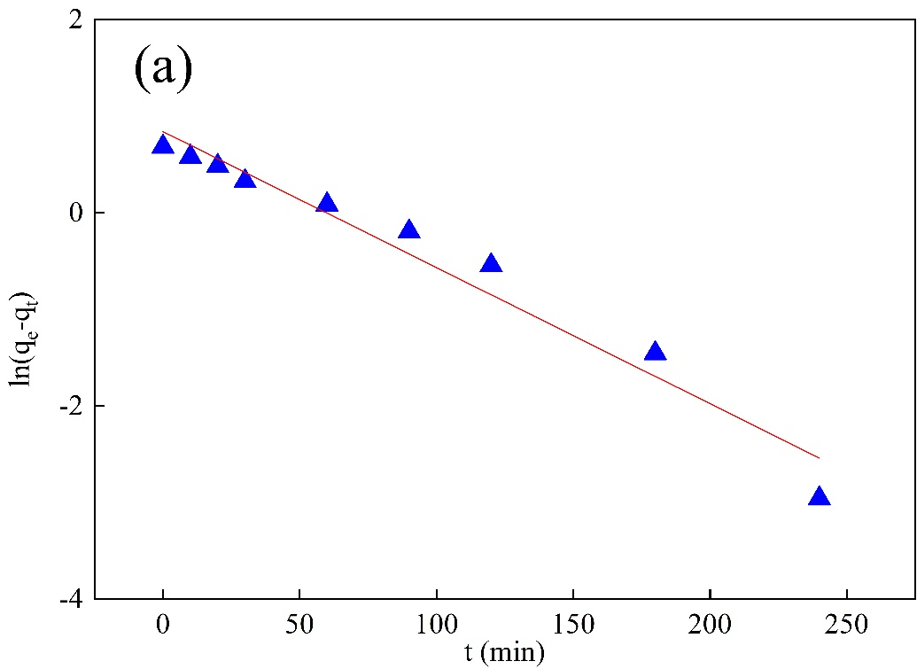
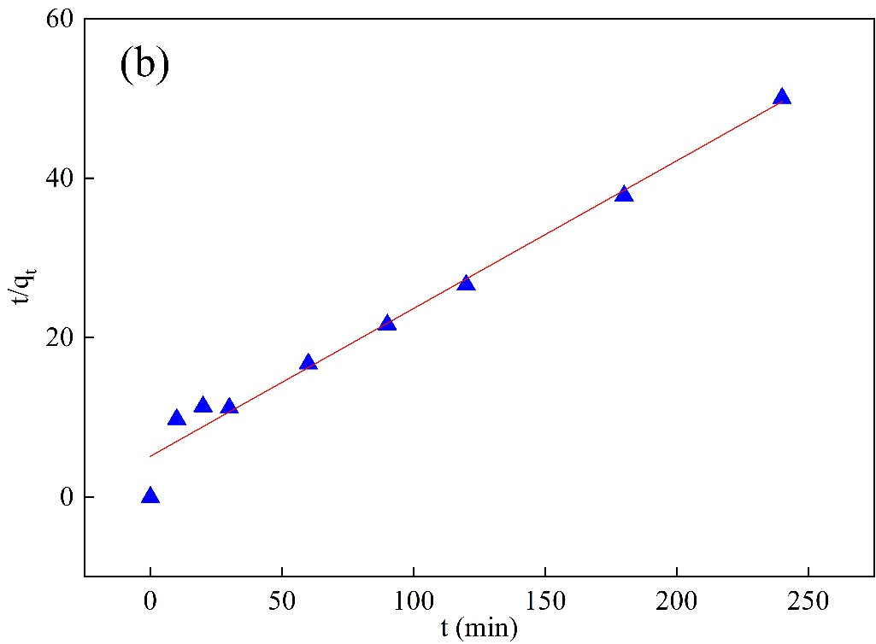

Fig. S1 Adsorption kinetics of Li(I) ions onto PAN-CE@SiO₂, pseudo-first-order (a) and pseudo-second-order kinetics(b).

Table S1
Elements contents in the real saltlake brine Li(I) in this work.
Elements | Li | K | Mg | Ca | Na
Concentration  (ppm) | 1085 | 25376 | 20.5 | 0.32 | 118593

Table s2 The calculated parameters for the adsorbents before and after adsorption
adsorbent | bond distance  (Å) |  |  |  |  |  |  |  |  | bond angle  (°) |  |  |  |  |  | Cavity Sizeª
 | C2-O10 | C7-O11 | C13-O18 | C27-O25 | O10-M | O11-M | O18-M | O25-M |  | C2-O10-C26 | C13-O18-C19 | C20-O25-C27 |  | O11-M-O25 | O10-M-O18
Functional group | 1.36 | 1.39 | 1.42 | 1.42 |  |  |  |  |  | 118.29 | 117.15 | 114.31 |  |  |  | 3.44(4.55)
Li(I) complex | 1.43 | 1.43 | 1.44 | 1.44 | 2.16 | 2.06 | 2.20 | 1.99 |  | 117.25 | 115.07 | 116.55 | 116.23 |  | 141.51
ª The cavity size is the minimum distance between two oxygen atoms in the opposite position, and the values in parentheses are the cavity size of the free crown ether.

