Supplementary Material for

Heterogeneity and Contribution of Microplastics From Industrial and Domestic Sources in a Wastewater Treatment Plant in Xiamen, China

Zouxia Long¹*, Wenling Wang^{1,}†, Xingguang Yu¹, Zhongyang Lin^{2, 3}, Jian Chen¹*

¹ Third Institute of Oceanography, Ministry of Natural Resources, Daxue Road 178, Xiamen, 361005, China.

² Zhejiang Institute of Geological Survey, Hangzhou, 311203, China

³ Technology Innovation Center for Ecological Evaluation and Remediation of Agricultural Land in Plain Area, Ministry of Natural Resources, Hangzhou, 311203, China

* Corresponding author, Zouxia Long, zouxialong@tio.org.cn; Jian Chen, chenjian@tio.org.cn

† Present address: Chongqing Ecological Environment Bureau Liangjiang New Area Branch, Block B5, Yuxing Plaza, No. 52, Huangshan Avenue, Chongqing, 401121, China.

Figure S1. The characteristics of Haicang WWTP. (a-b) The histogram and cumulative frequency curve of daily flow in 2017 and 2018. (c-f) Water quality indexes of the influent from January 2017 to November 2018.

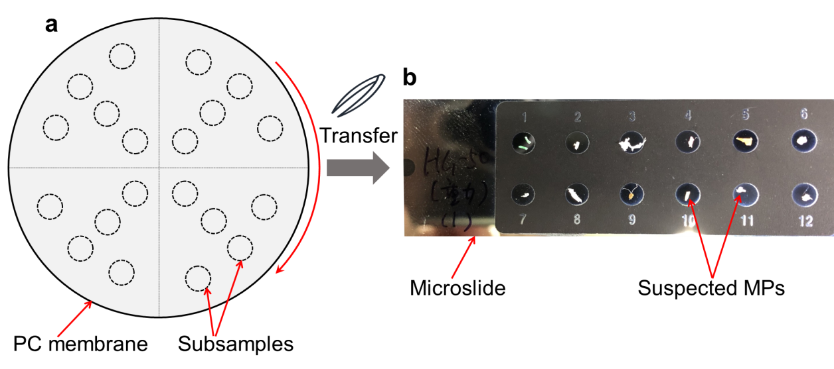
Figure S2. Schematic diagram of subsamples on PC membrane (a) and the suspected MPs transferred on a microslide (b).

Figure S3. The characteristics of MPs in different sites of Haicang WWTP in 2018.
Figure S4. The characteristics of MPs in different sites of Haicang WWTP in 2017. N/A: not available.

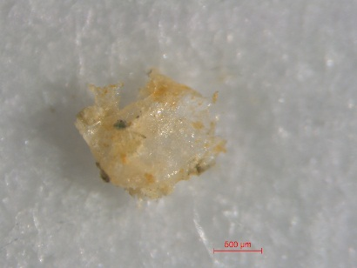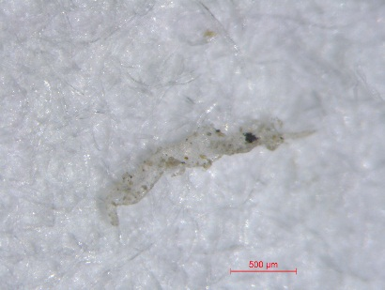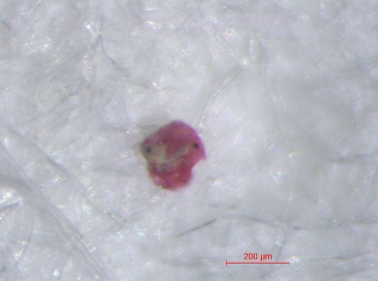
c
b
a
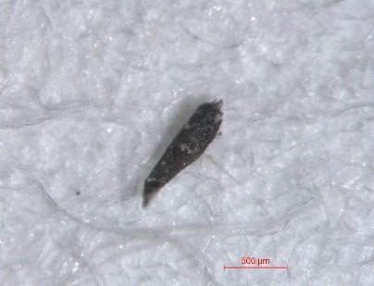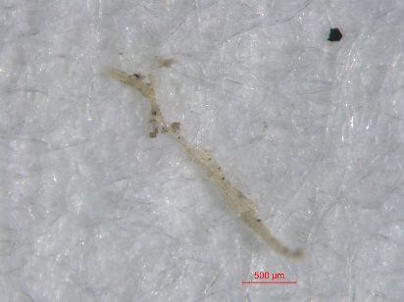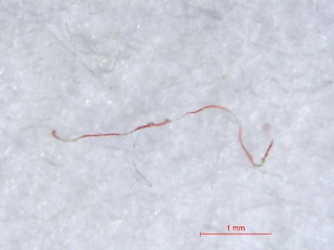
f
e
d
Figure S5. The surface morphology of MPs from industrial wastewater in 2018.

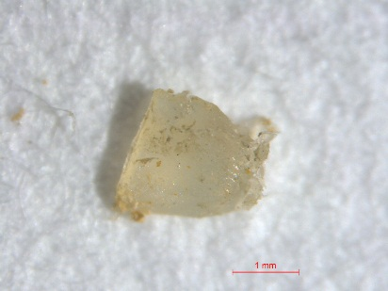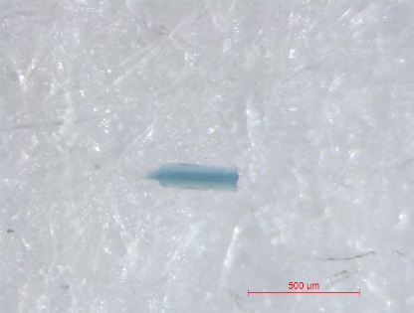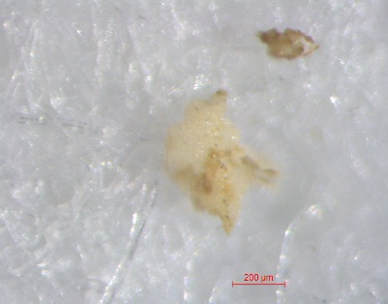
b
c
a
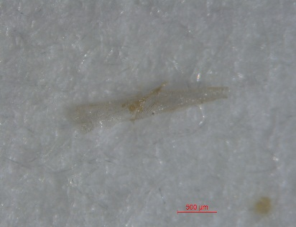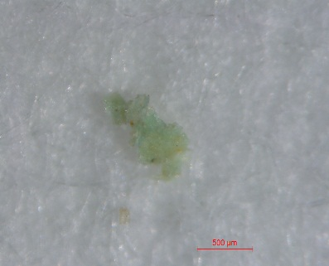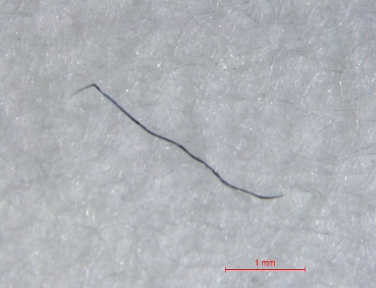
f
e
d
Figure S6. The surface morphology of MPs from domestic wastewater in 2018.

Table S1. The treated amount of wastewater and sludge production in the Haicang WWTP on the sampling day.
Sampling day | Treated amount  (tonnes) | Excess sludge  (tonnes) | Sludge cake  (tonnes) | Return sludge  (tonnes) | Return sludge ratio (%)
09-19-2017 | 6.84×10⁴ | 205.00 | 32.12 | 4.73×10⁴ | 84.33
10-24-2018 | 10.37×10⁴ | 596.39 | 83.41 | 7.30×10⁴ | 70.33

Table S2. The number of particles identified and detected as MPs in 2018.
Site | Particles identified (items) | MPs  (items) | Detection rate  (%) | Unclassified MPs  (items) | Total MPs (items)
W1-i | 198 | 77 | 38.89 | 46 | 123
W1-d | 148 | 96 | 64.86 | 32 | 128
W2 | 197 | 89 | 45.18 | 29 | 118
W3 | 81 | 15 | 18.52 | 0 | 15
S1 | 40 | 24 | 60.00 | 33 | 57
S2 | 57 | 41 | 71.93 | 0 | 41
S3 | 58 | 43 | 74.14 | 15 | 58
Total | 779 | 385 | 49.42 | 155 | 540

Table S3. MPs identified in industrial wastewater (W1-i) in 2018.
Mesh screen (μm) |  | 335 |  | 125 |  | 63 |  | 43
Items |  | Particles identified | MPs | Particles identified | MPs | Particles identified | MPs | Particles identified | MPs
Shape | Fibers | 19 | 9 | 40 | 16 | 21 | 10 | 10 | 1
 | Pellets | 0 | 0 | 1 | 0 | 1 | 0 | 0 | 0
 | Fragments | 11 | 9 | 20 | 10 | 10 | 3 | 16 | 7
 | Granules | 9 | 3 | 18 | 6 | 9 | 1 | 13 | 2
Color | Red | 4 | 0 | 20 | 9 | 6 | 1 | 2 | 1
 | Blue | 3 | 0 | 8 | 3 | 3 | 1 | 5 | 1
 | Green | 3 | 1 | 5 | 4 | 1 | 1 | 5 | 3
 | White | 7 | 5 | 11 | 7 | 2 | 0 | 2 | 0
 | Black | 11 | 6 | 15 | 2 | 11 | 4 | 11 | 1
 | Yellow | 6 | 5 | 10 | 5 | 7 | 0 | 4 | 0
 | Clear | 5 | 4 | 10 | 2 | 11 | 7 | 10 | 4
Polymer type | PE |  | 2 |  | 4 |  | 5 |  | 3
 | PP |  | 3 |  | 11 |  | 2 |  | 4
 | PS |  | 0 |  | 1 |  | 0 |  | 1
 | PE&PP |  | 4 |  | 0 |  | 1 |  | 2
 | PP&PE |  | 1 |  | 0 |  | 0 |  | 0
 | PES |  | 5 |  | 6 |  | 1 |  | 0
 | PET |  | 3 |  | 7 |  | 2 |  | 0
 | PA/Nylon |  | 0 |  | 1 |  | 1 |  | 0
 | PAN |  | 0 |  | 2 |  | 1 |  | 0
 | Add |  | 2 |  | 0 |  | 0 |  | 0
 | Other |  | 1 |  | 0 |  | 1 |  | 0
Table S4. MPs identified in domestic wastewater (W1-d) in 2018.
Mesh screen (μm) |  | 335 |  | 125 |  | 63 |  | 43
Items |  | Particles identified | MPs | Particles identified | MPs | Particles identified | MPs | Particles identified | MPs
Shape | Fibers | 17 | 10 | 7 | 7 | 3 | 0 | 6 | 2
 | Pellets | 0 | 0 | 0 | 0 | 5 | 0 | 0 | 0
 | Fragments | 16 | 14 | 5 | 3 | 10 | 9 | 5 | 2
 | Granules | 15 | 11 | 13 | 7 | 37 | 27 | 9 | 4
Color | Red | 8 | 5 | 4 | 4 | 2 | 0 | 2 | 2
 | Blue | 5 | 4 | 7 | 4 | 10 | 10 | 1 | 1
 | Green | 4 | 3 | 3 | 2 | 7 | 4 | 1 | 1
 | White | 11 | 10 | 1 | 1 | 16 | 8 | 2 | 0
 | Black | 5 | 2 | 2 | 0 | 4 | 1 | 3 | 1
 | Yellow | 4 | 3 | 3 | 2 | 4 | 1 | 6 | 0
 | Clear | 11 | 8 | 5 | 4 | 12 | 12 | 5 | 3
Polymer type | PE |  | 9 |  | 1 |  | 7 |  | 4
 | PP |  | 7 |  | 6 |  | 20 |  | 4
 | PS |  | 0 |  | 1 |  | 1 |  | 0
 | PE&PP |  | 4 |  | 1 |  | 1 |  | 0
 | PP&PE |  | 1 |  | 2 |  | 6 |  | 0
 | PES |  | 3 |  | 0 |  | 0 |  | 0
 | PET |  | 3 |  | 1 |  | 1 |  | 0
 | PA/Nylon |  | 0 |  | 1 |  | 0 |  | 0
 | PAN |  | 3 |  | 4 |  | 0 |  | 0
 | Add |  | 2 |  | 0 |  | 0 |  | 0
 | Other |  | 3 |  | 0 |  | 0 |  | 0
Table S5. MPs identified in industrial wastewater (W1-i) in 2017.
mesh screen (μm) |  | 335 |  | 125 |  | 63 |  | 43
Items |  | Particles identified | MPs | Particles identified | MPs | Particles identified | MPs | Particles identified | MPs
Shape | Fibers | 14 | 5 | 11 | 6 | 0 | 0 | 8 | 4
 | Pellets | 0 | 0 | 1 | 0 | 3 | 1 | 0 | 0
 | Fragments | 19 | 13 | 12 | 4 | 4 | 3 | 16 | 16
 | Granules | 13 | 9 | 18 | 10 | 19 | 11 | 11 | 9
Color | Red | 4 | 2 | 4 | 3 | 4 | 3 | 6 | 5
 | Blue | 0 | 0 | 0 | 0 | 2 | 2 | 1 | 1
 | Green | 5 | 2 | 9 | 4 | 4 | 4 | 3 | 3
 | White | 21 | 15 | 11 | 4 | 4 | 1 | 3 | 2
 | Black | 5 | 2 | 5 | 1 | 1 | 0 | 3 | 1
 | Yellow | 5 | 1 | 5 | 1 | 4 | 0 | 2 | 2
 | Clear | 6 | 5 | 8 | 7 | 7 | 5 | 17 | 15
Polymer type | PE |  | 11 |  | 5 |  | 2 |  | 9
 | PP |  | 8 |  | 7 |  | 7 |  | 9
 | PS |  | 3 |  | 1 |  | 0 |  | 5
 | PE&PP |  | 2 |  | 3 |  | 0 |  | 1
 | PP&PE |  | 0 |  | 3 |  | 3 |  | 2
 | PES |  | 0 |  | 0 |  | 0 |  | 0
 | PET |  | 3 |  | 1 |  | 3 |  | 0
 | PA/Nylon |  | 0 |  | 0 |  | 0 |  | 0
 | POM |  | 0 |  | 0 |  | 0 |  | 0
 | Other |  | 0 |  | 0 |  | 0 |  | 3

Table S6. MPs identified in domestic wastewater (W1-d) in 2017.
mesh screen (μm) |  | 335 |  | 125 |  | 63 |  | 43
Items |  | Particles identified | MPs | Particles identified | MPs | Particles identified | MPs | Particles identified | MPs
Shape | Fibers | 12 | 6 | 10 | 6 | 3 | 0 | 1 | 1
 | Pellets | 0 | 0 | 0 | 0 | 2 | 0 | 4 | 3
 | Fragments | 11 | 5 | 18 | 11 | 6 | 1 | 5 | 2
 | Granules | 13 | 9 | 20 | 13 | 20 | 9 | 4 | 1
Color | Red | 3 | 2 | 6 | 4 | 5 | 1 | 1 | 1
 | Blue | 1 | 1 | 6 | 6 | 1 | 1 | 2 | 1
 | Green | 5 | 3 | 7 | 1 | 5 | 2 | 1 | 1
 | White | 7 | 4 | 9 | 7 | 8 | 3 | 2 | 0
 | Black | 2 | 0 | 1 | 0 | 3 | 2 | 2 | 1
 | Yellow | 4 | 0 | 4 | 0 | 6 | 0 | 2 | 1
 | Clear | 14 | 10 | 15 | 12 | 3 | 1 | 4 | 2
Polymer type | PE |  | 8 |  | 9 |  | 1 |  | 2
 | PP |  | 3 |  | 10 |  | 3 |  | 0
 | PS |  | 5 |  | 3 |  | 2 |  | 0
 | PE&PP |  | 0 |  | 3 |  | 0 |  | 0
 | PP&PE |  | 0 |  | 2 |  | 2 |  | 1
 | PES |  | 0 |  | 1 |  | 0 |  | 0
 | PET |  | 1 |  | 0 |  | 1 |  | 1
 | PA/Nylon |  | 0 |  | 0 |  | 0 |  | 0
 | POM |  | 0 |  | 1 |  | 0 |  | 0
 | Other |  | 3 |  | 1 |  | 1 |  | 3

Table S7. The wastewater discharge and estimated MP number in industrial and domestic sources in different years.
Year | Industrial sources |  | Domestic sources
 | Wastewater  (×10⁷ tonnes) | Estimated MPs  (×10¹⁰ items) | Wastewater  (×10⁴ tonnes) | Estimated MPs  (×10¹⁰ items)
2017 | 1.57 | 4.01 | 1.04 | 1.50
2018 | 2.19 | 6.05 | 1.46 | 1.89
2019 | 2.21 | 5.89 | 1.54 | 2.10
2020 | 2.22 | 5.91 | 1.61 | 2.20
2035 | 6.55 | 17.41 | 5.81 | 7.92
The wastewater discharge in 2035 is an official estimated data based on the water consumption index. The number of MPs from industrial and domestic sources were based on the investigated results in 2017 and 2018, respectively. In the other years, they were based on the average abundance of MPs in 2017 and 2018.

