Supplementary Material
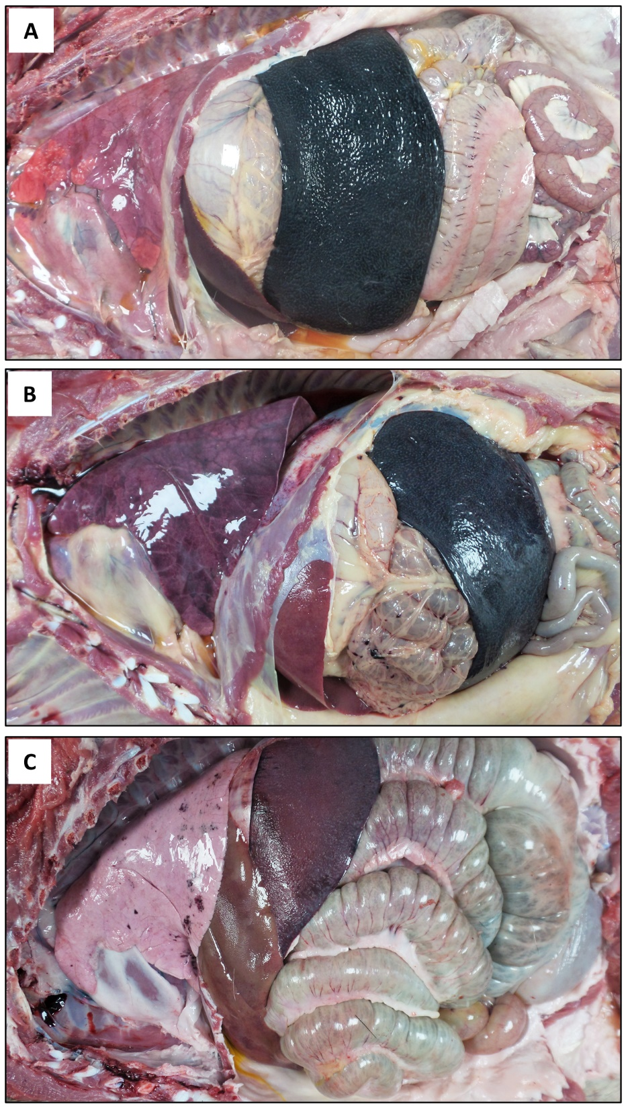
Supplementary Figure 1. Necropsy findings. Views of thoracic and abdominal cavities from (A) control wild boar (naïve animal IM challenged with Arm07), (B) orally vaccinated wild boar with Lv17/WB/Rie1 that did not survive the challenge, and (C) orally vaccinated wild boar with Lv17/WB/Rie1 that survived the challenge. Splenomegaly, congestive spleen, hydrothorax, and pulmonary edema and congestion are evident in (A) and (B).

