Figure S1A Correlations between coronal MS and infra-annular MS
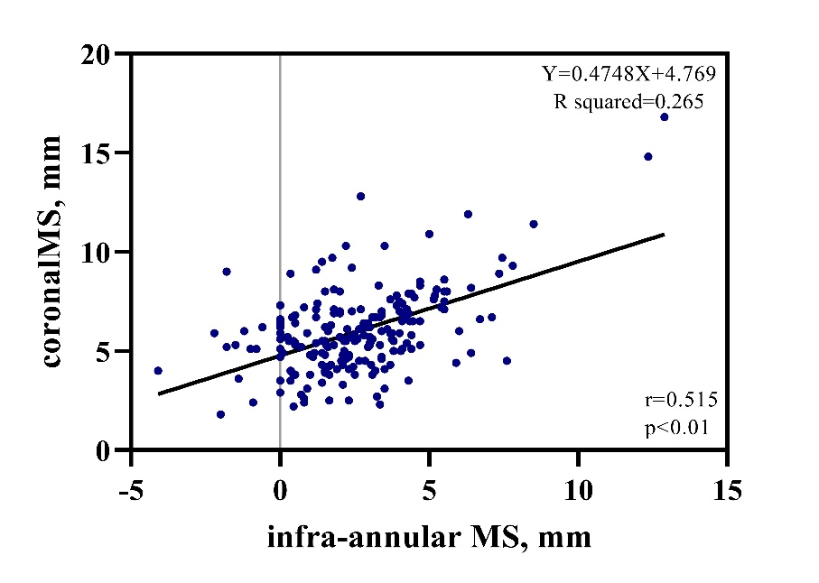
Figure S1B Correlations between implantation depth on fluoroscopy or CT
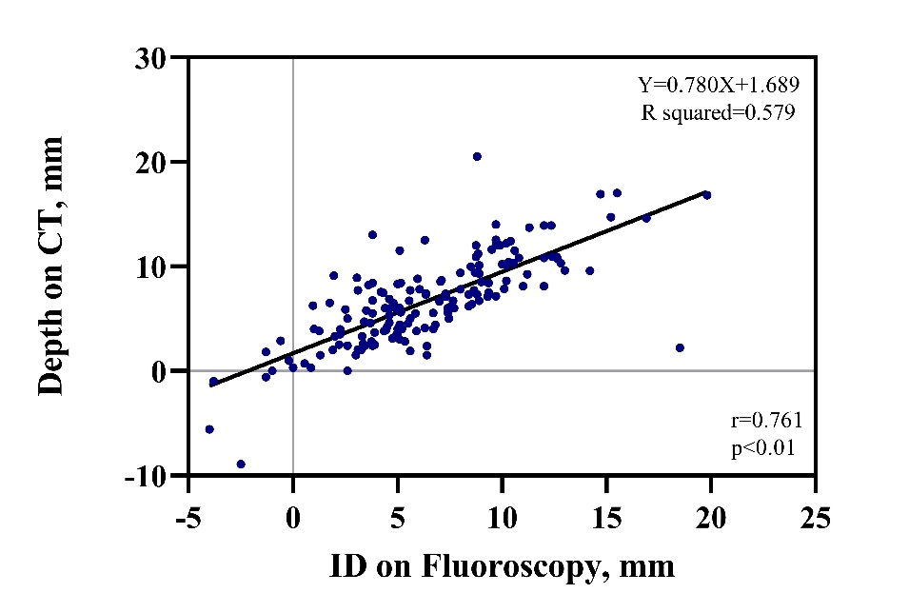

Figure S1C Correlations between ΔMSID and Δcoronal MSID
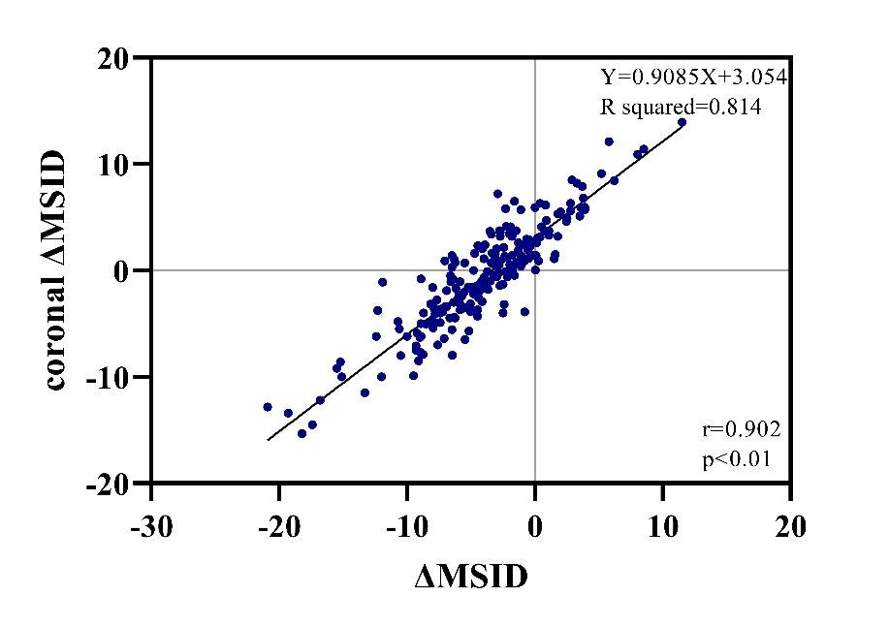

Supplementary Table 1A. Baseline variables comparison between different types of BAV.
 | Total  n=209 | Type 0  n=99 | Type 1  n=79 | T-BAV  n=31 | p Value
Age, yrs | 75.12±6.79 | 74.1±7.02 | 76.27±6.85 | 75.45±5.43 | 0.102
Male | 128(61.2%) | 54(54.5%) | 51(64.6%) | 23(74.2%) | 0.109
Body mass index, kg/m^2 | 22.53±3.11 | 22.31±2.98 | 22.79±3.28 | 22.62±3.07 | 0.589
Diabetes Mellitus | 41(19.6%) | 21(21.2%) | 14(17.7%) | 6(19.4%) | 0.843
Hypertension | 100(47.8%) | 49(49.5%) | 36(45.6%) | 15(48.4%) | 0.871
COPD | 43(20.6%) | 21(21.2%) | 14(17.7%) | 8(25.8%) | 0.626
CKD stage IV/V | 4(1.9%) | 1(1.0%) | 3(3.8%) | 0(0.0%) | 0.370
STS score, % | 6.80±4.51 | 6.10±3.77 | 7.77±5.41 | 6.54±3.79 | 0.045
Atrial Fibrillation/Flutter | 32(15.3%) | 14(14.1%) | 12(15.2%) | 6(19.4%) | 0.781
Preexisting LBBB | 18(8.6%) | 11(11.1%) | 4(5.1%) | 3(9.7%) | 0.344
Preexisting RBBB | 17(8.1%) | 9(9.1%) | 7(8.9%) | 1(3.2%) | 0.654
Baseline echocardiographic variables
Mean gradient, mmHg | 60.25±22.92 | 60.63±23.63 | 60.77±22.59 | 57.74±21.97 | 0.804
AVA, cm^2 | 0.51±0.29 | 0.53±0.26 | 0.47±0.33 | 0.59±0.31 | 0.133
Max velocity, m/s | 4.9±0.96 | 4.99±0.94 | 4.80±1.03 | 4.84±0.83 | 0.388
LVEF, % | 53.81±13.21 | 54.49±14.07 | 52.36±12.32 | 55.34±12.65 | 0.444
Computed tomography variables
Annulus Area, mm^2 | 477.22±106.73 | 459.53±100.09 | 491.67±117.29 | 496.87±92.23 | 0.073
Annulus perimeter | 78.66±8.35 | 77.25±7.97 | 79.69±8.96 | 80.56±7.33 | 0.059
Annular eccentricity index | 0.23±0.07 | 0.23±0.08 | 0.24±0.06 | 0.24±0.06 | 0.825
LVOT area, mm^2 | 508.29±154.72 | 499.54±153.44 | 509.46±163.25 | 533.26±137.37 | 0.571
LVOT perimeter | 84.52±13.23 | 83.85±12.78 | 84.86±14.64 | 85.79±10.92 | 0.746
LVOT eccentricity index * | 0.31±0.08 | 0.33±0.09 | 0.30±0.07 | 0.29±0.07 | 0.013
LVOT calcification | 36(17.2%) | 15(15.2%) | 13(16.5%) | 8(25.8%) | 0.381
AA diameter at 40mm, mm | 38.85±3.88 | 39.58±3.89 | 38.65±3.86 | 36.98±3.29 | 0.004
Max AA diameter, mm | 42.62±4.68 | 43.87±4.57 | 42.09±4.63 | 39.97±3.81 | <0.001
RCA height, mm | 17.34±3.85 | 17.98±4.44 | 16.42±2.98 | 17.66±3.40 | 0.023
LCA height, mm | 16.01±4.09 | 17.4±4.21 | 14.74±3.79 | 14.8±2.91 | <0.001
Aortic root angulation | 52.82±10.49 | 54.15±10.53 | 52.57±10.13 | 49.19±10.66 | 0.068
Infra-annular MS length, mm | 2.56±2.27 | 2.48±2.22 | 2.44±2.21 | 3.09±2.57 | 0.364
Coronal MS length, mm | 5.98±2.09 | 5.58±1.92 | 6.31±2.25 | 6.44±2.04 | 0.030
Values are presented as mean ± SD or n (%). p Values in bold are statistically significant, which is calculated by ANOVA (Analysis of Variance).
AA = ascending aorta; AVA = aortic valve orifice area; BAV = bicuspid aortic valve; COPD = chronic obstructive pulmonary disease; CKD = chronic kidney disease; F-BAV = functional bicuspid aortic valve; LBBB = left bundle branch block; LCA = left coronary height; LVEF = left ventricular ejection fraction; LVOT = left ventricular outflow tract; MS = membranous septum; RBBB = right bundle branch block; RCA = right coronary artery; STS = Society of Thoracic Surgeons

 | Total  n=209 | Type 0  n=99 | Type 1  n=79 | T-BAV  n=31 | p Value
Pre-dilatation | 204(97.6%) | 99(100%) | 75(94.9%) | 30(96.8%) | 0.058
Post-dilatation | 150(71.8%) | 71(71.7%) | 55(69.6%) | 24(77.4%) | 0.716
Second valve implantation | 17(8.1%) | 7(7.1%) | 4(5.1%) | 6(19.4%) | 0.057
Oversizing by annulus perimeter, % | 4.9±8.7 | 5.6±8.4 | 4.6±8.5 | 3.5±9.9 | 0.431
Oversizing by annulus area, % | 15.8±19.4 | 17.5±19.1 | 14.7±18.8 | 13.2±22 | 0.460
Oversizing by LVOT perimeter, % | -1.2±12.9 | -1.6±12.7 | -0.4±13.6 | -2.2±12 | 0.772
Oversizing by LVOT area, % | 13.4±31.7 | 12.6±28.8 | 16.4±36.4 | 8.7±27.4 | 0.488
Implantation depth, mm | 6.63±4.26 | 5.75±3.85 | 7.03±3.95 | 8.44±5.51 | 0.005
ΔMSID, mm | -4.07±4.85 | -3.26±4.43 | -4.59±4.31 | -5.35±6.79 | 0.055
Implant depth > infra-annular MS length | 173(82.8%) | 79(79.8%) | 68(86.1%) | 26(83.9%) | 0.537
Δcoronal MSID, mm | -0.86±4.85 | -0.52±4.88 | -0.80±4.43 | -2.03±5.68 | 0.322
New-onset conduction disturbances | 61(29.2%) | 29(29.3%) | 21(26.6%) | 11(35.5%) | 0.652
Post New LBBB | 42(20.1%) | 24(24.2%) | 12(15.2%) | 6(19.4%) | 0.324
Post New HAVB | 21(10%) | 6(6.1%) | 10(12.7%) | 5(16.1%) | 0.146
Post PPMI | 17(8.1%) | 4(4%) | 8(10.1%) | 5(16.1%) | 0.061
Supplementary Table 1B. Procedural Characteristics and conduction abnormalities
Values are presented as mean ± SD or n (%). p Values in bold are statistically significant, which is calculated by ANOVA (Analysis of Variance).
T-BAV = tricommissural raphe-type bicuspid aortic valve; HAVB = high-grade atrioventricular block; LBBB = left bundle branch block; LVOT = left ventricular outflow tract; MS = membranous septum; ΔMSID = membranous length minus implantation depth; NOCDs = New-Onset Conduction Disturbances; PPMI = permanent pacemaker implantation; RBBB = right bundle branch block.

Supplementary Table 1C. Detail Comparison between different types of BAV
 | Total  n=209 | Type 0  n=99 | Type 1  n=79 | T-BAV  n=31 | p Value | Type 0 vs. Type 1 | Type 0 vs. T-BAV | Type 1 vs. T-BAV
STS score, % | 6.80±4.51 | 6.10±3.77 | 7.77±5.41 | 6.54±3.79 | 0.045 | 0.062 | 0.919 | 0.450
LVOT eccentricity index | 0.31±0.08 | 0.33±0.09 | 0.30±0.07 | 0.29±0.07 | 0.013 | 0.037 | 0.037 | 0.916
AA diameter at 40mm, mm | 38.85±3.88 | 39.58±3.89 | 38.65±3.86 | 36.98±3.29 | 0.004 | 0.105 | 0.001 | 0.039
Max AA diameter, mm | 42.62±4.68 | 43.87±4.57 | 42.09±4.63 | 39.97±3.81 | <0.001 | 0.009 | <0.001 | 0.028
RCA height | 17.34±3.85 | 17.98±4.44 | 16.42±2.98 | 17.66±3.40 | 0.023 | 0.007 | 0.688 | 0.122
LCA height | 16.01±4.09 | 17.4±4.21 | 14.74±3.79 | 14.8±2.91 | <0.001 | <0.001 | 0.001 | 0.943
Coronal MS length, mm | 5.98±2.09 | 5.58±1.92 | 6.31±2.25 | 6.44±2.04 | 0.030 | 0.022 | 0.046 | 0.761
Implantation Depth | 6.63±4.26 | 5.75±3.85 | 7.03±3.95 | 8.44±5.51 | 0.005 | 0.091 | 0.046 | 0.485
One-way analysis of variance (ANOVA) with LSD or Dunnett multiple comparison test were performed. Values are presented as mean ± SD or n (%). p Values in bold are statistically significant.
AA = ascending aorta; T-BAV = tricommissural raphe-type bicuspid aortic valve; LCA = left coronary height; LVOT = left ventricular outflow tract; MS = membranous septum; RCA = right coronary artery; STS = Society of Thoracic Surgeons

Supplementary Table 2. Detail pre- and post-operative arrhythmic characteristics of Patients with New-onset HAVB
 | Preoperative Arrhythmia | Postoperative Arrhythmia | PPMI & time
Pt 1-7 | no conduction disturbance | 3°AVB | PPMI before discharge
Pt 8 | no conduction disturbance | Adams-Stroke syndrome, syncope, HAVB (P waves do not conduct to the ventricles for 50 seconds) | PPMI before discharge
Pt 9 | no conduction disturbance | HAVB (transient 3°AVB, 2°AVB type 2 (Mobitz II)) | patient and his family refuse PPMI
Pt 10 | 1°AVB | Frequent 3°AVB, sinus arrest for 4.72 seconds, CRBBB | PPMI before discharge
Pt 11 | 1°AVB | HAVB (transient 3°AVB), CLBBB, 1°AVB, 2°AVB type 1; no 3°AVB according to Holter and electrocardiography before discharge. | patient and his family refuse PPMI
Pt 12 | Afib | 2°AVB type 2 (Mobitz II) | PPMI before discharge
Pt 13 | Afib | Frequent 3°AVB, 2°AVB type 2 (Mobitz II) | PPMI before discharge
Pt 14 | Afib, CRBBB | Frequent 3°AVB, CLBBB, CRBBB | PPMI before discharge
Pt 15 | Afib, CRBBB | Transient HAVB, CRBBB before discharge. HAVB in 10 days electrocardiography | PPMI 10 days after discharge
Pt 16 | Afib, LBBB (undefined) | Afib with Long RR intervals | PPMI before discharge
Pt 17-18 | CRBBB | 3°AVB | PPMI before discharge
Pt 19 | CRBBB | HAVB (transient 3°AVB) and CRBBB , no 3°AVB according to Holter before discharge. | CRBBB at discharge, no PPMI
Pt 20 | CRBBB | Transient HAVB, CRBBB, LAH, no 3°AVB according to Holter before discharge. | no PPMI
Pt 21 | CRBBB, 1°AVB | 3°AVB, persistent pacemaker heart rate | PPMI before discharge
Afib: atrial fibrillation; AVB: atrioventricular block; CRBBB: complete right bundle branch block; LBBB: left bundle branch block; LAH: left anterior hemiblock; LPH: left posterior hemiblock; 1°AVB: first-degree atrioventricular block; 2°AVB: second-degree atrioventricular block; 3°AVB: third-degree atrioventricular block; PPMI: permanent pacemaker implantation;

Supplementary Table 3. Discriminatory ability of models to New-Onset Conduction Disturbances after TAVR in BAV patients.
 | C-statistic*
Age >73yrs | 0.592(0.509-0.675)
LVOT perimeter <66.8 mm | 0.557(0.468-0.646)
Infra-annular MS <3.7 mm | 0.572(0.489-0.655)
Coronal MS <4.9mm | 0.621(0.535-0.708)
ΔMSID <-2.9mm | 0.632(0.551-0.712)
Δcoronal MSID <1.8mm | 0.641(0.565-0.718)
Oversizing by LVOT perimeter >3.2% | 0.633(0.549-0.718)
Model1: Age >73 yrs+ LVOT perimeter <66.8mm+ Infra-annular MS <3.7mm | 0.672(0.591-0.752)
Model2: Age >73 yrs+ LVOT perimeter <66.8mm+ Coronal MS <4.9mm | 0.692(0.609-0.774)
Model3: Age >73 yrs+ ΔMSID <-2.9mm+ Oversizing by LVOT perimeter >3.2% | 0.752(0.679-0.824)
Model4: Age >73 yrs+ Δcoronal MSID<1.8mm+ Oversizing by LVOT perimeter >3.2% | 0.768(0.699-0.837)
* Concordance-statistic (c-statistic) was evaluated using the area under the receiver operating characteristic (ROC) curve (AUC).
Comparison of AUCs between Infra-annular MS and Coronal MS, ΔMSID, Δcoronal MSID was significant (P = 0.005, 0.026, 0.008, respectively). Comparison of AUCs between four multivariate models was non-significant except Model1 vs Model4 (P = 0.027).
LVOT = left ventricular outflow tract; MS = membranous septum; ΔMSID = membranous length minus implantation depth;

Supplementary Table 4A. Bicuspid aortic stenosis patients’ characteristics and HAVB
 | Total  (n=209) | No HAVB  (n=188) | HAVB  (n=21) | p Value
Age, yrs | 75.12±6.79 | 74.84±6.69 | 77.62±7.34 | 0.075
Male | 128(61.2%) | 116(61.7%) | 12(57.1%) | 0.684
Body mass index, kg/m^2 | 22.53±3.11 | 22.55±3.09 | 22.39±3.35 | 0.818
Diabetes Mellitus | 41(19.6%) | 40(21.3%) | 1(4.8%) | 0.129
Hypertension | 100(47.8%) | 89(47.3%) | 11(52.4%) | 0.661
COPD | 43(20.6%) | 40(21.3%) | 3(14.3%) | 0.640
CKD Stage 4-5 | 4(1.9%) | 4(2.1%) | 0(0.0%) | 1.000
STS score, % | 5.487(3.626,9.052) | 5.482(3.816,8.925) | 5.6(3.180,10.009) | 0.872
Atrial Fibrillation/Flutter | 32(15.3%) | 27(14.4%) | 5(23.8%) | 0.412
Preexisting LBBB | 18(8.6%) | 18(9.6%) | 0(0.0%) | 0.283
Preexisting RBBB | 17(8.1%) | 10(5.3%) | 7(33.3%) | <0.001
Mean gradient, mmHg | 56.0(43.0,70.5) | 56.0(43.0,71.0) | 56.0(50.0,69.0) | 0.559
Max velocity, m/s | 4.9(4.2,5.5) | 4.9(4.2,5.5) | 5(4.4,5.3) | 0.721
LVEF, % | 57.0(46.0,63.4) | 56.9(44.0,63.4) | 57.5(52.3,63.7) | 0.499
Type of BAV |  |  |  | 0.165
0 | 99(47.4%) | 93(49.5%) | 6(28.6%)
1 | 79(37.8%) | 69(36.7%) | 10(47.6%)
F-BAV | 31(14.8%) | 26(13.8%) | 5(23.8%)
Annulus perimeter, mm | 77.2(73.2,82.9) | 77.2(73.0,83.6) | 78.1(74.4,82.3) | 0.885
LVOT perimeter, mm | 83.8(75.4,92.7) | 83.9(75.5,93.2) | 80.9(74.3,91.3) | 0.341
Aortic root angulation | 52.82±10.49 | 52.69±10.49 | 54.00±10.66 | 0.587
Infra-annular MS length, mm | 2.3(1.2,3.9) | 2.3(1.2,4.0) | 2.1(1.5,3.5) | 0.642
Coronal MS length, mm | 5.7(4.7,7.0) | 5.9(4.8,7.1) | 4.8(4.1,5.5) | 0.003
Oversizing by annulus perimeter, % | 4.90± 8.70 | 4.62±8.82 | 7.42±7.02 | 0.162
Oversizing by annulus area, % | 15.80±19.40 | 15.25±19.71 | 20.59±16.32 | 0.233
Oversizing by LVOT perimeter, % | -1.20±12.90 | -1.89±12.82 | 4.59±12.89 | 0.029
Oversizing by LVOT area, % | 9.1(-7.8,29.6) | 8.2(-7.9,29) | 18.3(2.1,36.7) | 0.108
Pre-dilatation | 204(97.6%) | 185(98.4%) | 19(90.5%) | 0.080
Post-dilatation | 150(71.8%) | 133(70.7%) | 17(81%) | 0.324
Second valve implantation | 17(8.1%) | 16(8.5%) | 1(4.8%) | 0.861
Implant depth, mm | 6.3(3.9,9.0) | 6.3(3.8,9.2) | 6.3(4.6,7.3) | 0.732
ΔMSID, mm | -4(-6.6,-1.3) | -4.1(-6.8,-1.1) | -3.4(-5.8,-1.8) | 0.845
Δcoronal MSID, mm | -0.86±4.85 | -0.85±5.05 | -0.89±2.49 | 0.958
Values are presented as mean±SD or median (Quartile1,Quartile3) or n (%). p Values in bold are statistically significant.
CKD = chronic kidney disease; COPD = chronic obstructive pulmonary disease; F-BAV = functional bicuspid aortic valve; HAVB = high-grade atrioventricular block; STS = Society of Thoracic Surgeons; LBBB = left bundle branch block; LVEF = left ventricular ejection fraction; LVOT = left ventricular outflow tract; RBBB = right bundle branch block; MS = membranous septum; ΔMSID = infra-annular MS length minus implantation depth; Δcoronal MSID = coronal MS length minus implantation depth.

Supplementary table 4B. Logistic regression for the predictors of high-grade atrioventricular block
 | Univariate analysis |  | Multivariate analysis model 01* |  | Multivariate regression 02†
 | p Value | OR(95%CI) | p Value | OR(95%CI) | p Value | OR(95%CI)
Pre-existing RBBB | <0.001 | 8.90 (2.94-26.97) | 0.001 | 8.36(2.50-27.89) | <0.001 | 10.48(3.06-35.92)
Coronal MS length <5.5 mm | 0.002 | 5.86(1.90-18.10) | 0.004 | 5.78(1.75-19.12) | - | -
Pre-dilatation | 0.018 | 0.14(0.03-0.71) | - | - | - | -
Δcoronal MSID <1.8 mm | 0.035 | 8.92(1.17-68.08) | - | - | 0.030 | 10.76(1.26-91.57)
Oversizing by LVOT perimeter >6.4% | 0.008 | 3.50(1.39-8.77) | 0.010 | 3.80(1.38-10.50) | 0.011 | 3.68(1.34-10.11)
Multivariate logistic regression included parameters with a p value < 0.05 without significant multicollinearity using forward Likelihood Ratio method.
* c-statistics: 0.805 (95%CI: 0.699-0.911), p <0.001
† c-statistics: 0.791 (95%CI: 0.688-0.895), p <0.001
LVOT= left ventricular outflow tract; MS= membranous septum; RBBB= right bundle branch block; Δcoronal MSID=coronal MS length minus implantation depth

Supplementary Table 5A. Predictors of NOCDs in ID ≥ Infra-annular MS group
 | MS*≤ID  (n=173) | No NOCDs  (n=116) | New NOCDs  (n=57) | p Value
Age, yrs | 74.87±6.87 | 73.97±6.99 | 76.72±6.35 | 0.013
Diabetes Mellitus | 31(17.9%) | 16(13.8%) | 15(26.3%) | 0.044
MS length*, mm | 2.1(0.8, 3.4) | 2.1(0.5, 3.3) | 2.3(1.5, 3.5) | 0.217
MS length* <5 | 162(93.6%) | 108(93.1%) | 54(94.7%) | 1.000
Pre-dilatation | 169(97.7%) | 113(97.4%) | 56(98.2%) | 1.000
Post-dilatation | 126(72.8%) | 83(71.6%) | 43(75.4%) | 0.589
Second valve implantation | 15(8.7%) | 8(6.9%) | 7(12.3%) | 0.258
Annular area | 461.5(410.7, 528.1) | 470.8(421.1, 556.0) | 433.7(403.5, 509.4) | 0.030
Annular perimeter | 77.6(73.4, 83.2) | 78.8(74.3, 85.2) | 75.4(72.2, 81.2) | 0.025
LVOT area | 488.8(406.9, 609.9) | 494.4(413.6, 630.1) | 453.8(380.9, 564.7) | 0.017
LVOT perimeter | 83.8(75.5, 93.2) | 85.4(76.7, 94.8) | 80.9(73.7, 88.1) | 0.012
Oversizing by annular perimeter | 4.7±8.9 | 3.1±9.5 | 7.9±6.7 | <0.001
Oversizing by LVOT perimeter | -1.3±13.2 | -3.8±12.9 | 3.8±12.2 | <0.001
Implantation Depth | 7.3(4.8, 9.7) | 6.8(4.5, 9.5) | 7.7(5.9, 10.4) | 0.083
△MSID | -4.9(-7.4, -2.7) | -4.4(-7.4, -2.4) | -5.4(-7.4, -3.5) | 0.203
Values are presented as mean±SD or median (Quartile1,Quartile3) or n (%). p Values in bold are statistically significant.
MS* = Infra-annular membranous septum; LVOT = left ventricular outflow tract; NOCDs = New-Onset Conduction Disturbances; ΔMSID = infra-annular MS length minus implantation depth.

Supplementary Table 5B. Logistic regression of NOCDs in ID ≥ Infra-annular MS group
 | Univariate regression |  | Multivariate regression
 | p Value | OR(95%) | p Value | OR(95%)
Age, per 1 yrs | 0.014 | 1.06 (1.01-1.12) | 0.020 | 1.07 (1.01-1.12)
Diabetes Mellitus | 0.047 | 2.23 (1.01-4.92) | - | -
Infra-annular MS length, per 1mm | 0.415 | 1.07 (0.91-1.24) | - | -
Implantation Depth, per 1mm | 0.214 | 1.05(0.97-1.15) | - | -
△MSID, per 1mm | 0.968 | 0.97 (0.89-1.05) | - | -
Oversizing by LVOT perimeter, per 1% | 0.001 | 1.05 (1.02-1.08) | 0.001 | 1.05 (1.02-1.08)
Forward LR, univariate ≤ 0.05.
Multivariate logistic regression included parameters with a p value < 0.05 without significant multicollinearity using forward Likelihood Ratio method.
MS* = Infra-annular membranous septum; LVOT = left ventricular outflow tract; NOCDs = New-Onset Conduction Disturbances; ΔMSID = infra-annular MS length minus implantation depth.

