Supplementary Material

Supplementary Data
Supplementary Material should be uploaded separately on submission. Please include any supplementary data, figures and/or tables. All supplementary files are deposited to FigShare for permanent storage and receive a DOI.
Supplementary material is not typeset so please ensure that all information is clearly presented, the appropriate caption is included in the file and not in the manuscript, and that the style conforms to the rest of the article. To avoid discrepancies between the published article and the supplementary material, please do not add the title, author list, affiliations or correspondence in the supplementary files.

Supplementary Figures and Tables
For more information on Supplementary Material and for details on the different file types accepted, please see here. Figures, tables, and images will be published under a Creative Commons CC-BY licence and permission must be obtained for use of copyrighted material from other sources (including re-published/adapted/modified/partial figures and images from the internet). It is the responsibility of the authors to acquire the licenses, to follow any citation instructions requested by third-party rights holders, and cover any supplementary charges.

Supplementary Figures
Records identified through database search
(n = 1698)
Additional records identified through other sources
(n = 12)
Records after duplicates removed
(n = 1710)
Records screened
(n = 1710)
Full-text articles assessed for eligibility
(n = 83)
Studies included in qualitative synthesis
(n = 50)
Records excluded
(n = 1627)
Full-text articles excluded, with reasons being
(n = 33)
Outcomes not relevant (15)
Out of scope (12)
Insufficient details (6)
Identification
Screening
Eligibility
Included

Supplementary Figure 1 PRISMA diagram of selecting systematic review

Supplementary Figure 2 The factors affecting food safety (Uçar et al., 2016).

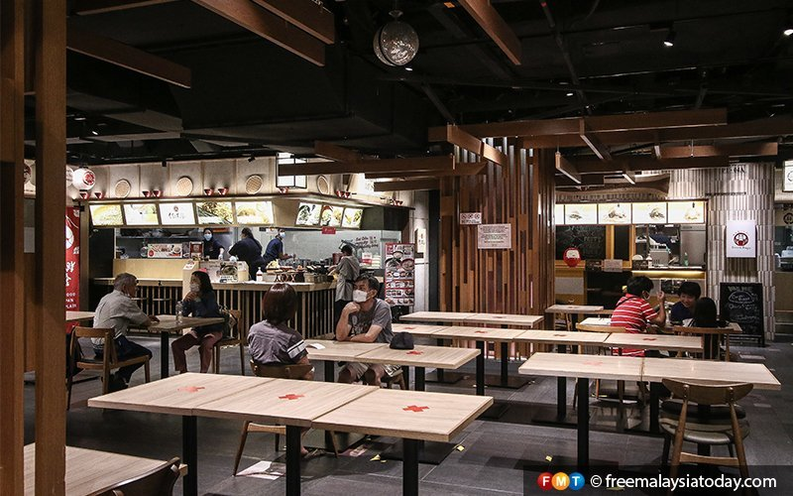
Supplementary Figure 3 Customers shown to be adhering to social distancing guidelines while dining in (Free Malaysia Today, 2020).

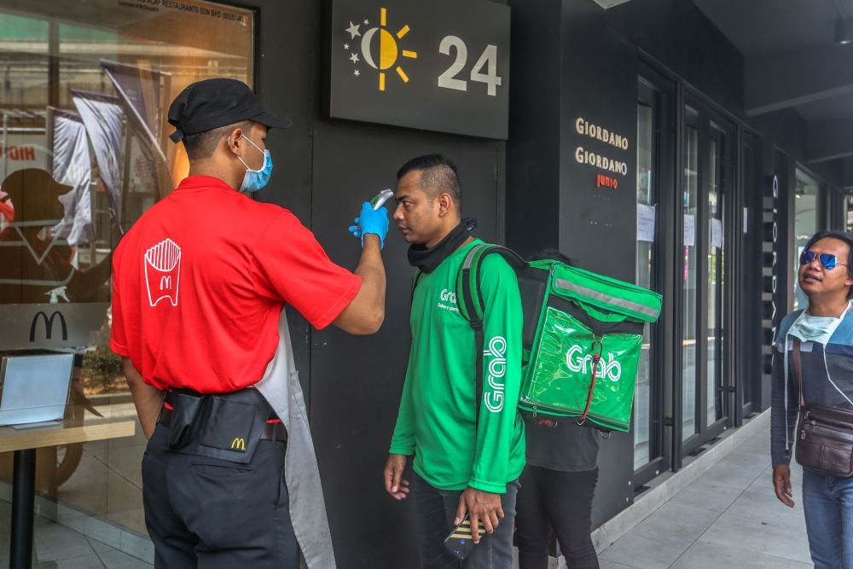
Supplementary Figure 4 A restaurant worker complying to MCO guidelines by screening individuals who wish to enter the premises (Lim, 2020).

Supplementary Figure 5 Practices in personal hygiene and kitchen sanitation (Uçar et al., 2016).

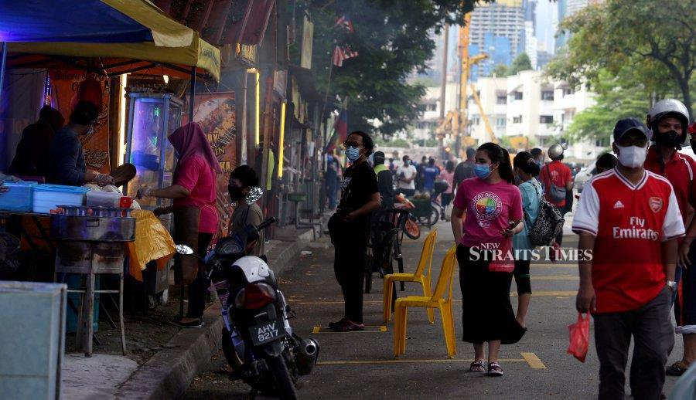
Supplementary Figure 6 Street vendors and customers seen wearing masks and social distancing (Tan, 2020).

Supplementary Figure 7 Overall impact of Covid-19 pandemic to the food supply chain

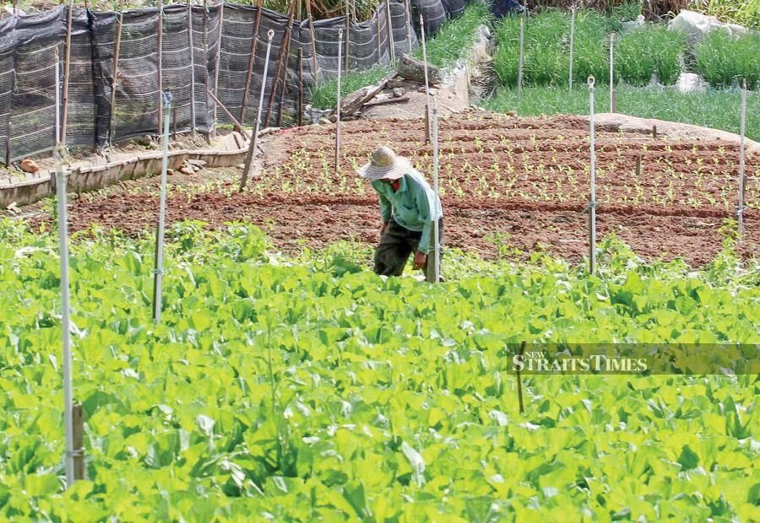
Supplementary Figure 8 A lone farmer working in a field (Man, 2020).

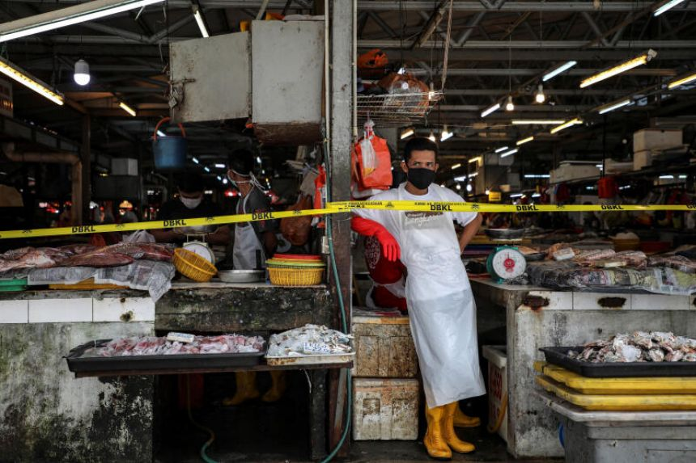
Supplementary Figure 9 A vendor wearing protective clothing in a market in Kuala Lumpur, Malaysia (Hassan & Leong, 2020).

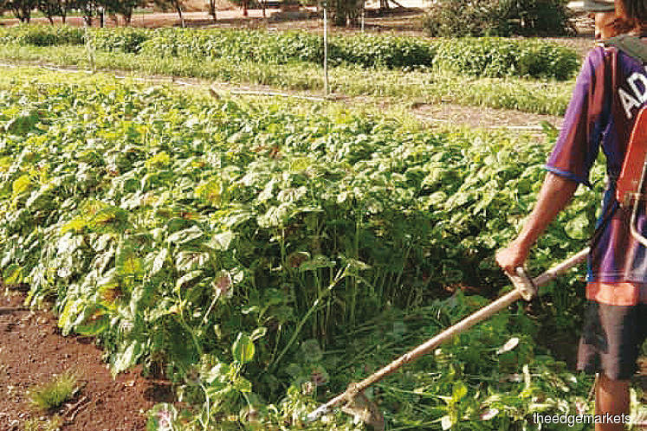
Supplementary Figure 10 A worker destroying vegetables that cannot be sold (Surendran, 2020).
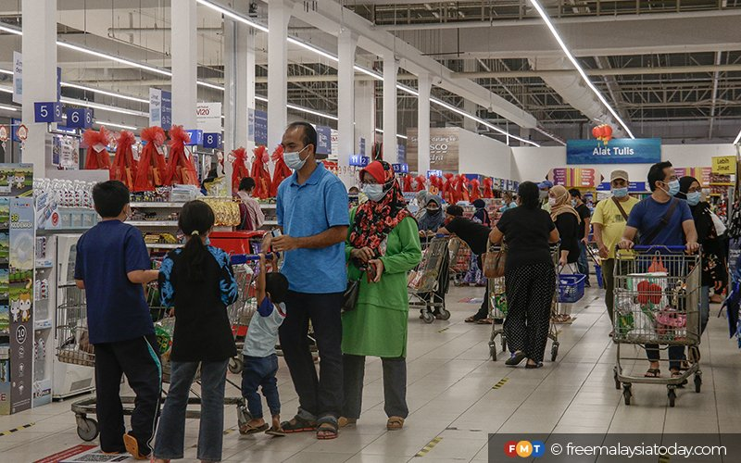
Supplementary Figure 11 People crowding at a grocery store following announcements of a MCO (Free Malaysia Today, 2021).

