Supplementary Material

Supplementary Figures and Tables

Supplementary Figures
Supplementary Figure 1. The numbers of reported CAE in Fuwai hospital between 2009 to 2015. CAE = coronary artery ectasia; CAG = coronary artery angiography.
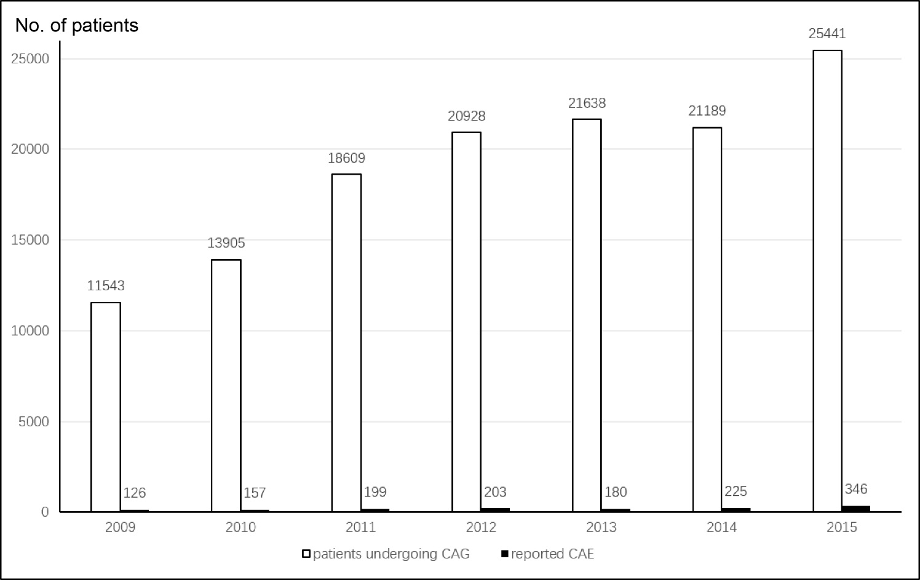

Supplementary Figure 2. Receiver operating characteristic (ROC) curve of plasma big ET-1 (A) and diffuse dilation (B) and a combination of diffuse dilation and big ET-1 (C) for predicting 5-year MACE.

Supplementary Figure 3. the potential effects of ET-1 on vascular endothelial cells, vascular smooth muscle cells and fibroblasts in the pathogenesis of vascular disease. ET: endothelin. MMP: matrix metalloproteinase.
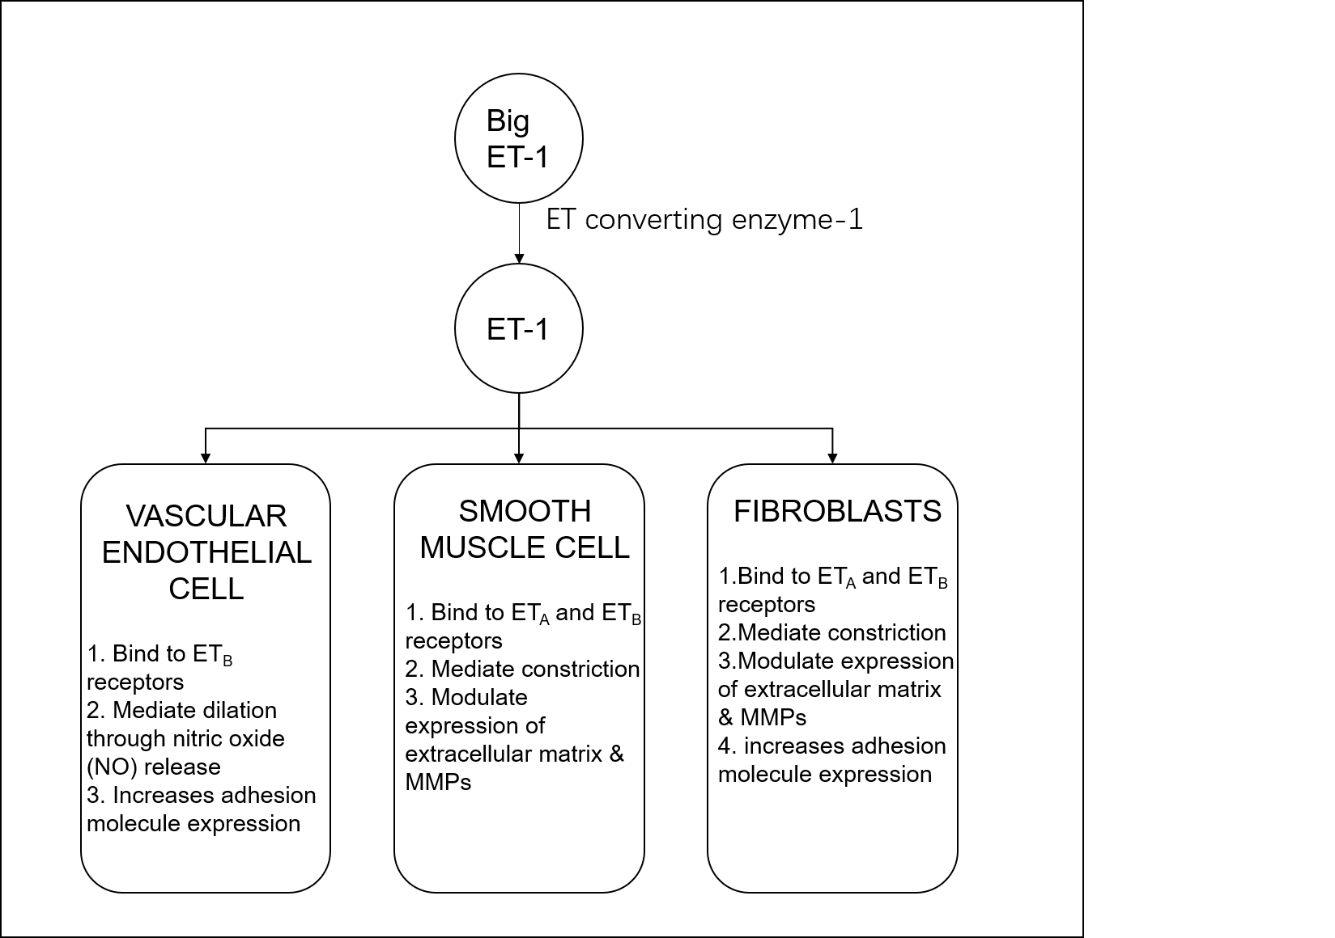

Supplementary Tables
Supplementary Table 1. Coronary artery reference diameter in 231 age-sex-matched angiographically normal subjects.
Coronary artery segment | reference diameter (mm)
Right coronary artery
Proximal | 3.7±0.6
Middle | 3.1±0.5
Distal | 2.8±0.5
Posterior descending | 1.7±0.4
Posterolateral branch | 1.9±0.4
Left anterior descending artery
Proximal | 3.2±0.6
Middle | 2.8±0.5
Distal | 2.0±0.4
Left circumflex artery
Proximal | 3.1±0.6
Distal | 2.4±0.4
Obtuse marginal | 1.9±0.5
Left main | 4.4±0.6
Values are mean ± SD.

