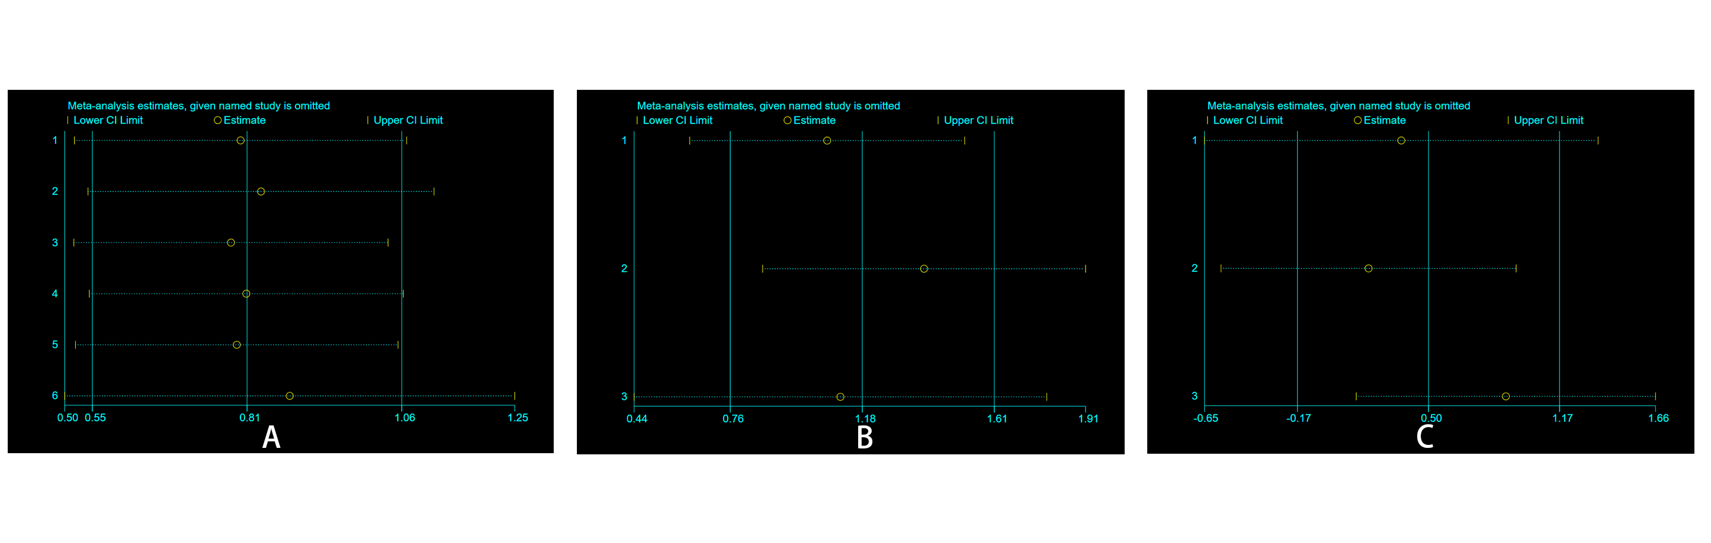
Supplement Fig. 1: Effect of individual studies on the combined HR, including TTV for PFS (A), the TTV for OS (B), and the TL-SSTR for PFS (C). HR: hazard ratio; TTV: total tumor volume; TL-SSTR: total-lesion somatostatin receptors expression OS: overall survival; PFS: progression-free survival.

