Supplementary Material

Supplementary Figures and Tables

Supplementary Figures

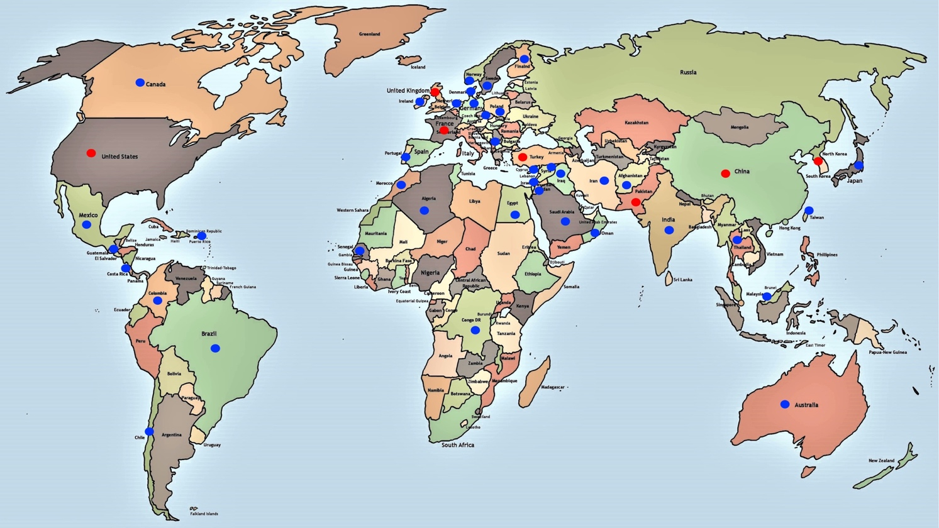
Supplementary Figure 1: Global distribution of AI cases. In the red circle, the countries with the highest frequency of described cases are highlighted; in the following order: Turkey (56), United States (30), France (24), Pakistan (19), Korea (16), China (15) and United Kingdom (14). The blue circles represent the rest of the countries in the world where AI cases have been found with a range of 1 to 9. (https://www.mapamundiparaimprimir.com/wp-content/uploads/2018/07/mapa-mundi-politico-con-nombres.jpg)

Supplementary Tables

Supplementary Table 1: Genes that participate in isolated and syndromic AI, inheritance patterns and associated type and subtype of AI.
GENE NAME | INHERITANCE | TYPE/SUBTYPE OF AI
ACP4, Acid Phosphatase 4 | AR | Hypoplastic AI
AMBN, Ameloblastin | AR/AD | Hypoplastic AI
AMELX, Amelogenin | X-LD | Hypoplastic/hypomaturation AI
AMTN, Amelotin | AD | Hypomineralized AI
COL17A1, Type I collagen alpha 1 chain | AD | Hypoplastic AI Hypoplastic/hypomaturation AI
ENAM, Enamelin | AD/AR | Localized Hypoplastic AI  Generalized Hypoplastic AI
FAM83H, Family with sequence similarity 83, member H | AD | Hypocalcified AI
GPR68, G-protein coupled receptor | AR | Hypomaturation AI
ITGB6, Integrin beta 6 chain | AR | Hypoplastic AI
KLK4, Peptidase 4 related with Kallikrein | AR | Hypomaturation AI
LAMA3, Laminin alpha 3 chain | AD | Hypoplastic AI
LAMB3, Laminin beta 3 chain | AD | Hypoplastic AI
MMP20, Metalloprotease 20 | AR | Hypomaturation AI  Hypoplastic/hypomaturation
ODAPH, Odontogenesis Associated Phosphoprotein | AR | Hypomineralized AI  Hypomineralized/hypoplastic AI
RELT, Receptor Expressed in Lymphoid Tissues | AR | Hypoplastic AI  Hypomineralized AI
SLC24A4, Solute carrier family 24, member A4 | AR | Hypomaturation AI
SP6, Factor de especificidad 6 | AD | Hypoplastic AI
GENE /SYNDROME OR PATHOLOGY | INHERITANCE | TYPE/SUBTYPE OF AI
CLDN16, Claudina 16  Familial hypomagnesemia with hypercalciuria and nephrocalcinosis | AR | Hypoplastic AI
CLDN19, Claudina 19  Familial hypomagnesemia with hypercalciuria and nephrocalcinosis | AR | Hypoplastic AI  Hypomaturation AI
CNNM4, Ancient conserved domain protein 4  Jalili Syndrome | AR | Hypoplastic AI  Hypomaturation AI  Hypomaturation/hypoplastic AI
DLX3, Distal Less 3  Tricho Dento Osseous Syndrome. | AD | Hypoplastic AI  Hypoplastic/hypomaturation AI
FAM20A, Family with sequence similarity 20, member A  Enamel renal gingival Syndrome | AR | Hypoplastic AI
LTBP3, Latent growth factor binding protein 3  AI with Brachyolmia | AR | Hypoplastic AI
SLC10A7, Solute transporter of family 10, member A7  AI with eskeletal dysplasia. | AR | Hypomineralized AI
STIM1, Stromal interaction molecule 1  Syndromic AI | AR | Hypomaturation AI
TP63, Tumoral protein 63  Ectodermal dysplasia | AD | Hypoplastic/hypomaturation AI
WDR72, Protein 72 with repeats WD  AI with Distal renal tubular acidosis (dRTA). | AR | Hypomaturation AI  Hypoplastic/hypomineralized AI

Supplementary Table 2: Countries with the highest number and percentage of mutations in the five continents.
COUNTRY | Nº MUTATIONS | %
Turkey | 56 | 18,4
Estados Unidos | 30 | 9,9
France | 24 | 7,9
Pakistan | 19 | 6,3
Korea | 16 | 5,3
China | 15 | 4,9
United Kingdom | 14 | 4,6
Thailand | 9 | 3,0
Costa Rica | 6 | 2
Brazil | 6 | 2
Morocco | 3 | 1
Australia | 2 | 0,66
TOTAL | 200 | 65,9

Supplementary Table 3: Number and percentage of mutations by continent.

CONTINENT | Nº MUTATIONS | %
ASIA | 153 | 50,3
EUROPE | 61 | 20,1
NORTH AMERICA | 31 | 10,2
CENTRAL AMERICA | 11 | 3,6
SOUTH AMERICA | 8 | 2,6
AFRICA* | 9 | 3,0
OCEANIA | 2 | 0,7
N. D.** | 29 | 9,5
TOTAL | 304 | 100,0
* Una ethnicity is african.
** To 29 ethnicities, marked as N. D., no continent could be assigned to them.

Supplementary Table 4: Summary that relates the categorization of the AI genes with their specificity. Genes marked in bold and blue color show association with cancer.

SPECIFICITY | % SPECIFICITY (RANK) | GENE | GENE CATEGORY
Totally specific | 100 | ACP4  AMTN  MMP20  ODAPH  RELT  SLC24A4  SP6 | CATEGORY 1  Genes with causal mutations of isolated or non-syndromic AI.
Very specific | 97-92 | AMELX  ENAM  FAM83H | CATEGORY 3  Genes with causal mutations of isolated AI and mutations responsible for other pathologies/conditions.
Medium specific | 83-50 | GPR68  AMBN  ITGB6 | CATEGORY 3
 |  | WDR72 | CATEGORY 5  Gene with causal mutations of isolated AI, AI associated with syndromes and other pathologies/conditions.
Few specific | 40-3 | COL17A1  KLK4 LAMA3  LAMB3 | CATEGORY 3
Non-specific | 0 | CNNM4  DLX3  FAM20A | CATEGORY 2  Genes with causal mutations of syndromic AI.
 |  | CLDN16  CLDN19  LTBP3  SLC10A7  STIM1  TP63 | CATEGORY 4  Genes with causal mutations of syndromic AI and mutations responsible for other pathologies/conditions.

