Supplementary Material

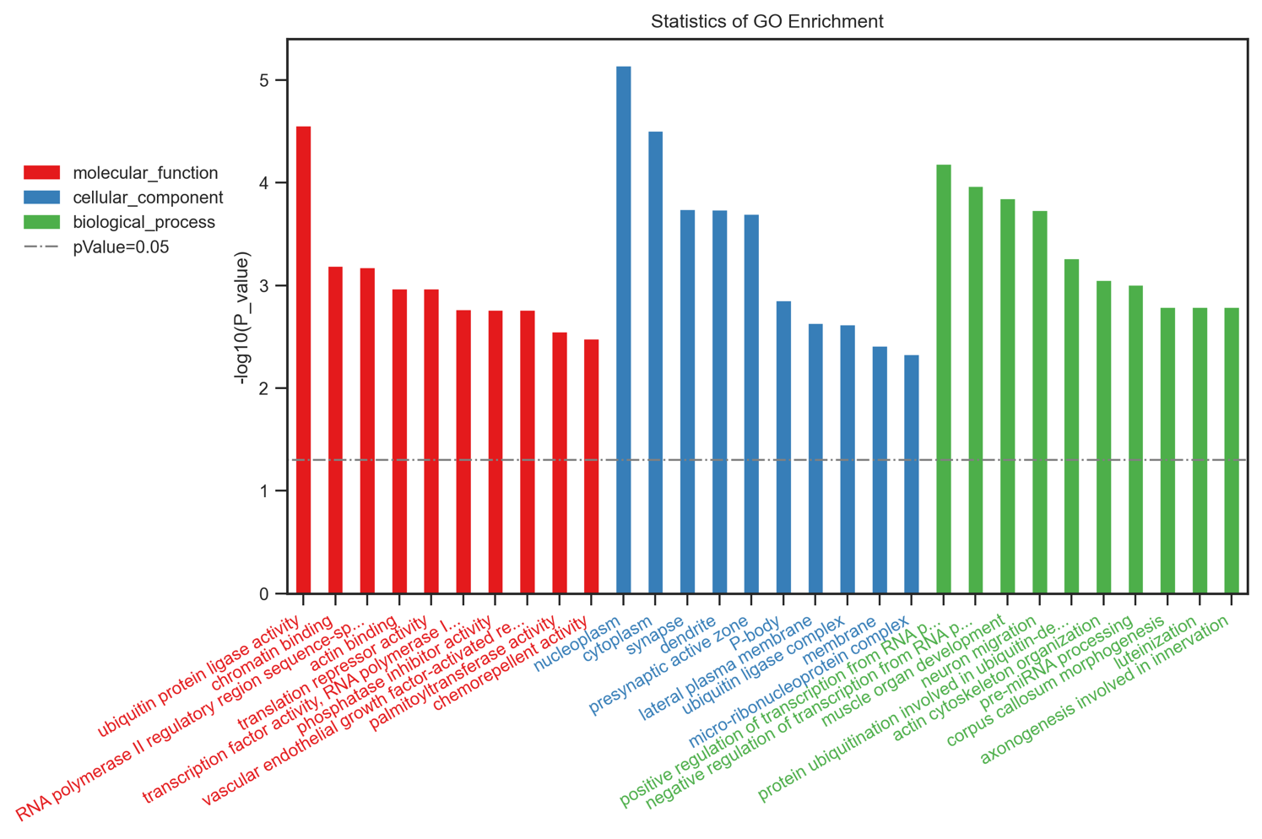
Supplementary Figure 1. Gene Ontology analysis of targets from differentially expressed miRNAs. The figure legends are required to have the same font as the main text, Data are shown as -log10 of P value for each term using Student's t-test. The Red bars showed molecular function terms; The Blue bars showed cellular component terms; The Green bars showed biological process.

