Supporting Information
A Novel Conductive Antibacterial Nanocomposite Hydrogel Dressing for Healing of Severely Infected Wounds

Lizhi Xiao^{a, #}, Fang Hui^{a, #}, Tenghui Tianª, Ruyue Yanª, Jingwei Xin^{b}, Xinyu Zhaoª, Yingnan Jiang^{a, *}, Zhe Zhang^{a, *}, Yulan Kuangª, Na Li^{c}, Yu Zhao^{a, *} and Quan Lin^{b}

#These authors contributed to the work equally and should be regarded as co-first author.
ª Jilin Ginseng Academy; Hospital of Affiliated Changchun University of Chinese Medicine, Changchun University of Chinese Medicine, Changchun, 130117, P. R. China;
^{b} State Key Laboratory of Supramolecular Structure and Materials, College of Chemistry; Chinese-Japan Union Hospital of Jilin University, Jilin University, Changchun, 130012, P. R. China;
^{c} Key Laboratory of Songliao Aquatic Environment of Ministry of Education, Jilin Jianzhu University, Changchun, 130118, P. R. China.

Corresponding Authors
*Y. J.: e-mail, jiangyn@ccucm.edu.cn
*Y. Z.: e-mail, cnzhaoyu1972@126.com
*Z. Z.: e-mail, zhangzhe@ccucm.edu.cn

Fig. S1 TEM image of the prepared Ag NPs.

Fig. S2 (A) The tested diagram between hydrogel compressive strain and compressive stress under the different reaction concentrations of PVA (wt 5%, 7.5%, 10% and 12.5%) of the prepared hydrogels. (B) The tested diagram between hydrogel tensile strain and tensile stress under the different reaction concentrations of PVA (wt 5%, 7.5%, 10% and 12.5%) of the prepared hydrogels.

Fig. S3 G' (Storage modulus) and G'' (Loss modulus) dependence vs time in continuous step strain measurements at the different reaction concentrations of PVA (A wt 5%, B wt 7.5%, C wt 10%, and D wt 12.5%) of the prepared hydrogels.

Fig. S4 The strain amplitude sweeps of hydrogels with the different reaction concentrations of PVA: A wt 5%, B wt 7.5%, C wt 10%, and D wt 12.5%.

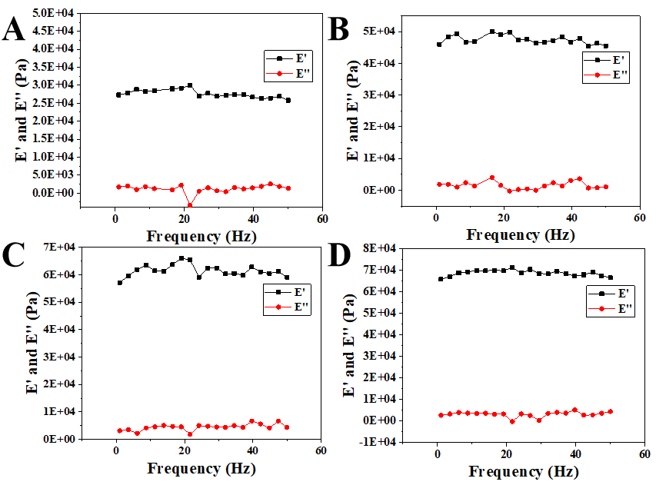
Fig. S5 The test diagram of dynamic storage modulus (E') and loss modulus (E'') of prepared PVP@Ag NPs/CPH with different PVA concentrations: (A) 5 wt%, (B) 7.5 wt%, (C) 10 wt%, and (D) 15 wt%, from 0 - 50 Hz.
The E' of the hydrogels raises with the increasing of the PVA reaction concentration.

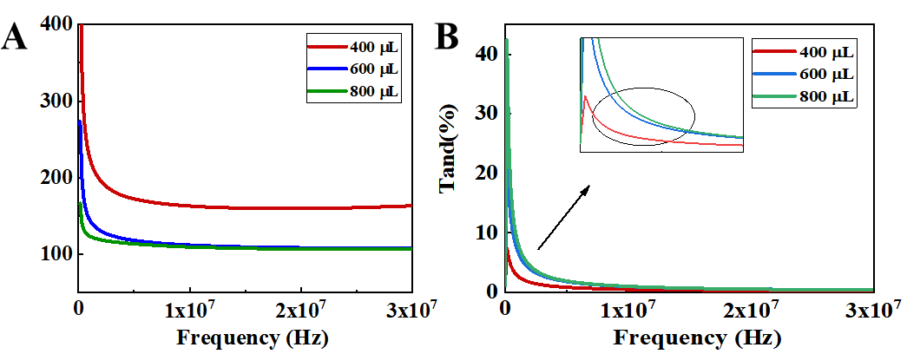
Fig. S6 The dielectric constant of PVP@Ag NPs/CPH with different AN content: (A) is the real part; and (B) is the imaginary part of the dielectric constant.

Fig. S7 G' (Storage modulus) and G'' (Loss modulus) dependence of time in continuous step strain measurements for hydrogels with the different gelatin contents: (A) 0.5 wt%, (B) 1 wt%, (C) 1.5 wt%, (D) 2 wt%, (E) 2.5 wt%, and (F) 3 wt%.

Fig. S8 The strain amplitude sweep of hydrogels with the different gelatin contents: (A) 0.5 wt%, (B) 1 wt%, (C) 1.5 wt%, (D) 2 wt%, (E) 2.5 wt%, and (F) 3 wt%.

Fig. S9 (A) Images of the flowing Ag NPs/CPH sol (left) without freeze-thawing, and the immobile Ag NPs/CPH gel (right) after freeze-thawing at room temperature. (B) Images of the Ag NPs/CPH material with different shapes, using the same molds for freeze-thawing.

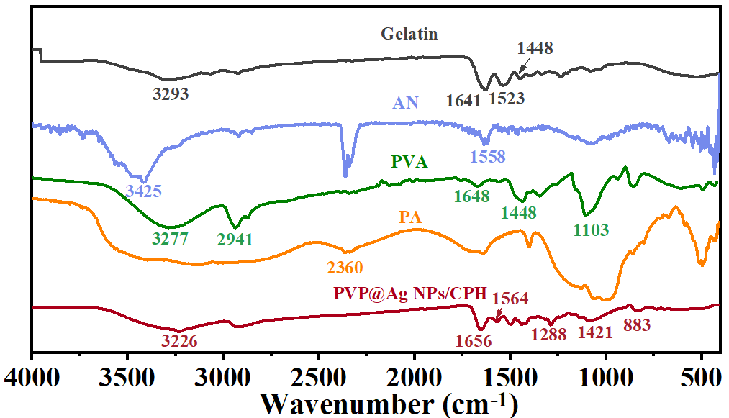
Fig. S10 FTIR spectra of gelatin (black line), AN (purple line), PVA (green line), PA (orange line), and PVP@Ag NPs/CPH (red line), respectively.

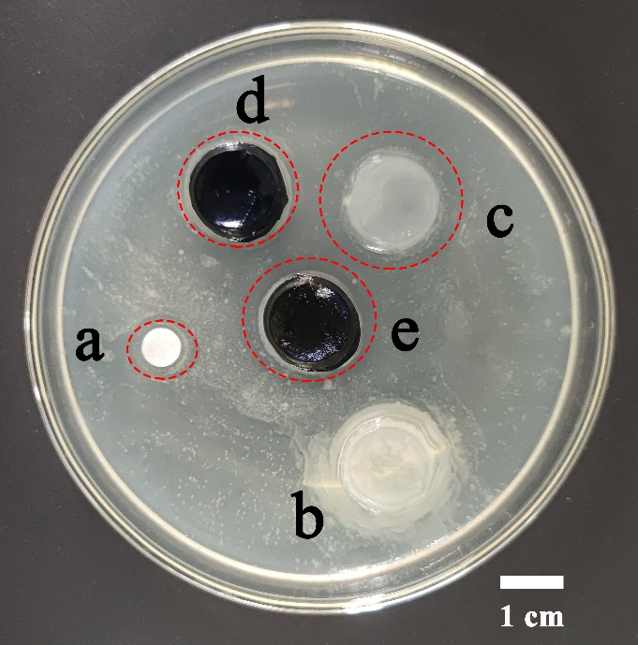
Fig. S11 Photo of the antibacterial plate experiment (S. aureus) for the nanocomposite hydrogel: a. Ag NPs group, b. PVA and gelation group, c. PVA, gelatin and Ag NPs group, d. CPH group, and e. Ag NPs/ CPH group.
Both Ag NPs/ CPH group and gelatin and Ag NPs group have obvious inhibition zones, as well as the Ag NPs group. It shows that the antibacterial effect of Ag NPs plays a leading role;
The CPH group has a smaller inhibition zone, which may be derived from the surface antibacterial effect of polyaniline;
PVA and gelation group does not have any antibacterial zone, and even the bacteria grow up near the patch;
It indicates that the main antibacterial effect of Ag NPs/CPH comes from Ag NPs, while polyaniline plays an auxiliary antibacterial effect. And other components such like PVA and gelation have no antibacterial activity.

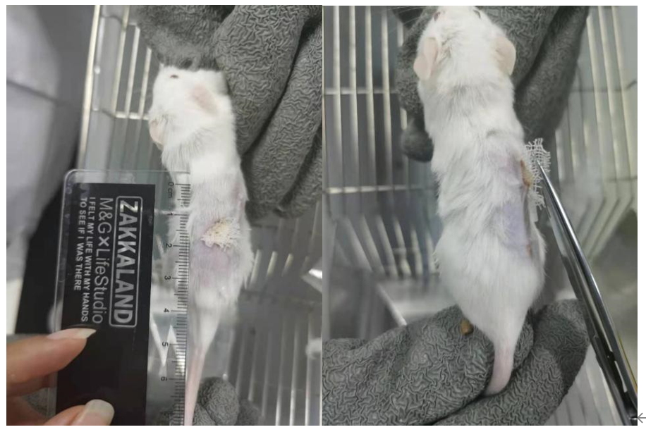
Fig. S12 Photos of gauze adhesion near the wound of the mice in the control group.

