Supplementary Material
Table S1. Anatomical ROIs generated based on the AAL parcellation. Each of the 45 labels contains ROIs in both left and right hemispheres, which yield a total of 90 ROIs.
Precentral gyrus | Lingual gyrus
Superior frontal gyrus (dorsal) | Superior occipital gyrus
Orbitofrontal cortex (superior) | Middle occipital gyrus
Superior frontal gyrus (medial) | Inferior occipital gyrus
Orbitofrontal cortex (medial) | Fusiform gyrus
Middle frontal gyrus | Postcentral gyrus
Orbitofrontal cortex (middle) | Superior parietal gyrus
Inferior frontal gyrus (opercula) | Inferior parietal lobule
Inferior frontal gyrus (triangular) | Supramarginal gyrus
Orbitofrontal cortex (inferior) | Angular gyrus
Rolandic operculum | Precuneus
Supplementary motor area | Paracentral lobule
Olfactory | Caudate
Rectus gyrus | Putamen
Insula | Pallidum
Anterior cingulate gyrus | Thalamus
Middle cingulate gyrus | Heschl gyrus
Posterior cingulate gyrus | Superior temporal gyrus
Hippocampus | Temporal pole (superior)
Parahippocampal gyrus | Middle temporal gyrus
Amygdala | Temporal pole (middle)
Calcarine cortex | Inferior temporal gyrus
Cuneus

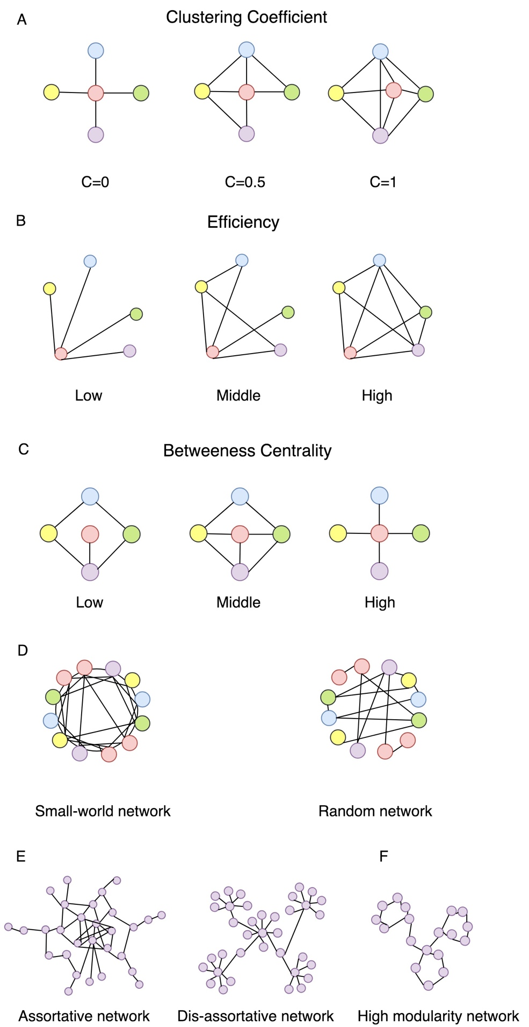
Figure S1. Topological parameters of graph theory: (A) Clustering Coefficient: a measure of degree to which nodes in a graph tend to cluster together; (B) Efficiency: the average inverse shortest path length in the network; (C) Betweeness Centrality: the fraction of all shortest paths in the network that contain a given node; (D) Small-world network: a class of network that is highly clustered, yet has small characteristic path lengths, like random networks; (E) Assortativity: how often nodes with a certain degree are linked to nodes with a similar degree; (F) Modularity: a subset of vertices in a graph that have higher connections with each other than with the rest of the network.

The mathematical definitions of graph network parameters:
- For a given graph N composed of n nodes, the Degree of a node “i” is defined as:
$$k_{i}=\sum_{j∈N}{a_{ij}}$$
where a_{ij} is the connection status between node i and j: a_{ij} = 1 if link exist, otherwise a_{ij} = 0.
- The Clustering coefficient represents how many nearest neighbors of node i are connected to each other as well, and is defined as ¹:
$$C_{i}=\sum_{i∈N}{\frac{2t_{i}}{k_{i}(k_{i}-1)means}}$$
where t_{i} is the number of triangles around a node i.
- The Local efficiency represents the efficiency of the local sub-graph of a node i that contains only the direct neighbors of node i, and is defined as ²:
$$E_{loc,i}=\frac{\sum_{j,h∈N, j≠i}{a_{ij}a_{ih}{\left[d_{jh}(N_{i})\right]}^{-1}}}{k_{i}(k_{i}-1)}$$
where d_{jh}(N_{i}) is the length of the shortest path between j and h which contains only neighbors of i.
- The Betweenness centrality is the fraction of all shortest paths in the network that pass through a given node i and is defined as ³:
$$b_{i}=\sum_{\begin{aligned}h,j∈N \\ h≠j, h≠i, j≠i\end{aligned}}{ \frac{ρ_{hj}(i)}{ρ_{hj}}}$$
where ρ_{hj} is the number of shortest paths between h and j, and ρ_{hj}(i) is the number of shortest paths between h and j that pass through i.
- The Characteristic path length is the average of all shortest paths between each possible pair in the network and defined as ¹:
$$L=\frac{1}{n}\sum_{i∈N}{L_{i}=\frac{1}{n}\sum_{i∈N}{\frac{\sum_{j∈N, j≠i}{d_{ij}}}{n-1}}}$$
where d_{ij} is the shortest path length (distance) between nodes i and j, and L_{i} is the average distance between node i and all other nodes.
- The Global efficiency is the average inverse shortest path length and defined as ²:
$$E=\frac{1}{n}\sum_{i∈N}{E_{i}}=\frac{1}{n}\sum_{i∈N}{\frac{\sum_{j∈N, j≠i}{d_{ij}^{-1}}}{n-1}}$$
where E_{i} is the efficiency of node i.
- To estimate the property of network Small-worldness, a matched random network with same number of nodes and edges as the real network was generated.
The Small-worldness represents the network with a higher local clustering but nearly the same characteristic path length as random networks, and is defined as the ratio of normalized clustering coefficient (γ=C / C_{rand}) and normalized characteristic path length (λ=L / L_{rand}) ¹:
$$σ=\frac{C/{C_{rand}}}{L/{L_{rand}}}$$
where C and L are the average Clustering coefficient and the Characteristic path length of real networks, and C_{rand} and L_{rand} indicate the means of random networks. In general, the Small-world topological organization should meet the criteria of γ > 1 and λ ≈ 1, or σ = γ / λ > 1 ⁴.
- The Modularity is a subset of vertices in a graph that have higher connections with each other than with the rest of the network and is defined as ⁵:
$$Q=\sum_{u∈M}{\left[e_{uu}-{\left(\sum_{v∈M}{e_{uv}}\right)}^{2}\right]}$$
where the network is fully segmented to a set of non-overlapping modules “M”. The modules u and v are the subsets in modules M, and e_{uv} is the number of all links that connect nodes in module u with nodes in module v.
- The Assortativity coefficient means how often nodes with a certain degree are linked to nodes with a similar degree and is defined as ⁶:
$$r=\frac{l^{-1}\sum_{(i,j)∈L}{k_{i}k_{j}-{\left[l^{-1}\sum_{(i,j∈L)}{\frac{1}{2}}\left(k_{i}+k_{j}\right)\right]}^{2}}}{l^{-1}\sum_{(i,j)∈L}{\frac{1}{2}\left(k_{i}^{2}+k_{j}^{2}\right)}-{\left[l^{-1}\sum_{(i,j)∈L}{\frac{1}{2}}\left(k_{i}+k_{j}\right)\right]}^{2}}$$
where l is the number of links between i and j.

Amplitude of Low-Frequency Fluctuation (ALFF)
After the preprocessing steps, we also calculated the square root of power spectrum of the R-fMRI temporal fluctuations, which is a marker for the intrinsic brain activity intensity in a voxel-wise manner. ALFF calculation was carried out using the REST toolkit, and the frequency range was set within 0.01-0.08 Hz (removing the very-low-frequency drift and high-frequency noise). However, the ALFF showed no significant difference of signal activation between the ESRD patients and the controls (Figure.S2).

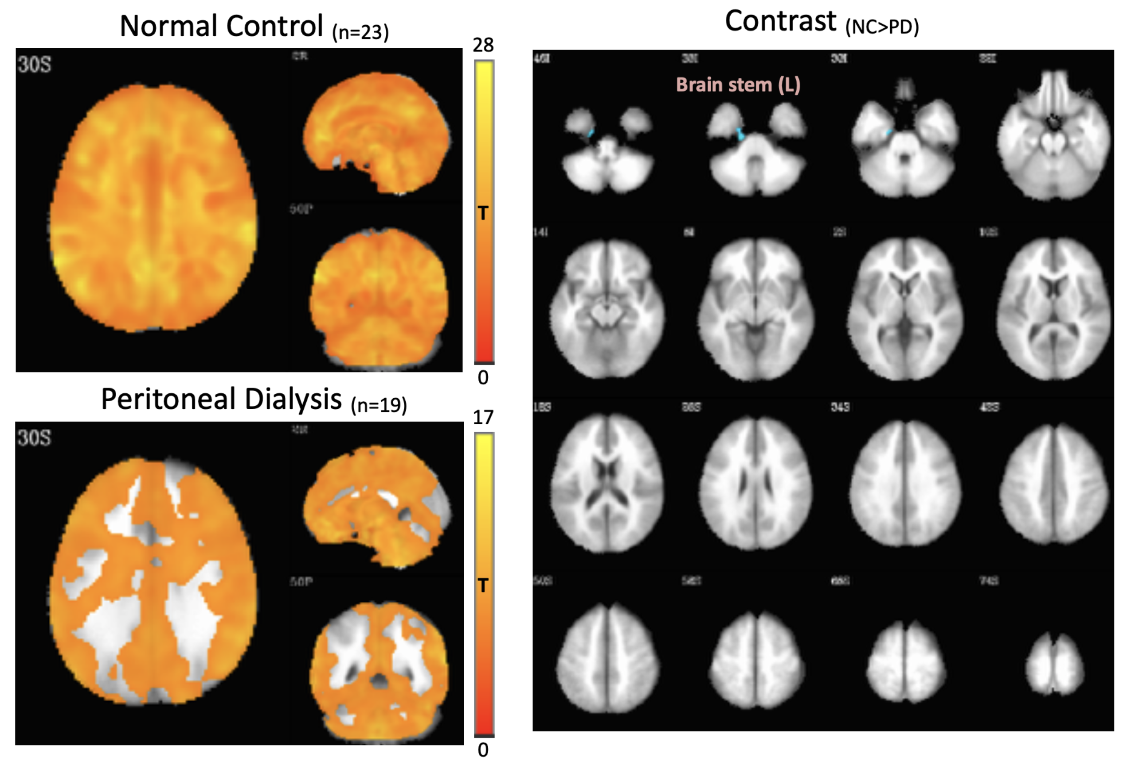
Figure S2. Amplitude of low-frequency fluctuations (ALFF) map of patients and controls. The connectivity map (FWE p < 0.05, cluster = 20 voxels) of either group is shown at the left side, and the contrast map (3dClustSim-corrected p < 0.05) at the right side. A trend of decreasing connectivity in PD patients is observed in the map (the left row), but no obvious significance is seen compared with controls (the right row, contrast map).

Table S2. Duration of receiving peritoneal dialysis (PD) therapy for each end stage renal disease (ESRD) patient
Patient | Gender | Age | Duration  (years)
1 | M | 41 | 1
2 | M | 47 | 6
3 | F | 70 | 1
4 | M | 30 | 1
5 | M | 75 | 9
6 | M | 34 | 2
7 | F | 48 | 7
8 | F | 65 | 2
9 | F | 26 | 2
10 | M | 49 | 6
11 | M | 58 | 2
12 | M | 41 | 16
13 | F | 37 | 3
14 | F | 59 | 2
15 | M | 51 | 3
16 | F | 56 | 7
17 | F | 55 | 4
18 | F | 51 | 5
19 | F | 53 | 1
M, male; F, female.

Table S3. Correlation Between Uric Acid and Graph Analysis Metrics
Group | Lab data vs. Graph Metrics | r (95% CI) | R² | p
PD | Uric Acid vs. Betweenness Centrality | <0.01 (-0.45 to 0.45) | <0.01 | 0.98
 | Uric Acid vs. Characteristic Path Length | -0.14 (-0.56 to 0.34) | 0.02 | 0.58
 | Uric Acid vs. Global Efficiency | 0.29 (-0.19 to 0.66) | 0.08 | 0.23
All | Uric Acid vs. Betweenness Centrality | -0.11 (-0.40 to 0.19) | 0.01 | 0.47
 | Uric Acid vs. Characteristic Path Length | -0.02 (-0.31 to 0.29) | <0.01 | 0.92
 | Uric Acid vs. Global Efficiency | -0.20 (-0.47 to 0.10) | 0.04 | 0.19
PD, peritoneal dialysis; r, Pearson correlation coefficient; CI, confident interval;
All, peritoneal dialysis patients plus controls

