SUPPLEMENTARY MATERIALS
Table 1 A – European sprat: landing data from year 2004 to year 2019 divided by country. Italian data and Croatian data since 2013 are from the EU-DCF (DCF, 2017); Croatian data from 2009 to 2012 refers to Eurostat (Eurostat, 2012) and Croatian data in red are estimated.
Year | Italian catch  (tonnes) | Croatian catch  (tonnes)
2004 | 80.41 | 54.14
2005 | 142.19 | 95.74
2006 | 86.59 | 58.30
2007 | 105.23 | 70.85
2008 | 121.98 | 82.13
2009 | 123.90 | 89.10
2010 | 163.00 | 110.80
2011 | 99.73 | 61.94
2012 | 35.07 | 146.11
2013 | 97.13 | 72.84
2014 | 138.83 | 47.83
2015 | 82.88 | 43.59
2016 | 54.63 | 46.20
2017 | 57.21 | 82.42
2018 | 154.92 | 49.38
2019 | 102.05 | 67.94

Table 2 A – Horse mackerels: landing data from 1970 to 2019 divided by country. Italian data from 1970 to 2003 are from Fortibuoni et al. (2018), since 2004 are from EU-DCF (EC, 2017). Croatian data from 1970 to 2012 are from the FishStatJ database (FAO-GFCM, 2019), whereas from 2013 to 2019 are from EU-DCF (EC, 2017).
Year | Italian catch data  (in tonnes) | Croatian catch data  (in tonnes)
1970 | 1063.30 | 346.00
1971 | 1378.49 | 1894.00
1972 | 1682.06 | 1154.00
1973 | 1968.23 | 626.00
1974 | 2254.40 | 384.00
1975 | 2505.34 | 491.00
1976 | 2432.00 | 445.00
1977 | 2497.00 | 389.00
1978 | 1967.00 | 692.00
1979 | 2103.00 | 1151.00
1980 | 2783.00 | 1268.00
1981 | 2696.90 | 1276.00
1982 | 2800.20 | 1333.00
1983 | 2065.60 | 1213.00
1984 | 2727.90 | 1208.00
1985 | 2631.60 | 2189.00
1986 | 2876.10 | 1779.00
1987 | 3034.00 | 1106.00
1988 | 2489.70 | 836.00
1989 | 2445.70 | 860.00
1990 | 1929.30 | 905.00
1991 | 2553.00 | 517.00
1992 | 1829.40 | 589.00
1993 | 1527.50 | 787.00
1994 | 1531.20 | 566.00
1995 | 1138.20 | 453.00
1996 | 1350.20 | 361.00
1997 | 861.70 | 336.00
1998 | 727.00 | 200.00
1999 | 820.90 | 90.00
2000 | 553.10 | 75.00
2001 | 738.80 | 192.00
2002 | 403.00 | 84.00
2003 | 455.20 | 112.00
2004 | 1213.13 | 264.00
2005 | 1053.28 | 569.00
2006 | 1090.19 | 590.00
2007 | 1186.13 | 550.00
2008 | 849.35 | 360.50
2009 | 884.08 | 314.82
2010 | 842.55 | 394.19
2011 | 871.63 | 367.67
2012 | 744.38 | 314.76
2013 | 408.66 | 281.03
2014 | 432.19 | 234.53
2015 | 374.48 | 437.03
2016 | 292.32 | 988.13
2017 | 310.51 | 915.41
2018 | 341.88 | 1463.51
2019 | 365.81 | 1581.63

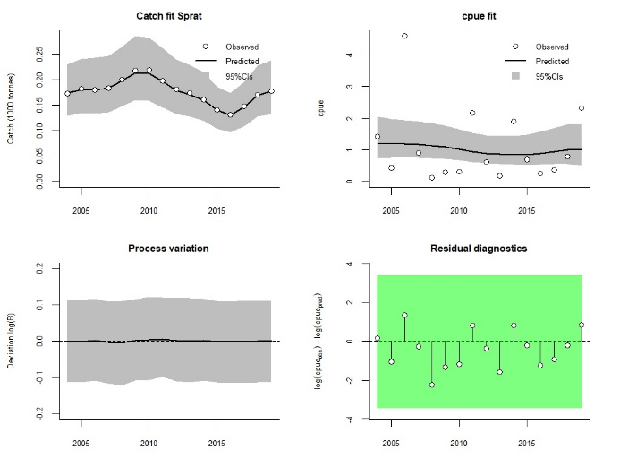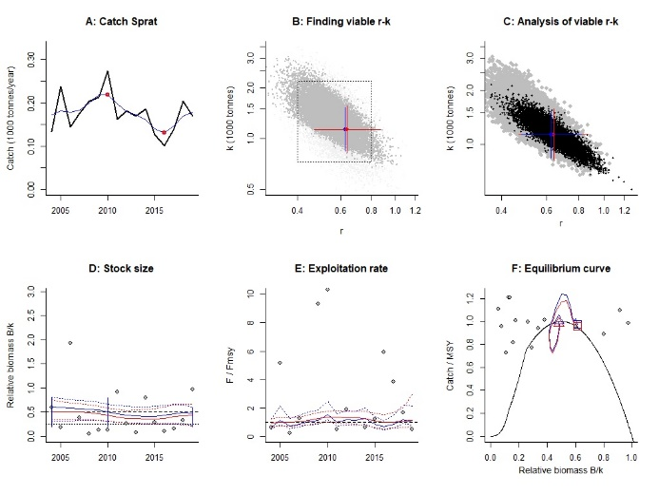
Figure 1A – European sprat in GSA 17 – CMSY model: fitting (left panel) and diagnostics (right panel).

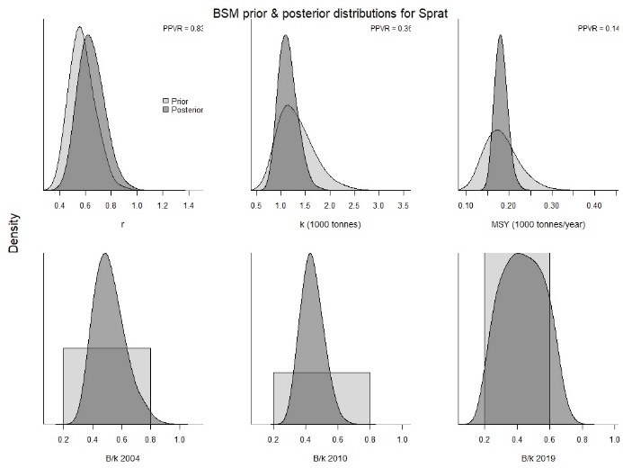
Figure 2A - European sprat in GSA 17 – Marginal posterior distributions along with prior densities. The lower the prior-posterior variance ratio (PPVR), the more the posterior knowledge is improved relative to prior knowledge

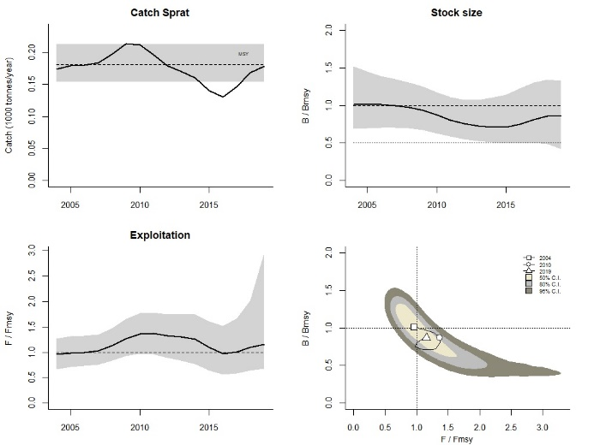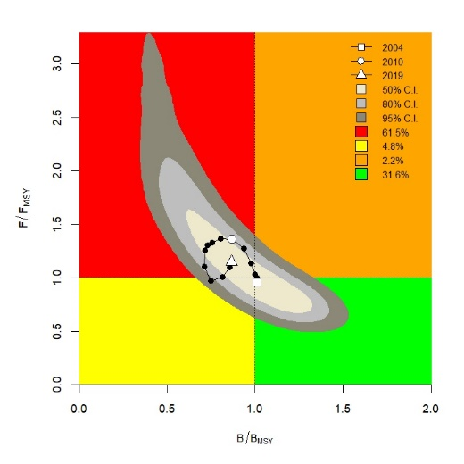
Figure 3A – European sprat in GSA 17 – CMSY model: output (left panel) and the Kobe pot (right panel).

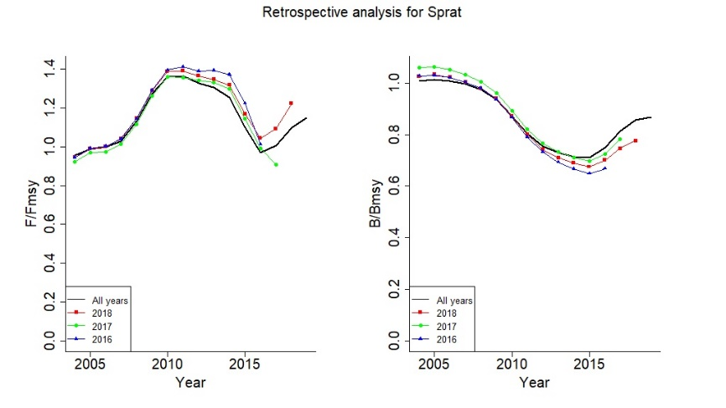
Figure 4A – European sprat in GSA 17 - CMSY model: retrospective analysis.

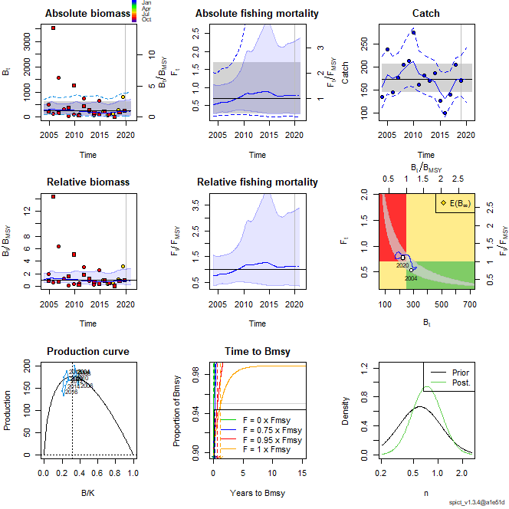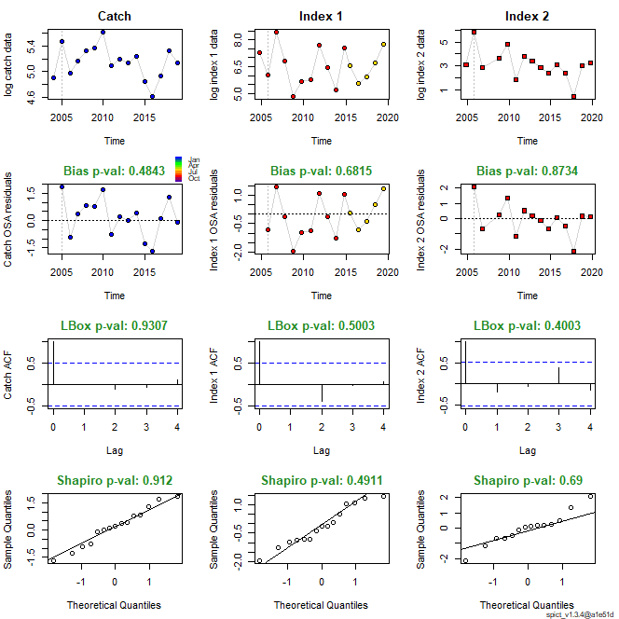
Figure 5A – European sprat in GSA 17 - SPiCT model: output (left panel) and relative diagnostics (right panel).

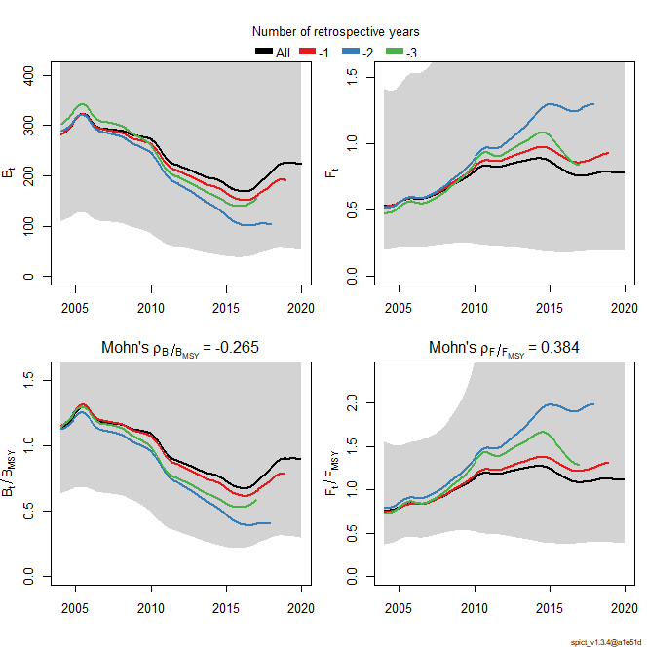
Figure 6A – European sprat in GSA 17 – SPiCT model: retrospective analysis.

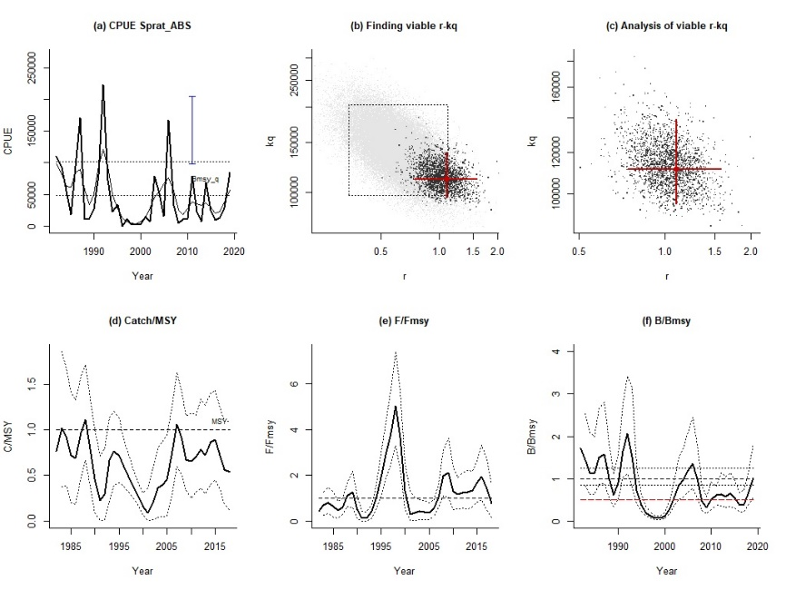
Figure 7A – European sprat in GSA 17 – AMSY model: output and diagnostics.

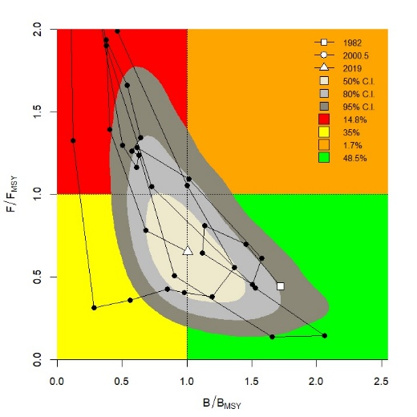
Figure 8A – European sprat in GSA 17 – AMSY model: the Kobe plot.

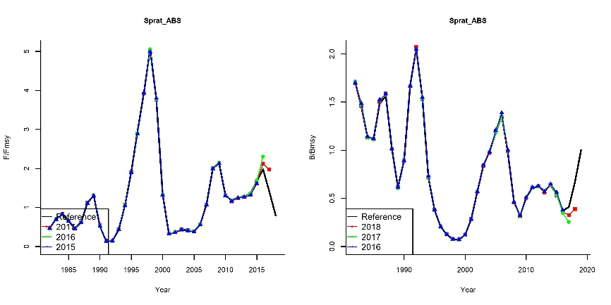
Figure 9A – European sprat in GSA 17 – AMSY model: retrospective analysis.

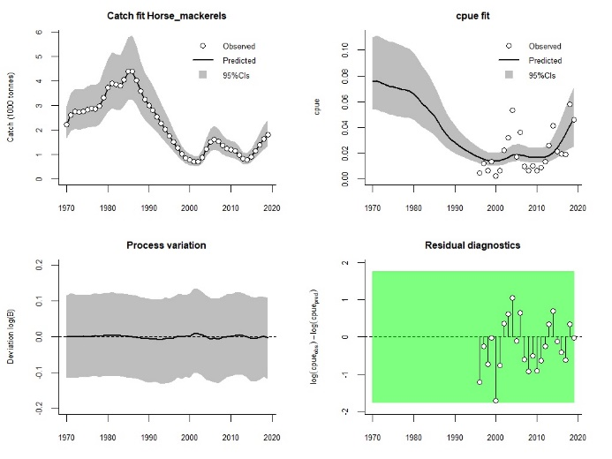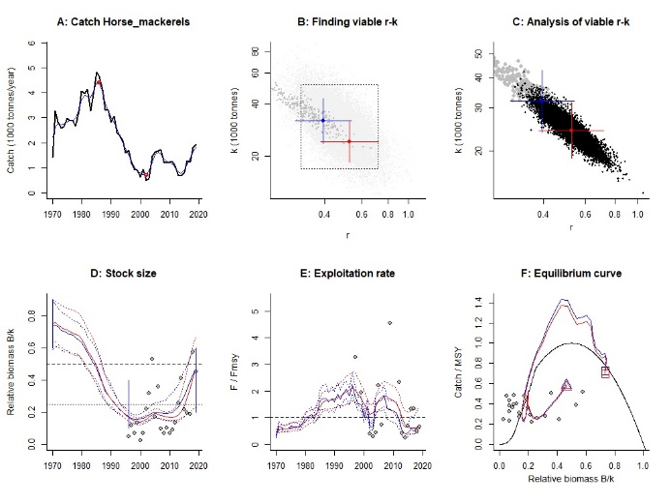
Figure 10A – Horse mackerels in GSA 17 – CMSY model: fitting (left panel) and diagnostics (right panel).
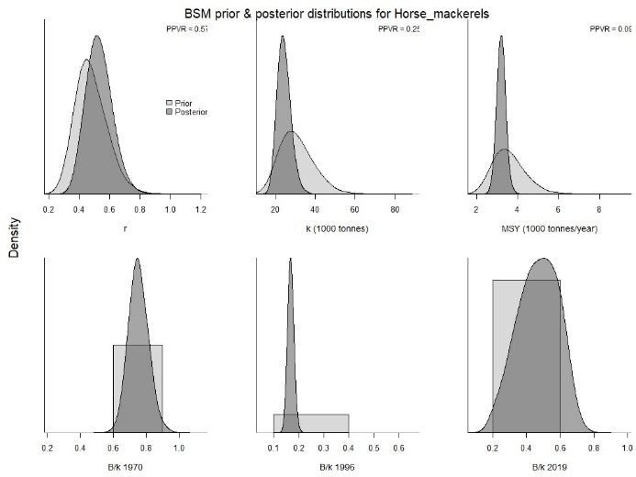
Figure 11A - Horse mackerels in GSA 17 – Marginal posterior distributions along with prior densities. The lower the prior-posterior variance ratio (PPVR), the more the posterior knowledge is improved relative to prior knowledge

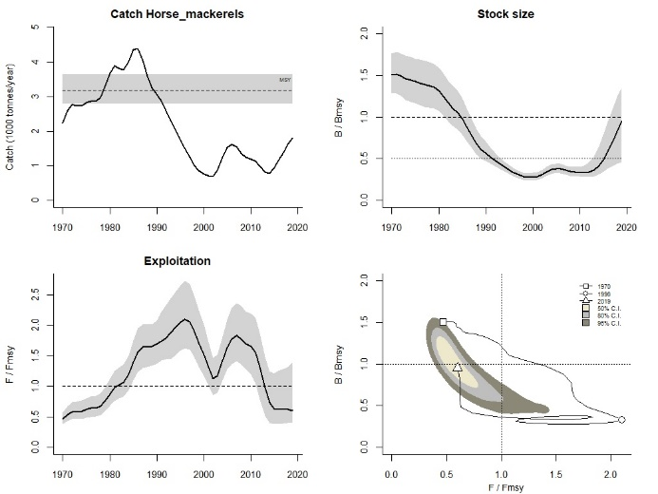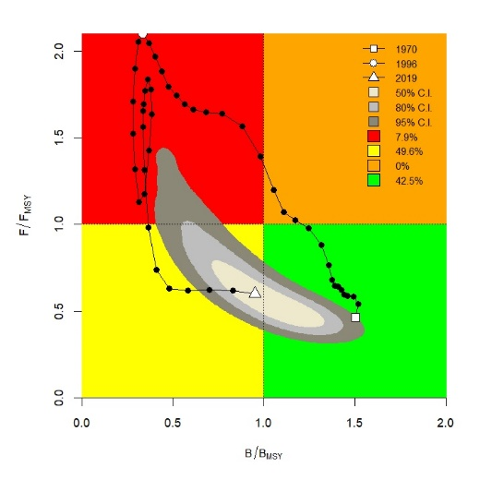
Figure 12A – Horse mackerels in GSA 17 – CMSY model: output (left panel) and the Kobe pot (right panel).

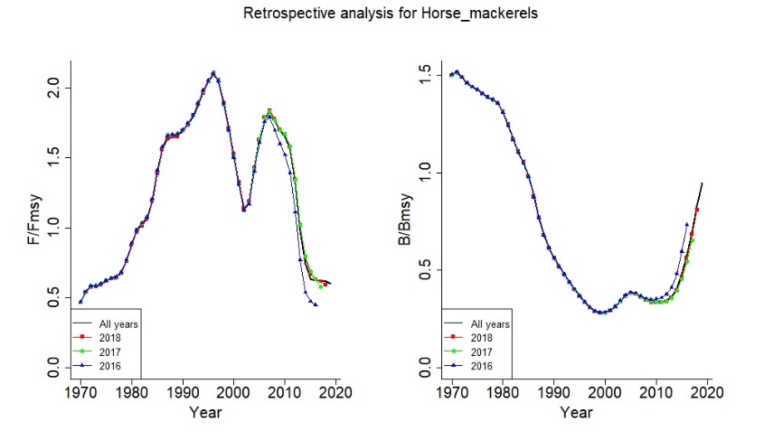
Figure 13A – Horse mackerels in GSA 17 - CMSY model: retrospective analysis.

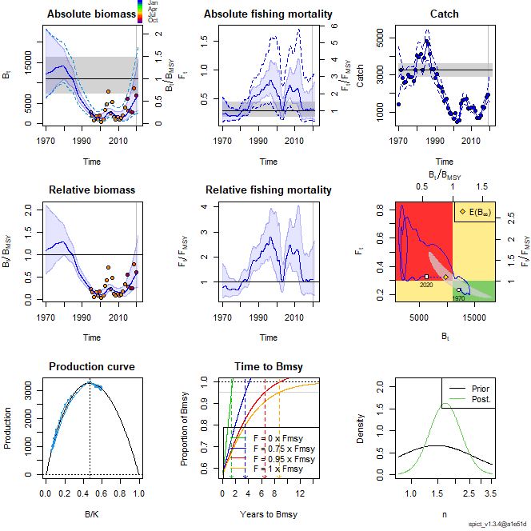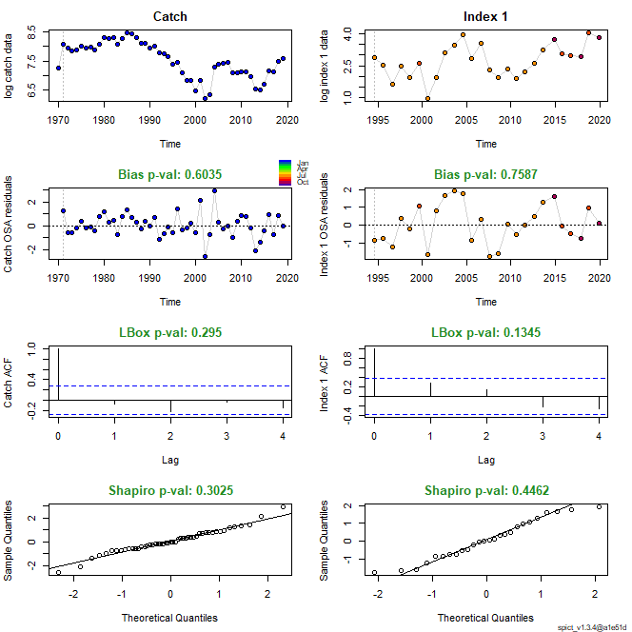
Figure 14A – Horse mackerels in GSA 17 - SPiCT model: output (left panel) and relative diagnostics (right panel).

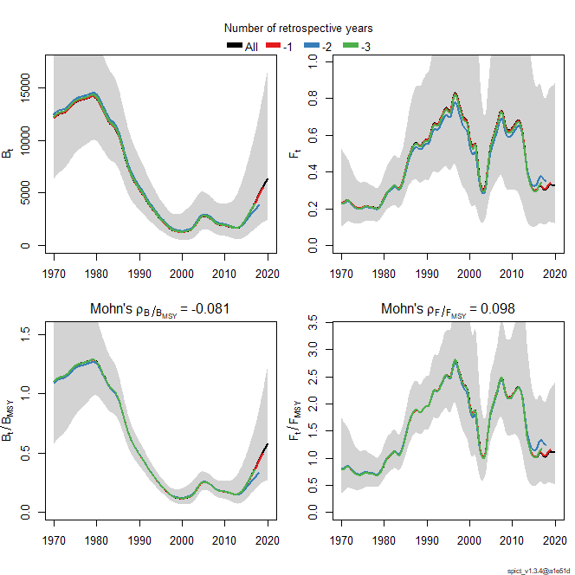
Figure 15A – Horse mackerels in GSA 17 – SPiCT model: retrospective analysis.

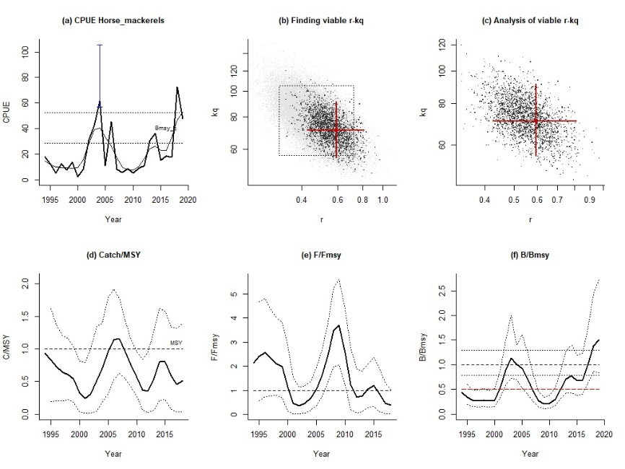
Figure 16A – Horse mackerels in GSA 17 – AMSY model: output and diagnostics.

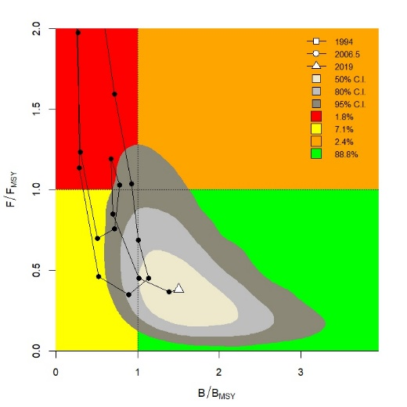
Figure 17A – Horse mackerels in GSA 17 – AMSY model: the Kobe plot.

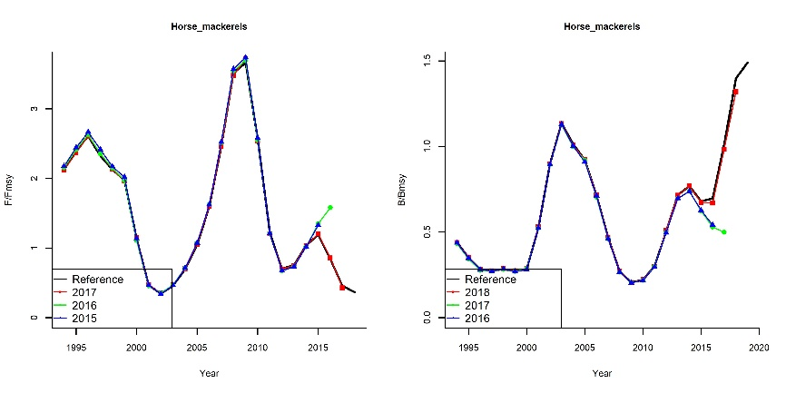
Figure 18A – Horse mackerels in GSA 17 – AMSY model: retrospective analysis.

