Supplemental Material

Validity of ESC risk assessment in idiopathic pulmonary arterial hypertension in China

Su-Gang Gong^{1,#}, Wen-Hui Wu^{1,#}, Chao Li², Qin-Hua Zhao¹, Rong Jiang¹, Ci-Jun Luo¹, Hong-Ling Qiu¹, Jin-Ming Liu, Lan Wang^{1,*} Rui Zhang^{1,*}

¹Department of Pulmonary Circulation, Shanghai Pulmonary Hospital, Tongji University School of Medicine, Shanghai, 200433, China
²Tongji University School of Medicine, Shanghai, 200092, China

#Drs Su-Gang Gong and Wen-Hui Wu contributed equally to this article.

*Co-correspondence:
Dr. Rui Zhang, MD, E-mail: zhangrui@tongji.edu.cn;
and Dr. Lan Wang, E-mail: wanglan198212@163.com;
Department of Pulmonary Circulation, Shanghai Pulmonary Hospital, Tongji University School of Medicine, No. 507 Zhengmin Road, Shanghai, 200433, China; Telephone: +86-21-65115006, Fax: +86-21-65115018;

Supplementary Figure S1. Kaplan-Meier survival estimates of all patients with IPAH at baseline.

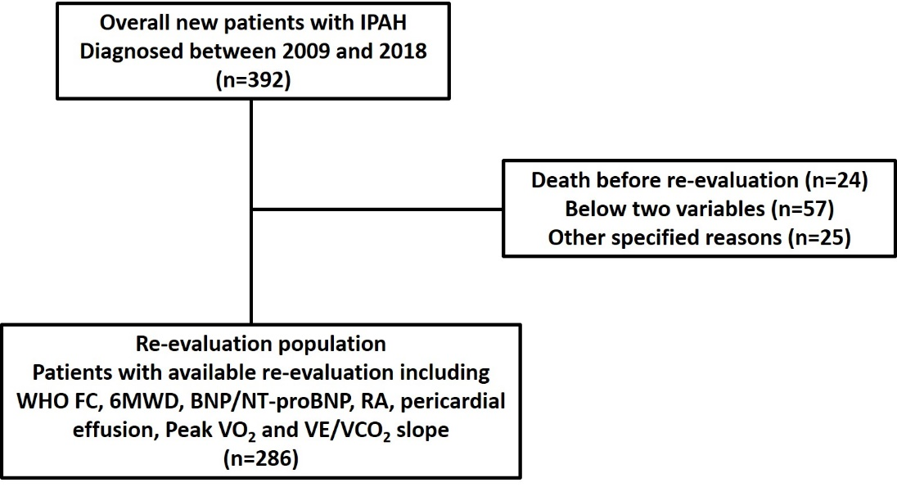

Supplementary Figure S2. Patient selection flow chart.
BNP: brain natriuretic peptide; IPAH: idiopathic pulmonary hypertension; 6MWD: 6-minute walking distance; NT-proBNP: N-terminal fragmental of pro-brain natriuretic peptide; RA: right atrium; VE/VCO₂: ventilatory equivalents for carbon dioxide; VO₂: oxygen consumption; WHO FC: World Health Organization functional class.

Supplementary Figure S3. Forest plot based on the prognostic values of 6-min walking distance (6MWD), World Health Organization (WHO) function class (FC), brain natriuretic peptide (BNP) or N-terminal fragment of proBNP (NT-proBNP), right arterial pressure (RAP), cardiac index (CI) and mixed venous oxygen saturation (S_{V}O₂) in the Intermediate risk (IR) and High risk (HR) groups. Values for the variables were obtained from re-evaluation. The reference value is from the respective Low risk group.

Supplementary Table S1. PAH-targeted treatment initiated within 3 months after PAH diagnosis and re-evaluation
Treatment | Baseline  (392) | Re-evaluation (286)
Monotherapy, n (%)
ERA* | 56 (14) | 38 (13)
PDE5-I# | 186 (48) | 107 (37)
Prostanoid¶ | 16 (4) | 10 (3)
Dual combination, n (%)
ERA+PDE5-I | 68 (17) | 102 (36)
PDE5-I+prostanoid | 2 (1) | 16 (6)
ERA+prostanoid | 31 (8) | 3 (1)
Triple combination, n (%) | 0 (0) | 5 (2)
Calcium channel blockers, n (%) | 5 (1) | 2 (1)
No treatment, n (%) | 28 (7) | 3 (1)
ERA: endothelin-receptor antagonist; PDE5-I: phosphodiesterase type-5 inhibitor
*ERA treatment included 12 patients in PATENT Trial.
#PDE5-I group included 10 patients in SERAPHIN Trial.
¶Prostanoid treatment included 11 patients in UT Trial and 3 patients in GRIPHON Trial.

Supplementary Table S2. Characteristics of IPAH patients in baseline risk assessment according to simplified version of 2015 ESC/ERS risk stratification
 | Low risk | Intermediate risk | High risk | All
Subjects, n (%) | 76 (24) | 207 (64) | 39 (12) | 322
Age, years | 36±15 | 42±16 | 39±14 | 38±14
Female, n (%) | 53 (70) | 143 (69) | 19 (49) | 215 (67)
WHO FC, n (%)
Class I-II | 55 (72) | 50 (24) | 0 (0) | 105 (33)
Class III | 21 (28) | 147 (71) | 31 (80) | 199 (60)
Class IV | 0 (0) | 10 (5) | 8 (21) | 18 (6)
6MWD, meters | 421±104 | 363±94 | 257±100 | 369±107
BNP, ng/L | 46 (23, 81) | 204 (132, 412) | 661 (370, 844) | 160 (71, 390)
NT-proBNP, ng/L | 171 (51, 287) | 1154 (560, 1918) | 2309 (2095, 2703) | 1679 (264, 1893)
Hemodynamics
RAP, mmHg | 5 (3, 6) | 8 (4, 12) | 15 (10, 22) | 7 (4, 11)
mPAP, mmHg | 62 (44, 65) | 62 (52, 70) | 61 (58, 81) | 62 (51, 78)
PAWP, mmHg | 7 (5, 10) | 7 (5, 10) | 9 (7, 11) | 9 (6, 11)
CI, L/min/m² | 3.1 (2.7, 3.7) | 2.2 (2.0, 2.4) | 1.8 (1.6, 1.9) | 2.4 (2.0, 3.1)
PVR, Wood units | 10 (7, 12) | 15 (12, 18) | 19 (15, 26) | 14 (10, 17)
S_{V}O₂, % | 71 (66, 77) | 61 (57, 67) | 47 (44, 55) | 64 (57, 70)
Initial therapies (within 3 months after diagnosis), n (%)
No specific therapy | 5 (7) | 17 (8) | 1 (3) | 23 (7)
CCB therapy | 5 (7) | 0 (0) | 0 (0) | 5 (16)
Monotherapy | 55 (72) | 120 (58) | 26 (67) | 201 (62)
Combination therapy | 11 (15) | 70 (34) | 12 (31) | 93 (29)
Values are expressed as mean±SD, medians (interquartile range) or n (%), unless otherwise stated. BMI: body mass index; BNP: brain natriuretic peptide; CCB: calcium channel blocker; CI: cardiac index; mPAP: mean pulmonary arterial pressure; 6MWD: 6-minute walking distance; NT-proBNP: N-terminal fragmental of pro-brain natriuretic peptide; PAWP: pulmonary artery wedge pressure; PE: pericardial effusion; PVR: pulmonary vascular resistance; RAP: right atrial pressure; SvO₂: mixed venous oxygen saturation; WHO FC: World Health Organization functional class.

Supplementary Table S3. Change in variable between baseline and re-evaluation
 | Baseline | Re-evaluation | p-value
Subjects, n | 392 | 286
Risk assessment, n (%) |  |  | <0.001
Low risk | 96 (25) | 85 (30)
Intermediate risk | 267 (68) | 159 (56)
High risk | 29 (7) | 42 (15)
WHO FC, n (%) |  |  | <0.001
Class I-II | 132 (34) | 76 (27)
Class III | 234 (60) | 122 (43)
Class IV | 26 (7) | 25 (9)
6MWD, meter | 379±107 | 396±120 | 0.009
BNP, ng/L | 211 (65, 426) | 184 (64, 453) | 0.698
NT-proBNP, ng/L | 748 (255, 1679) | 806 (146, 2326) | 0.098
Haemodynamics*
RAP, mmHg | 6 (3, 10) | 6 (4, 11) | 0.073
mPAP, mmHg | 58 (48, 68) | 57 (40, 65) | 0.068
PAWP, mmHg | 8 (6, 10) | 10 (7, 11) | 0.069
CI, L/min/m² | 2.4 (1.9, 3.0) | 2.6 (2.2, 3.4) | 0.009
PVR, Wood units | 14 (9, 18) | 10 (5, 15) | 0.004
S_{V}O₂, % | 62 (56, 69) | 65 (58, 74) | 0.038
Imaging (echocardiography)
RA area, cm² | 22 (16, 30) | 23 (17, 34) | 0.224
Pericardial effusion |  |  | <0.001
No PE, n (%) | 260 (66) | 170 (67)
Minimal PE, n (%) | 89 (25) | 73 (29)
PE, n (%) | 8 (2) | 10 (4)
Cardio-pulmonary exercise testing
Peak VO₂, mL/min/kg | 14±4 | 13±4 | 0.668
VE/VCO₂ slope | 56±33 | 52±28 | 0.108
Therapies, n (%) |  |  | <0.001
No specific/CCB therapy | 33 (8) | 5 (2)
Monotherapy | 258 (66) | 155 (54)
Combination therapy | 101 (26) | 126 (44)
*Haemodynamics of re-evaluation could be successfully measured in 44 patients.
Values are expressed as mean±SD, medians (interquartile range) or n (%), unless otherwise stated. BNP: brain natriuretic peptide; CCB: calcium channel blocker; CI: cardiac index; mPAP: mean pulmonary arterial pressure; 6MWD: 6-minute walking distance; NT-proBNP: N-terminal fragmental of pro-brain natriuretic peptide; PAWP: pulmonary artery wedge pressure; PE: pericardial effusion; PVR: pulmonary vascular resistance; RA: right atrium; RAP: right atrial pressure; SvO2: mixed venous oxygen saturation; VE/VCO2: ventilatory equivalents for carbon dioxide; VO2: oxygen consumption; WHO FC: World Health Organization functional class.

