Supplementary Appendix

TABLE OF CONTENTS

I. Supplementary Figures
- Haplotype sequence of the proband in the region including Var1 and Var2
- The size distribution of platelets (PLT) and the blood smear for the I-3, I-4, II-2 and II-3
- Monitoring of the platelets for the II-4
- Growth curves (A) and ABCG5/ABCG8 expression (B) in wild type (WT) and knowout (KO) SD rats
- The size distribution of platelets (PLT) for 30 individuals with giant platelets.

II. Supplementary Tables
- Primers of customized Gene Panel Test for 4 common FH causal genes
- Primers and PCR protocols for amplification of ABCG5 exons and splice regions
- Summary of all reported cases with ABCG5 deficiency
- Phenotype survey of the proband
- 9 variations identified in 30 individuals with abnormal platelet distribution

IV. Supplementary References

I. Supplementary Figures
Figure S1. Haplotype sequence of the proband around the region including Var1 and Var2
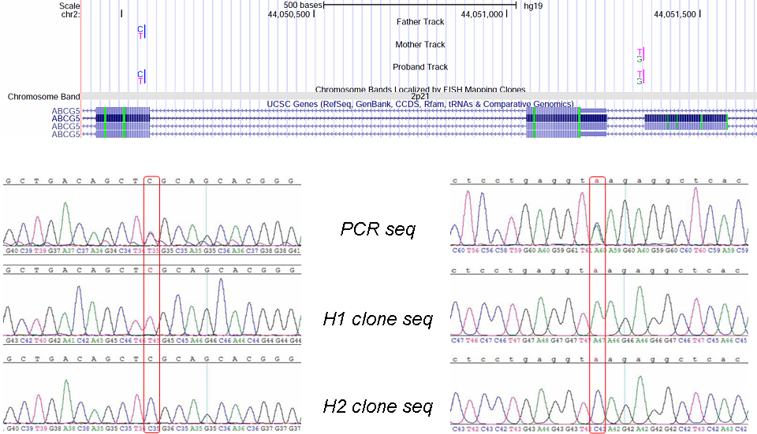
Figure S2. The size distribution of platelets (PLT) and the blood smear for the I-3, I-4, II-2 and II-3. The dash lines demonstrate the volume for the platelets, and the double dash lines show the 30 fL.
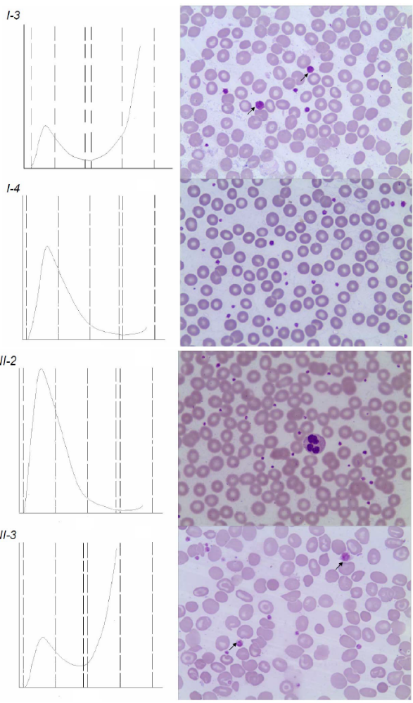

Figure S3. Monitoring of the platelets for the II-4. (A) Comparison of platelet size distribution before and after treatment. (B) Disappearance of giant platelets in blood smear for the II-4 after the treatments.

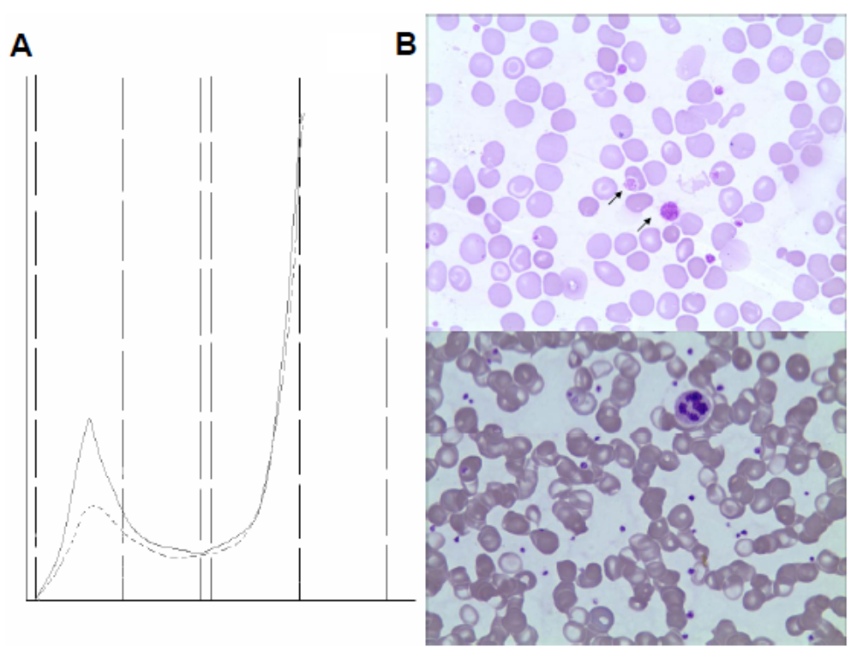
Figure S4 Growth curves (A) and ABCG5/ABCG8 expression (B) in wild type (WT) and knowout (KO) SD rats.

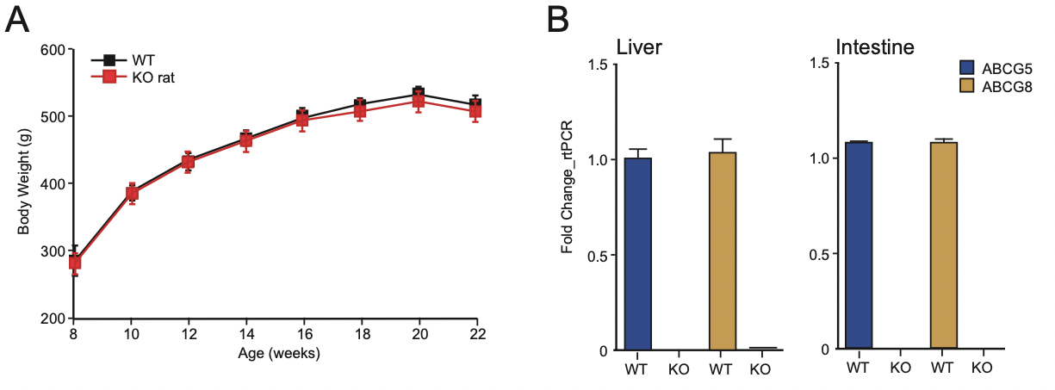
Figure S5 The size distribution of platelets (PLT) for 30 individuals with giant platelets.
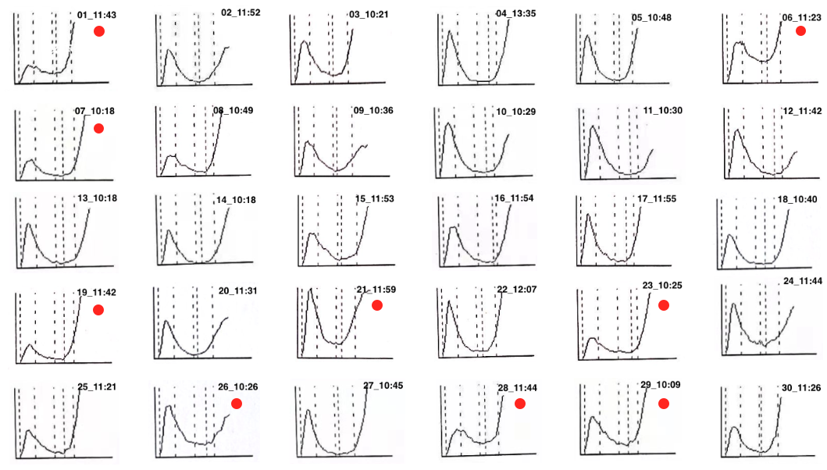
Red dots indicate the cases for which instrument could not export values for all parameters of the platelets

II. Supplementary Tables
Supplementary Table 1. Primers of customized Gene Panel Test for 4 common FH causal genes
Amplicon_ID | Ion_AmpliSeq_Fwd_Primer* | Ion_AmpliSeq_Rev_Primer* | Symbol | Chr | Amplicon_Start | Amplicon_  Stop
AMPL3677489788 | GGTGGTTACATCCAGCTTTAGGAA | CCTGAATGCTAACACTAAGAACCAGA | APOB | chr2 | 21228658 | 21228877
AMPL4702519983 | CTTGGTTTTCTTCAGCAAGGCTTT | CCCTTTGGTGCTCTGATTAGAGATTAAG | APOB | chr2 | 21263842 | 21264053
AMPL4702563407 | CAAGGGCAGACAGTGGCTAT | AGTCCTTCACAGGCAGATATTAACAAAA | APOB | chr2 | 21251109 | 21251326
AMPL4702569339 | AGGGTATCCACCAAGGCTCT | GAGGCTGAATTGTTTTGGGAACATAA | APOB | chr2 | 21241887 | 21242066
AMPL4702572764 | GCTGATCCCTCGCCATGTT | CTTTCTTCTCAGCCCCATCACTTT | APOB | chr2 | 21255269 | 21255465
AMPL587079551 | GCAAATGATGAAGTTCTCAGCTTCTTAT | CATTATTCCTGGGCTGAAACTAAATGA | APOB | chr2 | 21228401 | 21228550
AMPL587080662 | TGGTGAATGGAGACACTTCAACATT | GCTGTGCTTTGTGAGTTTATCAGTCA | APOB | chr2 | 21229947 | 21230169
AMPL587110603 | TGCATCAATGACAGATGAAGATGAAGAA | CCAGTCCTTCATGTCCCTAGAAATC | APOB | chr2 | 21229612 | 21229827
AMPL587118187 | CATAGAGAGAAATCTTTCAGTGGAGGAG | TCTGCTGGAAACAACGAGAACAT | APOB | chr2 | 21230282 | 21230433
AMPL587123574 | AGTCAGTGCTTGAAAGGAAGGAA | GATAACCGTGCCTGAATCTCAGT | APOB | chr2 | 21228088 | 21228304
AMPL587126935 | GGATGCAGTACTACTTCCACTTTTGTTA | CAACTGCAGACATATATGATACAATTTGATCAG | APOB | chr2 | 21232999 | 21233223
AMPL587127039 | TGATTTTGGCATCATCTAATGCAATTTGT | CCCACAGCAAGCTAATGATTATCTGAA | APOB | chr2 | 21233244 | 21233386
AMPL4702574822 | GCATAGCTCACCTTGCACATTGTA | CCACGAATGTCTACAGCAACTTG | APOB | chr2 | 21236021 | 21236172
AMPL4702588225 | TGAGTAGATTTTCCAGCAACTATGTGG | CAGGGAAAACCTTCAACATGGAAAG | APOB | chr2 | 21257647 | 21257848
AMPL4702597728 | GGAACTTGACCATTAACCCAGTACAAA | CTGATGCCATTTTCTTGTCTGATTTTCT | APOB | chr2 | 21249724 | 21249871
AMPL4702603581 | CACATTGCCCTTCCTCGTCTT | GATTCCTTCTGCTTTTTCTTTCACGAT | APOB | chr2 | 21260068 | 21260231
AMPL4702622694 | GAGGTCATGGAGACTGGCAAA | TCCCACATTGGGAACTGAAAGG | APOB | chr2 | 21247865 | 21248068
AMPL4702622904 | GGCTGGTGTCCTAACAGTCTCT | AATATTGTTGTGAAGGTCAGAGGCA | APOB | chr2 | 21236288 | 21236489
AMPL4702631687 | GTGCAGTAATTCAGGCCAGGAA | GCACCCTGAGAATTTGTGATGTC | APOB | chr2 | 21242664 | 21242851
AMPL4702639864 | CAGTGTGTACTGACAGGACTGG | TCCTGCTCCCTTCTACCTTGAA | APOB | chr2 | 21258527 | 21258667
AMPL4702643442 | CAGACTTGGCTGAAAGAATTACCC | GAGTTTGTGACAAATATGGGCATCAT | APOB | chr2 | 21245681 | 21245875
AMPL4702734718 | TCTGTGATCCAGGAGTCTATTAGCA | CCAAAGTAATGCAGGTGTTGAGAC | APOB | chr2 | 21237996 | 21238211
AMPL4702739643 | GCATCCTCCATACCTTGCAGTTG | CCCCTCTCTGCCCAGAATTG | APOB | chr2 | 21265220 | 21265425
AMPL587139369 | CCTCTCAAAATATTCTTGCAAGGTCTCA | GACCTAACTCTACTAGACTCCCCAAT | APOB | chr2 | 21233491 | 21233694
AMPL4233140585 | CTGTAACTCTTGAGAAGCTTCCTGAA | AAGATAACATTAAACAGCTGAAAGAGATGAAAT | APOB | chr2 | 21225169 | 21225362
AMPL587144133 | AAAAGCACTCTAACATCAATAGCCTCAA | GCATCCTGGATTCAAAATGTGGATACTA | APOB | chr2 | 21232847 | 21233004
AMPL587156123 | GCTAAGCTTGTGGTCAACTGCT | AGTACTGTGAGCTTAACCACGAAAAAT | APOB | chr2 | 21229294 | 21229506
AMPL587182477 | TGTTCAGACTGTTTGTGTGGTCAA | GCTTCAGGGAACACAATGCAAA | APOB | chr2 | 21234465 | 21234674
AMPL587201708 | CTTCATATCTTCCTGTTATCTGGTTGGT | GCTTCAGTTCATTTGGACTCCAAAA | APOB | chr2 | 21235125 | 21235341
AMPL587214973 | CTGGGTCAAGTGATGGAAGAGA | GGGTGCAAGAGTCAAAGGATAAT | APOB | chr2 | 21250816 | 21251001
AMPL587228279 | CCAATCCTTAGTGTCGCCTTGT | AATGGGAAGTATAAGAACTTTGCCACTT | APOB | chr2 | 21234797 | 21235017
AMPL587239776 | ACCTCTGTGGTCTTGAGAGACT | CATAAGGGAGGTAGGGACGGT | APOB | chr2 | 21225410 | 21225634
AMPL587243150 | ATTCTTGAGTAACTCGTACCAAGCC | GGGCCATTAGGCAAATTGATGAT | APOB | chr2 | 21225750 | 21225941
AMPL587244175 | CTTTGGTGCAGGTCCAGTTCATA | AACCACAGTCATGAACCCCTAC | APOB | chr2 | 21224438 | 21224662
AMPL587244614 | TGTGCAGAAATTGCTCAACTTGAC | GGCTGGACAGTGAAATATTATGAACTTGA | APOB | chr2 | 21224958 | 21225111
AMPL587253207 | TCTAGAGTCTCATTCCCCTAGTACCT | GTCCAAAGTACAAAGCCATCACTG | APOB | chr2 | 21252431 | 21252588
AMPL4702760901 | TGAATGTCCAGGGTGAGTCTGTAA | CAAAACATAGCTTCTTACCACACATCTC | APOB | chr2 | 21239353 | 21239574
AMPL587253845 | CCGTGATGTATATCAGAAATGTGTGGTA | CTTTCTGCCACTGCTCAGGAA | APOB | chr2 | 21224685 | 21224889
AMPL587271935 | CCAGGAAAAGTGCTTCTGAAATGATGTA | GGGTTACCAAGTCCTGACTCT | APOB | chr2 | 21252718 | 21252925
AMPL587273518 | CTTGGGCACGTTGTCTTTCAG | TTTTCTCTCTGTTTAGTCCTCTCCAGAT | APOB | chr2 | 21226066 | 21226222
AMPL637590428 | AAGTTGCTTACCGCCTGTCT | GGATATGGATGAAGATGACGACTTTTCTA | APOB | chr2 | 21227015 | 21227195
AMPL4653086575 | GACAGACCAGGCTGACATTTTC | CCTCCCTCCTGAAAGGTGAAAC | APOB | chr2 | 21266388 | 21266529
AMPL637979996 | TGTGGCGTAGAGACCCATCATAT | GCACAATTGGCCCAGAAAAATGG | APOB | chr2 | 21235455 | 21235634
AMPL1012820289 | GGCAAAGAACTGTTCTACTTAGTAGCA | GAGTCTGCCAGTCAATAAATACATGGAT | APOB | chr2 | 21237715 | 21237936
AMPL1012976280 | CCACTACTGGAGCTAGTGAGGTA | CAAGGCTGGAGTAAAACTGGAAGT | APOB | chr2 | 21246205 | 21246427
AMPL1226567828 | TGACACTAGATTTTCTACAGTTTGGTTT | CTCAACCGTACAGTTCCTAGAATATGA | APOB | chr2 | 21227770 | 21227986
AMPL1498067538 | GATTGATATCCAAATGGTCCCTGAGA | AGTCACATCTCTCTTGCCACAG | APOB | chr2 | 21256066 | 21256209
AMPL1500364378 | GGAAGTGCCTGGTGGTTCTTA | CATGCTGAAAACTACCCTCACTG | APOB | chr2 | 21250587 | 21250754
AMPL4701702467 | GCTTTTCCTTCCCATTCCCTGAA | AGTATGGAGCTTTTATTGAATTGAAACCT | APOB | chr2 | 21227307 | 21227433
AMPL4701702474 | AAAAGTCATTCTTTGAGCCCTTCCT | CTCTCCAATGTATGGGAGGTTGTAATT | APOB | chr2 | 21246525 | 21246649
AMPL3676958730 | GCTTTGCTTGTATGTTCTCCGTT | AGTGAGGCCAACACTTACTTGAATT | APOB | chr2 | 21228980 | 21229197
AMPL3677041254 | CAGGTGTCTGGAAGGTAGCTTT | GGTTTATAGCACACTTGTCACCTACA | APOB | chr2 | 21231894 | 21232117
AMPL3677066071 | GCTATCCAGGGTAAGCTGATTGTTTA | GAGTCAGTGAAGTTCTCCAGCA | APOB | chr2 | 21231085 | 21231264
AMPL3677151632 | AGAACTTCTAATTTGGACTCTCCTTTGG | CTTCCCCACATCTCACACACAA | APOB | chr2 | 21231329 | 21231513
AMPL3677154866 | CCCTGTTAACCTTAATGGAAAACGAACT | CTAAAGGCATGGCACTGTTTGG | APOB | chr2 | 21230542 | 21230729
AMPL3677216852 | AAGCAGGGCACTGACTTTGT | CTGTAATGGCCCCGTTTACCAT | APOB | chr2 | 21233824 | 21234047
AMPL3677248777 | AGGGTGATTCTCGCTAGAGGAAT | TCCACACCAGAATTTACCATCCTTAAC | APOB | chr2 | 21231617 | 21231804
AMPL3677250584 | TTGAGGGAGCCAGATTCATAAACC | TGGCCACATAGCATGGACTTC | APOB | chr2 | 21230795 | 21230992
AMPL3677272201 | AAGCCTCCTGTAACCAATTGATGATTAA | ATTACCACCAGTTTGTAGATGAAACCAA | APOB | chr2 | 21232242 | 21232448
AMPL3677303433 | GACAGCATCATCAATAAATCCAACCAATT | TCAGAGCCAAAGTCCATGAGTTAATC | APOB | chr2 | 21232537 | 21232730
AMPL4703594094 | GAGCCATAAGCTGTAGCAGATGA | CAAATGGAACTTCTGTTTAATCCTGCAT | APOB | chr2 | 21238274 | 21238498
AMPL4703615584 | CTGGATATTTTGCTCAGAGATGGTTAGT | CAATTTCCAGCTTCCAGTAGACAAAGATA | APOB | chr2 | 21256266 | 21256469
AMPL4703636088 | CCTTGCTGCTTTCTTCTTTTACCTTTTT | CATCTGGGAGTCTTCCTTATACCC | APOB | chr2 | 21237298 | 21237440
AMPL4703648744 | AGAAATGATGCCCCTCTTGATGTTC | CTTCAGTGCCACCCAGCTTA | APOB | chr2 | 21260881 | 21261061
AMPL4703666536 | TGTGTTGAGCCGATGGCTAAA | ACCTGAAATACAATGCTCTGGATCTC | APOB | chr2 | 21234130 | 21234341
AMPL3677036261 | CCATTTCCATGACCCTTTTCCAGAA | GAGCTTAGTAATGGAGTGATTGTCAAGA | APOB | chr2 | 21230947 | 21231138
AMPL3677110305 | GCTCACTGAGTAAAAGTGGCACTTTA | GCATCAGTGCAGCTCTTGAAC | APOB | chr2 | 21233643 | 21233864
AMPL3677111451 | CATGCTCCGTTCTCAGGTACT | GGTATCGCAGCTTCCATCACTG | APOB | chr2 | 21231222 | 21231378
AMPL3677168109 | AGCAAGAGTCCACCAATCAGAAA | AGCCTACAGGACACCAAAATAACC | APOB | chr2 | 21232069 | 21232293
AMPL3677196226 | CAGTAAACTCTGCCTTCCCTTCT | GCAAACACCTAAGAGTAAACCAAAACTT | APOB | chr2 | 21230685 | 21230846
AMPL3677218487 | AGCTTGCCAAAAGTAGGTACTTCAA | AGGGATCTGAAGGTGGAGGAC | APOB | chr2 | 21231467 | 21231660
AMPL3677282654 | AATTGTAAAGGAAGGAATGTGGAAGGT | GAAGTCAGTCTTCAGGCTCTTCAG | APOB | chr2 | 21231751 | 21231939
AMPL3677289611 | GAGTCACCTCACGGATTTTGTCA | GCTAAGCAATGTCCTACAACAAGTTAAGA | APOB | chr2 | 21232398 | 21232612
AMPL3677311738 | GGATTTGTTGGTCTACTTCATACCTCTC | ACCTAGCTGGAAAGTTAAAACAACACA | APOB | chr2 | 21232677 | 21232901
AMPL3677499003 | CCGGACTTCATTTTTCCATCTGATCT | AGCTAGAGGGCCTCTTTTTCAC | APOB | chr2 | 21228826 | 21229025
AMPL3766439257 | GGGTTCAGTTTTAATACAGAGATGCAC | AGCAGCTGCGAGAGATCTTC | APOB | chr2 | 21255143 | 21255307
AMPL587069627 | CATTTATTCCTACATGGGCCTCCATA | CATCCACAAACAATGAAGGGAATTTGAA | APOB | chr2 | 21230385 | 21230597
AMPL587074088 | GGAGGCAGGATATTTCTTACCATTTAGT | CTCTGTACCTGCTGGAATTGTCA | APOB | chr2 | 21227932 | 21228133
AMPL587080616 | TGTTGCCACTGACACTTCCAT | CAGTCAGATATTGTTGCTCATCTCCT | APOB | chr2 | 21229459 | 21229665
AMPL587096945 | TGCCTGTCAAAGGATTTGATGCT | ATGCGTCTACCTTACACAATAATCACAA | APOB | chr2 | 21230120 | 21230337
AMPL587113071 | CGTAGGCATGACAAGAACTGAATTTAGA | CAGTCTATGACAAGAGCTTATGGGAT | APOB | chr2 | 21228496 | 21228707
AMPL587129104 | CCTTGAAATCTGGAAGAGAAAGCTTGA | CCTGGATACACTGTTCCAGTTGT | APOB | chr2 | 21229776 | 21229995
AMPL587132430 | TGAAACTTGTCTCTCCCAATTGAATGA | TGTTCACTCCATTAACCTCCCATTTTT | APOB | chr2 | 21233332 | 21233545
AMPL587161788 | GCGTGAACTGGGACACAGTTA | GTGCAAACTTGACTTCAGAGAAATACAA | APOB | chr2 | 21228261 | 21228460
AMPL4702558855 | AAGGAAGATTATCTGCTAGAAAGCCA | TCTGTGGTTGACCTGCTTTCC | APOB | chr2 | 21235921 | 21236065
AMPL4702567381 | CTGTATCACTTGTTAGTCAGCAGACAT | CTTCTTTGGTGAAGGTAAGAGTTTCTGT | APOB | chr2 | 21257577 | 21257701
AMPL4702591921 | CCACACTGAACCAAGGCTTGT | TGATTAAGGGCTCTCCTGGCA | APOB | chr2 | 21255421 | 21255549
AMPL4702597715 | TGTTCCCATGGTAGAATTTGGACAA | GCTAGCAGACAATGCCAGTGT | APOB | chr2 | 21251274 | 21251495
AMPL4702600052 | AGGAGGCGGACCAGTTGTA | GCAAATCCTCCAGAGATCTAAAGATGTT | APOB | chr2 | 21236131 | 21236337
AMPL4702600811 | TTTTCCTTCCAAGCCAATCTGAGAA | TGGTATTCAAATACTTGTTTAGATAAATGGACA | APOB | chr2 | 21249819 | 21249945
AMPL587184183 | GCTTAGAGAAGGTCATATCCATCTTGTT | AGGTTTAACTCCTCCTACCTCCAAG | APOB | chr2 | 21234960 | 21235179
AMPL587200225 | GCCGTAGTTTCCCATTGTTGGT | TGATGGGCTCATATGCTGAAATGAAAT | APOB | chr2 | 21234294 | 21234515
AMPL587204596 | GGCTTTCCCATCCAGACTGAAT | GCACTGACAAAATTAATAGTGGTGCTC | APOB | chr2 | 21234631 | 21234845
AMPL587207454 | GTCAGCTGAAGCAAATCCAAAGG | CTCGGAACTATCAACTCTACAAATCTGTT | APOB | chr2 | 21250709 | 21250866
AMPL587218513 | TTGACTTCTTTGACAAACAAATGCTGTT | TGACCACAAGAATACGTTCACACTATC | APOB | chr2 | 21235286 | 21235504
AMPL587237827 | CGCAATGGCCTGGCTTTTAATTAT | CCTCTAACTTTACTTCCCAACTCTCAA | APOB | chr2 | 21224845 | 21225008
AMPL587238021 | TGAAGATTGTGTTGATCTCATCTTGGAT | AGCCCAAGAGGTATTTAAAGCCATT | APOB | chr2 | 21225282 | 21225457
AMPL587244227 | GACTTTCGAATATACCTGGGACAGT | GGGACTCAAGGATAACGTGTTTGAT | APOB | chr2 | 21225589 | 21225799
AMPL587251003 | GTTCTCCTGGAGCAAGCTTCAT | CAAAAGATTGATTGACCTGTCCATTCA | APOB | chr2 | 21224619 | 21224743
AMPL587258669 | CTTTCTGGAACCTCACGTCGAT | AGCTTCTGGCTTGCTAACCTC | APOB | chr2 | 21225897 | 21226108
AMPL587261233 | TGAGGGCTGTAGTAGAAGTTCCATT | CTTTCGTGATAGCTCATCTGTTTTTCTG | APOB | chr2 | 21227142 | 21227359
AMPL637430943 | AGAAGGCTAGTGACAGGGTCT | TGGTCAGTTTGCAAGCAAGTCT | APOB | chr2 | 21242483 | 21242707
AMPL4702608977 | GTACAAGCATCTTTTCGGGCTT | TCTTGGGAGAGGAGCTTGGT | APOB | chr2 | 21247694 | 21247905
AMPL4702615695 | TCCTCAGGACCTGAATGATCTCAA | CAGTCAAGCTGCTCAGTGGA | APOB | chr2 | 21245592 | 21245724
AMPL4702625136 | GCCTGGAACAGAGCACTTGAG | TTGTCAACTCTGATCAGCAGCA | APOB | chr2 | 21258375 | 21258571
AMPL4702659253 | CTCCTAGCGAAGTCCGGAATG | AAATCTTTGCCCGGAGGTGA | APOB | chr2 | 21245829 | 21246009
AMPL4702694445 | ACTGAAGTCCTTCATATTTGCCATCTTC | GGTTAGGATAGAATTCTCCCAGTTTTCA | APOB | chr2 | 21227431 | 21227638
AMPL4702714942 | AACATGGCTTGGTCAGGTATGAA | TGAATCTACTGAGGGCAAAACGTC | APOB | chr2 | 21239217 | 21239400
AMPL637944367 | GACCCTCAACTCAGTTTTGAATATGGT | CCATAAAACAAACACATGAACTGACAT | APOB | chr2 | 21226159 | 21226368
AMPL4233139900 | AAATTTACACGGATATGATAGTGCTCATCAA | ACAAATTGCATTAGATGATGCCAAAATCA | APOB | chr2 | 21233075 | 21233272
AMPL1012216917 | GGCTGACTTACAAACAGAGGCA | GATTCAAGAAGTGCCACCAGGAT | APOB | chr2 | 21265056 | 21265265
AMPL1012880407 | CTTCCTGACAGGGTTGGTGTT | CCACATCCCAGAAAACCTCTTCTT | APOB | chr2 | 21237128 | 21237349
AMPL1013060206 | AGTATATTTTGAGCTGACACACCATGTT | GCTTCTGAAACAAACACTTGTGCAAAT | APOB | chr2 | 21250951 | 21251109
AMPL4567386395 | TCCATGTATTTATTGACTGGCAGACTC | CCGATTATCCTAAGAGCTTGCATATGTA | APOB | chr2 | 21237910 | 21238048
AMPL1498159057 | CATTAGATACCTGGACACCTCAATCAG | TTTGAAGACTCTCCAGGAACTGAAAAA | APOB | chr2 | 21256161 | 21256320
AMPL4567917755 | TGTCTCTTAAGCTGCTGCAGTT | AAAAACAATCCATGATCTACATTTGTTTATTGA | APOB | chr2 | 21232925 | 21233071
AMPL4652891859 | GGTGCCCACTAGCTCAAAAGTT | CTGCTCCACTCACTTTACCGT | APOB | chr2 | 21259887 | 21260110
AMPL1637061913 | CAGGTTCTTGATCAGACTGACTATCTTT | AACGAGCTTCAGGAAGCTTCT | APOB | chr2 | 21225052 | 21225201
AMPL4652934767 | CTGGTGCAAACACACAAGTTCA | GGTGTATGGCTTCAACCCTGAG | APOB | chr2 | 21263737 | 21263890
AMPL4652943930 | TTTTGAGGACTTCCATGCTTAGAAA | GATTTTTCCCAGACAGTGTCAACAAAG | APOB | chr2 | 21249574 | 21249778
AMPL4653069015 | GCCATCTCAGCCCTGTAGAGT | CCTGTCTTACAGAAGAGGAAATGCTG | APOB | chr2 | 21266285 | 21266435
AMPL4703586227 | TGTGAATGGTACTAGTTCAGCCTGTA | CCAAACTGCTTCTCCAAATGGAC | APOB | chr2 | 21238155 | 21238319
AMPL4703597808 | GGATGGCAGCTTTCTGGATCAT | AGCACTTTTCCTGGACACCTTTTA | APOB | chr2 | 21252543 | 21252731
AMPL4703623413 | TCATGGAGCTGACTCAGTGATCT | CGGAGAAAGATGAACCTACTTACATCCT | APOB | chr2 | 21260726 | 21260933
AMPL4701683945 | GCAAACAGAATCTTACGTTGGCT | GGTCTACAGATTGGAGAGGTCATC | APOB | chr2 | 21246381 | 21246573
AMPL3676976464 | CATGTCTTCTCCTCATGAATTCTGAA | CCTATGAGCTCCAGAGAGAGGAC | APOB | chr2 | 21241791 | 21241929
AMPL3677020586 | ACTGAAGACCGTGTGCTCTTG | AATGCTGTACTCTACCGCTAAAGG | APOB | chr2 | 21229151 | 21229339
AMPL4703642609 | CTATTGAGGTGGTCTTGCAAAGTCT | GGTATTTTTGCCTAATGTTCATTGCTCT | APOB | chr2 | 21237392 | 21237543
AMPL4703654789 | CCATTTGTATGTGCATCGATGGT | GCTAAGGTTCAGGGTGTGGAG | APOB | chr2 | 21234002 | 21234171
AMPL413502387 | CCCTGACTCCGCTTCTTCT | CGCAGAAACAAGGCGTGTG | LDLR | chr19 | 11231020 | 11231223
AMPL413542372 | ATTCTTTAGTTGGCAGGAAATAGACACA | GGACTCACAGCACGTCTCC | LDLR | chr19 | 11210808 | 11211029
AMPL413576067 | CGGCGAAGGGATGGGTA | GCACTCGTAGCCGATCTTAAGG | LDLR | chr19 | 11221268 | 11221401
AMPL413629258 | CGAAGATGGCTCGGATGAGT | CATACCGCAGTTTTCCTCGTC | LDLR | chr19 | 11216101 | 11216281
AMPL413640942 | TGAGAAGTAGGTGGCCTCCA | TGCTTTGGTCTTCTCTGTCTTTGAATAA | LDLR | chr19 | 11241881 | 11242080
AMPL413738884 | GCCTGAATGGTGTGGACATCT | GAAACCTTCAGGGAGCAGCTT | LDLR | chr19 | 11226820 | 11226996
AMPL3989014358 | TCAGTGGGTCTTTCCTTTGAGTG | CGTTGTCGCAGTCCACTTG | LDLR | chr19 | 11213291 | 11213441
AMPL3989324171 | AAAGGCCCTGCTTCTTTTTCTCT | CCAACTTCATCGCTCATGTCCTT | LDLR | chr19 | 11217171 | 11217352
AMPL3989544606 | GGTGGCCAGCAATAGAATCTACT | TGATGACGGTGTCATAGGAAGAGA | LDLR | chr19 | 11224072 | 11224260
AMPL3989689733 | TTCCCGTTGGGAGGTCTTTTC | TGTACTCGCTCCGGTCCA | LDLR | chr19 | 11223802 | 11224025
AMPL3989797055 | CGCAAGGCGATCTCTAAACAAA | GTCAAAGTTGATGCTGTTGATGTTCT | LDLR | chr19 | 11240052 | 11240271
AMPL3989824420 | CGTCATTAGGCGCACACCTAT | GTGTCCTTACGGCTGTGGAG | LDLR | chr19 | 11233776 | 11233924
AMPL4055019071 | CACAGACTTGGGAAGTTCTCCAA | CAGAGCCCTCACGCTACTG | LDLR | chr19 | 11238547 | 11238742
AMPL4137497464 | AGCGTCCCCGGCTATAGAA | GGTCTGAGTCACAGACGAACTG | LDLR | chr19 | 11215817 | 11215976
AMPL4137530416 | GGAATCAGAGCTTCACGGGTTA | AGTGTCCCGACCCGGAT | LDLR | chr19 | 11199980 | 11200204
AMPL4703442186 | CTTCGAAGGTGTGGGTTTTGG | CCTTCCTCACACTGGCACTTG | LDLR | chr19 | 11222096 | 11222274
AMPL4703449287 | GAGAGAGGGTGGCCTGTG | ACAGTAGGTTTTCAGCCAACAAGTT | LDLR | chr19 | 11230699 | 11230864
AMPL4702062301 | TCAGCACGTGACCTCTCCTTA | CTCGTACGTAAGCCACACCT | LDLR | chr19 | 11227497 | 11227692
AMPL4703470320 | GGACTGGATCCACAGCAACAT | TCCTGAAGCTCCTTCCTGCT | LDLR | chr19 | 11224295 | 11224500
AMPL4702067023 | AATCCATTTGCATGCGTTCTTATGT | CAGTCTCTAGCCATGTTGCAGA | LDLR | chr19 | 11217957 | 11218155
AMPL413600486 | CACGATGGGAAGTGCATCTCT | GGAACACGTAAAGACCCCTACA | LDLR | chr19 | 11215931 | 11216153
AMPL413602187 | CTAGGACACAGCAGGTCGT | TCCCAGGGATGGAGTGATTATTTGTA | LDLR | chr19 | 11200168 | 11200392
AMPL413639801 | GAATGCATCACCCTGGACAAAG | CCTACAGCACTCATGTCTCAGT | LDLR | chr19 | 11218112 | 11218263
AMPL413643442 | TGAACCTGGAGGGTGGCTA | GTGCAAAGTTCAGAGGATGAAACTC | LDLR | chr19 | 11222235 | 11222401
AMPL413649256 | CCCGACTGCAAGGACAAATCT | CGGCACCTAAATCACTGCATGT | LDLR | chr19 | 11216240 | 11216365
AMPL413662091 | GGGTTCCCAGCAGGACTATTT | TGTTTTCAGTCACCAGCGAGT | LDLR | chr19 | 11226646 | 11226861
AMPL414667929 | TCAGTTCTGGAGGTGCGATG | ACCCCGTAGAGACAAAGTCAGA | LDLR | chr19 | 11213401 | 11213536
AMPL4702074984 | GCTGGCAGAGGAAATGAGAAGAAG | TGTCCAGGAGAAAAAGTGAACAGG | LDLR | chr19 | 11238698 | 11238861
AMPL4702081921 | CAGTGTGACCGGGAATATGACTG | CCCTCTGGCTTCACAAATCATTT | LDLR | chr19 | 11217306 | 11217441
AMPL4702091595 | CCTTCTCCTTGGCCGTCTTTG | CCTCCTAGTCACAACCAGTTTTCTG | LDLR | chr19 | 11227652 | 11227777
AMPL4702110420 | CACCGTCAGGCTAAAGGTCAG | CATCTCGTGACCAAAATGTTCGT | LDLR | chr19 | 11233884 | 11234102
AMPL3988950525 | CCAGGATGGCTCTGATGAGT | GCCGCCATCATCAAAAAGGG | LDLR | chr19 | 11210987 | 11211210
AMPL3989538556 | GCACGAGGTCAGGAAGATGAC | ATCATTCTCTGGGACAGGTCAGA | LDLR | chr19 | 11223985 | 11224119
AMPL3989604425 | CATGAGGAGCTGCCTCACA | GTCAAGCCCGGTGCTGAT | LDLR | chr19 | 11231179 | 11231360
AMPL4054977229 | TGTTCCCACGTCTGCAATGA | GTGGAATCTCATGAAACCCTCCTA | LDLR | chr19 | 11221360 | 11221580
AMPL4055022853 | CTCTCCAGGTGCTTTTCTGCTA | AGGAGATCTAGACACACAAGTGGA | LDLR | chr19 | 11227406 | 11227541
AMPL4137467001 | CTATGGAAGAACTGGCGGCTTA | GTCCCTTGAGGATCATATGCCT | LDLR | chr19 | 11240224 | 11240421
AMPL4703455705 | AATGATCTGCAGGTGAGCGT | AGGACAGAGTCGGTCCAGTAG | LDLR | chr19 | 11224114 | 11224336
AMPL4703467241 | GCCTCACAGGTTCCGATGTC | ACCAGAAGATTCCAGAAATTTCCAGAAC | LDLR | chr19 | 11230820 | 11230997
AMPL4401981955 | CTGGGATGGAGCTGCAGAA | CAGCCTGTGCCTGAAAACAG | LDLRAP1 | chr1 | 25889004 | 25889144
AMPL871354742 | GCTCTGCCTTCCAGGCTTG | CGCAGCAGGTGGCTTTG | LDLRAP1 | chr1 | 25893325 | 25893546
AMPL871359545 | GTGGAGTGGGAATAGCAGGTT | CAAACACCTTGTCGTGCATCT | LDLRAP1 | chr1 | 25883531 | 25883687
AMPL1417508083 | AGCCATTAGTCAGGTTCTCACTCT | ACTGTGAGGGATCCGGTCA | LDLRAP1 | chr1 | 25889962 | 25890152
AMPL1417508102 | GGTTGTGTGGCCAGCAGAT | TGGGAGCCAAGCCTGTTG | LDLRAP1 | chr1 | 25890289 | 25890490
AMPL1500485340 | TCCTAGGAAAGAAGGCTGGTG | ACTAGCGTCATGCCCAGGTA | LDLRAP1 | chr1 | 25880328 | 25880497
AMPL3676940843 | TGGATGAAGCGTTTTCGAGGT | TCTGAGTGGCTTGTGTTCTTAATCAG | LDLRAP1 | chr1 | 25891680 | 25891806
AMPL4702066737 | GGGCTTAGGAACAGTGAAGTGT | GAGGTTGTCTGTCAGGATAATTCCC | LDLRAP1 | chr1 | 25881266 | 25881428
AMPL4702080257 | CTGAAACTGCCCCTTGAGGT | GCTGGCTTTGTCCCTCTTCT | LDLRAP1 | chr1 | 25889452 | 25889586
AMPL4702068190 | GGGATGCTGTTCAGCCTCAAG | CAACTGGAGTAACAAGCTGGGA | LDLRAP1 | chr1 | 25880457 | 25880647
AMPL871344379 | GCTGATCTCCCACTGACAACC | GAGGTCAGGCTGAGGATCAC | LDLRAP1 | chr1 | 25890113 | 25890329
AMPL871380385 | GATCTCCTATTGCACAGCAGACA | GTAATGGTCACCTTTGGGTCCT | LDLRAP1 | chr1 | 25883644 | 25883865
AMPL4401988444 | GGAGGTGCTTTGATCTGAGGTTA | CTGAGGGTTTGTCCGAGACTG | LDLRAP1 | chr1 | 25893180 | 25893366
AMPL4401996594 | CCTCCCCATCCCCACTTC | CCACAATGTAGATGCAAAGTCTCAC | LDLRAP1 | chr1 | 25889107 | 25889232
AMPL4402007081 | GCCTTGGTCCTGCAGAGAAAG | GAAAAACCAAGAGGCTCTCCCA | LDLRAP1 | chr1 | 25889546 | 25889748
AMPL4402050903 | CAGAAGGTGACTCTGAAGGTGTC | CCCAAGTGGCAGAGTGGAT | LDLRAP1 | chr1 | 25881375 | 25881506
AMPL1417508234 | GCCCTGACACGTGATGGAC | AGCATAAGCCAGAAGTCACTGAATAAAT | LDLRAP1 | chr1 | 25893511 | 25893720
AMPL3676917086 | GCTTGTGTCCTGAGTCCCTGTA | CCAGCACAGGAAGCTAGCATT | LDLRAP1 | chr1 | 25891557 | 25891721
AMPL413508536 | TTGCTGGGTTTCTTCCATGTCA | CTCATCTTCACCAGGAAGCCA | PCSK9 | chr1 | 55509468 | 55509688
AMPL3712526399 | GCCAAGGTGCGGGTGTA | TCCCCAAGATCGTGCCAAG | PCSK9 | chr1 | 55505712 | 55505864
AMPL413519077 | GAACTTCAGCTCCTGCACAGT | CCGTCCTCGTCCTCCTG | PCSK9 | chr1 | 55505397 | 55505617
AMPL3712549622 | GAGCGGATTACCCCTCCAC | GGAGGTGCTGAGTCCCAAA | PCSK9 | chr1 | 55512271 | 55512440
AMPL3713799125 | CTTAGAGGTGTGAGAGGAGGCT | AGACAGCATCATGGCTGCAAT | PCSK9 | chr1 | 55523514 | 55523731
AMPL414595636 | GCCTACGCCGTAGACAACAC | GACAAGTCGGAACCATTTTAAAGCTC | PCSK9 | chr1 | 55529117 | 55529331
AMPL1012467495 | CCAGATGAGGAGCTGCTGA | GCTGGAGTCTGGAGGATGGA | PCSK9 | chr1 | 55524252 | 55524446
AMPL1013168806 | GCCTGATCAAGGAGCGAGAAAA | CCTCGATGTAGTCGACATGGG | PCSK9 | chr1 | 55512010 | 55512229
AMPL1494547002 | GCTCAACTGCCAAGGGAAGG | ACAGCATTCTTGGTTAGGAGACATTAG | PCSK9 | chr1 | 55518421 | 55518570
AMPL4703355908 | GTCTACGCCATTGCCAGGT | GGATCACACTTGTGAGGACCAA | PCSK9 | chr1 | 55525213 | 55525428
AMPL4701788825 | AGGCCTGAGTCTGCCTCT | GCTGGAGGCACCAATGATGT | PCSK9 | chr1 | 55522933 | 55523126
AMPL4701791645 | GTTGAGGCAGAGACTGATCCAC | GGGAGAGACTGTCAAGGTCACA | PCSK9 | chr1 | 55523758 | 55523955
AMPL4701827905 | CAGAGTGACCACCGGGAAATC | CCCAGGAGTACAGCTGCAA | PCSK9 | chr1 | 55517995 | 55518185
AMPL4701829390 | CTGTGCTGAGGCCACGA | GTGGCACAAACTGACACAGAAAAG | PCSK9 | chr1 | 55527096 | 55527308
AMPL3677194655 | CAGGCCTGGAGTTTATTCGGAAA | ACCTACCTCGGGAGCTGA | PCSK9 | chr1 | 55521663 | 55521868
AMPL413521968 | CCTCATGGGCACCGTCA | CCCTACACCCGCACCTT | PCSK9 | chr1 | 55505507 | 55505731
AMPL3677193311 | GGGAGCAGGTCTCCCCAA | GTTGAGGACGCGGCTGTA | PCSK9 | chr1 | 55521620 | 55521760
AMPL414611490 | GACGATGCCTGCCTCTACTC | CGACTCCTTCCAAAGCCAGAA | PCSK9 | chr1 | 55521824 | 55522014
AMPL414643158 | ATGTCTTCCATGGCCTTCTTCC | ACTAAGCACAGTCCCCAGTGTATAT | PCSK9 | chr1 | 55509646 | 55509783
AMPL3712540308 | GCTTCTGCAGGCCTTGAAGTT | GGTATTCATCCGCCCGGTA | PCSK9 | chr1 | 55512186 | 55512310
AMPL422385088 | CATCCCAGGATGGGTGTCTG | AGGCACCCAGAGTGAGTGA | PCSK9 | chr1 | 55529264 | 55529454
AMPL3713058928 | GTTGACTTTATGCTCATTCCCTCCT | TCGAAGTCGGTGACCATGAC | PCSK9 | chr1 | 55517901 | 55518044
AMPL423279419 | CCTCCTCTCTCCTACCATGAACTA | CCACTCCTGGAGAAACTGGAG | PCSK9 | chr1 | 55524085 | 55524295
AMPL3713751478 | CGCTGTGTGGACCTCTTTG | CGGCACAGACCCTGACTG | PCSK9 | chr1 | 55523076 | 55523257
AMPL4137386932 | TTGAGTTGATCCTGTCTAGTCCCT | GTGTGGACGCTGCAGTTG | PCSK9 | chr1 | 55525077 | 55525268
AMPL4137395318 | CATCACCATCTTTCACCATTCACC | TCATTGATGACATCTTTGGCAGAGAA | PCSK9 | chr1 | 55523675 | 55523805
AMPL1012192084 | CCTGAATGGCACATTTGAAAGTGTTATA | CCCATGCAAGGAGGAACATGA | PCSK9 | chr1 | 55509290 | 55509510
AMPL1012506113 | CACTTTGGCCTCACAGAAGGAT | CCGGCTCCTGACTACACAC | PCSK9 | chr1 | 55528941 | 55529155
AMPL4701756358 | CATCCAGCCACCTGCTGATT | CTATGAGGGTGCCGCTAACC | PCSK9 | chr1 | 55518248 | 55518464
AMPL4701822259 | GGTTTCCTAGCTCTTGCCTCAGA | GCACTGGTTGGGCTGAC | PCSK9 | chr1 | 55526937 | 55527130

Supplementary Table 2. Primers and PCR protocols for amplification of ABCG5 exons and splice regions
Primers for amplicons ABCG5 |  |  |  |  | PCR Protocols
Primer ID | Sequences (5'to3') | Amplicon (bp) | Exon (bp) | Flanking region (bp) | 94℃ | 94℃ | Tm | 72℃ | cycles | 72℃
ABCG5-E1 L: | CTCTCCACCCGATCCACTAA | 580 | 283 | 297 | 5 min | 30s | 56℃ | 45s | 30 | 5 min
ABCG5-E1 R: | TCACTCTGTTTCCTGGAGCA
ABCG5-E2 L: | AACACGTTAGGAGCCTGTCC | 395 | 122 | 273 | 5 min | 30s | 56℃ | 45s | 30 | 5 min
ABCG5-E2 R: | TTGGTAGCAGTTCCATTCACA
ABCG5-E3E4 L: | CACAGAGGGTCTCGGGAAG | 499 | 315 | 184 | 5 min | 30s | 59℃ | 45s | 30 | 5 min
ABCG5-E3E4 R: | GAGTGACGAGCAAAGGGAAG
ABCG5-E5 L: | TGTGCTGCCTCTTTCATGTC | 299 | 133 | 166 | 5 min | 30s | 59℃ | 30s | 30 | 5 min
ABCG5-E5 R: | AAAGGGCCCAAAGTATCTGC
ABCG5-E6 L: | CTCAGGCTGAAAGCCAGTTT | 382 | 140 | 242 | 5 min | 30s | 59℃ | 30s | 30 | 5 min
ABCG5-E6 R: | CCTGGCCACTGGTACAAATC
ABCG5-E7 L: | TGCATCAGTGTTCCCAGAGA | 282 | 130 | 152 | 5 min | 30s | 59℃ | 30s | 30 | 5 min
ABCG5-E7 R: | CATCCAGGCAGAAGTCTGAG
ABCG5-E8E9 L: | AGAGAGGGAACCTGGAGAGG | 788 | 520 | 268 | 5 min | 30s | 59℃ | 45s | 30 | 5 min
ABCG5-E8E9 R: | AGGTGGGCATTAACCACAAA
ABCG5-E10 L: | GATGGGCAAAGTGTAGATCCTC | 400 | 139 | 261 | 5 min | 30s | 59℃ | 30s | 30 | 5 min
ABCG5-E10 R: | CCTCCTTCTATGACTAGGGAACC
ABCG5-E11 L: | CCCACTCACCACAAAGGATT | 390 | 186 | 204 | 5 min | 30s | 59℃ | 30s | 30 | 5 min
ABCG5-E11 R: | CCATAACCACTATCAGTTCTCTGG
ABCG5-E12 L: | TTTCTAGGCAACGGTATTTCTTT | 526 | 113 | 413 | 5 min | 30s | 56℃ | 45s | 30 | 5 min
ABCG5-E12 R: | CCAAGTGTCCCTTACCTGTTG
ABCG5-E13 L: | AAGCGCTTGGTAAATACTTGTT | 1000 | 838 | 162 | 5 min | 30s | 56℃ | 60s | 30 | 5 min
ABCG5-E13 R: | TGCCTATAAGTAAACTCAGCTGAAAG

Supplementary Table 3. Summary of all reported cases with ABCG5 deficiency
Proband | Homozygous/Compound heterozygous | Mutation Position | Nucleotide alteration | PMID | TC (mg/dl） | β-sitosterol (mg/dl） | stomatocyte | Megaloplastocyte
1 | Homozygous | exon 6 | R243X | 11452359 | NaN | > 8 | YES | YES
2 | Homozygous | exon 9 | R419H | 11452359 | NaN | > 8 | NaN | NaN
3 | Homozygous | exon 9 | R389H | 11452359 | 267 | 18.98 | YES | YES
4 | Homozygous | exon 3 | del exon 3 | 11452359 | NaN | > 8 | NaN | NaN
5 | Homozygous | exon 9 | R389H | 11452359 | NaN | > 8 | NaN | NaN
6 | Compound heterozygous | exon 9/exon 11 | R419H/R550S | 11452359 | NaN | > 8 | NaN | NaN
7 | Homozygous | exon 8 | R408X | 11452359 | NaN | > 8 | NaN | NaN
8 | Homozygous | exon 9 | R389H | 11452359 | NaN | > 8 | NaN | NaN
9 | Homozygous | exon 9 | R419P | 11452359 | NaN | > 8 | NaN | NaN
10 | Compound heterozygous | exon 3/exon 9 | E197X/N437K | 11668628 | 432 | NaN | NaN | NaN
11 | Compound heterozygous | exon 9/intron 12 | R419H/IVS12+1G>A | 11855938, 12777658 | 707.66 | NaN | NaN | NaN
12 | Homozygous | exon 3 | del388-428/ins388-408 | 15375183 | 290.03 | 52.2 | NaN | NaN
13 | Compound heterozygous | intron11/exon4 | IVS11+3insT/E146X | 16029460 | 193.35 | 57.67 | YES | YES
14 | Compound heterozygous | intron11/exon4 | IVS11+3insT/E146X | 16029460 | 255.22 | 60.77 | YES | YES
15 | Homozygous | exon 2 | E77X | 16029460, 17785700 | 197.22 | 38.04 | YES | YES
16 | Homozygous | exon 2 | E77X | 16029460, 17785700 | 143.08 | 25.08 | YES | YES
17 | Homozygous | exon 2 | E77X | 16029460, 17785700 | NaN | 16.16 | YES | YES
18 | Compound heterozygous | exon 10/exon 11 | R446X/H510D | 17228349 | 224.67 | 14.6 | NaN | NaN
19 | Homozygous | exon 10 | R446X | 17976197 | 382.06 | 15.76 | NaN | NaN
20 | Homozygous | exon 10 | R446X | 17976197 | 246.33 | 12.77 | NaN | NaN
21 | Homozygous | exon 10 | R446X | 17976197 | 200.08 | 13.93 | NaN | NaN
22 | Homozygous | exon 7 | F283Ffs5X | 19111681 | 391.11 | 27.5 | NaN | NaN
23 | Compound heterozygous | exon 7/exon 10 | F283Ffs5X/R446X | 19111681 | 416.24 | 21.4 | NaN | NaN
24 | Compound heterozygous | exon 8/exon 9 | Y329X/N437K | 20521169 | 429.31 | NaN | NO | NO
25 | Compound heterozygous | exon 9/exon 10 | R389H/R446X | 20521169 | 708.82 | 7.1 | NO | NO
26 | Compound heterozygous | exon 9/exon 10 | R389H/R446X | 20521169 | 404.18 | 9.17 | NO | NO
27 | Homozygous | exon 9 | R389H | 20521169 | 643.47 | 7.07 | NO | NO
28 | Compound heterozygous | exon 9/exon 7 | R389H/G269R | 20521169 | 344.86 | 6.14 | NaN | NaN
29 | Compound heterozygous | exon 1/exon10 | Q16X/R446X | 20719861 | 1028.54 | 8.4 ª | NaN | NaN
30 | Homozygous | exon 1 | Q22X | 24166850 | 205.72 | 27.6 | YES | YES
31 | Homozygous | exon 1 | Q22X | 24166850 | 220.03 | 48.52 | YES | YES
32 | Homozygous | exon 1 | Q22X | 24166850 | 134.57 | 35.98 | YES | YES
33 | Homozygous | exon 10 | R446X | 24166850 | 220.03 | 57.54 | YES | YES
34 | Compound heterozygous | Intron 9/exon10 | IVS9＋2A>G/R446X | 24166850 | 331.79 | 48.9 | YES | YES
35 | Compound heterozygous | Intron 9/exon10 | IVS9＋2A>G/R446X | 24166850 | 143.85 | 29.64 | YES | YES
36 | Compound heterozygous | Intron 9/exon10 | IVS9＋2A>G/R446X | 24166850 | 343.78 | 23.64 | YES | YES
37 | Compound heterozygous | Intron 9/exon10 | IVS9＋2A>G/R446X | 24166850 | 338.75 | 61.93 | YES | YES
38 | Homozygous | Exon 9 | R419H | 24166850 | 315.93 | 68.91 | YES | YES
39 | Homozygous | Exon 7 | g.712G> A | 24166850 | 227.77 | 90.23 | YES | YES
40 | Homozygous | intron10 | IVS10-1 G>T | 24623560 | NaN | 12.8 | YES | YES
41 | Compound heterozygous | Exon 12/exon 9 | P558Efs14X/R389H | 25665839 | 525.83 | NaN | NaN | NaN
42 | Compound heterozygous | Exon 12/exon 9 | P558Efs14X/R389H | 25665839 | NaN | NaN | NaN | NaN
43 | Compound heterozygous | exon 1/exon 9 | S44A/R389H | 25665839 | 874.72 | NaN | NaN | NaN
44 | Compound heterozygous | exon12/exon 10 | P558Efs14X/R446X | 25665839 | 760.10 | NaN | NaN | NaN
45 | Homozygous | exon 10 | R446X | 26813946 | 300.00 | 20.20 | NaN | NaN
46 | Heterozygote | intron 1/exon 11 | IVS1-1G>A/L511X | 26892138 | 295.00 | 68.10 | NaN | YES
47 | Compound heterozygous | exon 9/intron 12 | R419H/IVS12-1G>A | 27170062 | 681.00 | 182.00 | NaN | NaN
48 | Compound heterozygous | exon 9/exon 9 | R419H/R389H | 27401767, 28203044 | 866.00 | 24.60 | NO | NO
49 | Compound heterozygous | exon 6/exon 10 | Q251X/R446X | 28521186 | 770.00 | 78.80 | NO | NO
ªSitosterolemia was initially ruled out because of the normal sitosterol:cholesterol ratio, but after one year sitosterol level increased to 8.4 mg/dL.

Supplementary Table 4. Phenotype survey of the proband
Variables | Pre-study | 6 Weeks | 9 Weeks | 14 Weeks | 18Weeks | 22 Weeks | 26Weeks | 34 Weeks | 68 Weeks | 75 Weeks | 127Weeks | 131Weeks | 136Weeks | 140 Weeks | Normal Value of Rang
TC(mg/dl) |  |  |  |  |  |  |  |  |  |  |  |  |  |  | <200
Value | 638.06 | 491.11 | 398.30 | 266.44 | 286.16 | 221.97 | 247.49 | 324.83 | 286.16 | 294.28 | 193.35 | 222.74 | 154.29 | 141.53
Change from prestudy |  | -146.95 | -239.75 | -371.62 | -351.90 | -416.09 | -390.57 | -313.23 | -351.90 | -343.78 | -444.71 | -415.32 | -483.76 | -496.52
LDL-C(mg/dl) |  |  |  |  |  |  |  |  |  |  |  |  |  |  | <120
Value | 527.46 | 406.04 | 343.39 | 187.94 | 208.04 | 156.61 | 182.91 | 243.62 | 172.85 | 157.00 | 109.82 | 136.12 | 71.54 | 51.43
Change from prestudy |  | -121.42 | -184.07 | -339.52 | -319.41 | -370.85 | -344.55 | -283.84 | -354.60 | -370.46 | -417.64 | -391.34 | -455.92 | -476.03
LDH(Iu/l) | 225.70 | 201.70 | 182.20 | 206.20 | 199.40 | 200.10 | 189.70 | 185.70 | 154.90 | 228.80 | 176.60 | NaN | 183.40 | 204.70 | 80~190
CK-MB(Iu/l) | 21.00 | 20.40 | 22.70 | 33.00 | 21.00 | 26.74 | 24.90 | 17.60 | 20.80 | 26.70 | 22.30 | NaN | 18.70 | 22.30 | 0~25
GPT(u/l) | 20.20 | 34.20 | 5.10 | 6.45 | 5.05 | 5.29 | 5.30 | 5.50 | 3.60 | 6.70 | 5.30 | NaN | 5.00 | 5.70 | 5~40
AST(u/l) | 41.50 | 56.00 | 27.50 | 29.67 | 29.73 | 28.16 | 28.20 | 31.30 | 25.70 | 29.70 | 23.70 | NaN | 27.60 | 27.30 | 5~40
ALP(u/l) | 240.90 | 243.80 | 215.70 | 216.80 | 217.80 | 222.70 | 216.60 | 200.50 | 201.10 | NaN | 270.50 | NaN | 257.50 | 256.10 | 34~104
Lactate dehydrogenase, LDH; Creatinine kinase, MB isoenzyme, CK-MB; Glutamic-pyruvic transaminase, GPT; Aspartate transaminase, AST; Alkaline phosphatase, ALP.

Supplementary Table 5. Nine variations identified in 30 individuals with abnormal platelet distribution
hg19 | Variant_ID | REF | ALT | Consequence | alt allele count | all allele counts | alt frequency | #homozygotes | Xinjian Cohort (patient ID)
chr2:44039633 | rs4148195 | G | A | c.*622C>T | 3’UTR | 36488 | 151740 | 0.24 | 5308 | 2,5,8,9,16,18,27
chr2:44039644 | v3 | T | TTAATCCTCAGT  AAAATCACTGGG |  | - | - | - | - | 23
chr2:44039650 | v4 | C | CTCAGTAAAATC  ACTGGGTGCTCTGTA |  | - | - | - | - | 14
chr2:44039839 | rs2278357 | C | T | c.*416G>A | 3’UTR | 33312 | 152020 | 0.219 | 4266 | 2,4,18,27
chr2:44039875 | rs2278356 | A | C | c.*380T>G | 3’UTR | 66283 | 151930 | 0.436 | 16244 | 4,5,8,9,16,18,27
chr2:44040401 | rs6720173 | G | C | p.Gln604Glu | missense | 32178 | 152082 | 0.212 | 3874 | 18
chr2:44050063 | rs199689137 | G | A | p.Arg446Ter | stop-gain | 19 | 152042 | 0.000125 | 0 | 30
chr2:44065090 | rs6756629 | G | A | p.Arg50Cys | missense | 10274 | 152086 | 0.0676 | 425 | 2,4,10,11,16,27
chr2:44065755 | rs781098379 | G | A | p.Gln22Ter | stop-gain | - | - | - | - | 28
Alternative allele count, all allele counts, alternative frequency and number of homozygotes are all from gnomAD database.

IV. Supplementary References
- Kasama T, Byun DS, Seyama Y. Quantitative analysis of sterols in serum by high-performance liquid chromatography. Application to the biochemical diagnosis of cerebrotendinous xanthomatosis. J Chromatogr 1987;400:241-6.
- Hidaka H, Nakamura T, Aoki T, et al. Increased plasma plant sterol levels in heterozygotes with sitosterolemia and xanthomatosis. J Lipid Res 1990;31:881-8.
- Barsam SJ, Psaila B, Forestier M, et al. Platelet production and platelet destruction: assessing mechanisms of treatment effect in immune thrombocytopenia. Blood 2011;117:5723-32.
- Depoorter M, Goletti S, Latinne D, Defour J. Optimal flagging combinations for best performance of five blood cell analyzers. Int J Lab Hematol 2015;37:63-70.
- Martin M: Cutadapt removes adapter sequences from high-throughput sequencing reads. 2011 2011, 17(1).
- Li H, Durbin R: Fast and accurate short read alignment with Burrows-Wheeler transform. Bioinformatics 2009, 25(14):1754-1760.
- McKenna A, Hanna M, Banks E, Sivachenko A, Cibulskis K, Kernytsky A, Garimella K, Altshuler D, Gabriel S, Daly M et al: The Genome Analysis Toolkit: a MapReduce framework for analyzing next-generation DNA sequencing data. Genome research 2010, 20(9):1297-1303.

