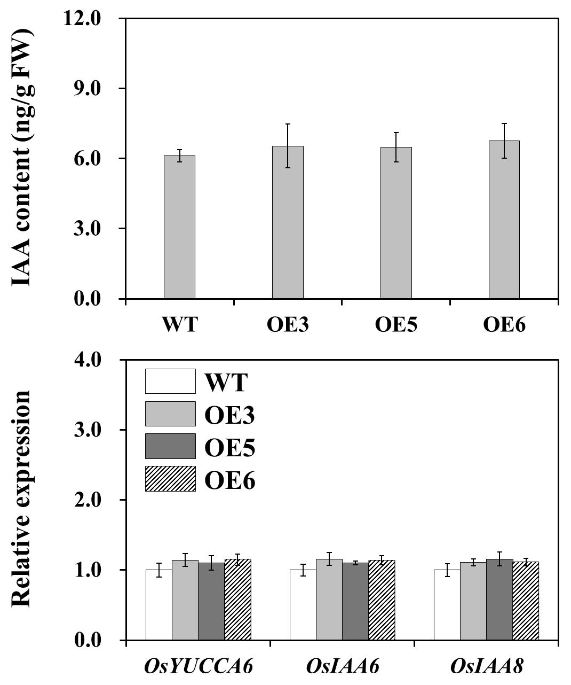
FIGURE S1│IAA content and the expression of IAA signaling related genes in the leaves of OsIAA18 overexpression and WT plants under control growth conditions. Data are presented as means ± SE (n=3). * and ** indicate a significant difference from that of WT at P < 0.05 and < 0.01, respectively, by Student’s t-test.
Table S1│Primers used in this study.
Primer name | Primer sequence (5′-3′)
Primers for identifying transformants
hptⅡ-PCR-F | ACAGCGTCTCCGACCTGATGCA
hptⅡ-PCR-R | AGTCAATGACCGCTGTTATGCG
Primers for real-time quantitative PCR
OsIAA18-F | AAGAATGTGGGAAGGAGCTAACG
OsIAA18-R | ATGGTGGTGAGGGACAGCAT
OsYUCCA6-F | CCATTCCCAGATGGTTGGAAGG
OsYUCCA6-R | CATGTTGCGCCTCAAGATATTTG
OsIAA6-F | GGCTATCGTCAGCTGTCAAACA
OsIAA6-R | GCAATTTGCGCATTAGTTTGG
OsIAA8-F | CCGCTAGACGGCTACAAAGG
OsIAA8-R | GGTGATGGATGCTCTGAACATG
OsNCED4-F | GATTGCACGGCACCTTCATT
OsNCED4-R | CTCTGTAATTTGATTTTTCACTGGCTAAT
OsNCED5-F | GGATGGGCTGAACTTCTTCCAG
OsNCED5-R | CAGCACATTCGTGATGAACCCT
OsRAB16C-F | TTCCCGGCCAGCACTAAAT
OsRAB16C-R | AAACTGCACGTACATCACGACAT
OsRAB16D-F | CGGGTAAACAATAAAGTCGTGATG
OsRAB16D-R | GCGCACTTACATACAGTGCTACGT
OsRAB21-F | CACACCACAGCAAGAGCTAAGTG
OsRAB21-R | TGGTGCTCCATCCTGCTTAAG
OsLEA3-F | GCCGTGAATGATTTCCCTTTG
OsLEA3-R | CACACCCGTCAGAAATCCTCC
OsP5CS1-F | CCCGTCCCGGAGCTTCGTGAG
OsP5CS1-R | CCTAAGTCGCTGTCGCCCCAC
OsP5CS2-F | GCTGCCGTCGGTCAGAGTG
OsP5CS2-R | CTCGTATGGTTGCCTCCTGGT
OsCu/Zn-SOD1-F | TCAATCATTGGCAGAGCCGT
OsCu/Zn-SOD1-R | ACAGCCAGATCCCCCTTACT
OsPOD8.1-F | CTGCTCCAAAGTGAACTAATAATTAAGTAAAG
OsPOD8.1-R | CCCAGCCTTATTCCCAAATTT
Osactin-F | TTATGGTTGGGATGGGACA
Osactin-R | AGCACGGCTTGAATAGCG

