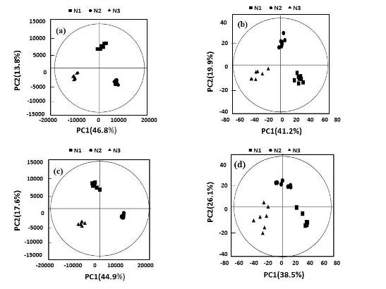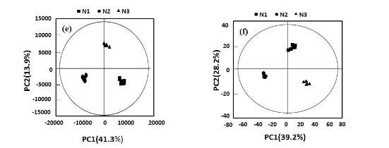
Figure 1S. PCA score plots derived from metabolites (a, b) in young shoots, metabolites (c, d) in mature leaves, and metabolites (c, d) in roots under low (0.3 mmol/L, N1), intermediate (1.5 mmol/L, N2), and high levels of nitrogen (4.5 mmol/L, N3). The nutrient solution is based on (a) UPLC-Q-TOF/MS and (b) GC×GCTOF/MS.
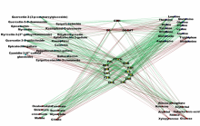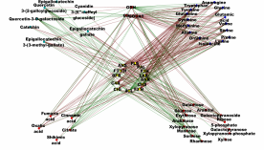
a) Young shoots b) Roots
Figure 2S. Map of significant gene-metabolite correlations. The ligature between metabolites and genes indicates their correlation. Positive correlations are shown in red, and negative correlations are shown in green.
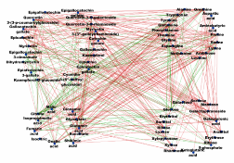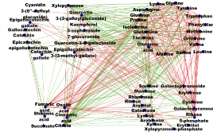
a) Young shoot b) Root
Figure 3S. Map of significant metabolite–metabolite correlations. The ligature between metabolites and gene indicates their correlation. Positive correlations are shown in red and negative correlations are shown in green.

