/SUPPLEMENTAL MATERIAL
Search strategy 1
Definition 2
Figure S1 Results of quality assessment using the Cochrane Collaboration’s risk of bias tool (Randomized Controlled Trial) 4
Figure S2 Forest plot for the association between blood transfusion strategies with in-hospital and follow-up mortality 5
Figure S3 Funnel plot analysis of potential publication bias 6
Figure S4 A leave-one-out sensitivity analysis of this meta-analysis 7

Search strategy
  - Search strategy for PubMed:
(((Transfusion[Title/Abstract]) OR (Blood transfusion[Title/Abstract])) OR (Red blood cell transfusion[Title/Abstract]))) AND ((((((Myocardial infarction[Title/Abstract]) OR (Acute myocardial infarction[Title/Abstract])) OR (ST-segment elevation myocardial infarction[Title/Abstract])) OR (Non-ST-segment elevation myocardial infarction[Title/Abstract])) OR (Acute coronary syndrome[Title/Abstract])) OR (Percutaneous coronary intervention[Title/Abstract])).
  - Search strategy for Cochrane Library:
#1 (Transfusion):ti,ab,kw OR (Blood transfusion):ti,ab,kw OR (Red blood cell transfusion):ti,ab,kw
#2 (Myocardial infarction):ti,ab,kw OR (Acute myocardial infarction):ti,ab,kw OR (ST-segment elevation myocardial infarction):ti,ab,kw OR (Non-ST-segment elevation myocardial infarction):ti,ab,kw OR (Acute coronary syndrome):ti,ab,kw
#3 (Percutaneous coronary intervention):ti,ab,kw
#4 #2 OR #3
#5 #1 AND #4
  - Search strategy for EMBASE:
#1 “Transfusion”:ab,ti
#2 “Blood transfusion”:ab,ti
#3 “Red blood cell transfusion”:ab,ti
#4 “Myocardial infarction”:ab,ti
#5 “Acute myocardial infarction”:ab,ti
#6 “ST-segment elevation myocardial infarction”:ab,ti
#7 “Non-ST-segment elevation myocardial infarction”:ab,ti
#8 “Acute coronary syndrome”:ab,ti
#9 “Percutaneous coronary intervention”:ab,ti
#10 #1 OR #2 OR #3
#11 #4 OR #5 OR #6 OR #7 OR #8 OR #9
#12 #10 AND #11
  - Search strategy for Web of Science:
#1 TI=(Transfusion OR Blood transfusion OR Red blood cell transfusion) OR AB= (Transfusion OR Blood transfusion OR Red blood cell transfusion)
#2 TI=(Myocardial infarction OR Acute myocardial infarction OR ST-segment elevation myocardial infarction OR Non-ST-segment elevation myocardial infarction OR Acute coronary syndrome OR Percutaneous coronary intervention) OR AB=(Myocardial infarction OR Acute myocardial infarction OR ST-segment elevation myocardial infarction OR Non-ST-segment elevation myocardial infarction OR Acute coronary syndrome OR Percutaneous coronary intervention)
#3 #1 AND #2
  - Search strategy for Clinicaltrials.gov:
Transfusion OR Blood transfusion OR Red blood cell transfusion | Myocardial infarction OR Acute myocardial infarction OR ST-segment elevation myocardial infarction OR Non-ST-segment elevation myocardial infarction OR Acute coronary syndrome OR Percutaneous coronary intervention

Definition
1.1 All-cause mortality: All of the deaths that occur in the included population, regardless of the cause.
1.2 Overall mortality: It includes in-hospital all-cause mortality and follow-up all-cause mortality.
1.3 In-hospital mortality: All-cause mortality during hospitalization.
1.4 Follow-up mortality: All-cause mortality during the follow-up period.
1.5 Follow-up reinfarction: reinfarction during the follow-up period.
1.6 Follow-up stroke: stroke during the follow-up period.
1.7 Follow-up heart failure: heart failure during the follow-up period.

Figure S1 Results of quality assessment using the Cochrane Collaboration’s risk of bias tool (Randomized Controlled Trial)
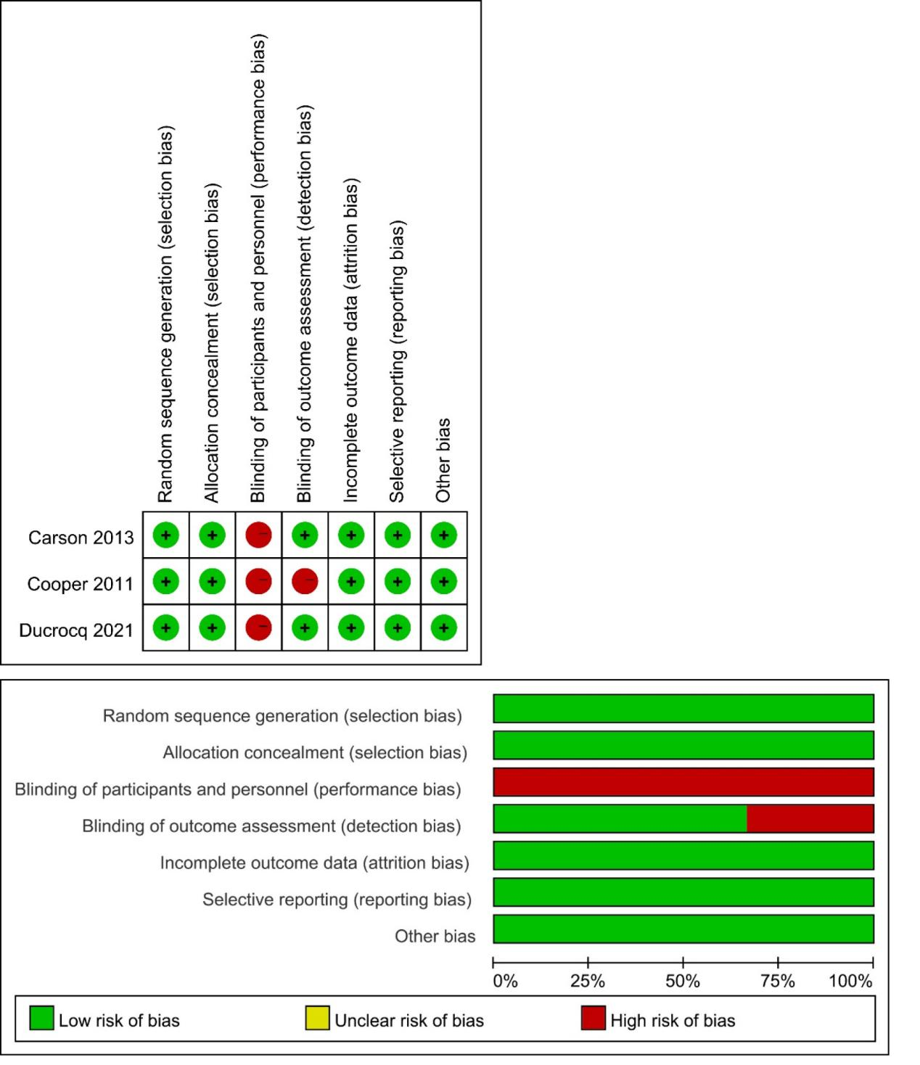

Figure S2 Forest plot for the association between blood transfusion strategies with in-hospital and follow-up mortality
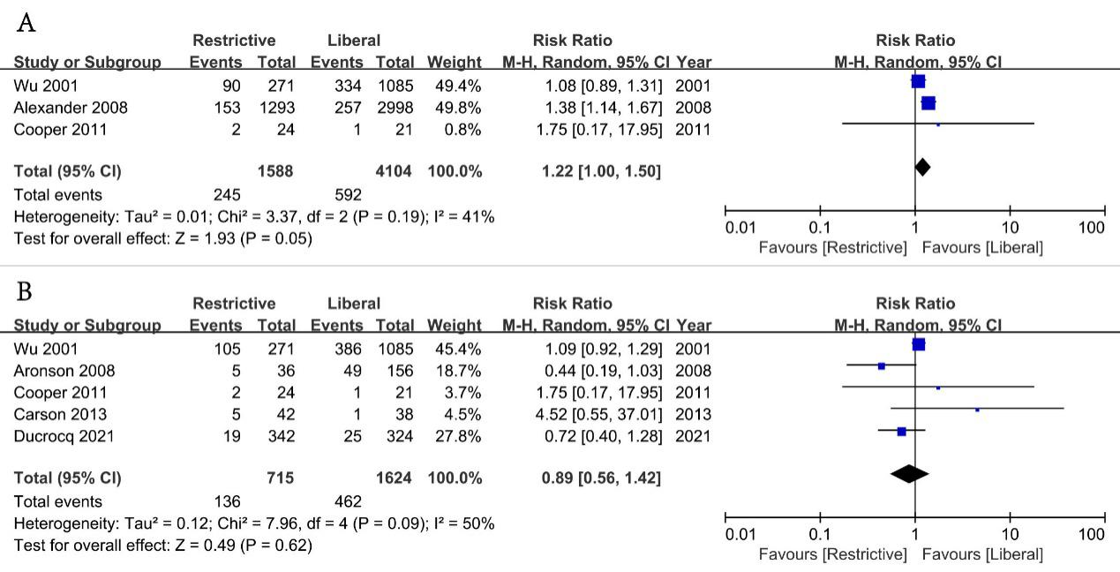
A: In- hospital mortality; B: Follow-up mortality

Figure S3 Funnel plot analysis of potential publication bias
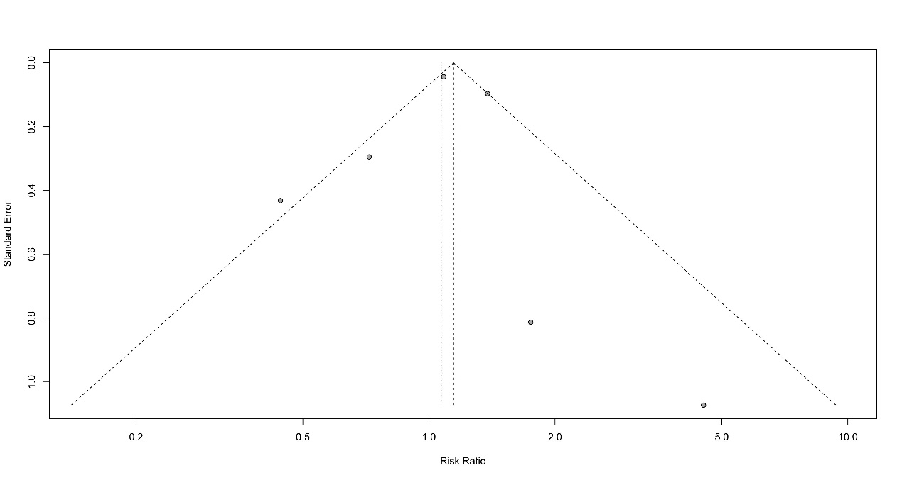

Figure S4 A leave-one-out sensitivity analysis of this meta-analysis
