Supplementary information

Risk Factors for Invasive Aspergillosis in Patients Admitted to the ICU with COVID-19: A Multicenter Retrospective Study

Jiqian Xu^{1,2,6}, Xiaobo Yang¹, Zheng Lv¹, Ting Zhou¹, Hong Liu^{1,2}, Xiaojing Zou¹, Fengsheng Cao⁴, Lu Zhang⁴, Boyi Liu⁵, Wei Chen⁵, Yuan Yu¹, Huaqing Shu¹, Shiying Yuan¹, Ming Hu^{3†}, Chaolin Huang^{2†}, You Shang^{1,2,6†}

Figure S1.

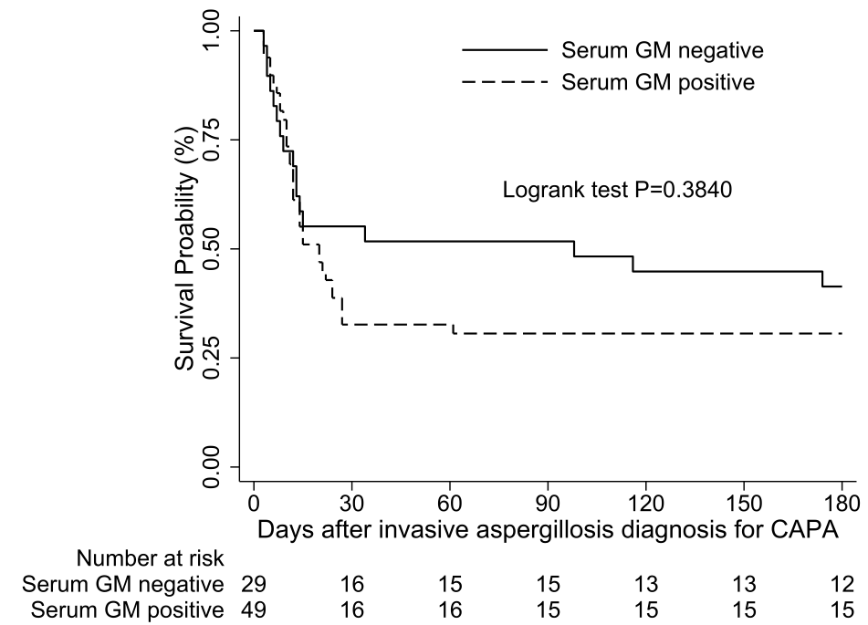
Figure S1. Kaplan–Meier plots of the patients with CAPA according to serum GM index.
Abbreviations: CAPA: coronavirus disease–associated invasive pulmonary aspergillosis; GM, galactomannan.

Figure S2.
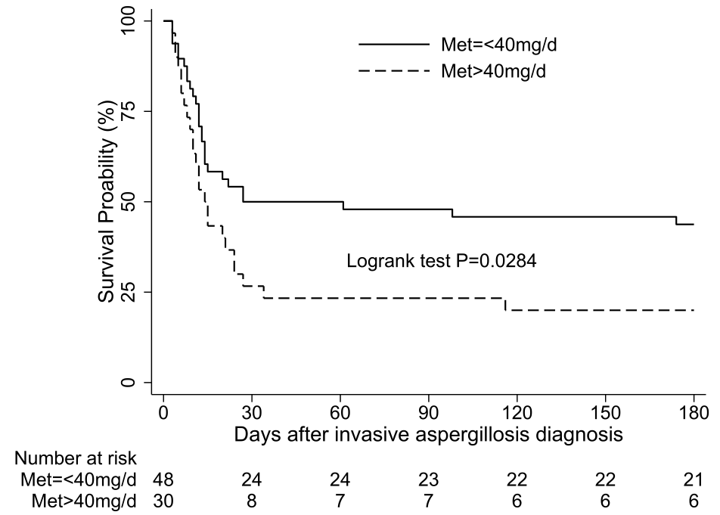
Figure S2. Survival curve of the patients with CAPA according to Methylprednisolone dosage.
Abbreviations: CAPA: coronavirus disease–associated invasive pulmonary aspergillosis; Met, Methylprednisolone.

Table S1. Bacterial Co-infection or Secondary Bacterial Infection of COVID-19 Patients with or without CAPA at the time of CAPA diagnosis*

Tracheal aspirate or sputum culture | Total  N= 28 (%) | With CAPA  N=12(%) | Without CAPA  N=16 (%) | p value
Klebsiella spp. | 13 (46.4) | 10 (62.5) | 3 (25.0) | 0.055
Acinetobacter baumannii | 10 (35.7) | 6 (50.0) | 4 (25.0) | 0.167
Stenotrophomonas maltophilia | 2 (7.1) | 2 (16.7) | 0 (0.0) | 0.175
Pseudomonas spp. | 2 (7.1) | 1 (8.3) | 0 (6.3) | 0.683
Escherichia coli | 1 (3.6) | 0 (0.0) | 1 (6.3) | 0.571

Abbreviations: CAPA, coronavirus-associated invasive pulmonary aspergillosis; COVID-19, coronavirus disease 2019;
* These bacteria were from the culture of tracheal aspirate or sputum.

