Supplementary data for

Identification of novel Type three secretion system (T3SS) inhibitors by computational methods and anti-Salmonella evaluations
Yonghui Wang,¹ Meihui Hou,² Zhaodong Kan³, Guanghui Zhang³, Yunxia Li³, Lei Zhou^{4,}* and Changfa Wang^{1,}*
¹College of Agronomy, Liaocheng University, Liaocheng 252059, China
²Burns and plastic surgery department, The 960th Hospital of the PLA Joint Logistics Support Force, Jinan 252059, China
³Laizhou city laiyu chemical co., Ltd, Laizhou 261400, China
⁴School of Biological Science and Technology, University of Jinan, Jinan 250022, China
* Correspondence:
Lei Zhou
bio_zhoul@ujn.edu.cn
Changfa Wang
wangcf1967@163.com

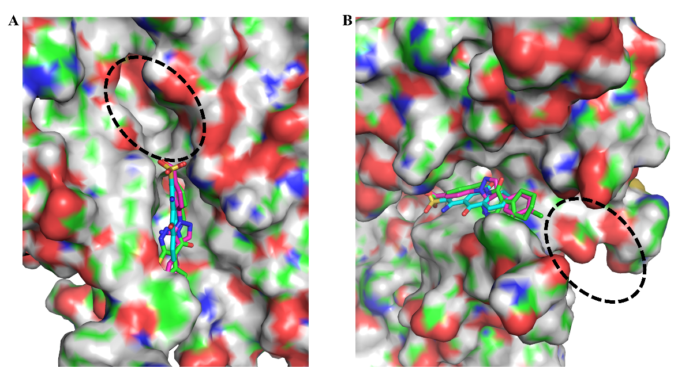
Figure 1. The predicted binding modes of compounds 5, 19, and 32 with SipD protein.

Virtual screening method:
Molecular docking based virtual screening was performed using the Autodock 4.2 program (Huey et al., 2007; Morris et al., 1998). The crystal structure of the Salmonella type III secretion system tip protein SipD in complex with deoxycholate (PDB ID: 3O01) (Chatterjee et al., 2011) was used to construct the docking model. The missing hydrogen atoms were added, Gasteiger charges was assigned, and the protein were parameterized with AD4 type by Autodock Tools 1.5.6. Finally, the protein structure was used as an input for the Autogrid program. Grid map with 60 x 60 x 60 points was made according to the conformation of ligand, and the grid spacing was set to 0.375 Å. Rigid ligand docking was performed for prepared SPECS database (www.specs.com, contains more than 200,000 compounds) compounds. Docking calculations were carried out using the Lamarckian genetic algorithm (LGA). After molecular docking simulation, the top 300 compounds were selected for the following cluster analysis. “Clustering Molecules” protocols embedded in Pipeline Pilot 7.5 (Pipeline Pilot; Accelrys Software Inc., San Diego, CA) was used to do the cluster analysis. Finally, according to the cluster analysis results, the 46 candidate compounds were selected and purchased from SPECS database supplier.

