Supplementary Material

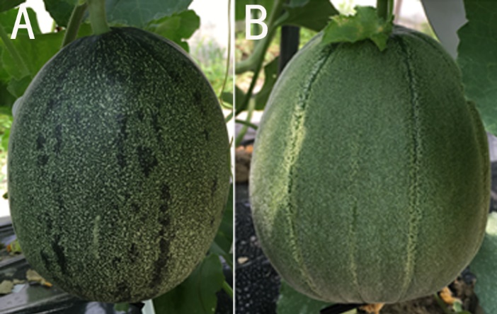
Supplementary Figure 1. Immature melon fruit of HPG (A, maternal parent, dark green and mottled rind) and MR-5 (B, paternal parent, dark green and non-mottled rind).

