Supplementary Material

Supplementary Figure 1. Probit analyses for detecting infectious virus in respiratory samples. Cell culture (a) for the detection of subgenomic RNA (b) Ag rapid FIA positivity (c), and Ag Gold (d) with respect to days post symptom onset. Blue line represents the probit curve, and dotted red lines represent the 95% confidence interval. Circles indicate marker points.

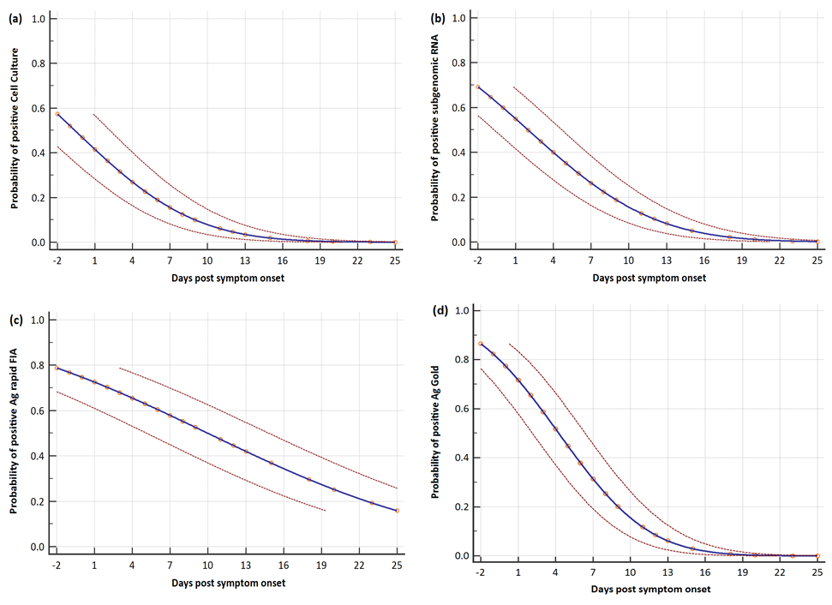
Days post symptom onset with less than 5% chances of positive results were: 11.7, 15.01, 34.60, and 13.56 days for SARS-CoV-2 Vero E6 culture, subgenomic RNA, Ag rapid FIA, and Ag Gold, respectively.

Supplementary Figure 2: Assessment of subgenomic RNA in respiratory tract sample specimens.
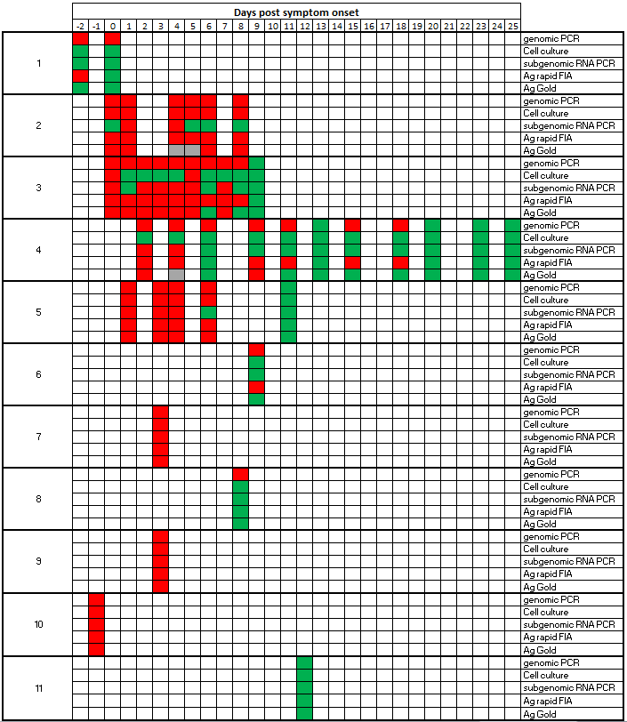
Individual patient charts with viral culture, Ag rapid FIA, and Ag Gold results in relation to the days post symptom onset. Positive test results are indicated in red, negative test results in green, and the unavailability of samples in grey. The assay was considered positive if any one or more respiratory samples (oropharynx, nasopharynx, or saliva) were positive on the same day as sample collection.

Supplementary Table
Supplementary Table 1: SARS-CoV-2 RT-PCR, cell culture and SARS-CoV-2 Ag-RDTs results for the examined clinical samples.
Sample No. | Days PSO | SARS-CoV-2 rRT-PCR |  |  |  | Cell Culture | Ag Rapid FIA | Ag Gold
 |  | N-gene | E-gene | RdRp-gene | sgRNA
1 | -2 | 30.55 | 30.11 | 30.30 | UD | Neg | Pos | Neg
2 | 0 | 31.64 | 31.74 | 32.21 | UD | Neg | Neg | Neg
3 | 0 | 18.84 | 17.96 | 18.02 | UD | Pos | Pos | Pos
4 | 1 | 17.85 | 17.74 | 17.88 | 24.06 | Pos | Pos | Pos
5 | 1 | 36.53 | 34.42 | 34.64 | UD | Neg | Neg | Neg
6 | 1 | 27.65 | 27.91 | 27.79 | UD | Neg | Pos | Pos
7 | 4 | 27.47 | 27.54 | 27.69 | 32.70 | Neg | Pos | NA
8 | 4 | 27.88 | 27.50 | 27.70 | 35.92 | Pos | Pos | NA
9 | 5 | 31.44 | 31.83 | 31.91 | UD | Pos | Pos | NA
10 | 5 | 28.00 | 27.50 | 28.37 | UD | Neg | Pos | NA
11 | 6 | 26.48 | 25.40 | 25.55 | 31.45 | Pos | Pos | Pos
12 | 6 | 29.35 | 29.24 | 29.39 | UD | Neg | Pos | Neg
13 | 8 | 39.06 | UD | 39.06 | UD | Neg | Neg | Neg
14 | 8 | 29.30 | 28.40 | 28.76 | UD | Pos | Pos | Pos
15 | 0 | 20.70 | 21.27 | 21.48 | UD | Pos | Pos | Pos
16 | 0 | 24.55 | 25.84 | 26.20 | 33.81 | Neg | Neg | Pos
17 | 1 | 21.60 | 22.29 | 22.74 | UD | Neg | Pos | Pos
18 | 2 | 24.77 | 25.57 | 25.80 | 31.36 | Neg | Pos | Pos
19 | 3 | 25.05 | 26.14 | 26.01 | UD | Neg | Neg | NA
20 | 3 | 23.36 | 24.24 | 24.35 | 30.53 | Neg | Pos | Pos
21 | 4 | 23.92 | 24.91 | 24.87 | 29.75 | Neg | Pos | Pos
22 | 4 | 28.21 | 29.38 | 29.14 | UD | Neg | Neg | Neg
23 | 5 | 23.73 | 24.57 | 24.92 | 29.79 | Neg | Neg | Neg
24 | 5 | 23.28 | 24.54 | 24.65 | 29.71 | Pos | Pos | Pos
25 | 5 | 30.00 | 30.31 | 30.77 | UD | Neg | Pos | Neg
26 | 6 | 29.95 | 31.06 | 31.30 | UD | Neg | Pos | Neg
27 | 7 | 32.78 | 33.84 | 33.40 | UD | Neg | Neg | Neg
28 | 7 | 23.65 | 24.61 | 24.42 | 30.55 | Neg | Pos | Pos
29 | 7 | 22.46 | 23.84 | 24.33 | 28.24 | Neg | Pos | Pos
30 | 8 | 32.62 | 33.39 | 34.35 | UD | Neg | Pos | Neg
31 | 9 | 35.24 | UD | 37.95 | UD | Neg | Neg | Neg
32 | 2 | 33.79 | NA | NA | UD | Neg | Neg | NA
33 | 2 | 23.50 | NA | NA | UD | Neg | Pos | NA
34 | 2 | 23.29 | NA | NA | 32.69 | Neg | Pos | Pos
35 | 4 | 37.17 | NA | NA | UD | Neg | Neg | Neg
36 | 4 | 23.67 | NA | NA | 32.89 | Neg | Pos | NA
37 | 4 | 20.09 | NA | NA | 31.91 | Neg | Neg | Neg
38 | 6 | 36.45 | NA | NA | UD | Neg | Neg | Neg
39 | 6 | 29.01 | NA | NA | UD | Neg | Neg | Neg
40 | 6 | 24.73 | NA | NA | UD | Neg | Neg | Neg
41 | 9 | 35.38 | NA | NA | UD | Neg | Neg | NA
42 | 9 | 26.96 | NA | NA | UD | Neg | Pos | Pos
43 | 9 | 26.71 | NA | NA | UD | Neg | Pos | Neg
44 | 11 | 33.67 | 35.77 | 36.60 | UD | Neg | Pos | Neg
45 | 13 | 35.33 | NA | NA | UD | Neg | Neg | Neg
46 | 15 | 32.12 | NA | NA | UD | Neg | Pos | Neg
47 | 18 | 31.46 | NA | NA | UD | Neg | Pos | Neg
48 | 23 | 37.10 | NA | NA | UD | Neg | Neg | Neg
49 | 20 | 37.35 | NA | NA | UD | Neg | Neg | Neg
50 | 25 | 36.46 | NA | NA | UD | Neg | Neg | Neg
51 | 1 | 16.56 | 18.35 | 18.70 | 23.65 | Pos | Pos | Pos
52 | 2 | 32.63 | 34.40 | 36.45 | UD | Neg | Neg | Neg
53 | 3 | 19.10 | 20.30 | 20.40 | 24.15 | Pos | Pos | Pos
54 | 4 | 22.27 | 24.21 | 24.40 | 29.33 | Pos | Pos | Pos
55 | 6 | 24.99 | 26.92 | 27.24 | 32.66 | Neg | Neg | Neg
56 | 6 | 32.31 | 35.00 | 34.51 | 31.2 | Pos | Pos | Pos
57 | 11 | 37.27 | UD | UD | UD | Neg | Neg | Neg
58 | 9 | 32.25 | 35.31 | 36.50 | UD | Neg | Pos | Neg
59 | 3 | 25.01 | NA | NA | 32.64 | Pos | Pos | Pos
60 | 8 | 34.47 | 31.18 | 30.43 | UD | Neg | Neg | Neg
61 | 3 | 29.14 | NA | NA | 34.65 | Pos | Pos | Pos
62 | -1 | 17.53 | 12.11 | 13.55 | 22.59 | Pos | Pos | Pos
63 | 12 | 36.11 | 27.53 | 27.68 | UD | Neg | Neg | Neg
Days PSO; days post symptom onset, sgRNA; subgenomicRNA

