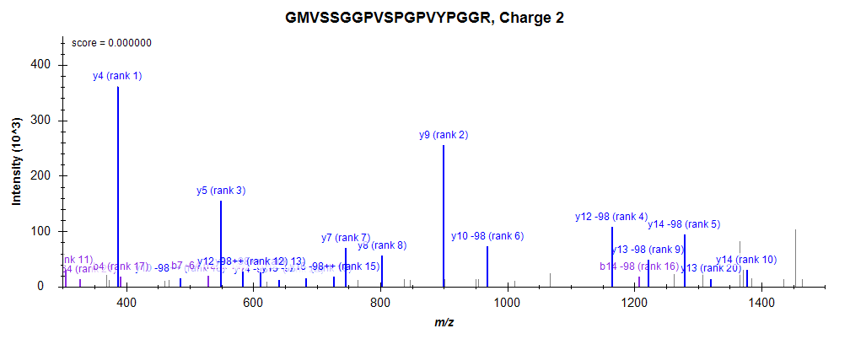
GM[Oxidation]VSSGGPVS[Phospho]PGPVYPGGR

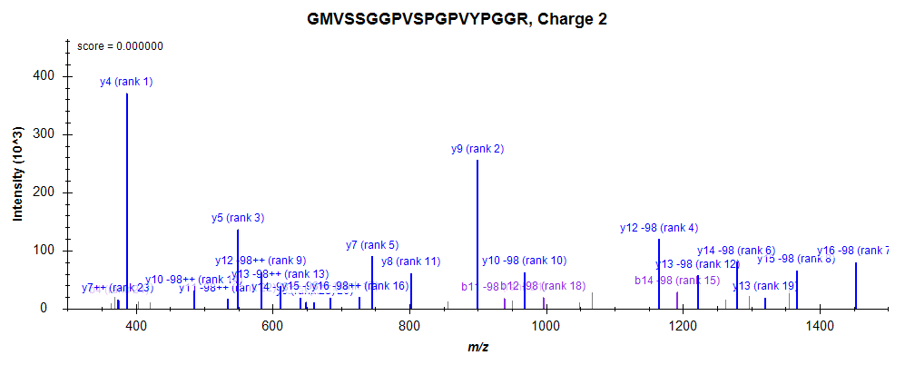
GMVSSGGPVS[Phospho]PGPVYPGGR

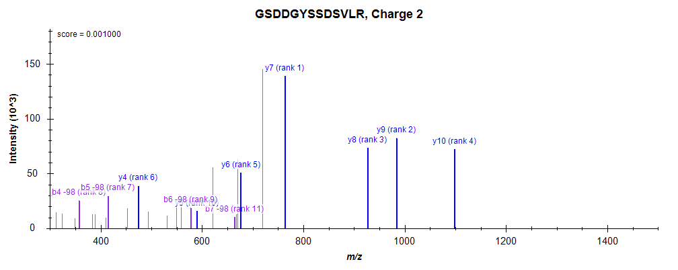
GS[Phospho]DDGYSSDSVLR

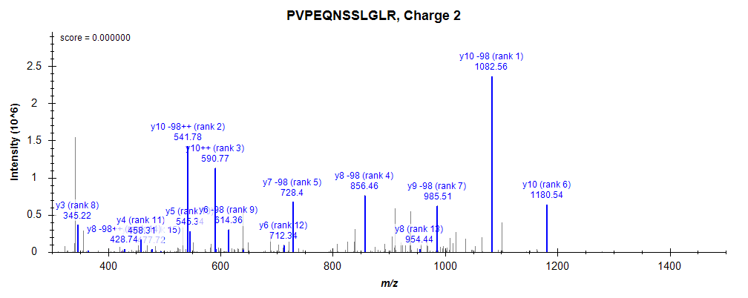
PVPEQNS[Phospho]S[Phospho]LGLR

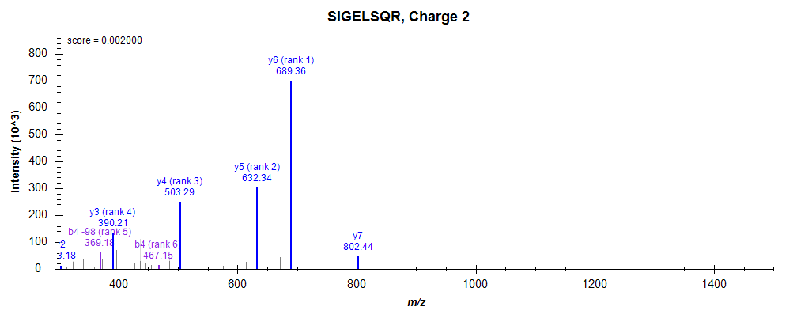
S[Phospho]IGELSQR

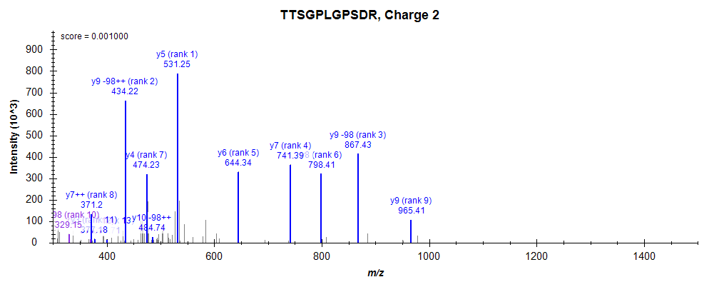
T[Phospho]TS[Phospho]GPLGPSDR

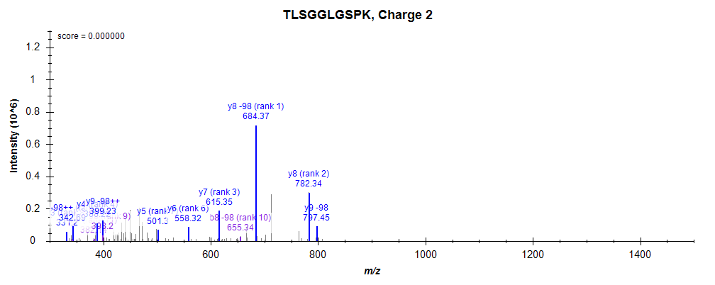
TLS[Phospho]GGLGS[Phospho]PK

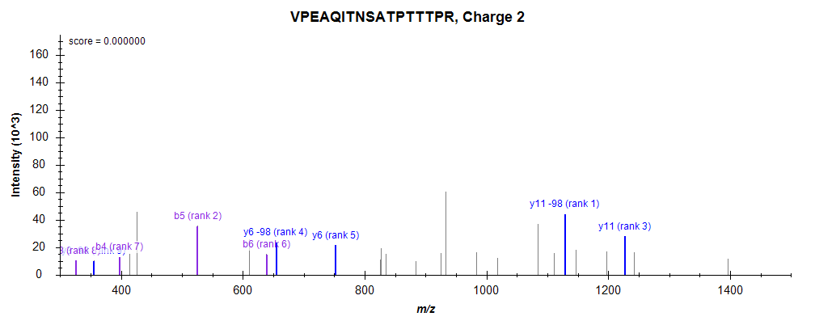
VPEAQITNSATPTTT[Phospho]PR

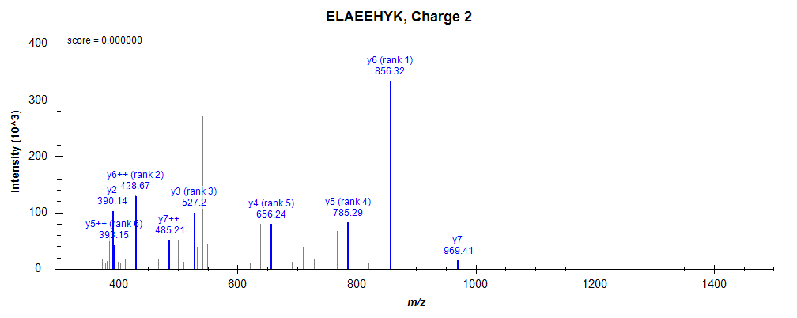
ELAEEHY[Phospho]K

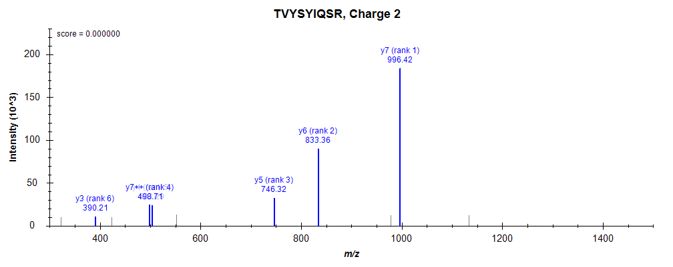
TVYSY[Phospho]IQSR

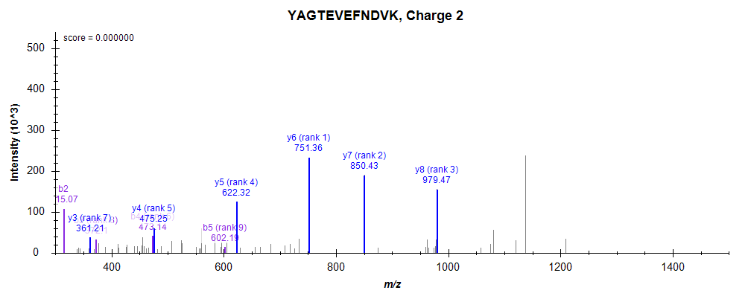
Y[Phospho]AGTEVEFNDVK

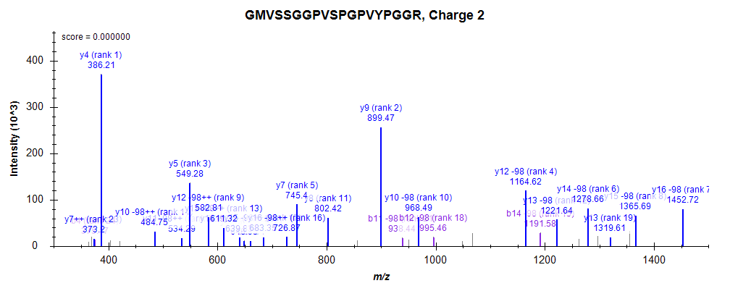
GMVSSGGPVS[Phospho]PGPVYPGGR

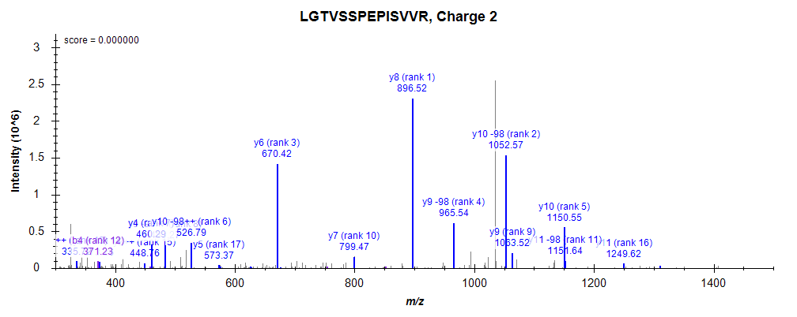
LGTVSS[Phospho]PEPISVVR

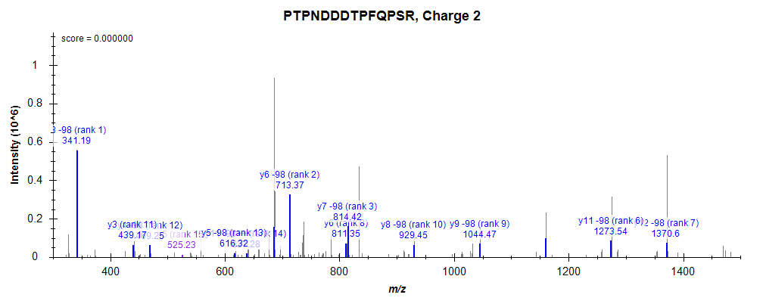
PTPNDDDTPFQPS[Phospho]R

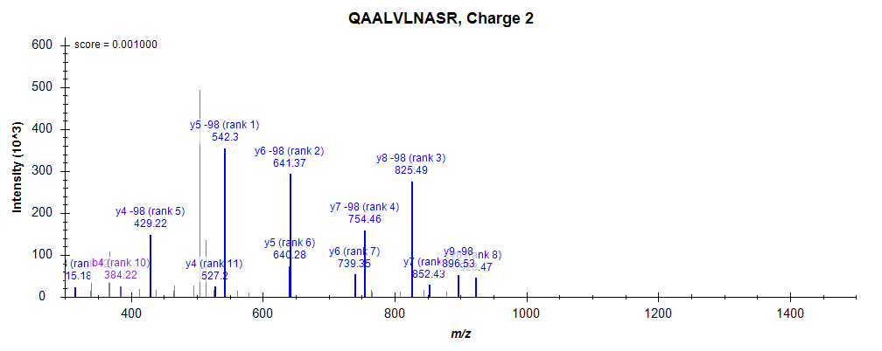
QAALVLNAS[Phospho]R

