Supplementary Materials
Table S1. Peak activations and coordinates of the ICN spatial maps.
ICNs | X | Y | Z
Basal ganglia network （4）
Caudate (21) | 12 | 17 | -1
Subthalamus/hypothalamus (16) | 3 | -13 | -16
Putamen (90) | -24 | 2 | -4
Thalamus (29) | -9 | -15 | 10
Auditory domain (AUD)（3）
Superior temporal gyrus ([STG], 5) | 63 | -19 | -1
Superior temporal gyrus ([STG], 43) | -39 | -25 | 8
Superior temporal gyrus ([STG], 85) | -54 | -37 | 14
Sensorimotor domain (SM)（9）
Postcentral gyrus ([PoCG], 3) | -54 | -13 | 32
Left postcentral gyrus ([L PoCG], 41) | -36 | -31 | 59
Paracentral lobule ([ParaCL], 2) | -6 | -37 | 65
Right postcentral gyrus ([R PoCG], 9) | 42 | -28 | 62
Superior parietal lobule ([SPL], 13) | -18 | -58 | 65
Supplementary motor area ([SMA], 84) | 12 | -4 | 53
Postcentral gyrus ([PoCG], 33) | -21 | -34 | 59
Postcentral gyrus ([PoCG], 35) | -36 | -19 | 44
Supramarginal gyrus ([SMG], 61) | 63 | -25 | 32
Visual domain (VS)（8）
Calcarine gyrus ([CalcarineG], 19) | -6 | -97 | -4
Middle occipital gyrus ([MOG], 94) | -51 | -76 | 8
Middle occipital gyrus ([MOG], 98) | -27 | -94 | -1
Cuneus (97) | -3 | -88 | 17
Calcarine gyrus ([CalcarineG], 23) | -18 | -64 | 11
Fusiform gyrus (28) | 33 | -40 | -10
Inferior occipital gyrus ([IOG], 27) | 45 | -64 | -13
Lingual gyrus ([LingualG], 59) | -21 | -67 | -7
Cognitive-control domain (CC)（16）
Left Inferior parietal lobule/Postcentral gyrus(L [IPL/PoCG], 96) | -57 | -28 | 35
aInsula (22) | -30 | 23 | -1
Inferior frontal gyrus ([IFG], 30) | -51 | 23 | 5
Right inferior frontal gyrus ([R IFG], 36) | 45 | 17 | 26
Left inferior frontal gyrus ([R IFG], 54) | -39 | 17 | 26
Middle frontal gyrus ([MiFG], 12) | -27 | 53 | 8
Left Supplementary motor area/Precentral gyrus (L [SMA/PreCG], 73) | -6 | 2 | 65
Middle frontal gyrus ([MiFG], 32) | -33 | 41 | 32
Supplementary motor area([SMA], 86) | -6 | 11 | 50
Superior medial frontal gyrus ([SMFG], 62) | 0 | 41 | 38
Precentral gyrus ([L PreCG], 57) | 54 | 5 | 20
Inferior frontal gyrus ([IFG], 31) | 36 | 44 | -7
ParaHippocampal gyrus ([PHG], 15) | -24 | -10 | -22
pInsula (49) | 36 | 8 | 11
Superior frontal gyrus ([SFG], 95) | -18 | 17 | 53
Superior frontal gyrus ([SFG], 25) | -18 | -1 | 56
Default-mode domain (DM)（8）
Precuneus (63) | 0 | -67 | 56
Precuneus + Cuneus (38) | -6 | -82 | 35
Anterior cingulate cortex ([ACC], 47) | -3 | 56 | 14
Posterior cingulate cortex ([PCC], 11) | -3 | -31 | 23
Anterior cingulate cortex ([ACC], 82) | 6 | 35 | 14
Posterior cingulate cortex ([PCC], 17) | -3 | -64 | 26
Angular gyrus ([AG], 93) | -51 | -50 | 43
Left Angular gyrus ([L AG], 51) | -51 | -64 | 41
Cerebellar domain (CB)（3）
Cerebellum ([CB], 4) | -12 | -64 | -43
Cerebellum ([CB], 14) | -27 | -73 | -34
Cerebellum ([CB], 77)

Basal ganglia network
Auditory network

Sensorimotor network

Visual network

Cognitive executive network

Default mode network

Cerebellar network

Table S2. The head motion between the case group and the normal group
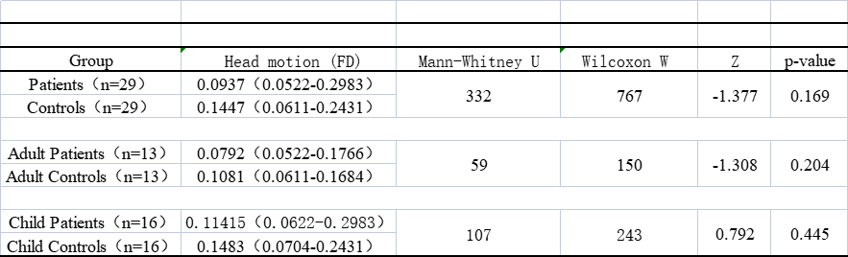

Continuous variables were expressed as median and interquartile range. Continuous parameters were checked for the normality of distribution using the Shapiro–Wilk test and compared using Mann-Whitney U test. A value of P<0.05 was considered as statistically significant.

