Figure S1. The detected result of Patient 1 by mNGS using CSF.
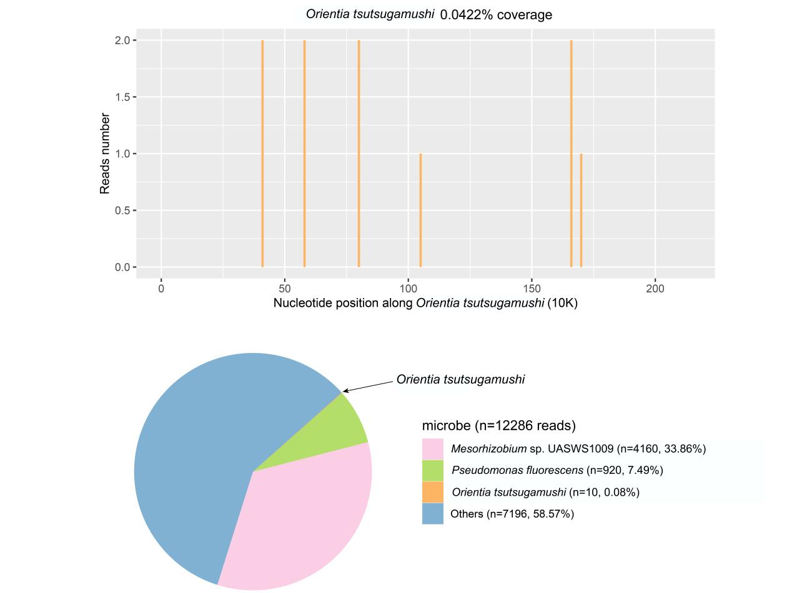

Figure S2. The detected result of Patient 2 by mNGS using CSF and blood.
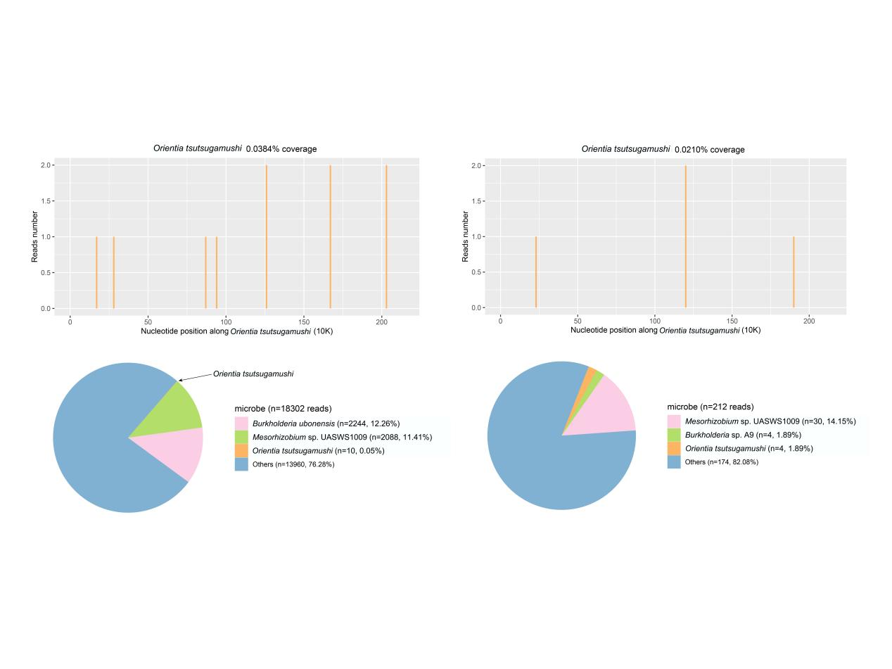
Figure S3. The detected result of Patient 3 by mNGS using blood.
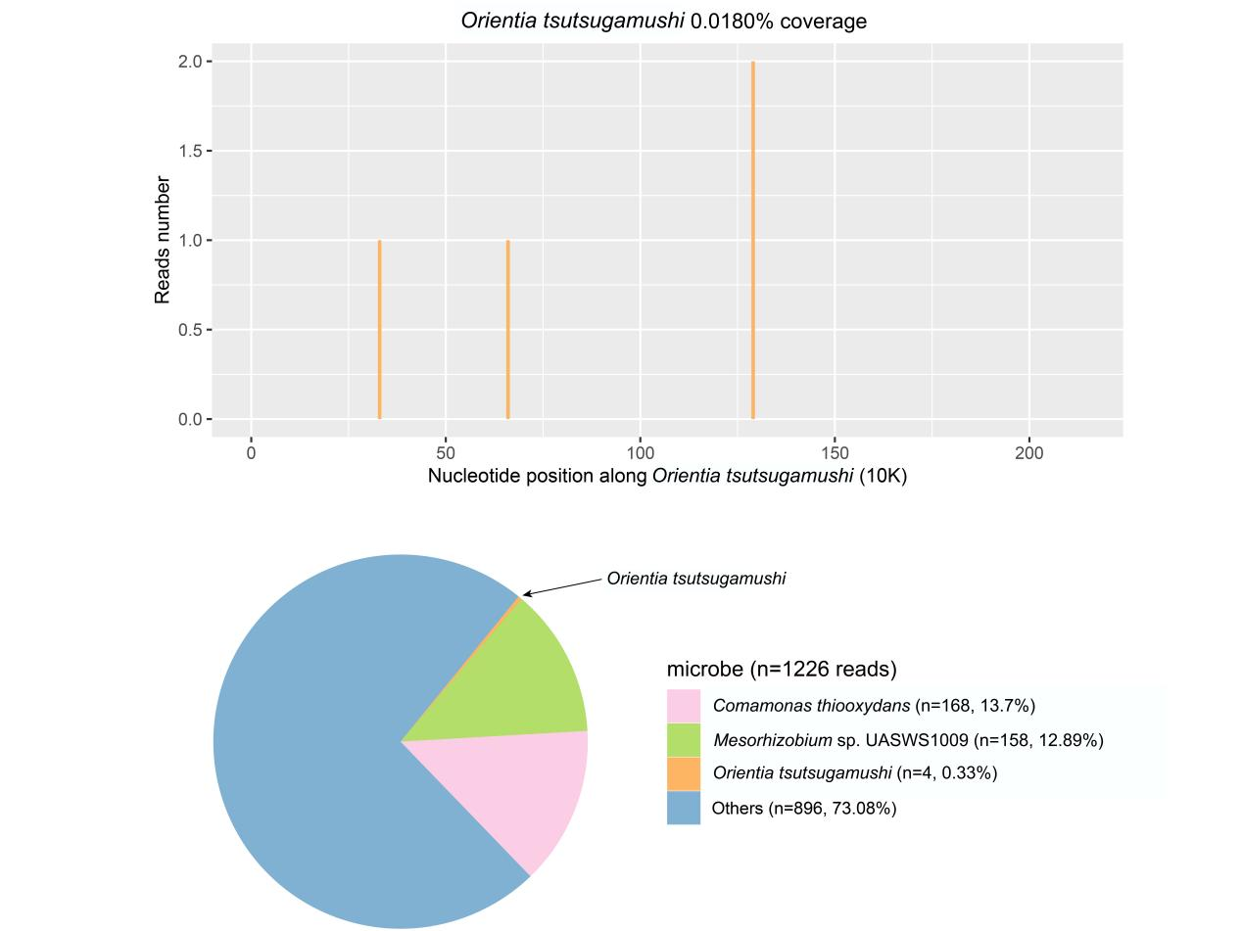
Figure S4. The detected result of Patient 4 by mNGS using blood.
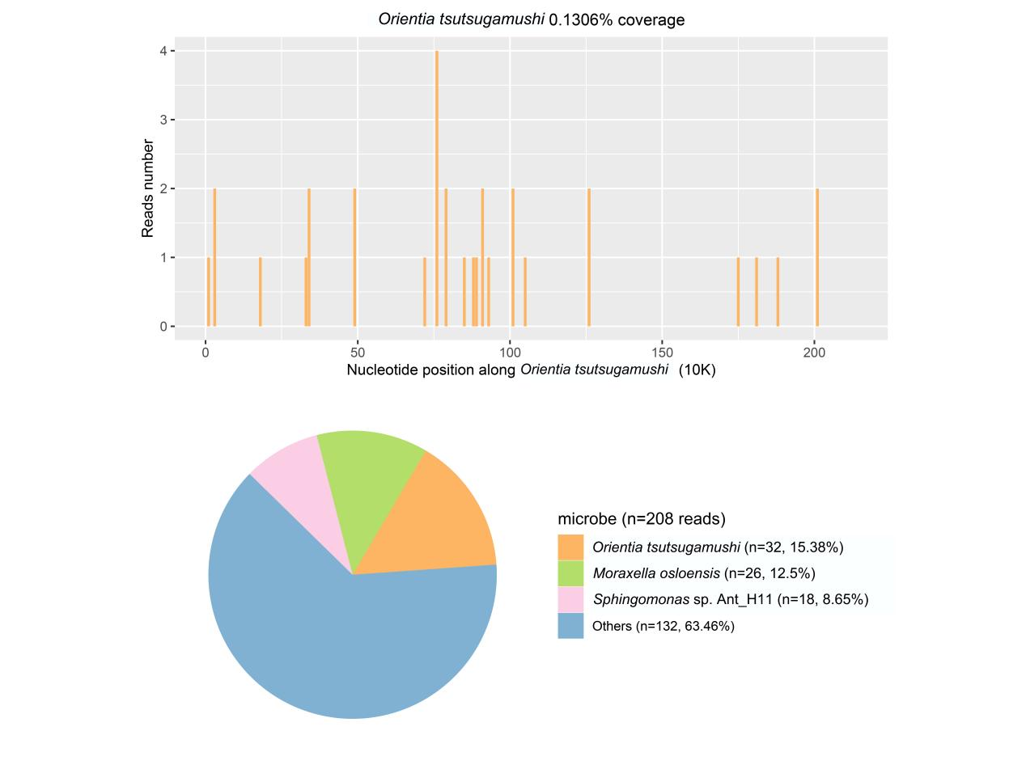
Figure S5. The detected result of Patient 5 by mNGS using blood.
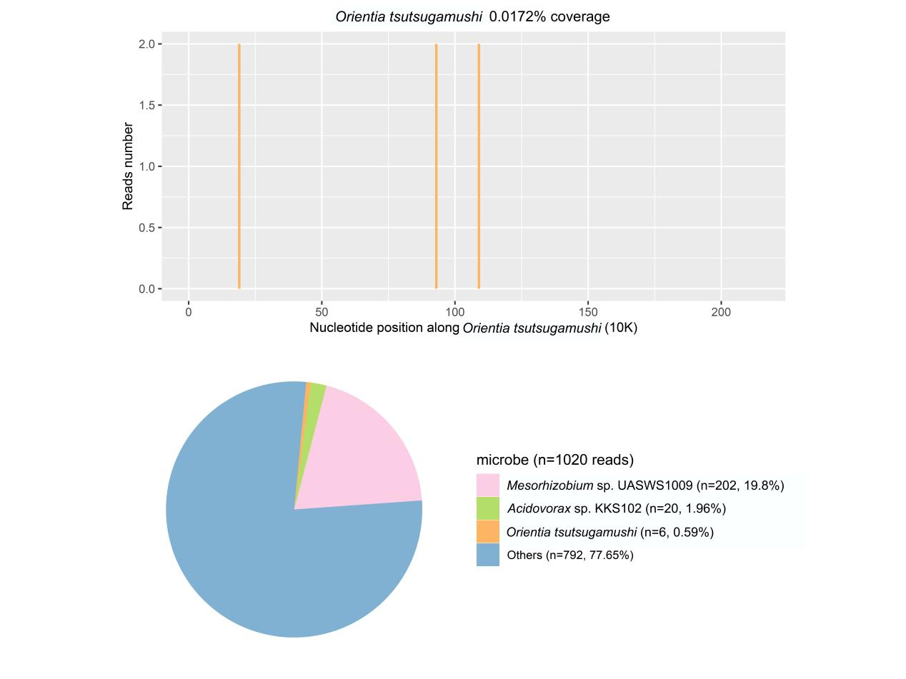
Figure S6. The detected result of Patient 6 by mNGS using blood.
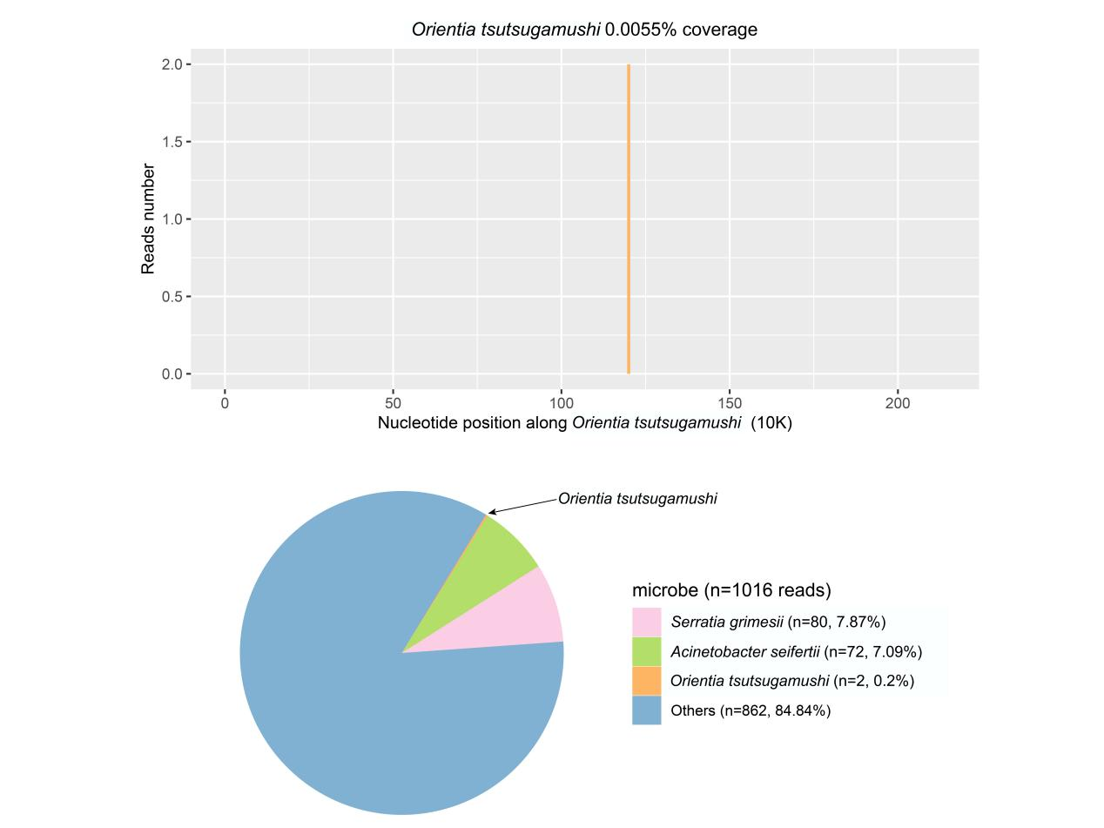
Figure S7. The detected result of Patient 7 by mNGS using CSF and blood.
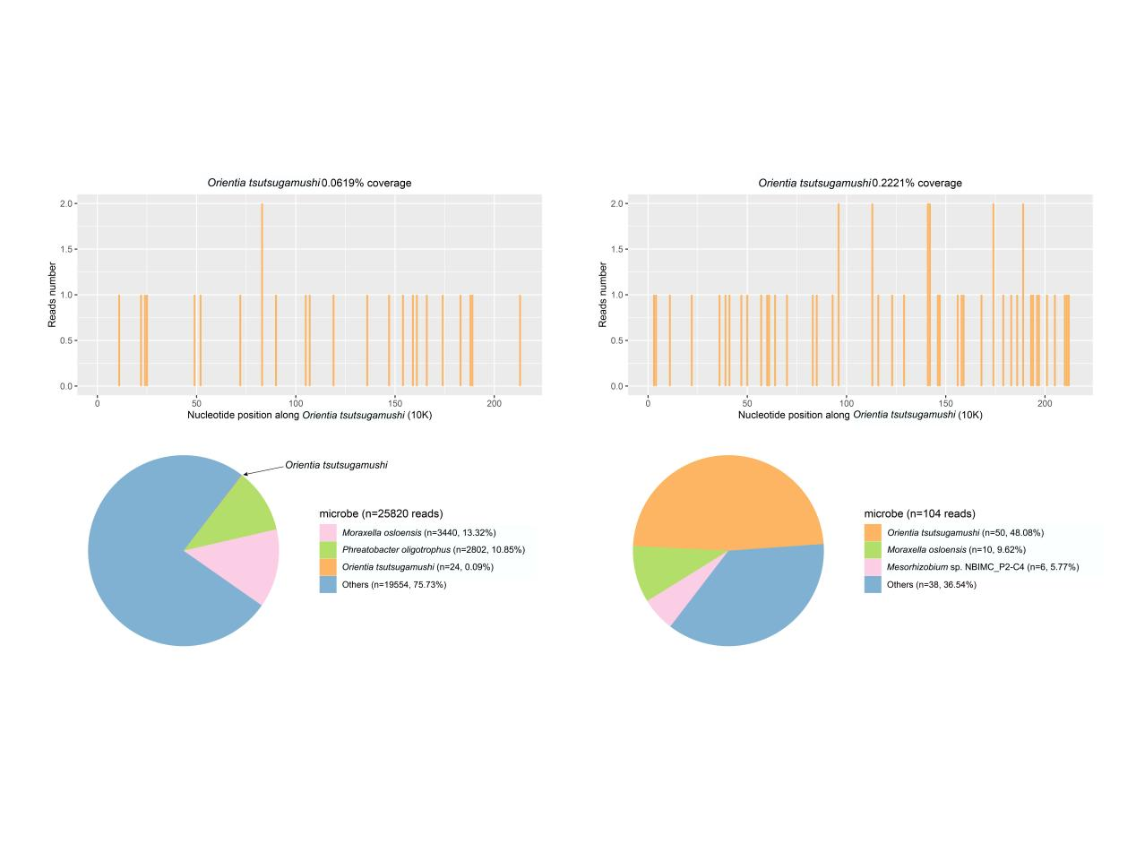
Figure S8. The detected result of Patient 8 by mNGS using pleural fluid and blood.
Figure S9. The detected result of Patient 9 by mNGS using CSF.
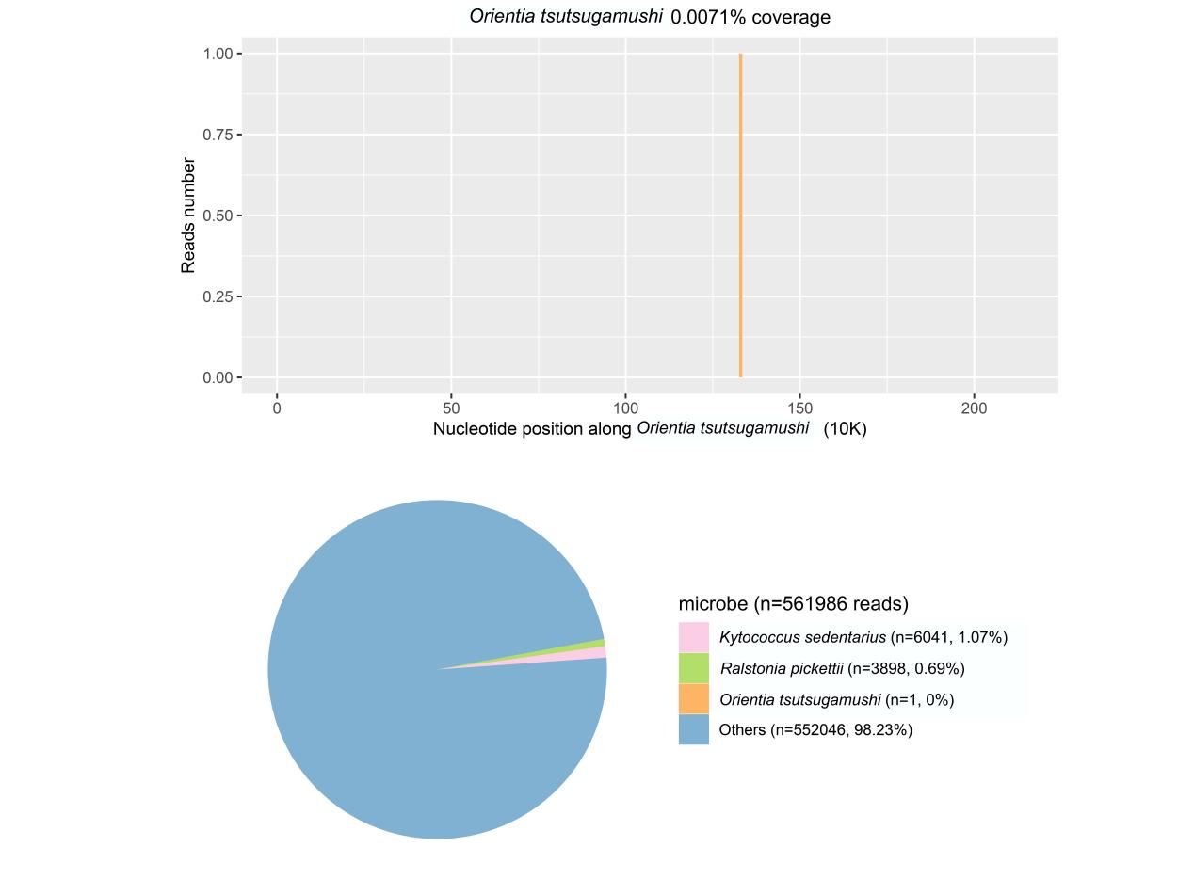
Figure S10. The detected result of Patient 10 by mNGS using CSF.
Figure S11. The detected results of qPCR.
