The expression of CD28 and its synergism on the immune response of flounder (Paralichthys olivaceus) to thymus-dependent antigen

Wenjing Liu¹, Jing Xing^{1,2*}, Xiaoqian Tang^{1,2}, Xiuzhen Sheng¹, Heng Chi¹ and
Wenbin Zhan^{1,2}
¹ Laboratory of Pathology and Immunology of Aquatic Animals, KLMME, Ocean University of China, Qingdao, China,
² Laboratory for Marine Fisheries Science and Food Production Processes, Qingdao National Laboratory for Marine Science and Technology, Qingdao, China

Supplemental Table S1
Sequences of primers used for gene cloning.
Primer name | Sequence (5'-3') | Application
CD28-F1 | GTGCCGTGCCCAATCAAGACT | Gene cloning
CD28-R1 | CTGCCCTCTGGGTTTGGTGTT
CD28-1 | TAAAGGAGTGCCCAGTGTTGT | 3' RACE
CD28-2 | GATTTGGATTCTGATGGTTGT
CD28-1 | AGTCTTGATTGGGCACGGCAC | 5' RACE
CD28-2 | CTTCACATCTGTAGGTTCCAT
CD28-RFP-F | CCCAAGCTTATGAGCGTTAGCTGGATGT (HindIII) | Eukaryotic expression
CD28-RFP-R | CGCGGATCCATGAAGTGTCGTGGTATTGGTTTC (BamHI)
CD28-F2 | CCCAAGCTTTGCAGGTCATCATGTACCACTCATG (BamHI) | Prokaryotic expression
CD28-R2 | CGCGGATCCTCAGAAGTGTCGTGGTATTGGTTTC (HindIII)
CD28-F3 | CCCAATCAAGACTGAAGACGA | qPCR
CD28-R3 | TAAAGGGAGGAGGGAATGTAA
β-actin F | GAGGGAAATCGTGCGTGACAT | qPCR
β-actin R | ATTGCCGATGGTGATGACCTG
F: forward; R: reverse; RACE, rapid amplification of cDNA ends; β-actin, accession No. HQ386788.1

Supplemental Table S2
Sequences of primers used for RT-PCR
Gene’s name | Primer sequences (5'-3') | Size (bp) | Genbank accession no.
CD3 | F: ATCGCCATGACGCTCCTC | 161 | AB081751.1
 | R: AAGCCTTTGGTTTGATCGTG
CD4-1 | F: CAACTTGCCTGGCTCAATCACT | 213 | AB643634
 | R: ACCGACTGGGTTCAAACTCACC
CD4-2 | F: GGTCCGCACCTACAAGAATAGC | 165 | AB640684
 | R: ATCCCACTGTCTTCGTTCCTCA
IgM | F: AAGTCCACAAATTACCCTCCAA | 219 | AB052744
 | R: TTCTCGCTTTTATGTTCCTCAG
CD28 | F: TTCCAACGTCTCATGCACTGG | 94 | MT019836.1
 | R: TTTTTGCTGTTTGCGCTCCAC
IL-2 | F: TAGAGGATGCCAGTATCGGTT | 246 | KY307833.1
 | R: TACATTCTGCGGAGGTCGTTG
IL-10 | F: CTACGAAGCGAACGATGA | 200 | XM_020086558.1
 | R: CGAAGATTTGCTGTATGGA
IL-6 | F: CAAAGGTTGGCTGAAGGC | 218 | DQ267937.1
 | R: TGGAAAGTGCTGGGGTTG
TNF-α | F: TCCTGGCGTTTTCTTGGT | 135 | AB040448.1
 | R: TGGCTCTGCTGCTGATTT
IFN-γ | F: TGGTCTGTCTGTCCCTGTG | 132 | AB435093.1
 | R: GCTTCCCGTTGAATCTGT
AKT | F: TCGTAGCAAAAGATGAAGT | 164 | XM_020084943.1
 | R: TGACAAGTGGAAGAAAAGC
PI3K | F: CCTTGGAAAGAAATGGAT | 153 | KY763984.1
 | R: TCTGGAGGGGAAAACTGC
NF-κB | F: CAACAGAGCCCCAAACAC | 264 | HM771267.1
 | R: CGGAGCTGCATCTTCACT
ZAP70 | F: CTAGTGCGAGACAGAGATGA | 115 | XM_020098352.1
 | R: CCTCTGGCATGGAGAATTTAC
NFAT | F: CCCGTGCATGTCAACTTCTACGT | 112 | XM_020091042.1
 | R: CATCAGTGGGTTCTGTCTTTATTATCG
β-actin | F: GAGGGAAATCGTTCGTGACAT | 142 | AF135499.1
 | R: ATTGCCGATGGTGATGACCTG

Supplemental Table S3
Molecule | Species | Accession number
CD28 | H. sapiens | CAD57003
 | M. mulatta | ABH08508.1
 | C. familiaris | AAF72533.1
 | R. norvegicus | CAA39003.1
 | G.gallus | NP_990642.1
 | S. alpinus | XP_023828332.1
 | C. semilaevis | AEM98131
 | O. niloticus | AMQ36815.1
 | T. rubripes | NP_001267008.1
 | O. fasciatus | ARP51378.1
 | D. labrax | AIK66542.1
 | P. olivaceus | MT019836.1
CTLA-4 | H. sapiens | NP_005205.2
 | M. musculus | NP_033973.2
 | C. idella | ANS56464.1
 | O. mykiss | NP_001118005.1

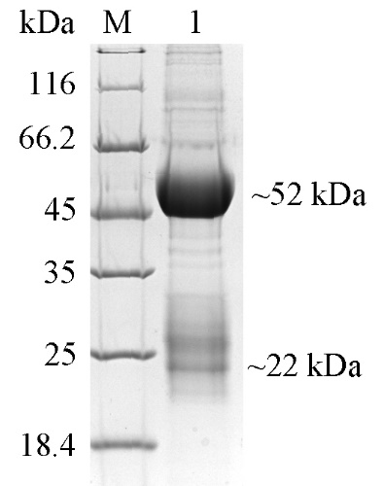
Supplemental Figure S1. SDS-PAGE analysis of purified anti-CD28 polyclonal antibody. Lane M, protein molecular weight marker; Lane 1, polyclonal antibody purified by HiTrap Protein G HP column.

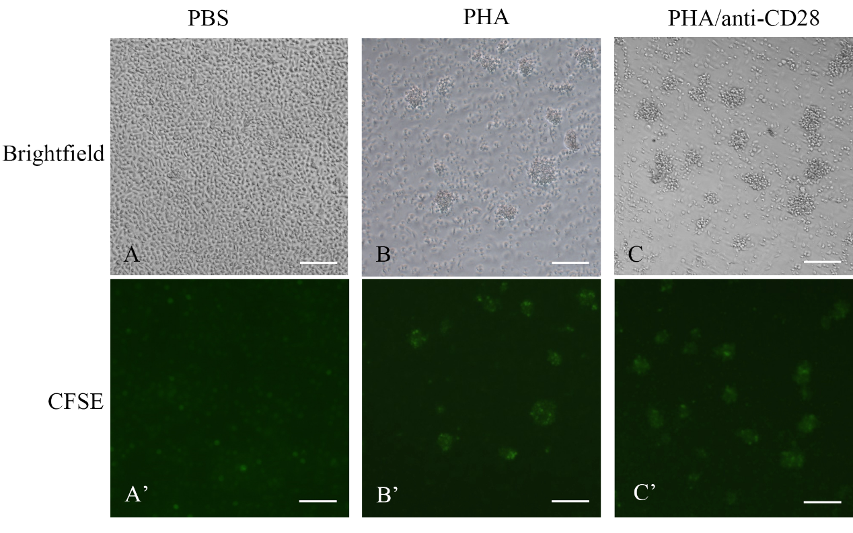
Supplemental Figure S2. Effect of stimulants on cultured leukocytes of flounder. Lymphocytes from peripheral blood were cultured for 72h with PBS (A and A’); with PHA (B and B’); with PHA+anti-CD28 (C and C’), respectively. Bar=50 μm. Images are representative of n =3.
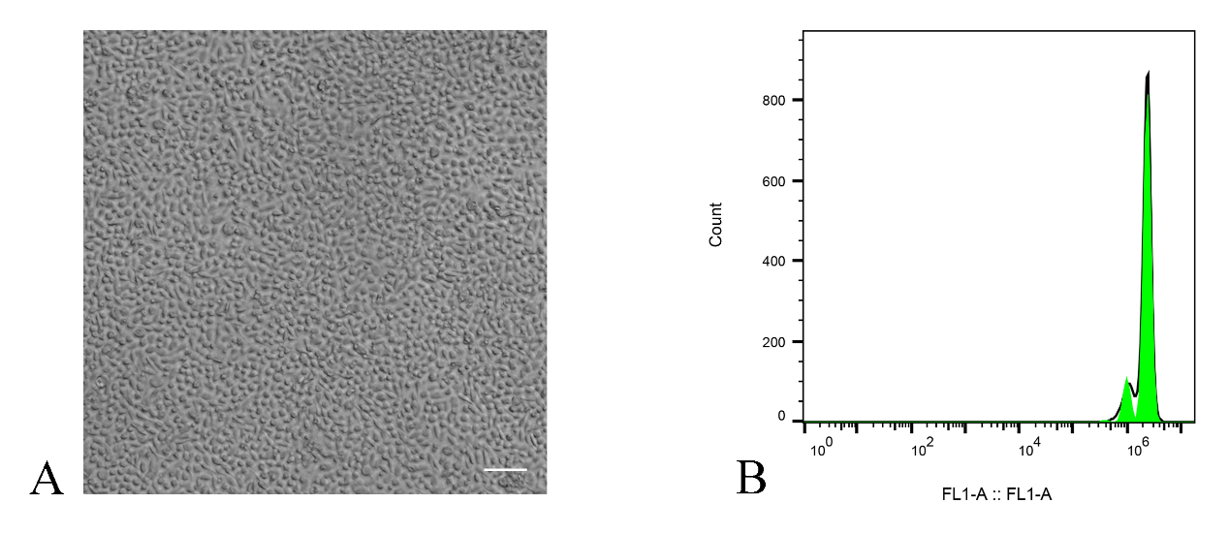
Supplemental Figure S3. Effect of un-immunized rabbit-IgG on cultured leukocytes of flounder. A. Lymphocytes from peripheral blood cultured for 72 h with of rabbit. Bar=50 μm. Images are representative of n =3. B. Leukocytes proliferation measured by CFSE. The leukocytes were cultured with un-immunized rabbit-IgG for 72 h, n=3.

