Supporting information
Fabrication and characterization of 3D printing Ta-GelMA-BG scaffolds by chemical crosslinking processing for promotion osteointegration
Fujian Zhao ^{a1}, Xiongfa Ji ^{b1}, Yang Yan ^{c, d}, Zhen Yang ^{c, d}, Xiaofeng Chen ^{c, d}, Limin Ma ^{b}*
ª Stomatological Hospital, Southern Medical University, Guangzhou 510280, China
^{b} Department of Orthopedics, Guangdong Provincial People’s Hospital, Guangdong Academy of Medical Sciences, Guangzhou 510080, China
^{c} Department of Biomedical Engineering, School of Materials Science and Engineering, South China University of Technology, Guangzhou 510641, China
^{d} National Engineering Research Center for Tissue Restoration and Reconstruction, South China University of Technology, Guangzhou 510006, China
*Corresponding authors: E-mail: malimin7@126.com (Limin Ma)
¹ These authors contributed equally to this work.

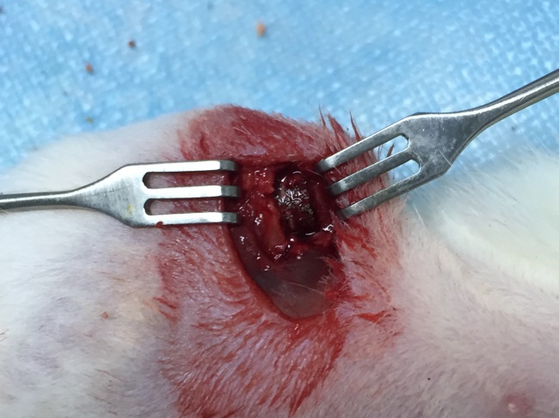
Figure. S1 Surgical placement of materials placed on critical-size bone defect of rat.

Table S1 mBMSCs related gene primer pairs used in the RT-qPCR.
Genes | Primer sequences
ALP | Forward:5'-TGCCTACTTGTGTGGCGTGAA-3’
 | Reverse:5'-TCACCCGAGTGGTAGTCACAATG-3’
OPN | Forward:5'-GCAGTCTTCTGCGGCAGGCA-3’
 | Reverse:5'-CACCGGGAGGGAGGAGGCAA-3’
OCN | Forward:5'-AGCAGCTTGGCCCAGACCTA-3’
 | Reverse:5'-TAGCGCCGGAGTCTGTTCACTAC-3’
COLⅠ | Forward:5'-ATGCCGCGACCTCAAGATG-3'
 | Reverse:5'-TGAGGCACAGACGGCTGAGTA-3'
RUNX2 | Forward:5'-CACTGGCGGTGCAACAAGA-3'
 | Reverse:5'-TTTCATAACAGCGGAGGCATTTC-3'
GAPDH | Forward:5'-CTCCCACTCTTCCACCTTCG -3’
 | Reverse:5'-TTGCTGTAGCCGTATTCATT -3’

