Supplementary Figures
Pattern Recognition Receptors (PRRs) in Macrophages Possess Prognosis and Immunotherapy Potential for Melanoma

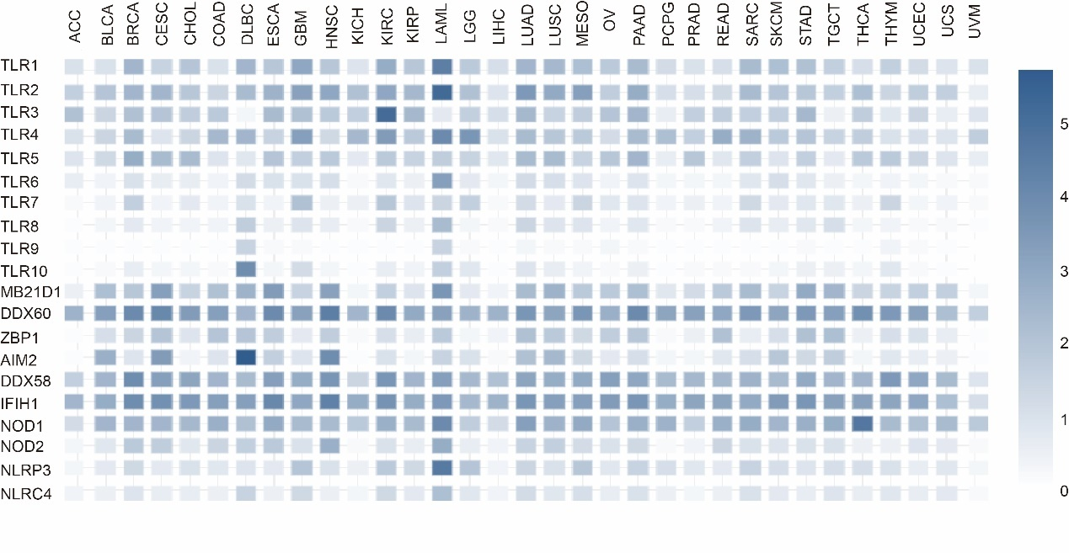
Figure S1 The expression profiles of PRRs in 33 types of tumors.
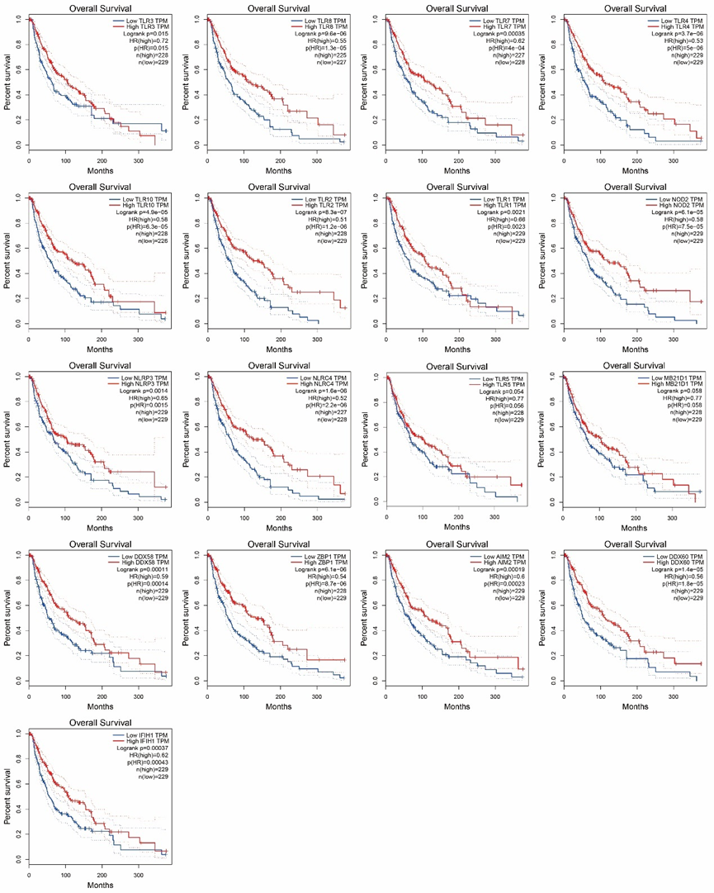
Figure S2 The survival curves of 17 SKCM-prognosis-related PRR genes (pHR<0.05).
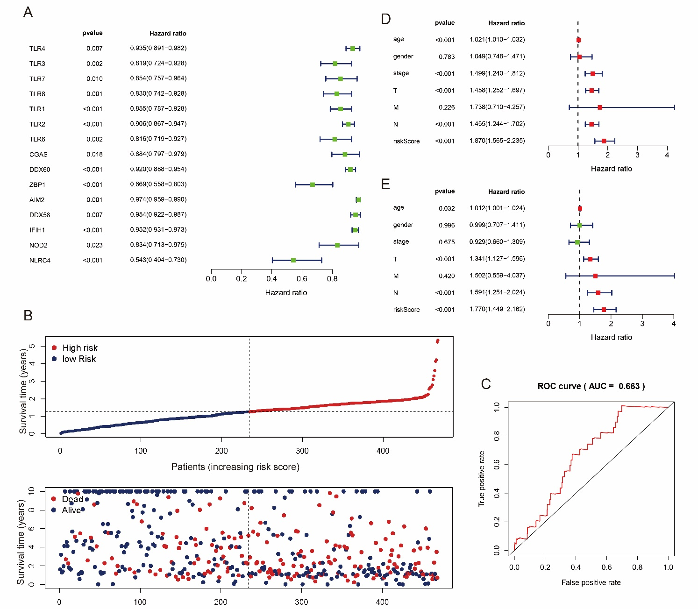
Figure S3 The construction of PRR-based COX prognosis model. (A) Hazard ratio of 15 PRRs in SKCM calculated by COX analysis. (B) Distribution of patients’ risk score and survival time, and status of SKCM (Alive/Dead). The black dotted line is the optimal cut-of value for dividing patients into low risk and high risk groups. (C) ROC curve of PRR-based COX prognosis model (AUC=0.663). (D) Univariate hazard ratio analysis of age, gender, stage, T, M, N, and risk score. (E) risk score (p < 0.001, HR = 1.770,) was presented as an independent prognostic predictor by multivariate Cox regression.
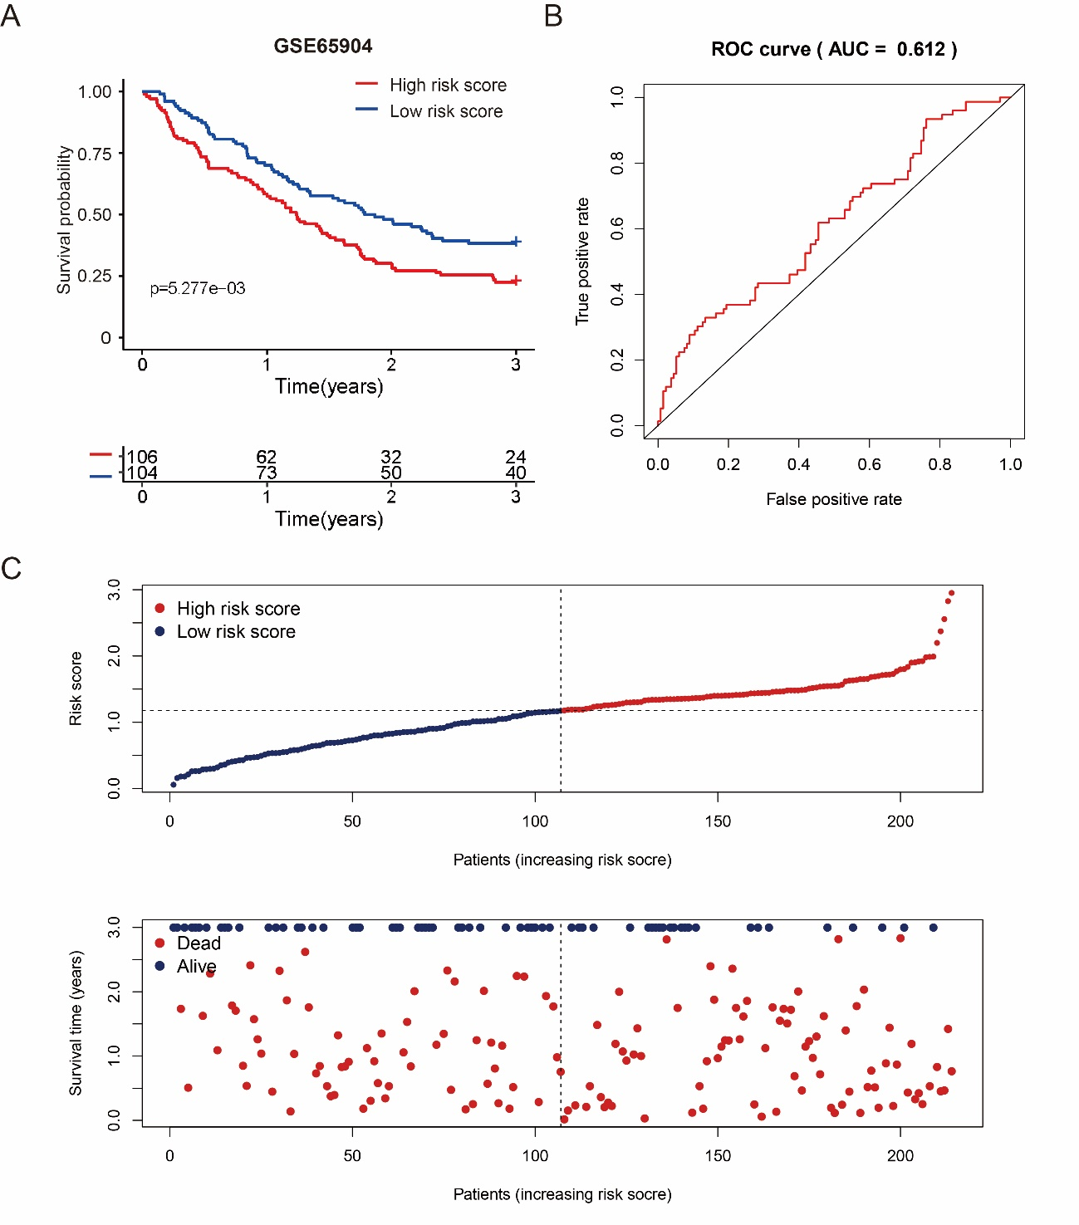
Figure S4 The verification of PRR-based COX prognosis model by analyzing testing dataset. (A) Kaplan-Meier curve of low risk score group and high risk score group of testing dataset (GSE65904), and samples which are no data of survival times are filtered. (B) ROC curve of testing dataset in PRR-based COX prognosis model (AUC=0.612). (C) Distribution of patients’ risk score and survival time, and status of testing dataset (Alive/Dead). The black dotted line is the optimal cut-of value for dividing patients into low risk and high risk groups.

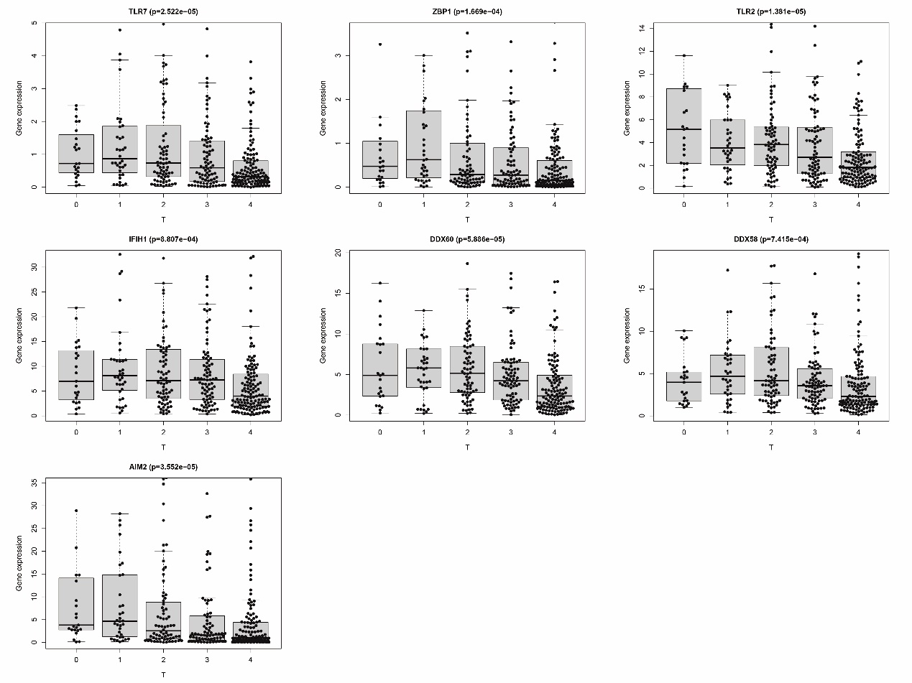
Figure S5. The expression of 7 PRR genes from COX model is high-correlated to tumor size (T)(P<0.05).
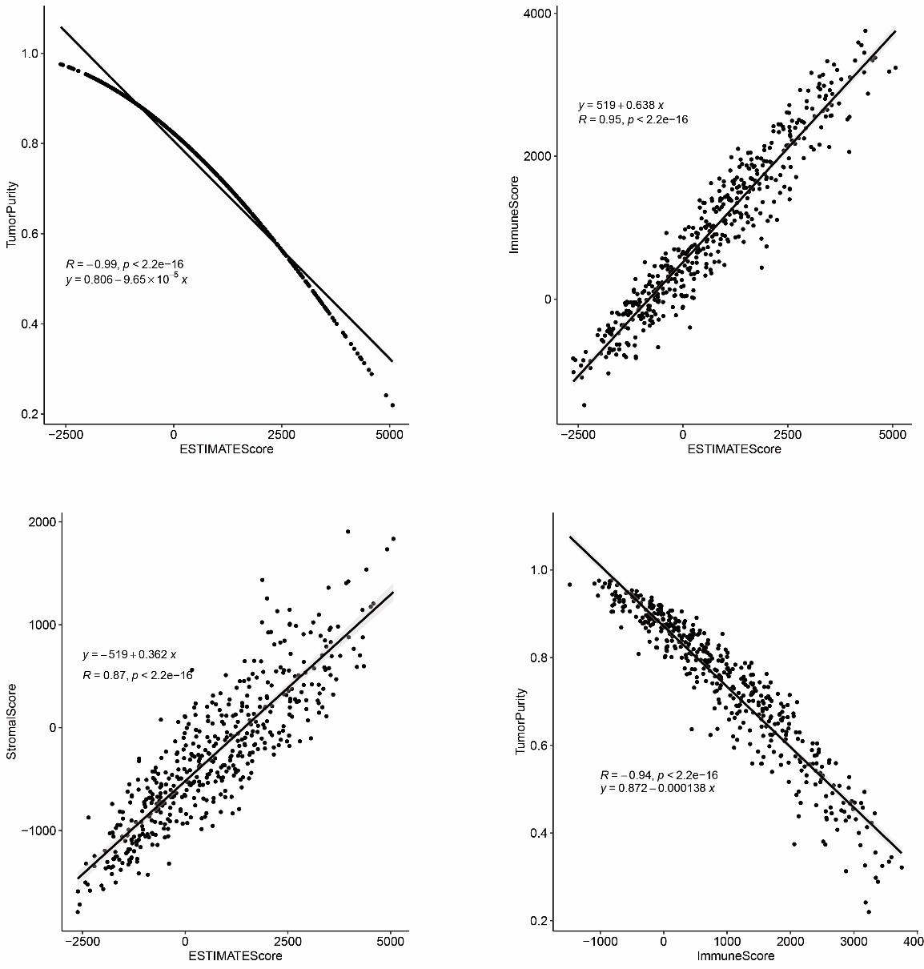
Figure S6 ESTIMATE analysis of SKCM samples.

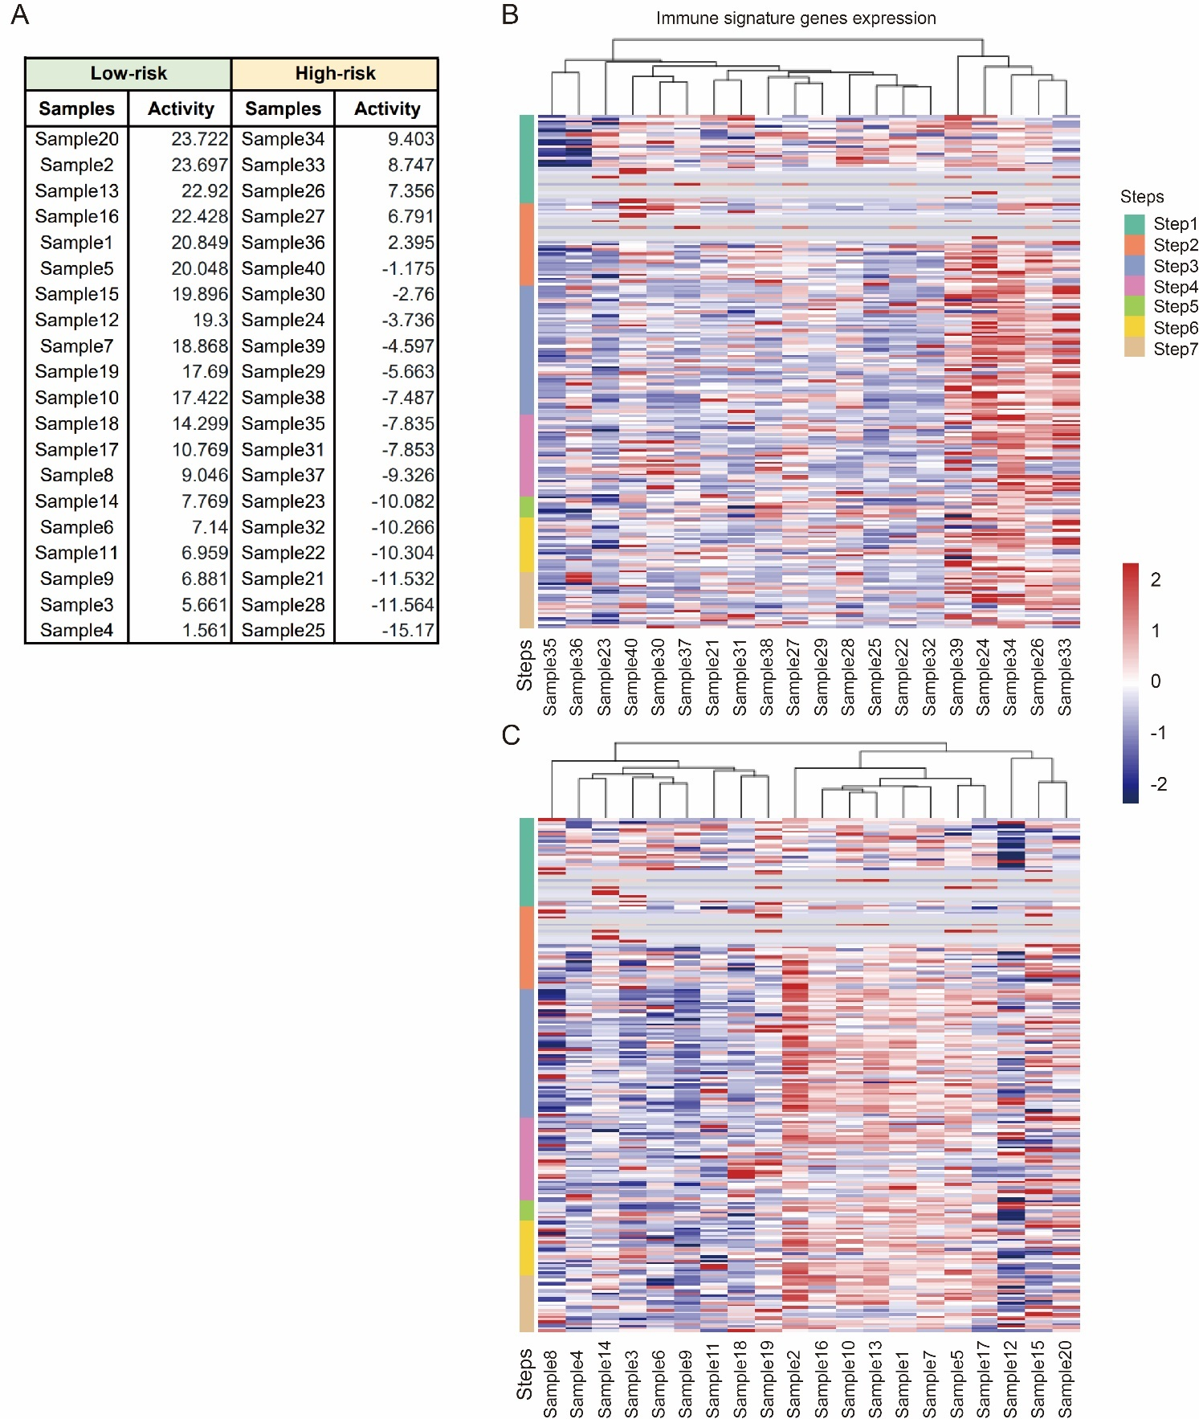
Figure S7 Immune activity and immune signature gene expression analysis by TIP. (A) The Immune activity score of top20 low risk score SKCM samples and top20 high risk score SKCM samples. (B) Heatmap shows immune signature gene expression of TOP-20 high risk score SKCM samples. (C) Heatmap shows immune signature gene expression of TOP-20 low risk score SKCM samples.
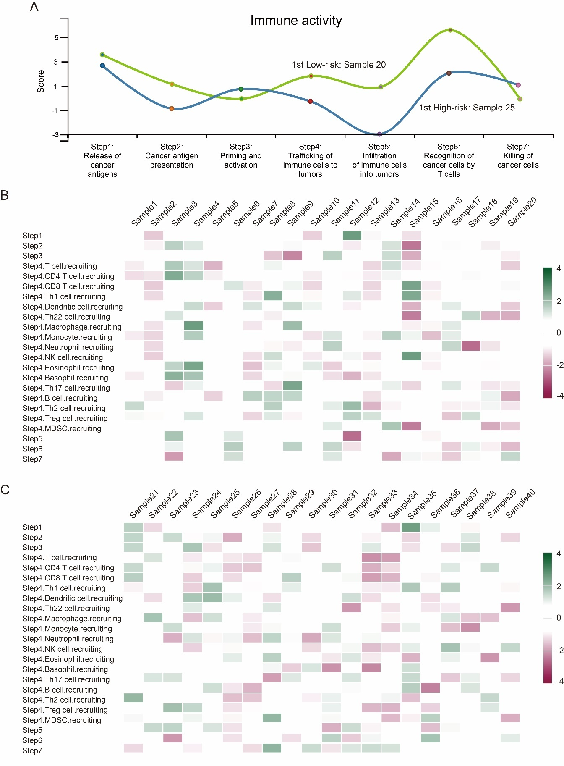
Figure S8 Immune activity analysis by TIP. (A) Schematic diagram of the step of TIP analysis. (B) The heatmap of score of diverse steps within top20 low risk score SKCM samples. (C) The heatmap of score of diverse steps within top20 high risk score SKCM samples.
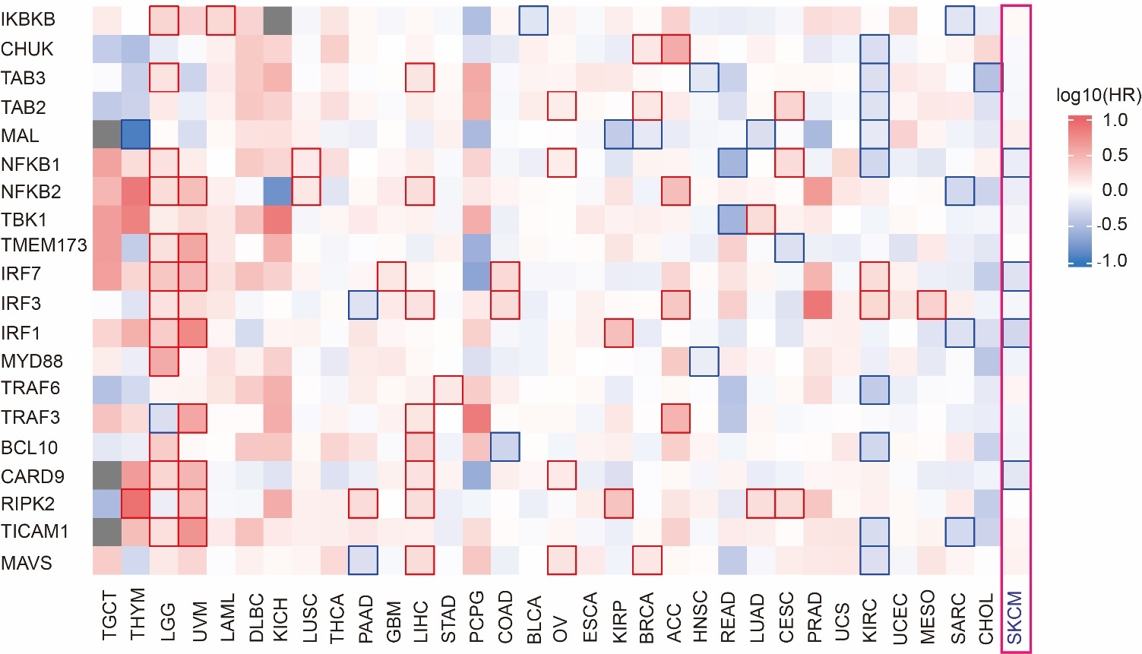
Figure S9 Expression of innate immune-signaling molecules hardly correlated to SKCM prognosis (tumor types=33, samples=9502).

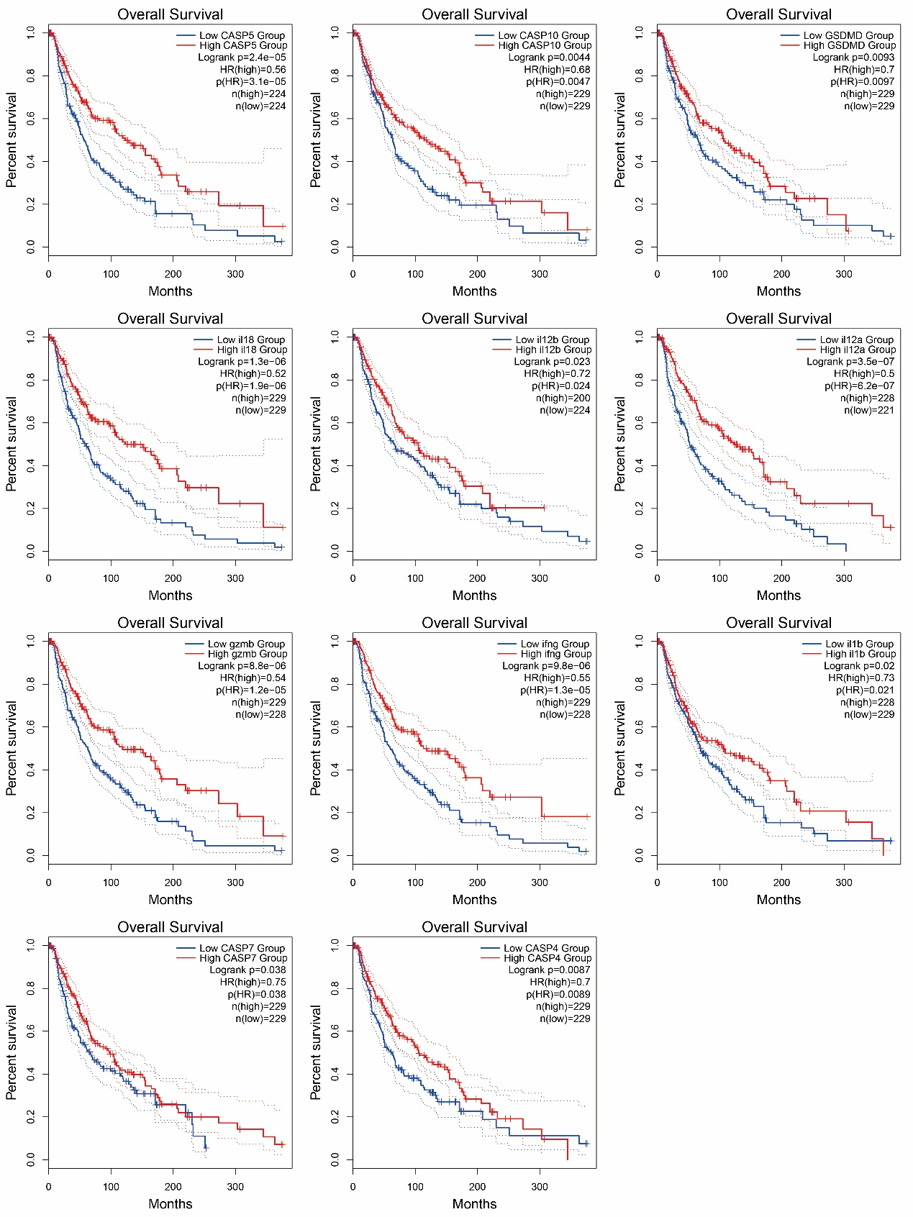
Figure S10 The survival curves of 11 prognosis-positive effector molecules of innate immunity in SKCM (pHR<0.05).
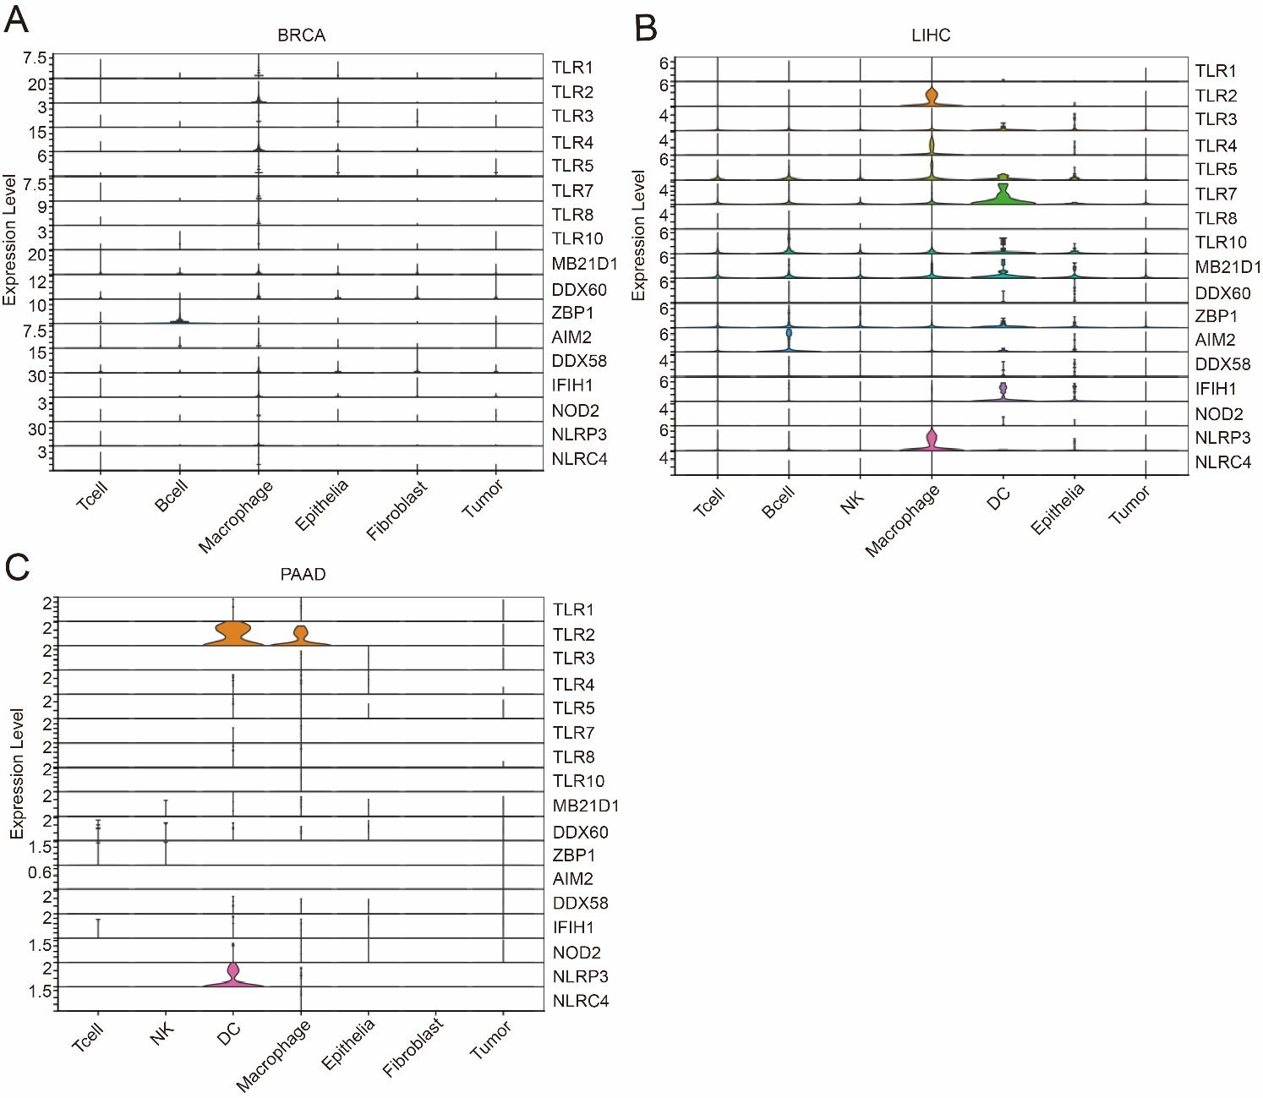
Figure S11 Single-cell sequencing analysis reveals the expression of PRRs on different cell types in different tumors. (A) Single-cell PRR expression profiles of different cellular types in BRCA. (B) Single-cell PRR expression profiles of different cellular types in LIHC. (C) Single-cell PRR expression profiles of different cellular types in PAAD.

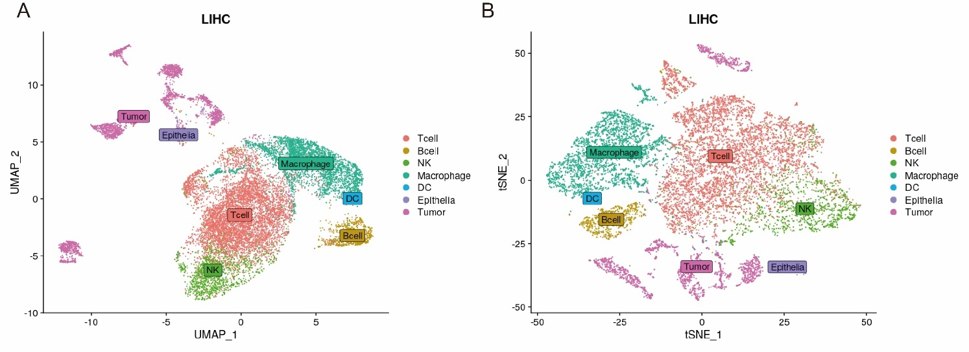
Figure S12 Single-cell profiles of cell subpopulations and expression of PRRs in LIHC samples. (A-B) Single-cell expression profiles distinguish different cell types in LIHC.

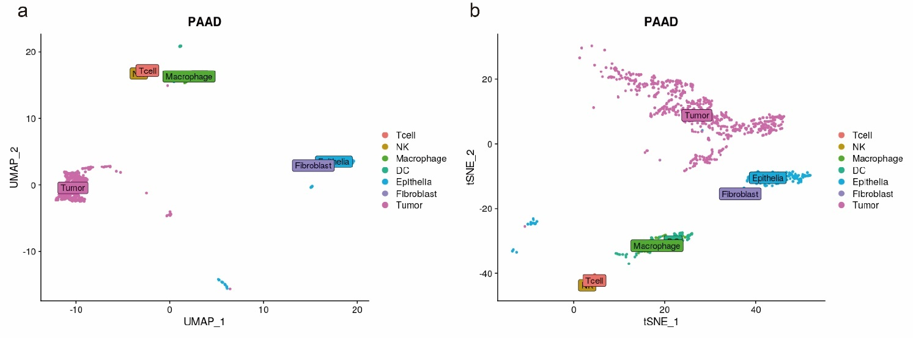
Fig S13 Single-cell profiles of cell subpopulations and expression of PRRs in PAAD samples. (A-B) Single-cell expression profiles distinguish different cell types in PAAD.

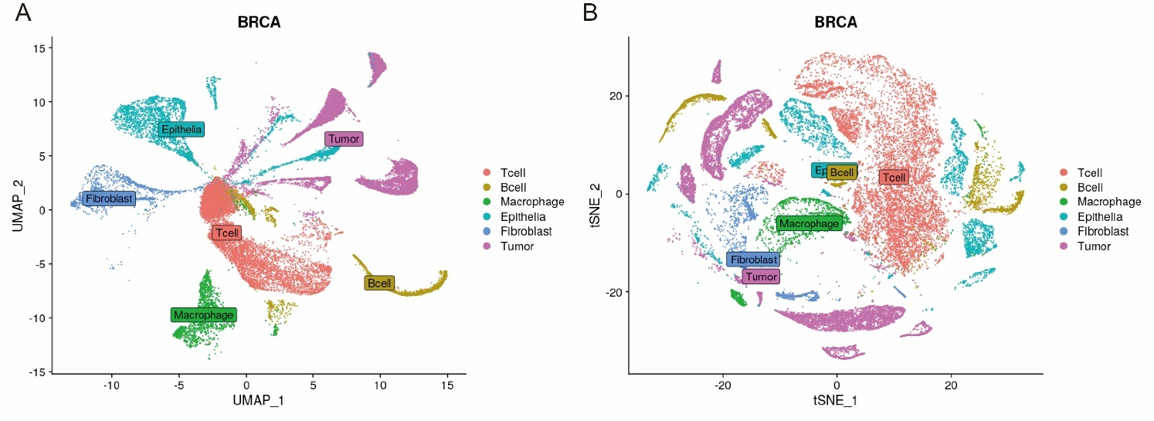

Figure S14 Single-cell profiles of cell subpopulations and expression of PRRs in BRCA samples. (A-B) Single-cell expression profiles distinguish different cell types in BRCA.

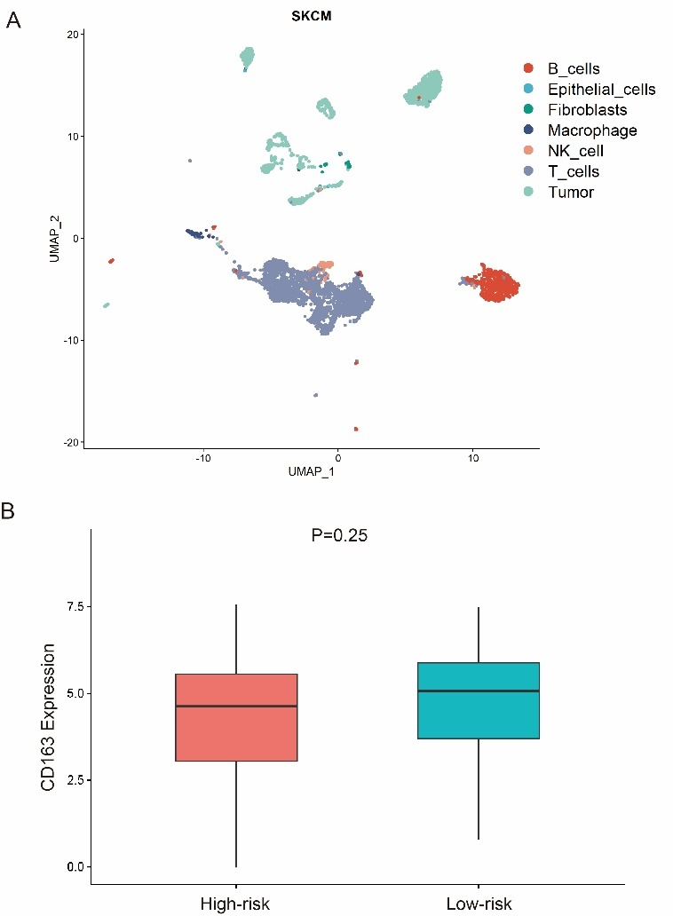
Figure S15 Single-cell profiles of cell subpopulations and expression of CD163 in SKCM samples. (A) Single-cell expression profiles distinguish different cell types in melanoma（UMAP）. (B) CD163 is not significant expression in high-risk macrophages within SKCM samples (P=0.25).

Figure S16 GO enrichment analysis of macrophages’ differentially expressed genes in melanoma. (A-B) GO enrichment analysis of down-regulated genes in high risk score melanoma-infiltrated macrophages. (C-D) GO enrichment analysis of up-regulated genes in high risk score melanoma-infiltrated macrophages.
Figure S17 KEGG enrichment analysis of macrophages’ differentially expressed genes in melanoma. (A-B). KEGG enrichment analysis of down-regulated genes in high risk score melanoma-infiltrated macrophages. c-d). KEGG enrichment analysis of up-regulated genes in high risk score melanoma-infiltrated macrophages.

