Supplementary Material

Supplementary Figures
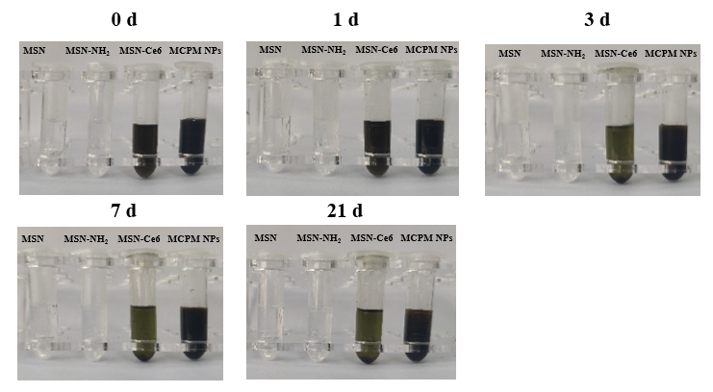
Supplementary Figure 1. Photographs of MSN, MSN-NH₂, MSN-Ce6 and MCPM NPs at days 0, 1, 3, 7 and 21. (From left to right in the photos, four EP tubes are solutions of MSN, MSN-NH₂, MSN-Ce6 and MCPM NPs)
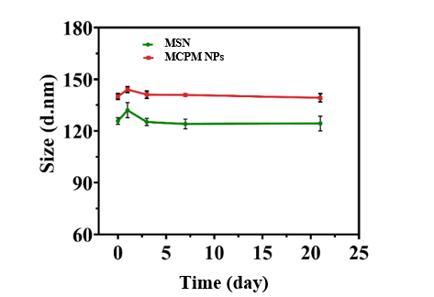
Supplementary Figure 2. The hydrodynamic size of MSN and MCPM NPs in a 21-day period. (The green line is solutions of MSN and the red line is solutions of MCPM NPs)
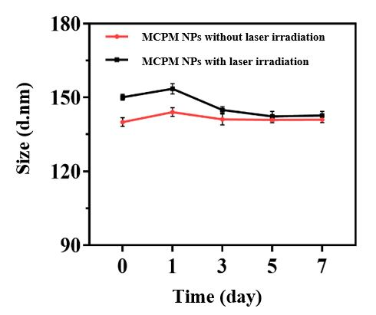
Supplementary Figure 3. The hydrodynamic size of MCPM NPs with or without laser irradiation in a 7-day period. (The red line is size of MCPM NPs without laser irradiation and the black line is size of MCPM NPs with laser irradiation)
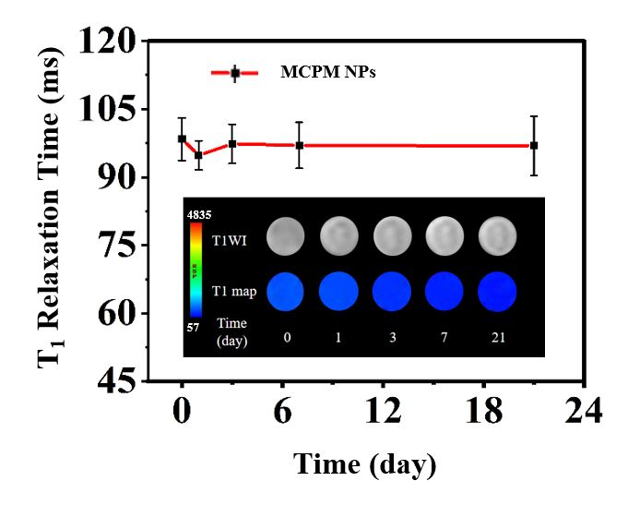
Supplementary Figure 4. The changes in T₁ relaxation time of MCPM NPs in a 21-day period. (The red line is T₁ relaxation time value of MCPM NPs, the embedded image is the corresponding MRI images)

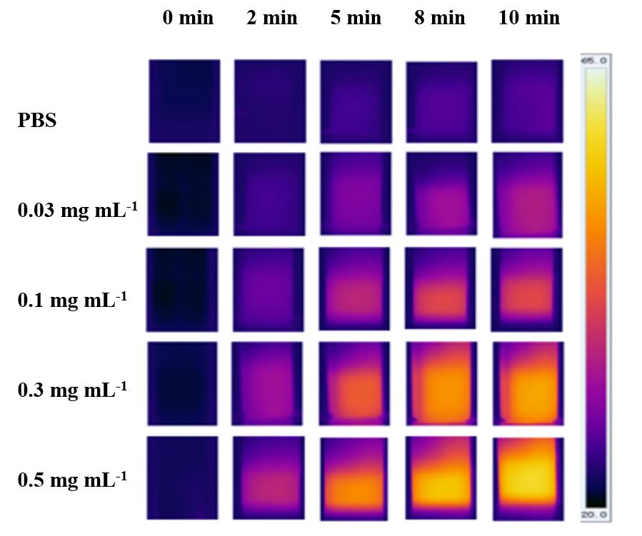
Supplementary Figure 5. The infrared thermal images of PBS and different concentrations of MCPM NPs solution (0, 0.03, 0.1, 0.3, 0.5 mg mL⁻¹) during 808 nm laser irradiation (0, 2, 5, 8, 10 min).

