Supplementary Material

Methods:

Characterization of PPy@Fe₃O₄ NPs
The FTIR spectra were recorded on a FTIR spectrometer (Spectrum 2000; Perkin-Elmer, Waltham, MA, USA).

Cell culture and animals
All animal experiments was approved by the Experimental Animal Center of Shanghai Jiaotong University. All nude mice were group bred under a 12-hour light/12-hour dark cycle with liberal supply of food and drink. The room temperature was set between 18℃ to 25℃, and the humidity was maintained to 60%. The nude mice were allowed to acclimate for one week before the start of experiments. Human lung adenocarcinoma A549 cells in this experiment were provided from the Cell Bank of the Chinese Academy of Sciences. A549 cells were incubated in RPMI 1640 medium containing 10% fetal bovine serum (FBS) and 1% Penicillin-Streptomycin. Meantime, all cultures were carried out at 37℃ in a humidified atmosphere of 5% carbon dioxide (CO₂) and 95% air. Cells were passaged by trypsinization when the confluence reached 80%, and we changed the medium every two days.

Cytotoxicity assay
The relative cell viability was calculated according to the following equation: Cell viability(%)=(OD experimental/OD control)*100%.
The photothermal conversion efficiency was calculated by the following equation：$ŋ$=$\frac{hS(T_{max}−T_{surr})−Q_{Dis}}{I(1−{10}^{{−A}_{808}})}$
where h is the heat transfer coefficient, s is the surface area of the container, T_{max} is the maximum steady-state temperature of the sample solution, T_{surr} is the ambient surrounding temperature, Q_{Dis} is the heat input due to light absorption by the solvent and container, I is the laser power, and A₈₀₈ is the absorbance of the sample solution at 808 nm.

Supplementary Figures
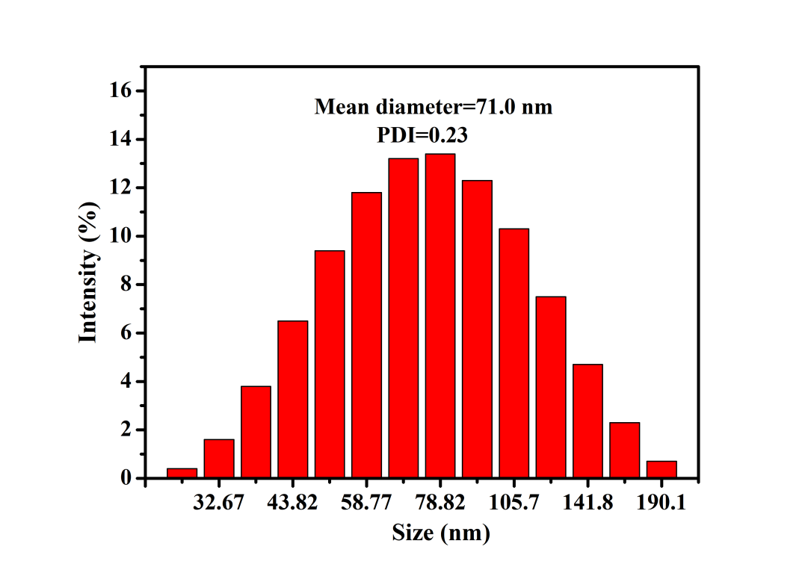
Supplementary Figure 1. The mean diameter of PPy@Fe₃O₄ nanoparticles is 71.0 nm.
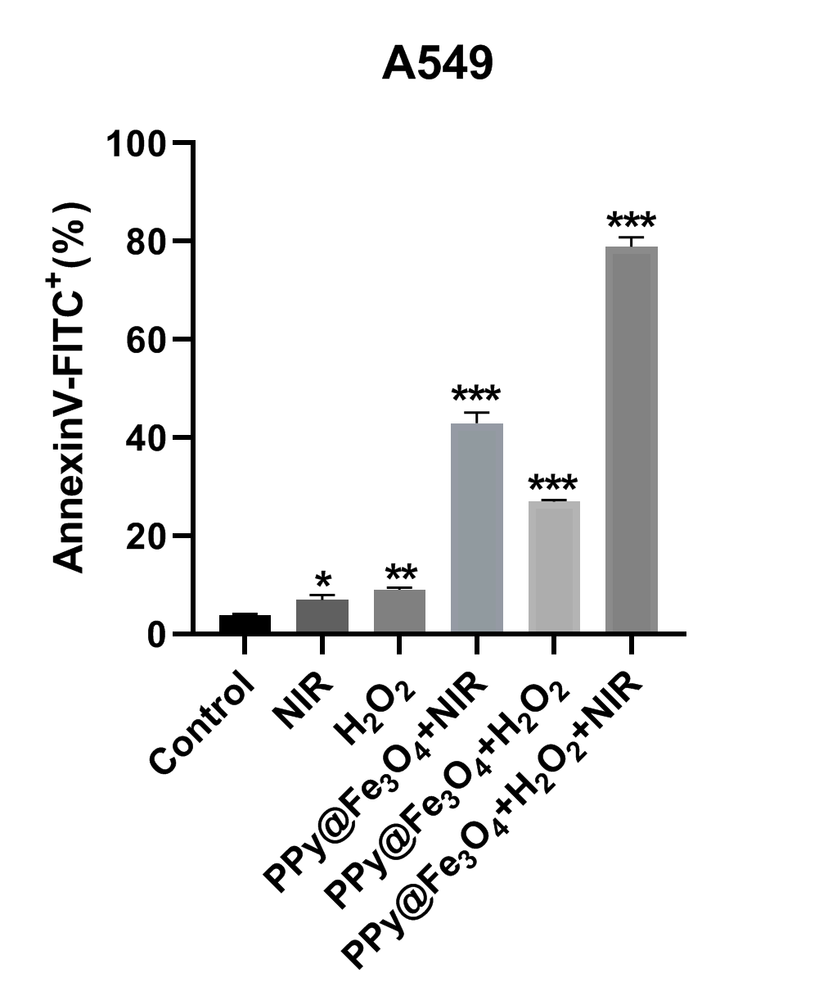
Supplementary Figure 2. The proportion of apoptosis in different groups.

