Supplementary Material

Supplementary Figures and Tables
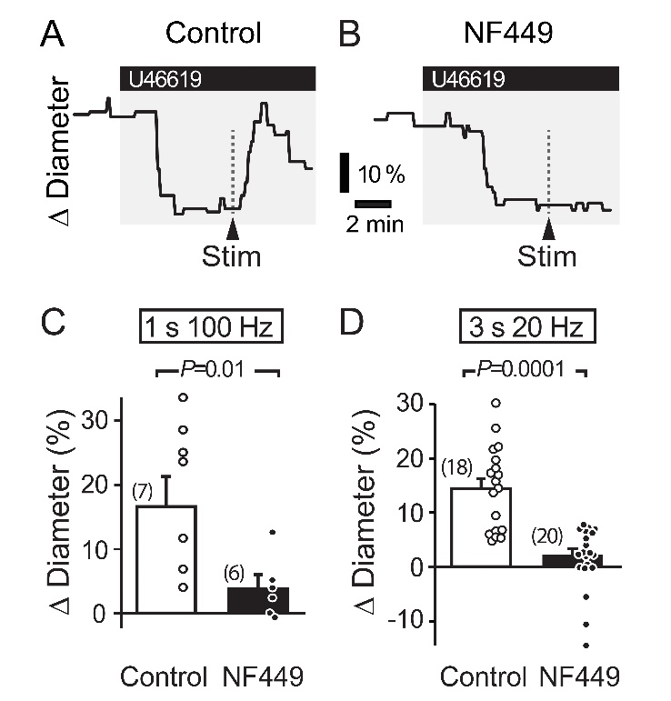
Supplementary Figure 1. Stimulation-evoked capillary dilation in adult rat cortex depends on P2X1 receptors. A-B. Capillary diameter changes in response to 200 nM U46619 and superimposed neuronal stimulation (Stim; 1s 100 Hz) in a control condition (A) and in the presence of 100 nM NF449, a potent P2X1 blocker (B). C-D. Summary data demonstrating the effect of NF449 on capillary diameter evoked by a 1 s 100 Hz high-frequency stimulation (C) and a 3 s 20 Hz low-frequency stimulation (D). P values obtained from Student’s t-tests. Number in parentheses above each bar indicates N.

Supplementary Table 1. Capillary diameter (µm; mean ± s.e.m.) at baseline, after pharmacological treatment, and following stimulation (Stim) for experiments plotted in Figure 1 and Figure 3. No significant differences were detected in baseline diameter between groups (naïve vs. MCAO-Contra vs. MCAO-Ipsi) in any experiment.

 |  | Baseline (µm,) | U46619 | U+Drug | Stim
U46619 only | Naïve | 5.6 ± 0.4 | 4.9 ± 0.4 | n/a | 5.6 ± 0.4
 | MCAO Contra | 5.6 ± 0.4 | 5.1 ± 0.4 | n/a | 5.7 ± 0.5
 | MCAO Ipsi | 5.4 ± 0.5 | 4.8 ± 0.6 | n/a | 5.0 ± 0.6
HET0016 | Naïve | 5.5 ± 0.3 | 5.0 ± 0.4 | 4.7 ± 0.4 | 5.2 ± 0.5
 | MCAO Contra | 5.1 ± 0.5 | 4.6 ± 0.4 | 4.5 ± 0.5 | 5.0 ± 0.5
 | MCAO Ipsi | 5.3 ± 0.4 | 4.9 ± 0.5 | 4.9 ± 0.5 | 5.4 ± 0.5
L-161,982 | Naïve | 5.7 ± 0.3 | 5.0 ± 0.2 | 4.9 ± 0.2 | 5.0 ± 0.2
 | MCAO Contra | 4.9 ± 0.3 | 4.2 ± 0.3 | 4.1 ± 0.3 | 4.2 ± 0.3
 | MCAO Ipsi | 5.3 ± 0.3 | 4.6 ± 0.3 | 4.4 ± 0.3 | 4.2 ± 0.3
L-161,982 + HET0016 | Naïve | 4.6 ± 0.5 | 4.0 ± 0.6 | 4.0 ± 0.6 | 4.1 ± 0.5
 | MCAO Contra | 6.1 ± 0.4 | 5.4 ± 0.4 | 5.5 ± 0.4 | 5.6 ± 0.4
 | MCAO Ipsi | 5.2 ± 0.6 | 4.4 ± 0.5 | 4.4 ± 0.6 | 4.5 ± 0.6
DETA-NONOate | Naïve | 6.1 ± 0.3 | 5.4 ± 0.3 | 5.3 ± 0.3 | 5.9 ± 0.3
 | MCAO Contra | 5.9 ± 0.4 | 5.1 ± 0.4 | 5.2 ± 0.4 | 5.7 ± 0.5
 | MCAO Ipsi | 5.7 ± 0.5 | 5.1 ± 0.5 | 4.9 ± 0.5 | 5.4 ± 0.5

