Supplementary Material

Testing the Two-Factor Structure of the Simulator Sickness Questionnaire in Clinical and Non-Clinical Participants

Supplementary Data
Because we were interested in the use of the Simulator Sickness Questionnaire (SSQ) in clinical and non-clinical samples, the main article examined the two- and three-factor structures of the SSQ by combining all participants in Study 1. In this online supplement, we present the results of the confirmatory factor analyses conducted separately for the non-clinical and the clinical participants from Study 1.
The clinical sample consisted of 423 adults (306 women, 117 men) recruited from the general population and diagnosed with an anxiety disorder (n = 346) or gambling disorder (n = 77). The non-clinical sample (i.e., healthy controls) comprised 453 adults (245 women, 207 men) who did not receive these diagnoses. The mean age of the clinical and non-clinical participants was 37.90 (SD = 13.73, range between 16 to 76) and 32.06 (SD = 12.17, range between 15 to 76), respectively. Eight clinical participants and one non-clinical participant with missing data were excluded from the analyses. The ratio of participants per variable was 26 to 1 (clinical sample) and 28 to 1 (non-clinical sample), confirming that the samples met basic assumptions and criteria to perform a factor analysis (Nunnally, 1978).
To calculate the SSQ-Total raw score, the non-weighted procedure was followed (i.e., summing all raw 16 items of the SSQ only once and not multiplying the total by a constant). The mean SSQ-Total raw score, Nausea score, and Oculomotor score in the non-clinical sample were 2.96 (SD = 3.86, range between 0 and 42), 1.09 (SD = 2.15, range between 0 and 25), and 1.87 (SD = 2.29, range between 0 and 17), respectively. The mean SSQ-Total raw score, Nausea score, and Oculomotor score in the clinical sample were 5.90 (SD = 5.73, range between 0 and 26), 2.52 (SD = 3.18, range between 0 and 17), and 3.38 (SD = 3.22, range between 0 and 15), respectively. The mean SSQ-Total-Anx, SSQ-Nausea-Anx, and SSQ-Oculomotor-Anx in the clinical sample were 4.84 (SD = 4.84, range between 0 and 22), 1.89 (SD = 2.67, range between 0 and 14) and 2.94 (SD = 2.84, range between 0 and 13), respectively.
Maximum likelihood estimation was used for structural equation modeling and modification indices as well as a global appraisal of traditional indexes and their critical values were used, as suggested by Byrne (1994), Tabachnick and Fidell (2007), and Arbuckle (2020): CFI (> .90), PCFI (> .75), GFI > .90 and RMSEA (< .07). The statistical significance of the chi-square is reported but should not be used given the known limitation of this index with large samples (Byrne, 1994; Tabachnick & Fidell, 2007).
The results of confirmatory factor analyses testing Kennedy et al.’s (1993) three-factor structure indicated that it was inadequate for both the non-clinical [χ2 (96) = 499.95, p < .001, CFI = .81, PCFI = .65, GFI = .89, RMSEA = .10, RMR = .015, AIC = 579.95, BIC = 744.58] and clinical [χ2 (96) = 501.46, p < .001, CFI = .81, PCFI = .65, GFI = .88, RMSEA = .10, RMR = .028, AIC = 581.46, BIC = 743.36] samples.
For the non-clinical sample, the plausibility of the two-factor solution was confirmed by the fit indices (CFI = .90, PCFI = .75, RMSEA = .07, AIC = 391.34, BIC = 539.51), the examination of the modification indices, the low value of the RMR (.011), and a strong percentage of variance explained (GFI = .92). The chi-square was also significant, χ2 (100) = 319.34, p < .001. The plausibility of the two-factor solution was also confirmed for the clinical sample, as shown by the fit indices much closer to the critical values than the alternative model (CFI = .85, PCFI = .71, RMSEA = .09, AIC = 497.86, BIC = 643.56), the examination of the modification indices, the low value of the RMR (.026), and a strong percentage of variance explained (GFI = .89). The chi-square was significant, χ2 (100) = 425.86, p < .001. It is important to note that although some of the fit indices reached the critical values for the three-factor solution (e.g., GFI = .89), a larger number of fit indices reached the critical values for the two-factor solution in both the non-clinical and clinical samples. This conclusion is also clearly supported when comparing the AIC and BIC indices (Burnham & Anderson, 2004). The final structural equation models are presented in Supplementary Figure 1 and Supplementary Figure 2, where circles represent latent variable and rectangles represent measured variables (Q stands for Question or item number; e stands for error). Finally, the plausibility of the two-factor solution without items 1 and 9 was tested with the clinical sample. The results seemed to favor this structure based on the fit indices (CFI = .86, PCFI = .69, RMSEA = .09, AIC = 379.74, BIC = 509.26), the examination of the modification indices, the low value of the RMR (.024), and a strong percentage of variance explained (GFI = .91). The chi-square was significant, χ2 (73) = 315.74, p < .001. In short, the fit indices favored the two-factor model, and thus, suggest that it is more appropriate in both clinical and non-clinical populations. As discussed in the article, replications with less heterogenous clinical samples may lead to improved fit.

Supplementary Figures
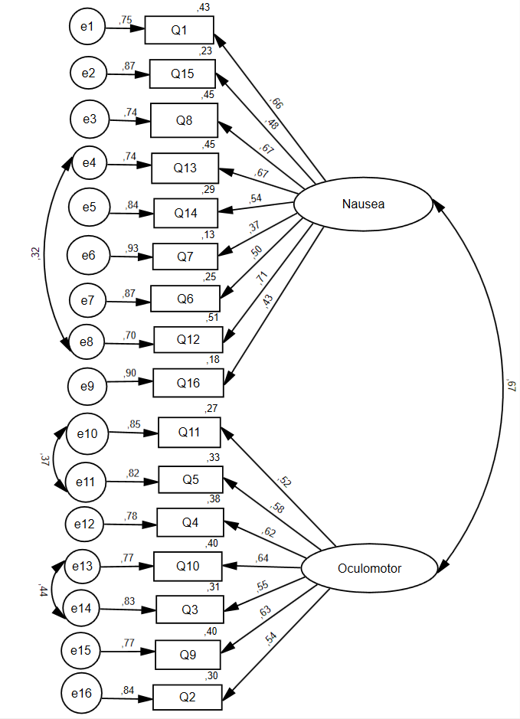
Supplementary Figure 1. Confirmatory factor analysis of the SSQ with two factors in non-clinical participants
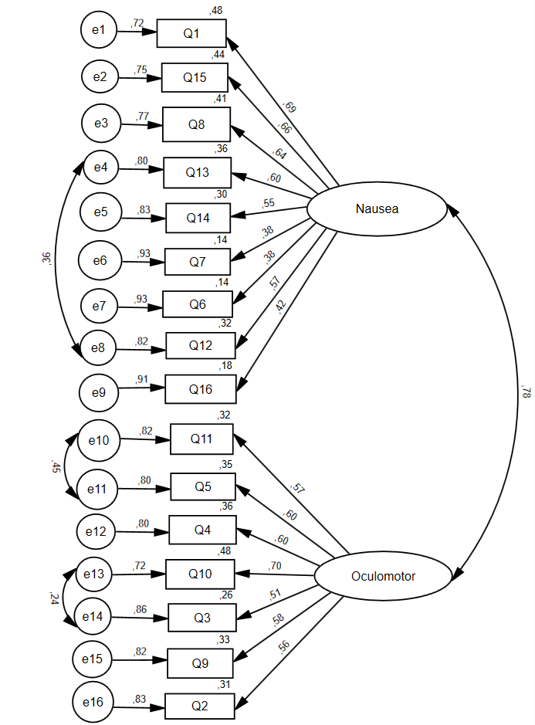
Supplementary Figure 2. Confirmatory factor analysis of the SSQ with two factors in clinical participants

Reference of studies used for the sample in Study 1
The sample for Study 1 consists of data collected in the following studies.
Aimé, A., Cotton, K., & Bouchard, S. (2009). Reactivity to virtual reality immersions in a subclinical sample of women concerned with their weight and shape. Journal of Cybertherapy and Rehabilitation, 2(2), 111-120.
Baus, O., Bouchard, S., Gougeon, V., & Roucaut, F.-X. (2011). Comparison of anxiety in response to virtual spiders while immersed in augmented reality, head-mounted display, or cave-like system. Oral presentation at the 16th Annual Cybertherapy & Cyberpsychology Conference, Gatineau, June 20-22.
Bouchard, S., Bernier, F., Boivin, É., Dumoulin, S., Laforest, M., Guitard, T., et al. (2013). Empathy toward virtual humans depicting a known or unknown person expressing pain. Journal of CyberPsychology, Behavior and Social Networking, 16(1), 61-71. DOI: 10.1089/cyber.2012.1571
Bouchard, S., Bernier, F., Boivin, E., Guitard, T., Laforest, M. Dumoulin, S. & Robillard, G. (2012). Modes of immersion and stress induced by commercial (off-the-shelf) 3D games. Journal of Defense Modeling and Simulation: Applications, Methodology, Technology, 1-14. DOI: 10.1177/1548512912446359.
Bouchard, S., Bernier, F., Boivin, E., Morin, B., & Robillard, G. (2012). Using biofeedback while immersed in a stressful videogame increases the effectiveness of stress management training. PLoS ONE, 4(7), 1-11. DOI: 10.1371/journal.pone.0036169.
Bouchard, S., Côté, S., Robillard, G., St-Jacques, J., & Renaud, P. (2006). Effectiveness of virtual reality exposure in the treatment of arachnophobia using 3D games. Technology and Health Care, 14(1), 19-27. DOI: 10.3233/THC-2006-14103
Bouchard, S., Dumoulin, S., Labonté-Chartrand, G., & Robillard, G., & Renaud, P. (2006). Perceived realism has a significant impact on the feeling of presence. Oral presentation at the 11th Annual CyberTherapy Conference 2006, Gatineau (Québec), June 12-15.
Bouchard, S., Dumoulin, S., Robillard, G., Guitard, T., Klinger, É., Forget, H., Loranger, C., & Roucaut, F.-X. (2017). Exposure in virtual reality is more effective and efficient than in vivo exposure when using broad range of stimuli for the treatment of social anxiety disorder: A three-arm randomized controlled trial. British Journal of Psychiatry, 210(4), 276-283. DOI: 10.1192/bjp.bp.116.184234
Bouchard, S., & Labonté-Chartrand, G. (2011). Emotions and the emotional valence afforded by the virtual environments. In J.-J. Kim (Ed.) Virtual Reality (pp. 501-514). Croatia: InTech.
Bouchard, S. Robillard, G., Giroux, I., Jacques, C., Loranger, C., St-Pierre, M., Chrétien, M., & Goulet, A. (2017). Using virtual reality in the treatment of gambling disorder: The development of a new tool to practice cognitive behaviour therapy. Frontiers in Psychiatry, 8(27), 10pp. DOI: 10.3389/fpsyt.2017.00027
Bouchard, S., St-Jacques, J., Renaud, P., & Wiederhold, B.K. (2009). Side effects of immersions in virtual reality for people suffering from anxiety disorders. Journal of Cybertherapy and Rehabilitation, 2(2), 127-137.
Bouchard, S., St-Jacques, J., Robillard, G., & Renaud, P. (2008). Anxiety increases the sense of presence in virtual reality. Presence: Teleoperators and Virtual Environments, 4(1), 376-391. DOI: 10.1162/pres.17.4.376
Côté, S. & Bouchard, S. (2005). Documenting the efficacy of virtual reality exposure with psychophysiological and information processing measures. Applied Psychophysiology and Biofeedback, 30(3), 217-232. DOI: 10.1007/s10484-005-6379-x
Dumoulin, S., Gougeon, V., Loranger, C., & Bouchard, S. (2011). Are distraction and attention the main variables in pain management: An experimental study using a cold-pressor test and virtual reality. Poster presentation at the 45th Annual Convention of the Association for Behavioral and Cognitive Therapy (ABCT), Toronto, November 10-13.
Guitard, T., & Bouchard, S. (2006). Failure to influence presence by manipulating narrative content. Poster presentation at the 11th Annual CyberTherapy Conference 2006, Gatineau (Québec), June 12-15.
Guitard, T., Bouchard, S., Bélanger, C., & Berthiaume, M. (2019). Exposure to a standardized catastrophic scenario in virtual reality on a personalized scenario in imagination for generalized anxiety disorder. Journal of Clinical Medecine, 8(309), DOI:10.3390/jcm8030309
Hajjar, A., Bouchard, S., Loranger, C., & Berthiaume, M. (2020). The efficacy of performing tasks in virtual reality that are infeasible in vivo: a clinical trial with acrophobia sufferers. Cypsy25 Conference.
Laforest, M., Bouchard, S., Crétu, A.-M., & Mesly, O. (2016). Inducing an anxiety response using a contaminated virtual environment: Validation of a therapeutic tool for obsessive-compulsive disorder. Frontiers in ICT, 3(18), 1-11. doi: 10.3389/fict.2016.00018.
Michaud, M., Bouchard, S., Dumoulin, S., & Zhong, X.-W. (2004). Manipulating presence and its impact on anxiety. Poster presentation at the Cybertherapy Conference 2004, San Diego, January 10-12.
Quintana, P., Nolet, K., Baus, O., & Bouchard, S. (2019). The effect of exposure to fear-related body odorants on anxiety and interpersonal trust toward a virtual character. Chemical Senses, 44(9), 683-692. DOI: 10.1093/chemse/bjz063
Robillard, G., Bouchard, S., Fournier, T., & Renaud, P. (2003). Anxiety and presence during VR immersion: A comparative study of the reactions of phobic and non-phobic participants in therapeutic virtual environments derived from computer games. CyberPsychology and Behavior, 6(5), 467-476. DOI: 10.1089/109493103769710497
Tardif, N., Therrien, C.-É., Bouchard, S. (2019). Re-examining psychological mechanisms underlying virtual reality-based exposure for spider phobia. Cyberpsychology, Behavior, and Social Networking, 22(1), 39-45. DOI: 10.1089/cyber.2017.0711

