Supplemental Figures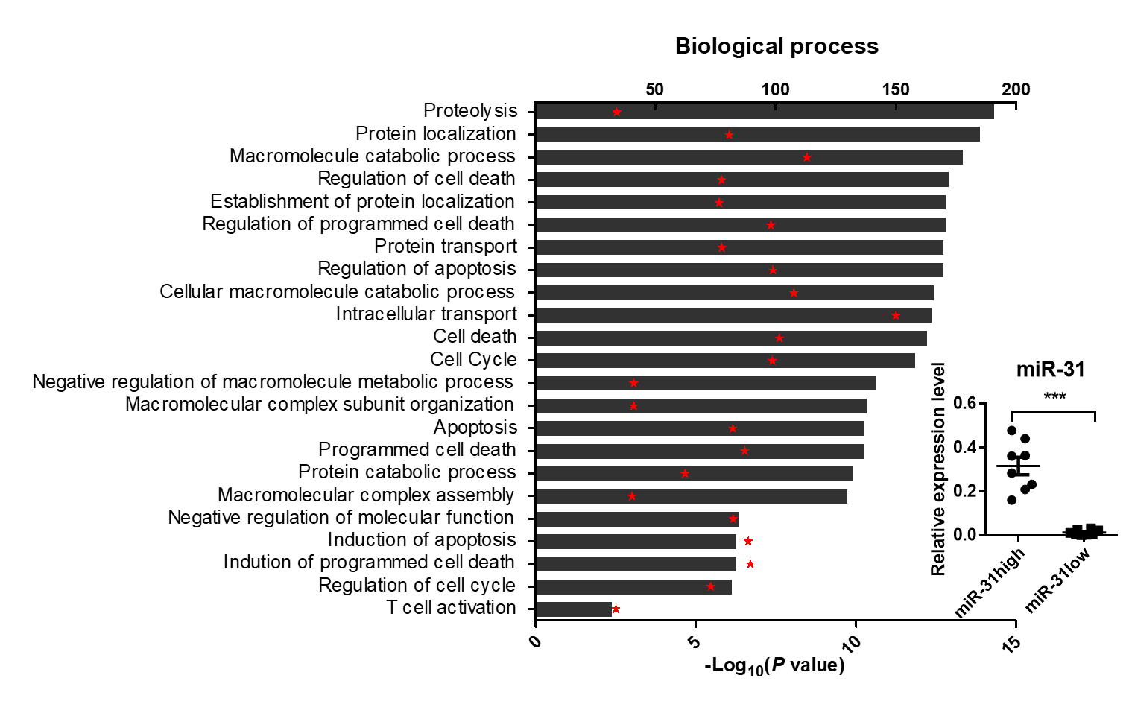
Fig. S1. Lower miR-31 level is associated with higher expression of genes involved in T cell activation and proliferation, cell cycling and cell death in vivo. Blood miR-31 levels were quantified for 30 HIV-1 infected individuals, 8 individuals with highest miR-31 expression (miR-31high) and 8 individuals with the lowest miR-31 expression (miR-31low) were selected as miR-31high group and miR-3low group (P < 0.001 for the difference in miR-31 levels between the two groups, fold change = 23.47). Shown are GO analyses of differentially expressed genes between the two groups. “Red star” indicates log10 (P), the height of “black bar” represents gene numbers enriched in each GO category.

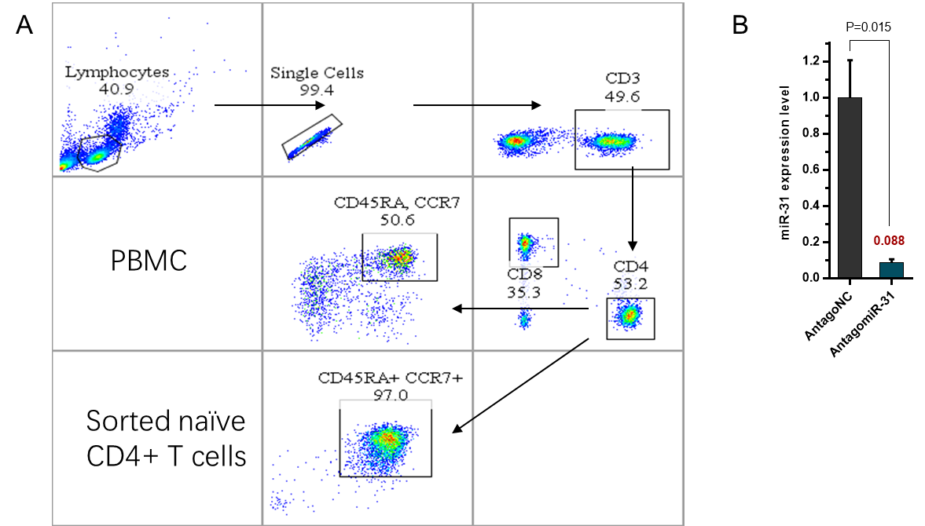

Fig. S2. MiR-31 knockdown efficiency in naïve CD4 T cell. (A) Representative plots to illustrate gating strategy used to identify naïve CD4 T cells. (B) Knockdown efficiency of miR-31 in purified naïve CD4 T cells 48 hrs after antagomir-31 transfection, assessed by quantitative RT-PCR.

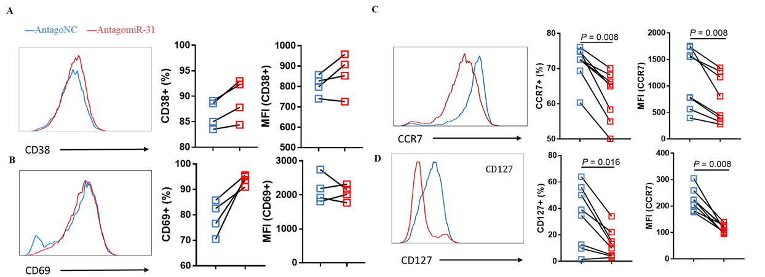

Fig. S3. Effects of antagomiR-31 treatment on surface marker expression of naïve CD4+ T cells. The assayed markers included CD38 (A), CD69 (B), CCR7 (C) and CD127 (D). Blue, antagomir-31 transfected group; red, antagoNC transfected group. Shown from left to right were representative FACS plot, frequency of positive cells, and median fluorescent intensity (MFI).

Fig. S4. MiR-31 level was negatively correlated with viral load. Relative blood levels of miR-31 were plot against plasma viral loads for HIV-1-infected individuals (n=50) (P < 0.001, Spearman rho = -0.482).

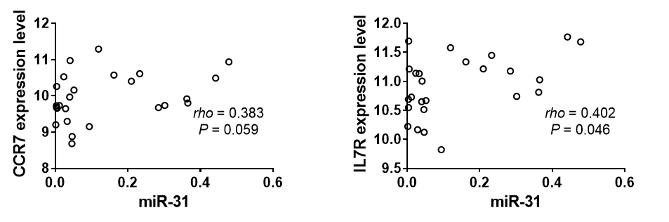
Fig. S5. Correlation of miR-31 to CCR7 and IL7R. The measurements were performed with blood samples of HIV infected individuals (n = 25), with levels of miR-31 and CCR7/IL7R being assessed by microarray and quantitative RT-PCR, respectively.

