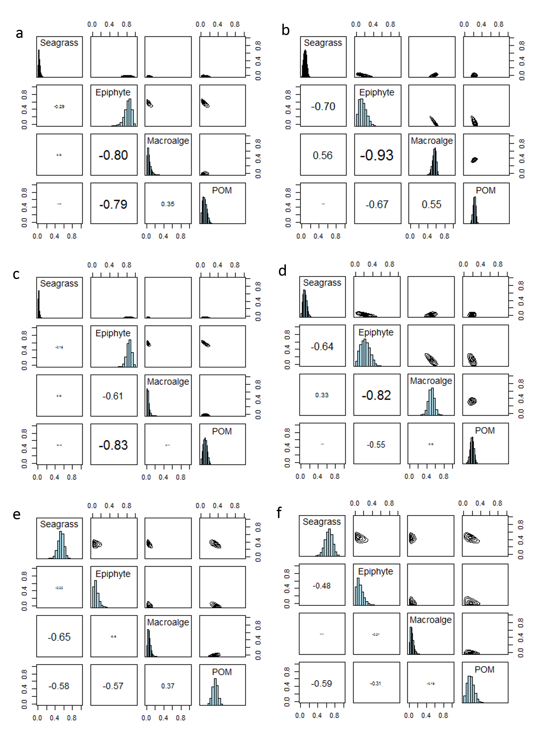

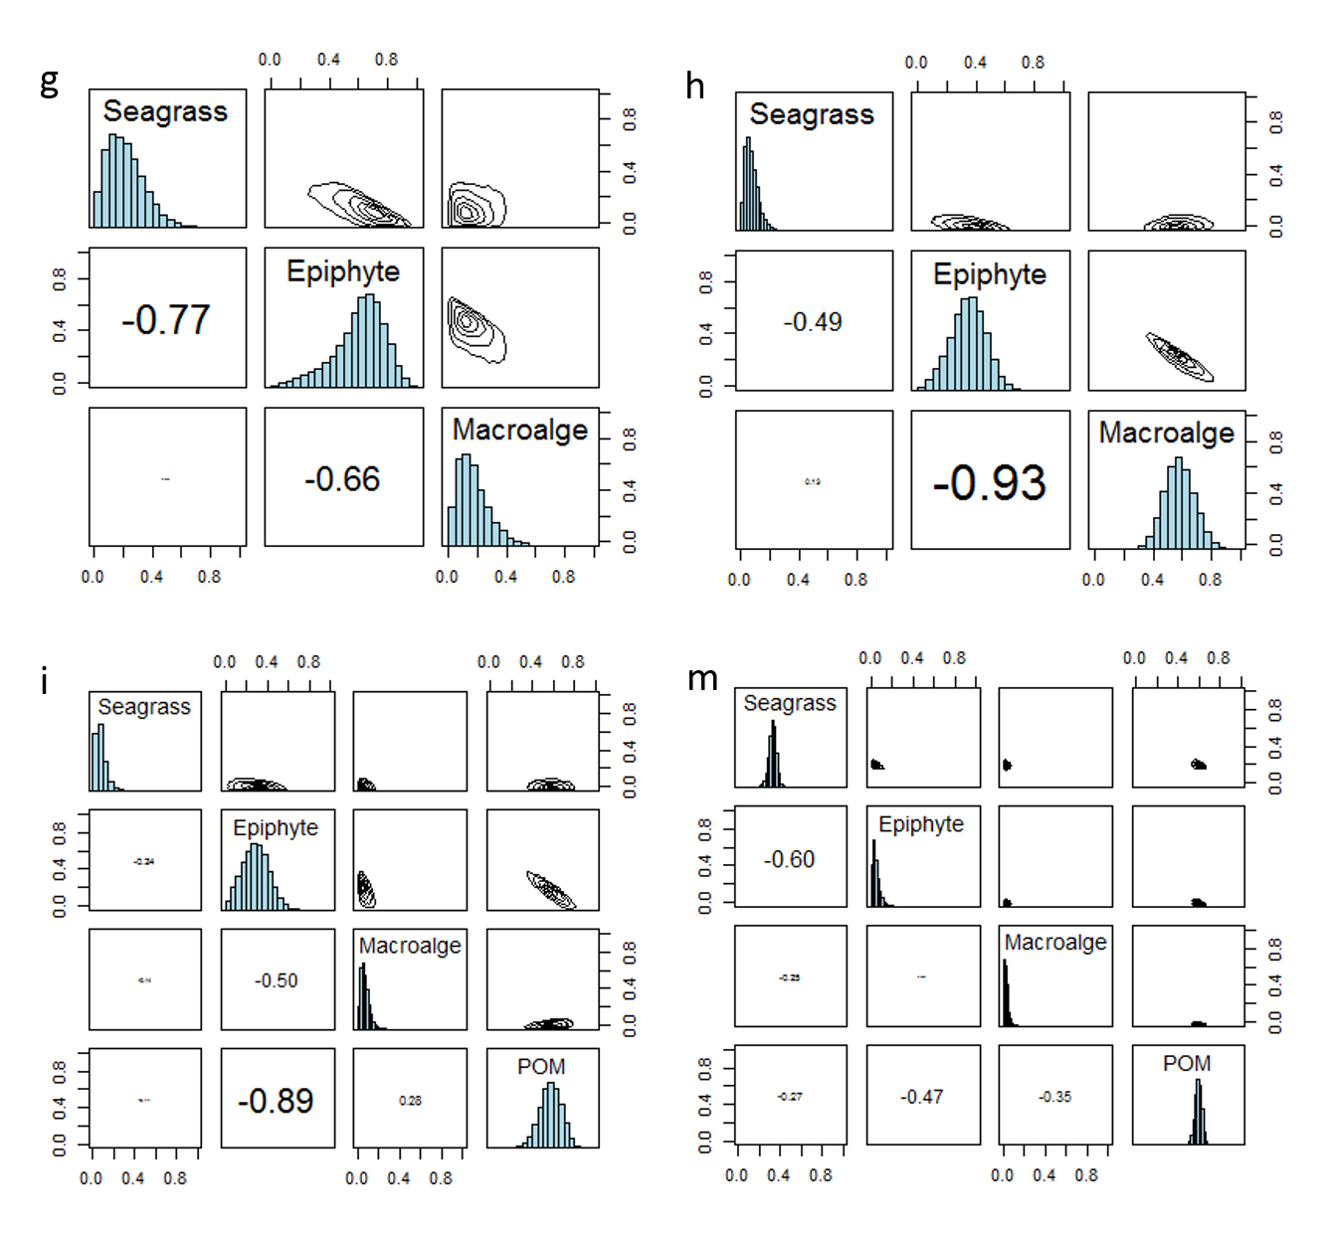
Figure 1. Matrix plots computed using the SIMMR model show the contribution proportion of each source to omnivores (a, b), carnivores (c, d), detritivores (e, f), herbivores (g, h) and planktivores (i, m) in summer (a, c, e, g, i) and winter (b, d, f, h, m). The histograms show the posterior probability distributions for each food source. The boxes to the left side of histograms show the correlation values between sources. The boxes to the right side of histograms show contours of the joint posterior probability distribution for contributions for pairs of food sources.

