Supplementary Material

Supplementary Figures and Tables

Supplementary Figures
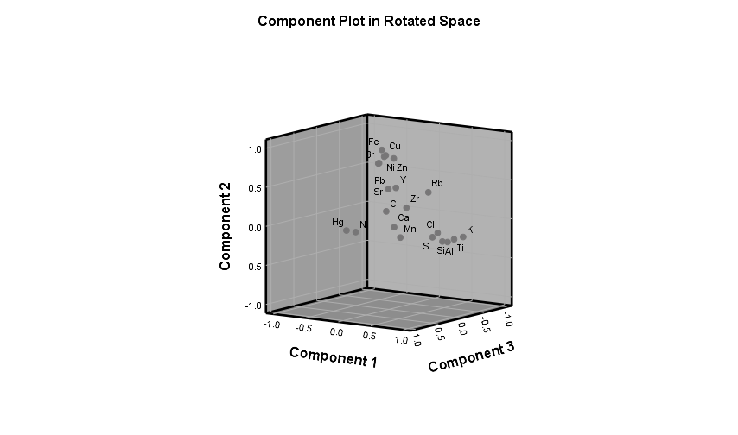
Supplementary Figure 1. Component plot in rotated space extracted by PCA from Congo Basin sediment samples.

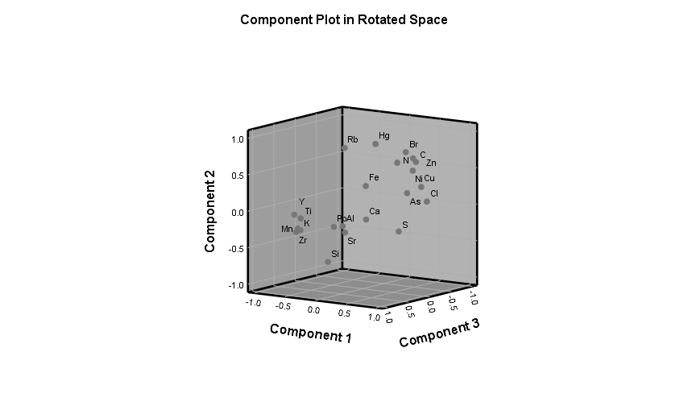
Supplementary Figure 2. Component plot in rotated space extracted by PCA from Peru Margin sediment samples.

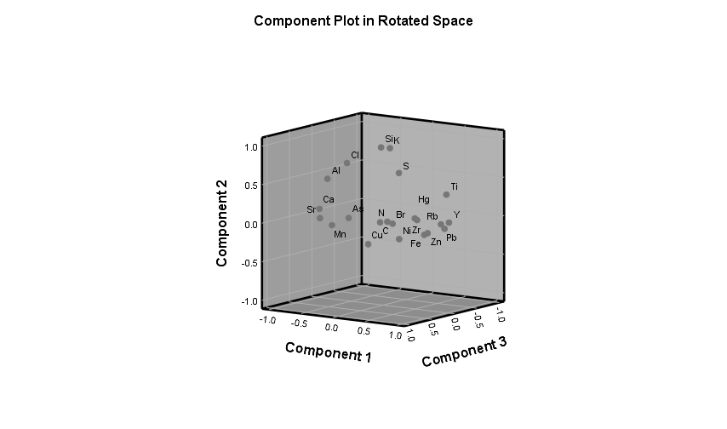
Supplementary Figure 3. Component plot in rotated space extracted by PCA from Amazon Fan sediment samples.

Supplementary Figure 4. Regression analysis of the C/N ratios and Hg concentrations of Congo Basin sediment samples.

Supplementary Figure 5. Regression analysis of the C/N ratios and Hg concentrations of Peru Margin sediment samples.

Supplementary Figure 6. Regression analysis of the C/N ratios and Hg concentrations of Amazon Fan sediment samples.

Supplementary Tables
Supplementary Table 1. Correlation matrix of Congo Basin sediment samples.
 | Al | Si | S | Cl | K | Ca | Ti | Mn | Fe | Ni | Cu | Zn | Br | Rb | Sr | Y | Zr | Pb | Hg | C | N
Al | 1.00 | 0.94 | 0.74 | 0.83 | 0.80 | 0.60 | 0.88 | 0.68 | -0.30 | -0.27 | -0.22 | -0.16 | -0.12 | -0.22 | -0.06 | -0.16 | -0.27 | 0.00 | 0.08 | 0.05 | 0.13
Si | 0.94 | 1.00 | 0.73 | 0.90 | 0.88 | 0.59 | 0.93 | 0.68 | -0.32 | -0.27 | -0.25 | -0.14 | -0.11 | -0.15 | -0.06 | -0.16 | -0.30 | -0.03 | 0.06 | 0.07 | 0.06
S | 0.74 | 0.73 | 1.00 | 0.60 | 0.64 | 0.63 | 0.75 | 0.61 | -0.20 | -0.17 | -0.20 | -0.18 | -0.24 | -0.21 | -0.05 | -0.14 | -0.16 | -0.02 | 0.04 | -0.10 | 0.11
Cl | 0.83 | 0.90 | 0.60 | 1.00 | 0.74 | 0.68 | 0.78 | 0.69 | -0.20 | -0.23 | -0.15 | 0.05 | 0.14 | -0.23 | 0.12 | -0.23 | -0.51 | 0.09 | 0.13 | 0.27 | 0.09
K | 0.80 | 0.88 | 0.64 | 0.74 | 1.00 | 0.24 | 0.94 | 0.37 | -0.26 | -0.20 | -0.19 | -0.09 | -0.19 | 0.26 | -0.17 | -0.05 | 0.05 | -0.08 | -0.28 | 0.04 | -0.18
Ca | 0.60 | 0.59 | 0.63 | 0.68 | 0.24 | 1.00 | 0.41 | 0.80 | -0.06 | -0.14 | -0.10 | 0.04 | 0.18 | -0.63 | 0.35 | -0.31 | -0.69 | 0.09 | 0.55 | 0.15 | 0.35
Ti | 0.88 | 0.93 | 0.75 | 0.78 | 0.94 | 0.41 | 1.00 | 0.59 | -0.24 | -0.20 | -0.21 | -0.18 | -0.19 | 0.00 | -0.17 | -0.10 | -0.04 | -0.03 | -0.09 | -0.01 | 0.03
Mn | 0.68 | 0.68 | 0.61 | 0.69 | 0.37 | 0.80 | 0.59 | 1.00 | -0.19 | -0.21 | -0.22 | -0.15 | 0.08 | -0.66 | 0.10 | -0.24 | -0.58 | 0.12 | 0.56 | 0.13 | 0.41
Fe | -0.30 | -0.32 | -0.20 | -0.20 | -0.26 | -0.06 | -0.24 | -0.19 | 1.00 | 0.73 | 0.76 | 0.70 | 0.64 | 0.30 | 0.62 | 0.30 | 0.22 | 0.41 | -0.09 | -0.03 | -0.09
Ni | -0.27 | -0.27 | -0.17 | -0.23 | -0.20 | -0.14 | -0.20 | -0.21 | 0.73 | 1.00 | 0.68 | 0.55 | 0.55 | 0.31 | 0.53 | 0.34 | 0.24 | 0.26 | -0.10 | 0.10 | -0.05
Cu | -0.22 | -0.25 | -0.20 | -0.15 | -0.19 | -0.10 | -0.21 | -0.22 | 0.76 | 0.68 | 1.00 | 0.60 | 0.58 | 0.32 | 0.54 | 0.34 | 0.16 | 0.29 | -0.06 | 0.13 | -0.10
Zn | -0.16 | -0.14 | -0.18 | 0.05 | -0.09 | 0.04 | -0.18 | -0.15 | 0.70 | 0.55 | 0.60 | 1.00 | 0.70 | 0.34 | 0.71 | 0.21 | -0.09 | 0.37 | -0.07 | 0.24 | -0.16
Br | -0.12 | -0.11 | -0.24 | 0.14 | -0.19 | 0.18 | -0.19 | 0.08 | 0.64 | 0.55 | 0.58 | 0.70 | 1.00 | 0.03 | 0.81 | 0.09 | -0.23 | 0.36 | 0.18 | 0.59 | 0.10
Rb | -0.22 | -0.15 | -0.21 | -0.23 | 0.26 | -0.63 | 0.00 | -0.66 | 0.30 | 0.31 | 0.32 | 0.34 | 0.03 | 1.00 | 0.04 | 0.34 | 0.67 | -0.04 | -0.71 | -0.09 | -0.61
Sr | -0.06 | -0.06 | -0.05 | 0.12 | -0.17 | 0.35 | -0.17 | 0.10 | 0.62 | 0.53 | 0.54 | 0.71 | 0.81 | 0.04 | 1.00 | 0.15 | -0.23 | 0.24 | 0.27 | 0.39 | 0.07
Y | -0.16 | -0.16 | -0.14 | -0.23 | -0.05 | -0.31 | -0.10 | -0.24 | 0.30 | 0.34 | 0.34 | 0.21 | 0.09 | 0.34 | 0.15 | 1.00 | 0.38 | -0.06 | -0.26 | -0.12 | -0.25
Zr | -0.27 | -0.30 | -0.16 | -0.51 | 0.05 | -0.69 | -0.04 | -0.58 | 0.22 | 0.24 | 0.16 | -0.09 | -0.23 | 0.67 | -0.23 | 0.38 | 1.00 | -0.09 | -0.58 | -0.33 | -0.27
Pb | 0.00 | -0.03 | -0.02 | 0.09 | -0.08 | 0.09 | -0.03 | 0.12 | 0.41 | 0.26 | 0.29 | 0.37 | 0.36 | -0.04 | 0.24 | -0.06 | -0.09 | 1.00 | 0.04 | 0.02 | 0.06
Hg | 0.08 | 0.06 | 0.04 | 0.13 | -0.28 | 0.55 | -0.09 | 0.56 | -0.09 | -0.10 | -0.06 | -0.07 | 0.18 | -0.71 | 0.27 | -0.26 | -0.58 | 0.04 | 1.00 | 0.22 | 0.49
C | 0.05 | 0.07 | -0.10 | 0.27 | 0.04 | 0.15 | -0.01 | 0.13 | -0.03 | 0.10 | 0.13 | 0.24 | 0.59 | -0.09 | 0.39 | -0.12 | -0.33 | 0.02 | 0.22 | 1.00 | 0.15
N | 0.13 | 0.06 | 0.11 | 0.09 | -0.18 | 0.35 | 0.03 | 0.41 | -0.09 | -0.05 | -0.10 | -0.16 | 0.10 | -0.61 | 0.07 | -0.25 | -0.27 | 0.06 | 0.49 | 0.15 | 1.00

Supplementary Table 2. Correlation matrix of Peru Margin sediment samples.
 | Al | Si | S | Cl | K | Ca | Ti | Mn | Fe | Ni | Cu | Zn | As | Br | Rb | Sr | Y | Zr | Pb | Hg | C | N
Al | 1.00 | 0.57 | 0.51 | 0.05 | 0.60 | 0.65 | 0.57 | 0.55 | -0.16 | -0.21 | -0.21 | -0.15 | -0.16 | -0.34 | -0.26 | 0.48 | 0.18 | 0.19 | 0.04 | -0.26 | -0.21 | -0.21
Si | 0.57 | 1.00 | 0.16 | -0.33 | 0.79 | 0.19 | 0.61 | 0.74 | -0.35 | -0.70 | -0.60 | -0.70 | -0.49 | -0.75 | -0.54 | 0.36 | 0.45 | 0.65 | 0.32 | -0.65 | -0.78 | -0.79
S | 0.51 | 0.16 | 1.00 | 0.71 | -0.05 | 0.57 | -0.02 | -0.12 | 0.00 | 0.36 | 0.46 | 0.22 | 0.34 | 0.03 | -0.43 | 0.25 | -0.43 | -0.45 | -0.16 | -0.12 | 0.28 | 0.24
Cl | 0.05 | -0.33 | 0.71 | 1.00 | -0.57 | 0.29 | -0.55 | -0.66 | 0.08 | 0.69 | 0.80 | 0.55 | 0.58 | 0.62 | -0.16 | -0.07 | -0.84 | -0.86 | -0.35 | 0.28 | 0.72 | 0.70
K | 0.60 | 0.79 | -0.05 | -0.57 | 1.00 | 0.18 | 0.94 | 0.96 | -0.13 | -0.66 | -0.67 | -0.52 | -0.53 | -0.68 | -0.04 | 0.34 | 0.75 | 0.79 | 0.43 | -0.38 | -0.72 | -0.70
Ca | 0.65 | 0.19 | 0.57 | 0.29 | 0.18 | 1.00 | 0.10 | 0.09 | -0.35 | -0.08 | -0.03 | -0.09 | -0.09 | -0.16 | -0.45 | 0.83 | 0.05 | -0.03 | -0.48 | -0.25 | -0.03 | -0.04
Ti | 0.57 | 0.61 | -0.02 | -0.55 | 0.94 | 0.10 | 1.00 | 0.96 | 0.05 | -0.50 | -0.56 | -0.34 | -0.44 | -0.58 | 0.16 | 0.19 | 0.70 | 0.69 | 0.48 | -0.23 | -0.58 | -0.56
Mn | 0.55 | 0.74 | -0.12 | -0.66 | 0.96 | 0.09 | 0.96 | 1.00 | -0.07 | -0.66 | -0.70 | -0.52 | -0.56 | -0.70 | 0.01 | 0.25 | 0.75 | 0.81 | 0.43 | -0.38 | -0.75 | -0.72
Fe | -0.16 | -0.35 | 0.00 | 0.08 | -0.13 | -0.35 | 0.05 | -0.07 | 1.00 | 0.58 | 0.54 | 0.69 | 0.68 | 0.30 | 0.61 | -0.48 | -0.22 | -0.27 | 0.41 | 0.43 | 0.34 | 0.34
Ni | -0.21 | -0.70 | 0.36 | 0.69 | -0.66 | -0.08 | -0.50 | -0.66 | 0.58 | 1.00 | 0.91 | 0.87 | 0.77 | 0.79 | 0.38 | -0.44 | -0.72 | -0.85 | -0.16 | 0.64 | 0.90 | 0.89
Cu | -0.21 | -0.60 | 0.46 | 0.80 | -0.67 | -0.03 | -0.56 | -0.70 | 0.54 | 0.91 | 1.00 | 0.82 | 0.79 | 0.68 | 0.21 | -0.37 | -0.83 | -0.88 | -0.14 | 0.45 | 0.85 | 0.83
Zn | -0.15 | -0.70 | 0.22 | 0.55 | -0.52 | -0.09 | -0.34 | -0.52 | 0.69 | 0.87 | 0.82 | 1.00 | 0.69 | 0.75 | 0.54 | -0.40 | -0.58 | -0.69 | -0.03 | 0.70 | 0.83 | 0.83
As | -0.16 | -0.49 | 0.34 | 0.58 | -0.53 | -0.09 | -0.44 | -0.56 | 0.68 | 0.77 | 0.79 | 0.69 | 1.00 | 0.52 | 0.30 | -0.39 | -0.65 | -0.71 | -0.01 | 0.39 | 0.67 | 0.65
Br | -0.34 | -0.75 | 0.03 | 0.62 | -0.68 | -0.16 | -0.58 | -0.70 | 0.30 | 0.79 | 0.68 | 0.75 | 0.52 | 1.00 | 0.50 | -0.44 | -0.65 | -0.76 | -0.33 | 0.80 | 0.86 | 0.89
Rb | -0.26 | -0.54 | -0.43 | -0.16 | -0.04 | -0.45 | 0.16 | 0.01 | 0.61 | 0.38 | 0.21 | 0.54 | 0.30 | 0.50 | 1.00 | -0.55 | 0.05 | -0.11 | 0.20 | 0.67 | 0.40 | 0.45
Sr | 0.48 | 0.36 | 0.25 | -0.07 | 0.34 | 0.83 | 0.19 | 0.25 | -0.48 | -0.44 | -0.37 | -0.40 | -0.39 | -0.44 | -0.55 | 1.00 | 0.38 | 0.37 | -0.35 | -0.46 | -0.43 | -0.43
Y | 0.18 | 0.45 | -0.43 | -0.84 | 0.75 | 0.05 | 0.70 | 0.75 | -0.22 | -0.72 | -0.83 | -0.58 | -0.65 | -0.65 | 0.05 | 0.38 | 1.00 | 0.89 | 0.26 | -0.26 | -0.76 | -0.74
Zr | 0.19 | 0.65 | -0.45 | -0.86 | 0.79 | -0.03 | 0.69 | 0.81 | -0.27 | -0.85 | -0.88 | -0.69 | -0.71 | -0.76 | -0.11 | 0.37 | 0.89 | 1.00 | 0.38 | -0.45 | -0.90 | -0.88
Pb | 0.04 | 0.32 | -0.16 | -0.35 | 0.43 | -0.48 | 0.48 | 0.43 | 0.41 | -0.16 | -0.14 | -0.03 | -0.01 | -0.33 | 0.20 | -0.35 | 0.26 | 0.38 | 1.00 | -0.09 | -0.32 | -0.31
Hg | -0.26 | -0.65 | -0.12 | 0.28 | -0.38 | -0.25 | -0.23 | -0.38 | 0.43 | 0.64 | 0.45 | 0.70 | 0.39 | 0.80 | 0.67 | -0.46 | -0.26 | -0.45 | -0.09 | 1.00 | 0.65 | 0.69
C | -0.21 | -0.78 | 0.28 | 0.72 | -0.72 | -0.03 | -0.58 | -0.75 | 0.34 | 0.90 | 0.85 | 0.83 | 0.67 | 0.86 | 0.40 | -0.43 | -0.76 | -0.90 | -0.32 | 0.65 | 1.00 | 1.00
N | -0.21 | -0.79 | 0.24 | 0.70 | -0.70 | -0.04 | -0.56 | -0.72 | 0.34 | 0.89 | 0.83 | 0.83 | 0.65 | 0.89 | 0.45 | -0.43 | -0.74 | -0.88 | -0.31 | 0.69 | 1.00 | 1.00

Supplementary Table 3. Correlation matrix of Amazon Fan sediment samples.
 | Al | Si | S | Cl | K | Ca | Ti | Mn | Fe | Ni | Cu | Zn | As | Br | Rb | Sr | Y | Zr | Pb | Hg | C | N
Al | 1.00 | 0.59 | -0.03 | 0.78 | 0.33 | 0.85 | -0.57 | 0.23 | -0.71 | -0.57 | -0.25 | -0.73 | 0.27 | -0.33 | -0.79 | 0.79 | -0.79 | -0.24 | -0.82 | -0.42 | 0.08 | -0.01
Si | 0.59 | 1.00 | 0.32 | 0.66 | 0.84 | 0.22 | 0.26 | -0.10 | -0.27 | -0.30 | -0.28 | -0.25 | -0.05 | -0.23 | -0.17 | 0.13 | -0.10 | 0.06 | -0.19 | -0.09 | -0.09 | -0.06
S | -0.03 | 0.32 | 1.00 | 0.22 | 0.52 | -0.24 | 0.38 | -0.03 | 0.13 | 0.06 | -0.16 | 0.13 | 0.06 | 0.21 | 0.27 | -0.32 | 0.27 | -0.09 | 0.24 | 0.23 | 0.06 | 0.00
Cl | 0.78 | 0.66 | 0.22 | 1.00 | 0.49 | 0.56 | -0.27 | 0.05 | -0.47 | -0.45 | -0.28 | -0.50 | 0.13 | -0.04 | -0.50 | 0.46 | -0.55 | -0.26 | -0.57 | -0.15 | 0.09 | 0.08
K | 0.33 | 0.84 | 0.52 | 0.49 | 1.00 | -0.02 | 0.49 | -0.01 | 0.01 | -0.01 | -0.11 | 0.07 | 0.03 | 0.01 | 0.15 | -0.12 | 0.15 | 0.13 | 0.07 | 0.02 | -0.15 | -0.10
Ca | 0.85 | 0.22 | -0.24 | 0.56 | -0.02 | 1.00 | -0.84 | 0.24 | -0.75 | -0.61 | -0.20 | -0.81 | 0.37 | -0.48 | -0.95 | 0.98 | -0.94 | -0.19 | -0.92 | -0.63 | 0.02 | -0.12
Ti | -0.57 | 0.26 | 0.38 | -0.27 | 0.49 | -0.84 | 1.00 | -0.30 | 0.63 | 0.46 | 0.07 | 0.71 | -0.35 | 0.30 | 0.85 | -0.86 | 0.90 | 0.33 | 0.84 | 0.48 | -0.10 | 0.03
Mn | 0.23 | -0.10 | -0.03 | 0.05 | -0.01 | 0.24 | -0.30 | 1.00 | -0.15 | 0.25 | 0.29 | -0.17 | 0.35 | 0.07 | -0.20 | 0.22 | -0.26 | -0.22 | -0.23 | -0.11 | 0.01 | -0.03
Fe | -0.71 | -0.27 | 0.13 | -0.47 | 0.01 | -0.75 | 0.63 | -0.15 | 1.00 | 0.77 | 0.41 | 0.89 | 0.06 | 0.70 | 0.84 | -0.71 | 0.73 | 0.29 | 0.82 | 0.41 | -0.01 | 0.06
Ni | -0.57 | -0.30 | 0.06 | -0.45 | -0.01 | -0.61 | 0.46 | 0.25 | 0.77 | 1.00 | 0.62 | 0.81 | 0.08 | 0.69 | 0.73 | -0.59 | 0.61 | 0.12 | 0.69 | 0.36 | 0.06 | 0.20
Cu | -0.25 | -0.28 | -0.16 | -0.28 | -0.11 | -0.20 | 0.07 | 0.29 | 0.41 | 0.62 | 1.00 | 0.55 | 0.01 | 0.47 | 0.31 | -0.12 | 0.19 | -0.02 | 0.28 | 0.33 | 0.02 | 0.18
Zn | -0.73 | -0.25 | 0.13 | -0.50 | 0.07 | -0.81 | 0.71 | -0.17 | 0.89 | 0.81 | 0.55 | 1.00 | -0.13 | 0.68 | 0.92 | -0.77 | 0.81 | 0.26 | 0.87 | 0.51 | -0.03 | 0.15
As | 0.27 | -0.05 | 0.06 | 0.13 | 0.03 | 0.37 | -0.35 | 0.35 | 0.06 | 0.08 | 0.01 | -0.13 | 1.00 | 0.19 | -0.23 | 0.37 | -0.30 | 0.27 | -0.23 | -0.28 | 0.06 | -0.04
Br | -0.33 | -0.23 | 0.21 | -0.04 | 0.01 | -0.48 | 0.30 | 0.07 | 0.70 | 0.69 | 0.47 | 0.68 | 0.19 | 1.00 | 0.63 | -0.50 | 0.40 | -0.03 | 0.49 | 0.55 | 0.32 | 0.41
Rb | -0.79 | -0.17 | 0.27 | -0.50 | 0.15 | -0.95 | 0.85 | -0.20 | 0.84 | 0.73 | 0.31 | 0.92 | -0.23 | 0.63 | 1.00 | -0.94 | 0.93 | 0.26 | 0.94 | 0.60 | -0.02 | 0.15
Sr | 0.79 | 0.13 | -0.32 | 0.46 | -0.12 | 0.98 | -0.86 | 0.22 | -0.71 | -0.59 | -0.12 | -0.77 | 0.37 | -0.50 | -0.94 | 1.00 | -0.92 | -0.17 | -0.90 | -0.64 | -0.03 | -0.15
Y | -0.79 | -0.10 | 0.27 | -0.55 | 0.15 | -0.94 | 0.90 | -0.26 | 0.73 | 0.61 | 0.19 | 0.81 | -0.30 | 0.40 | 0.93 | -0.92 | 1.00 | 0.39 | 0.93 | 0.53 | -0.04 | 0.09
Zr | -0.24 | 0.06 | -0.09 | -0.26 | 0.13 | -0.19 | 0.33 | -0.22 | 0.29 | 0.12 | -0.02 | 0.26 | 0.27 | -0.03 | 0.26 | -0.17 | 0.39 | 1.00 | 0.34 | -0.08 | -0.20 | -0.08
Pb | -0.82 | -0.19 | 0.24 | -0.57 | 0.07 | -0.92 | 0.84 | -0.23 | 0.82 | 0.69 | 0.28 | 0.87 | -0.23 | 0.49 | 0.94 | -0.90 | 0.93 | 0.34 | 1.00 | 0.53 | 0.01 | 0.13
Hg | -0.42 | -0.09 | 0.23 | -0.15 | 0.02 | -0.63 | 0.48 | -0.11 | 0.41 | 0.36 | 0.33 | 0.51 | -0.28 | 0.55 | 0.60 | -0.64 | 0.53 | -0.08 | 0.53 | 1.00 | 0.29 | 0.34
C | 0.08 | -0.09 | 0.06 | 0.09 | -0.15 | 0.02 | -0.10 | 0.01 | -0.01 | 0.06 | 0.02 | -0.03 | 0.06 | 0.32 | -0.02 | -0.03 | -0.04 | -0.20 | 0.01 | 0.29 | 1.00 | 0.62
N | -0.01 | -0.06 | 0.00 | 0.08 | -0.10 | -0.12 | 0.03 | -0.03 | 0.06 | 0.20 | 0.18 | 0.15 | -0.04 | 0.41 | 0.15 | -0.15 | 0.09 | -0.08 | 0.13 | 0.34 | 0.62 | 1.00

