Supplementary Information II-

Passive Acoustic Monitoring During Construction and Reduction of Vessel Strike Risk for Baleen and Sperm Whales

Summary
This section provides an example of minimum considerations in developing a passive acoustic monitoring (PAM) Plan focused on Atlantic Outer Continental Shelf (OCS) wind lease and wind energy areas which currently cover the Gulf of Maine to South Carolina. This example is focused on two components: 1) reduction of vessel strike risk and 2) species detection during construction and operation. This example is not intended for large-scale, long-term regional monitoring (see Supplementary Information I for that). In this example, we follow the six step process discussed in detail in the body of the manuscript (PAM recommendations by the National Oceanic and Atmospheric Administration [NOAA] and Bureau of Ocean Energy Management [BOEM]). Of note, regulating agencies may include additional requirements for project-specific PAM Plan approvals.

Species of Interest
The species focus for the Northeast U.S. is on marine mammals classified as endangered under the Endangered Species Act or critically endangered under the International Union for Conservation of Nature Red List. These species are the following: the critically endangered North Atlantic right whale (NARW), Eubalaena glacialis; endangered fin whale, Balaenoptera physalus; blue whale, Balaenoptera musculus; sei whale, Balaenoptera borealis; and sperm whale, Physeter macrocephalus. In particular, the NARW is a largely coastal species spending most of its time near shore on the shelf; its critically endangered status renders it the primary focus for potential effects of offshore wind development and other anthropogenic activities. The NARW and other species are predominantly low-frequency sound producers (except for the sperm whale), and therefore all PAM recording technologies, PAM system requirements, and PAM designs at a minimum need to be constructed with low-frequency requirements in mind (see Table 1). Consideration should also be given to the frequency requirements required to capture the core detection bandwidth for sperm whales and delphinids (see Table 2).

PAM Data Collection Approaches
Real-time acoustic data collection is an essential tool that can increase situational awareness and help reduce the risk of vessel strike and the risk of acute sound exposure during construction and operation activities. Real time is defined here as the relay of PAM data (processed or raw) over a timely or operationally usable time delay. The frequency at which the data is relayed back to shore or to a nearby vessel may range from every minute, hour, or day. The selection will depend upon the speed needed to inform decision making agreed upon in the PAM Plan. Real-time acoustic information will be needed at varying degrees throughout the construction period and during operation. It is expected that other observational tools (e.g., drones, visual observers) will be used in conjunction with PAM to reduce risk to protected species.

PAM Recording Technologies
Real-time recording technologies suited to these requirements can be fixed surface buoys, autonomous underwater vehicles (AUVs), Autonomous Surface Vehicles, drifters, and possibly towed arrays. Fixed surface buoys have the capability to provide a continuous stream of real-time information when deployed in strategic locations. AUVs, such as gliders, are a mobile platform that may or may not spend some of the time sub surface and therefore may be more restricted in the timing of the real-time relays. However, AUVs are mobile and can provide track line coverage or surveillance of larger areas when needed. Both fixed surface buoys and gliders have been used previously in vessel strike reduction and risk mitigation (see examples in Section 4, PAM Design). Drifters are heavily reliant on tidal currents and wind and may have relevance where dense coverage is needed prior to or during specific construction events. Towed arrays are limited for hearing low-frequency species when a motorized vessel is underway; therefore, they are unlikely to be valuable for detecting low-frequency species unless the array is stationary.

PAM Design
The PAM design for each of these monitoring pieces will need to be considered separately since their objectives are different.

Vessel Strike Risk Reduction
In the case of offshore wind energy development, an array of real-time PAM systems that transect the key transit routes used during construction and maintenance activities should be established. A potential design is provided in Figure SII-1. A few real-time PAM vessel strike mitigation systems exist and are provided here as examples for possible PAM designs.
The Transport Canada/Department of Fisheries and Oceans NARW monitoring and surveillance system focuses on using aerial surveillance and at least six real-time PAM fixed surface buoys in addition to AUV real-time gliders, which report back 24/7 on species detected in the Gulf of St. Lawrence (https://www.dfo-mpo.gc.ca/fisheries-peches/commercial-commerciale/atl-arc/narw-bnan/narw-science-eng.html). The latest visual and acoustic detections are reported on WhaleMap (Johnson et al. 2021; https://whalemap.ocean.dal.ca/). If a NARW is visually or acoustically detected, management actions are put in place, and if a NARW is detected again during days 9–15, the action will be extended an additional 15 days. Details are available at https://www.dfo-mpo.gc.ca/fisheries-peches/commercial-commerciale/atl-arc/narw-bnan/management-gestion-eng.html.
The Cornell University, U.S. NARW Boston Shipping Channel real-time monitoring array (https://portal.nrwbuoys.org/ab/dash/) was designed to alert Liquid Natural Gas (LNG) tankers and other vessels to the presence of NARWs. This system uses a series of 10 real-time fixed surface buoys installed in the Boston shipping lanes (Spaulding et al. 2009). These buoys rely on an on-board automated detector to select a subset of recorded sounds that are most likely to be NARW upcalls, and a 2-second audio snippet of each of the sounds in this subset are sent to shore for aural review by an analyst. The analyst then determines whether NARWs have been detected within the 5-nautical mile range of each buoy, and if so, alert inbound LNG tankers that an NARW has been heard. When LNG ships approach the shipping lane, analysts are on duty until the ships are anchored at port, issuing updates to ships every 20 minutes. Details are also uploaded online to the Right Whale Listening Network, distributed by email, and incorporated into marine safety bulletins, including applications such as Whale Alert. With considerable advance warning, ships can be slowed or re-routed to reduce the risk of ship strike. At this time, only LNG ships are mandated to reduce their speeds in the areas around buoys that have detected whales; however, all ships are encouraged to check whale-buoy alerts and slow down below 10 knots if necessary. Slowing down increases the chance a ship’s crew can spot a whale while there is still time to avoid it or give the whale a chance to move out of the way. Once a NARW has been detected, the buoy that heard the whale remains ‘alight’ for 24 hours (https://portal.nrwbuoys.org/ab/dash/), and LNG ships need to continue at reduced speeds. If during this time additional NARWs are detected, the 24 hour period is extended, but if no further NARWs are detected, the buoy alert is removed.
The NOAA Slow Zone Program These Slow Zones are established when North Atlantic right whales are detected both visually (i.e., Dynamic Management Area) and acoustically (i.e., Acoustic Slow Zone). A Dynamic Management Area is triggered when 3 or more North Atlantic right whales are sighted within 3–5 miles of one another. This criteria emerged from Clapham and Pace (2001), which showed an aggregation of three or more whales is likely to remain in the area for several days, in contrast to an aggregation of fewer whales. Given that visual and acoustic data differ, where the number of individual North Atlantic right whales cannot yet be derived from acoustic data alone, an Acoustic Slow Zone is established when three or more upcall detections from an acoustic system occur within an evaluation period (e.g., 15 minutes), an acoustic equivalent determined by NOAA NEFSC acoustic experts. To trigger an Acoustic Slow Zone, an acoustic system must meet the following criteria: (1) evaluation of the system has been published in the peer-reviewed literature, (2) false detection rate is 10% or lower over daily time scales, and (3) missed detection rate is 50% or lower over daily time scales. Once triggered, Slow Zones are set up as a rectangular area encompassing a circle of 15 (for Dynamic Management Areas) or 20 (for Acoustic Slow Zones) nautical miles around the core sightings (Dynamic Management Area) or recorder location at the time of detection (Acoustic Slow Zone). The Slow Zone lasts for 15 days and can be extended with additional sightings or acoustic detections. Figure SII provides a more detailed example focused on a regional design for reducing vessel strike risk in the Massachusetts/Rhode Island region. However, this design can be applied to all wind energy lease areas.

NARW Species Detection During Construction and Operation
Real time PAM recordings are the most appropriate method for avoiding noise impacts on species of interest during construction in addition to reducing vessel strike risk during construction and operation. Similar to vessel strike reduction risk, real-time PAM monitoring is essential to raising awareness and making the decision to delay or halt operations when protected species are detected. The number of real-time recorders and spacing will need to be determined on a project-by-project basis to suit the project need(s) for real-time species detection information that may be used prior to and continuously during pile-driving operations and other activities. At a minimum, the real-time recorder(s) should be located no closer than 1 km (or the closest distance to avoid masking by project noise) from the pile being driven and should be capable of and placed in locations that allow for a 10-km detection radius from the pile-driving operations. Acoustic monitoring should begin at least 60 minutes immediately prior to the initiation of pile driving, occur continuously during activity, and continue until at least 30 minutes post pile driving. The acoustic data should be monitored continuously and viewed at the frequency range appropriate to detect the target species of interest (see Tables 1 and 2). Any target species’ acoustic detections and relevant information should be communicated immediately to the agreed-upon responsible parties in the PAM Plan, such as the Protected Species Observers (PSOs) or vessel captains.
Next, we present an example of where real-time monitoring was used previously as a trigger for mitigation.
Woods Hole Oceanographic Institution/NOAA U.S. Coast Guard's maritime domain awareness real-time monitoring. In this case, the U.S. Coast Guard was interested in understanding the presence of endangered species occurrence in the area where they routinely undertake gunnery exercise training. Real-time NARW upcall detections were reported on near-real-time occurrence estimates for humpback, sei, fin, and NARWs from a single site for a year (Baumgartner et al. 2019). In practice, the analyst reviewed detection data for this study once a day, usually between 07:00 and 10:00 local time, and the resulting near-real-time occurrence estimates were displayed on the website within minutes of the analyst's review. The near-real-time occurrence estimates were also (a) distributed directly to interested users via email and text messages, eliminating the need for users to check a website (robots4whales.whoi.edu) constantly, (b) made available in Whale Alert (www.whalealert.org), a smartphone/tablet app for iOS and Android platforms, and (c) viewable in the U.S. Coast Guard's One View software to easily allow Coast Guard personnel to monitor whale presence. For the U.S Coast Guard’s purpose, they would monitor the presence of NARWs several weeks prior to their gunnery exercise operations and decide whether to proceed with operations based on whether NARWs had been acoustically present days prior to their intended operations or not. In this case, the area of Coast Guard operations was small; therefore, a single fixed moored buoy reporting in real time was sufficient (Baumgartner et al 2019).

PAM System and Data Analysis Requirements
For all PAM deployments, all hardware specifications need to follow those outlined in the recommendations. A number of real-time acoustic detection software options have been developed, with several having been used extensively for detecting NARWs and other large whales (Baumgartner and Mussoline 2011, Baumgartner et al. 2019, Baumgartner et al. 2020, Gervaise et al. 2021).

PAM Archiving, Reporting and Visualization
All confirmed passive acoustic detections of target species/species, whether from archival or real-time data, must be archived in a publicly accessible location. For the U.S. East Coast, all species detection data and ambient noise metrics should be reported to the Northeast Passive Acoustic Reporting System via nmfs.pacmdata@noaa.gov. Formatted spreadsheets that follow ISO standards with required detection, measurement, and metadata information are available for submission purposes (see Supplemental Information III for details). When real-time PAM is used during construction for mitigation purposes, a subset of the information required on species detections is expected to be provided and uploaded no later than 24 after the detection. Full acoustic detection data, metadata, and GPS data records must be submitted within 48 hours via the formatted spreadsheets. When PAM is used for long-term monitoring, all data (detection data, metadata, GPS data, and ambient noise data) should be provided via the formatted spreadsheets and uploaded within 90 days of the retrieval of the recorder or data collection. The spreadsheets can be downloaded from https://www.fisheries.noaa.gov/resource/document/passive-acoustic-reporting-system-templates. For further assistance, contact nmfs.pacmdata@noaa.gov. The NOAA and BOEM PAM recommendations provide more detailed information on real time data analyses, design and application.

Supplementary Figures
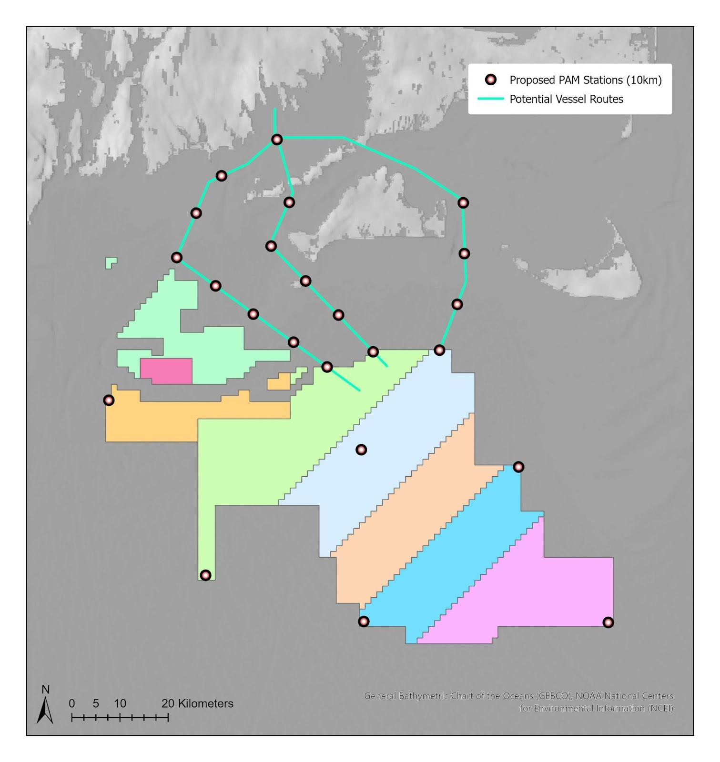
Supplementary Figure SII. This map provides an example of a tentative design for PAM Fixed Surface Buoys (red dots) recording in real time, spaced at 10 km along three tentative vessel servicing channels (green lines) and at the corners of the proposed Massachusetts/Rhode Island offshore wind energy lease block area (separate lease blocks are shown as separate-colored sections).

References
Baumgartner, M. F., J. Bonnell, P. J. Corkeron, S. M. Van Parijs, C. Hotchkin, B. A. Hodges, J. Bort Thornton, B. L. Mensi, and S. M. Bruner. 2020. Slocum Gliders Provide Accurate Near Real-Time Estimates of Baleen Whale Presence From Human-Reviewed Passive Acoustic Detection Information. Frontiers in Marine Science 7.
Baumgartner, M. F., J. Bonnell, S. M. Van Parijs, P. J. Corkeron, C. Hotchkin, K. Ball, L. P. Pelletier, J. Partan, D. Peters, J. Kemp, J. Pietro, K. Newhall, A. Stokes, T. V. N. Cole, E. Quintana, and S. D. Kraus. 2019. Persistent near real-time passive acoustic monitoring for baleen whales from a moored buoy: System description and evaluation. Methods in Ecology and Evolution 10:1476-1489.
Baumgartner, M. F., and S. E. Mussoline. 2011. A generalized baleen whale call detection and classification system. Journal of the Acoustical Society of America 129:2889-2902.
Clapham, P. J., and R. M. Pace. 2001. Defining Triggers for Temporary Area Closures to Protect Right Whales from Entanglements: Issues and Options.
Gervaise, C., Y. Simard, F. Aulanier, and N. Roy. 2021. Optimizing passive acoustic systems for marine mammal detection and localization: Application to real-time monitoring North Atlantic right whales in Gulf of St. Lawrence. Applied Acoustics 178:107949.
Johnson, Hansen, Daniel Morrison, and Christopher Taggart. 2021. WhaleMap: a tool to collate and display whale survey results in near real-time. Journal of Open Source Software 6, no. 62: 3094.
Spaulding, E., M. Robbins, T. Calupca, C. W. Clark, C. Tremblay, A. Waack, A. Warde, J. Kemp, and K. Newhall. 2009. An autonomous, near-real-time buoy system for automatic detection of North Atlantic right whale calls. Proceedings of Meetings on Acoustics 6:010001.

