Supplementary Material

**NMR-Spectra**

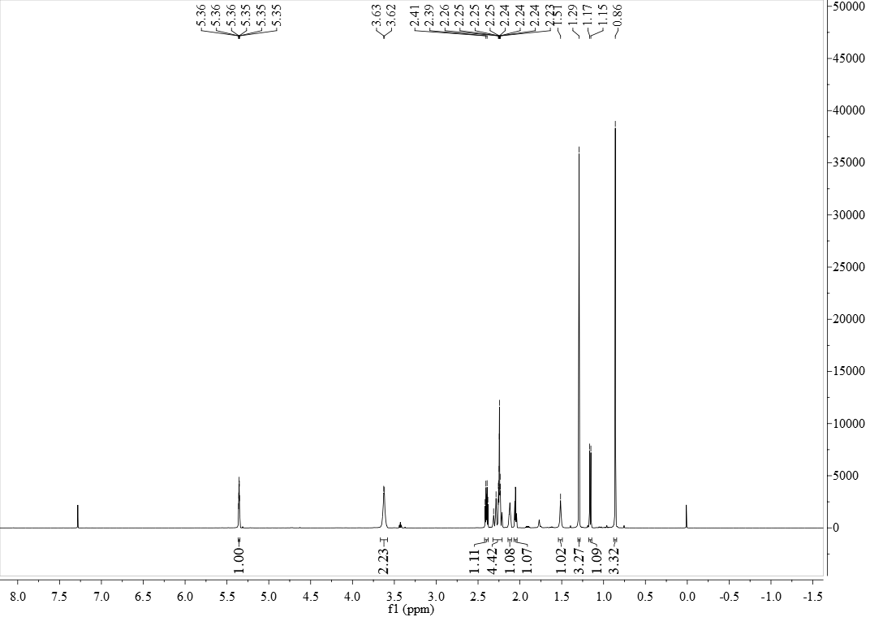

**FigureS1.** 1H NMR (600 MHz, CDCl3) of compound **2**

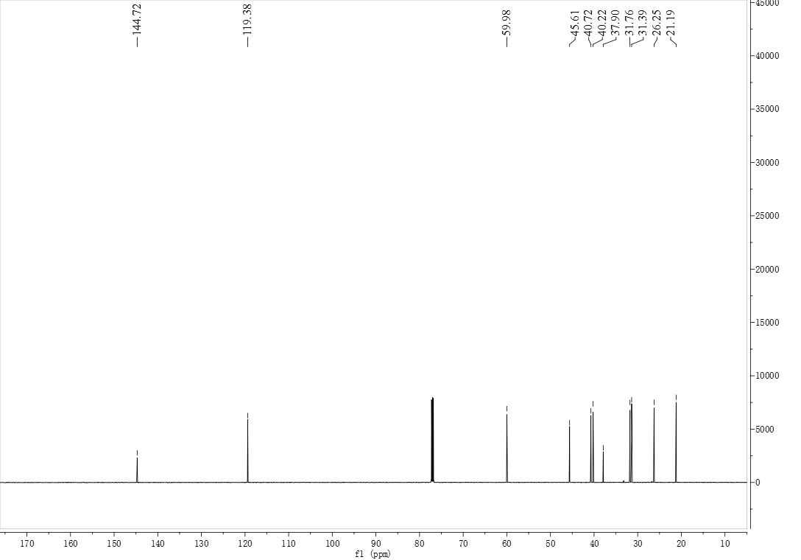

**FigureS2.** 13C NMR (150 MHz, CDCl3) of compound **2**

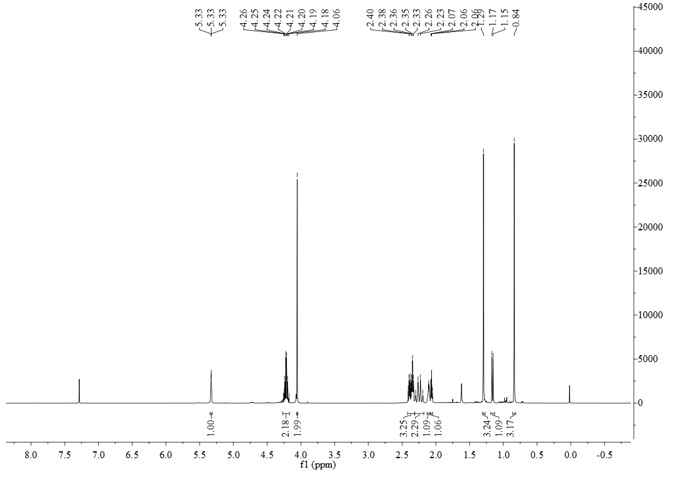

**FigureS3.** 1H NMR (600 MHz, CDCl3) of compound **3**

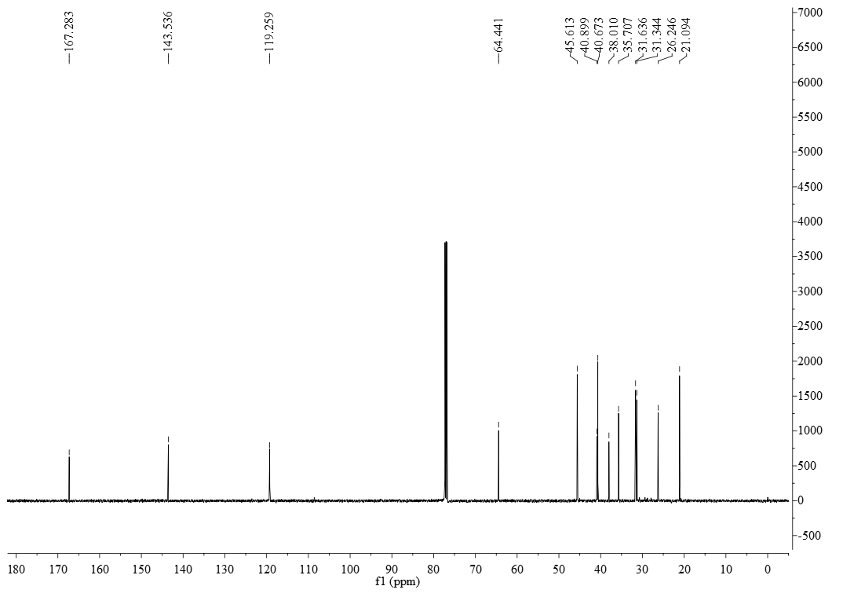

**FigureS4.** 13C NMR (150 MHz, CDCl3) of compound **3**

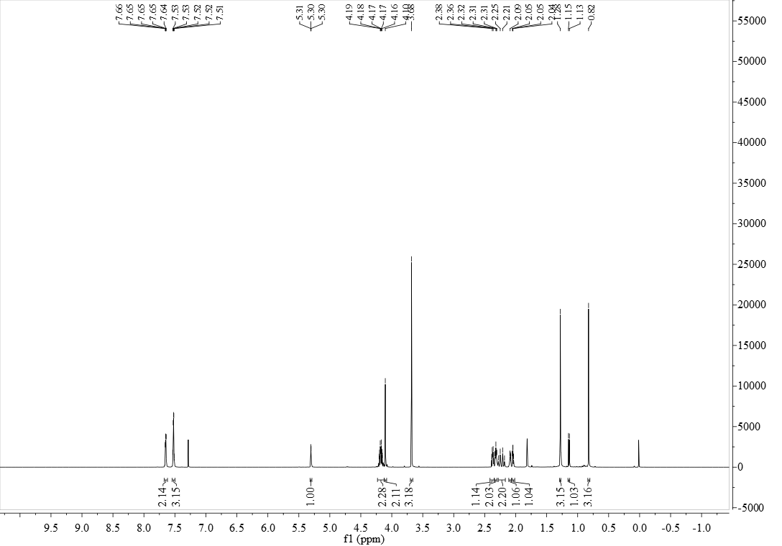

**FigureS5.** 1H NMR (600 MHz, CDCl3) of compound **5a**

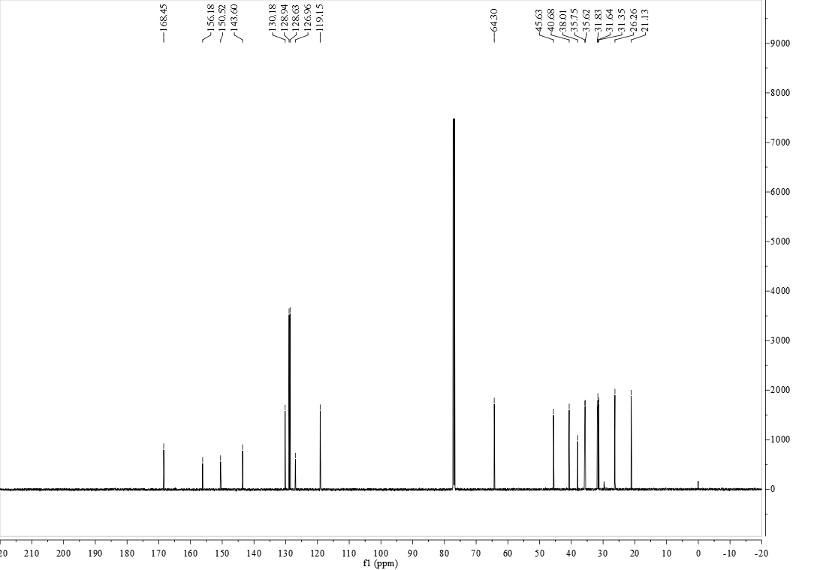

**FigureS6.** 13C NMR (150 MHz, CDCl3) of compound **5a**

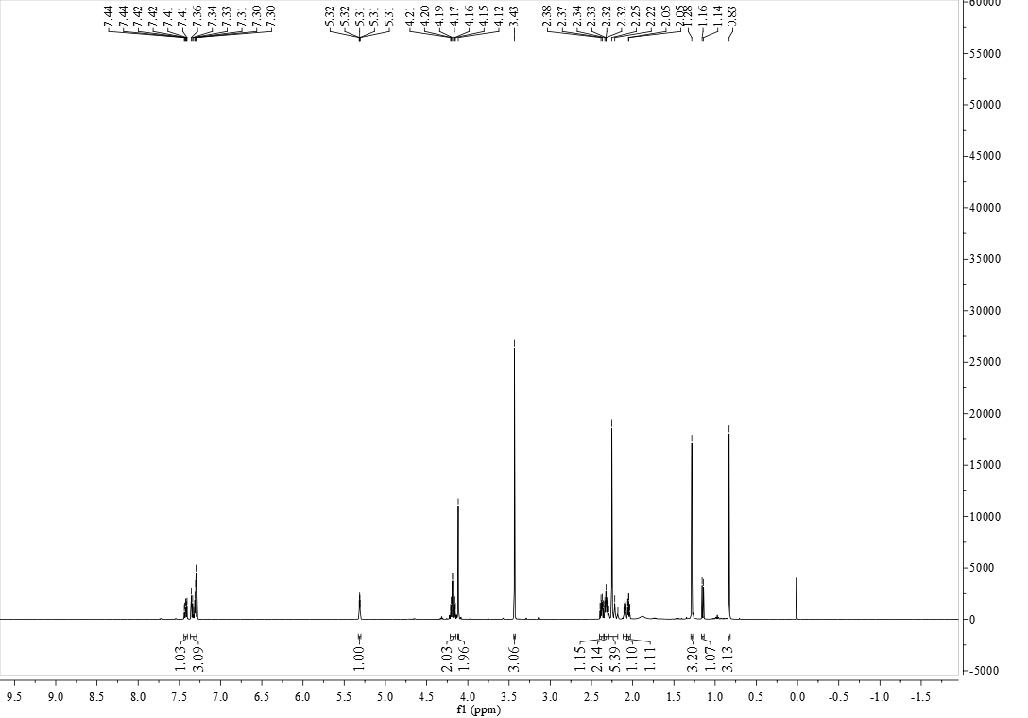

**FigureS7.** 1H NMR (600 MHz, CDCl3) of compound **5b**

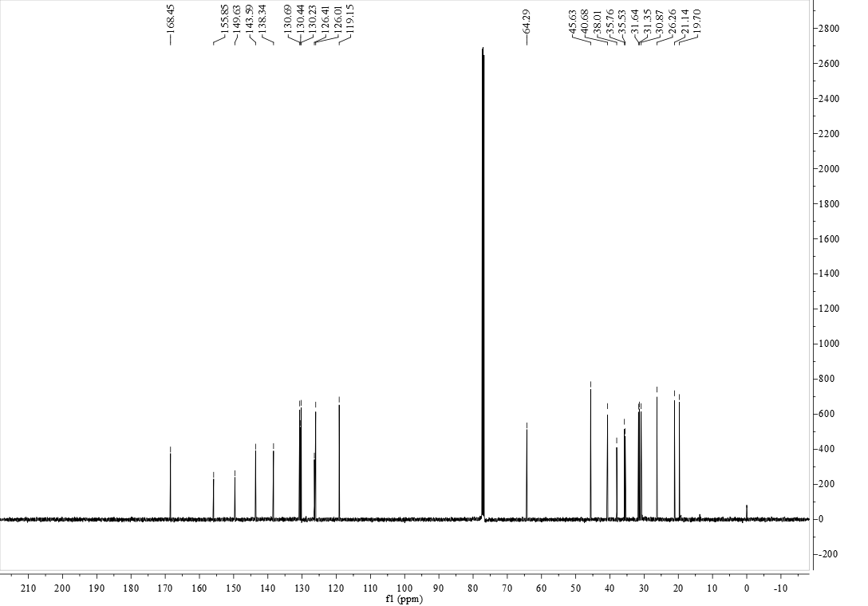

**FigureS8.** 13C NMR (150 MHz, CDCl3) of compound **5b**

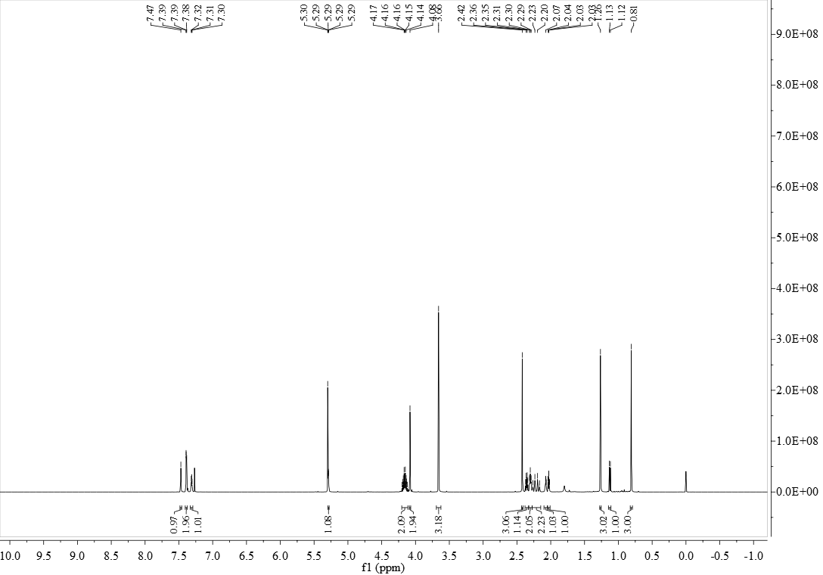

**FigureS9.** 1H NMR (600 MHz, CDCl3) of compound **5c**

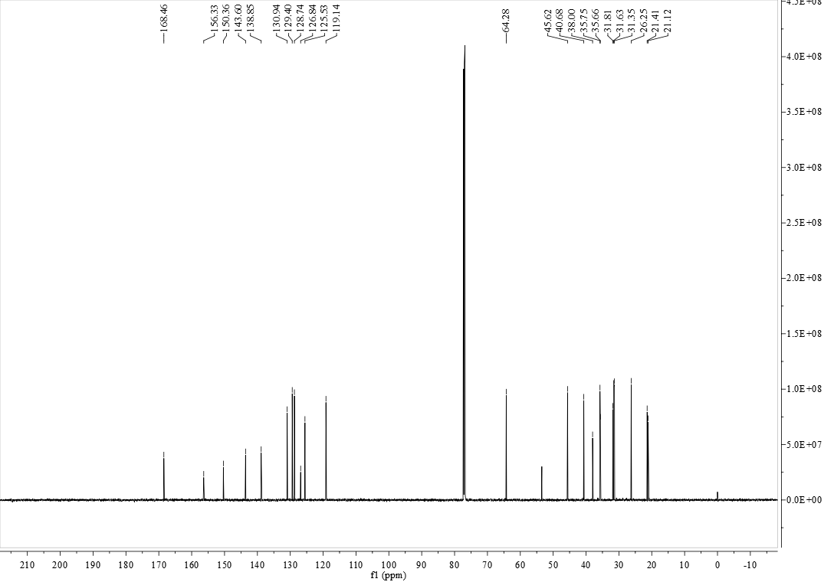

**FigureS10.** 13C NMR (150 MHz, CDCl3) of compound **5c**

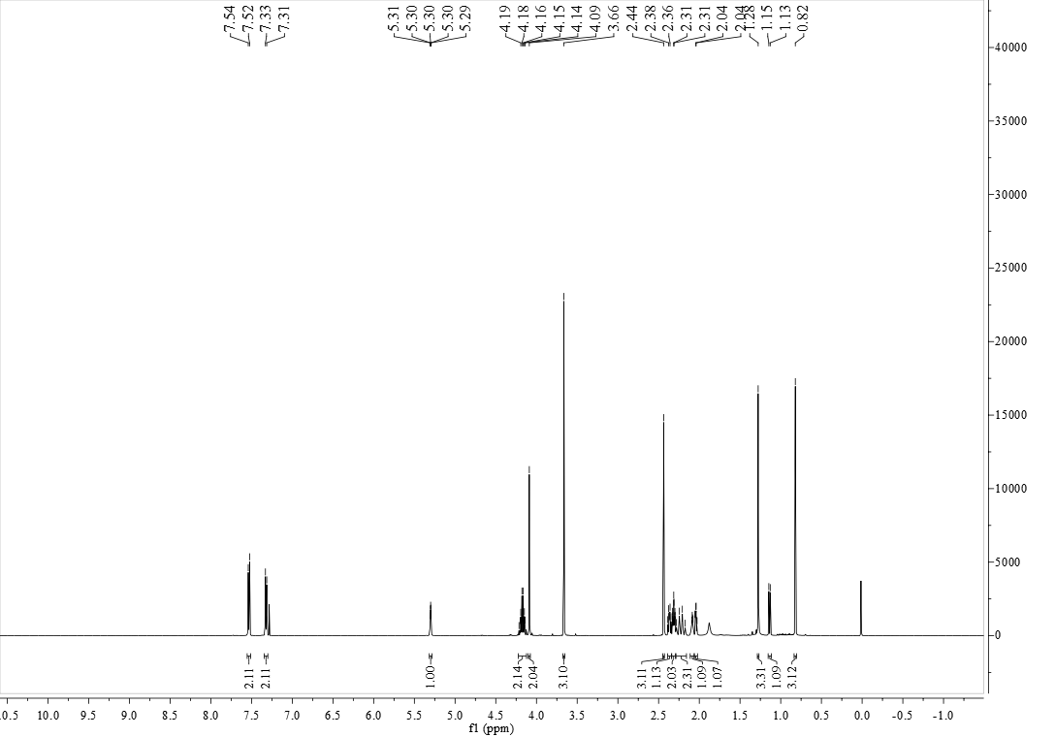

**FigureS11.** 1H NMR (500 MHz, CDCl3) of compound **5d**

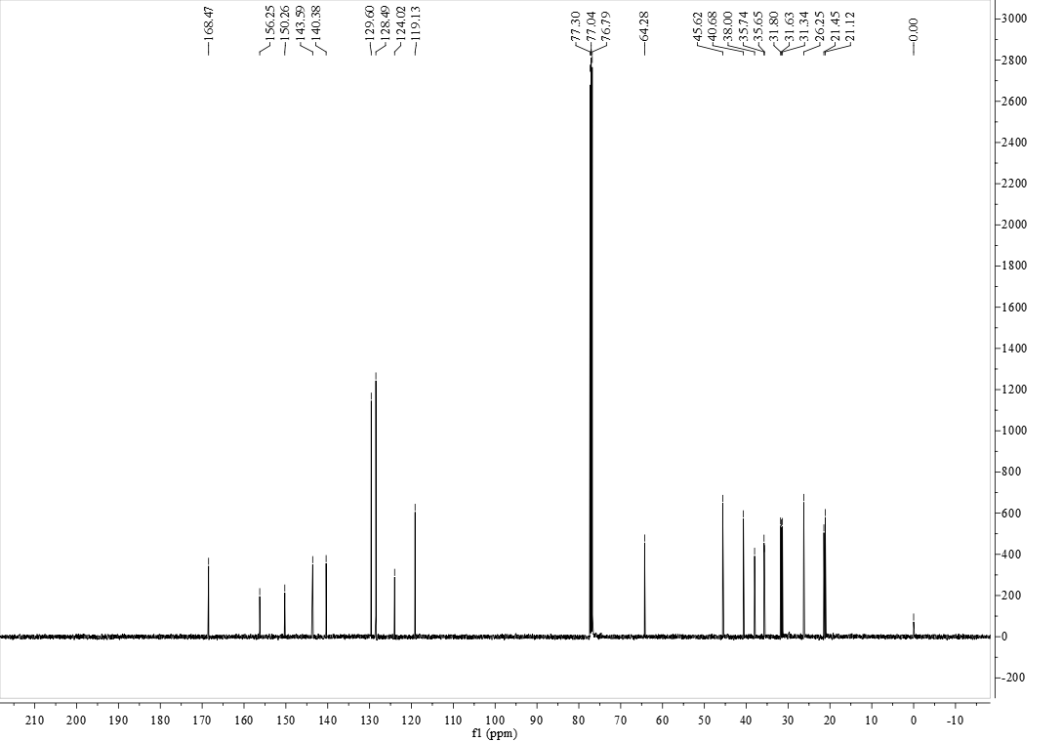

**FigureS12.** 13C NMR (125 MHz, CDCl3) of compound **5d**

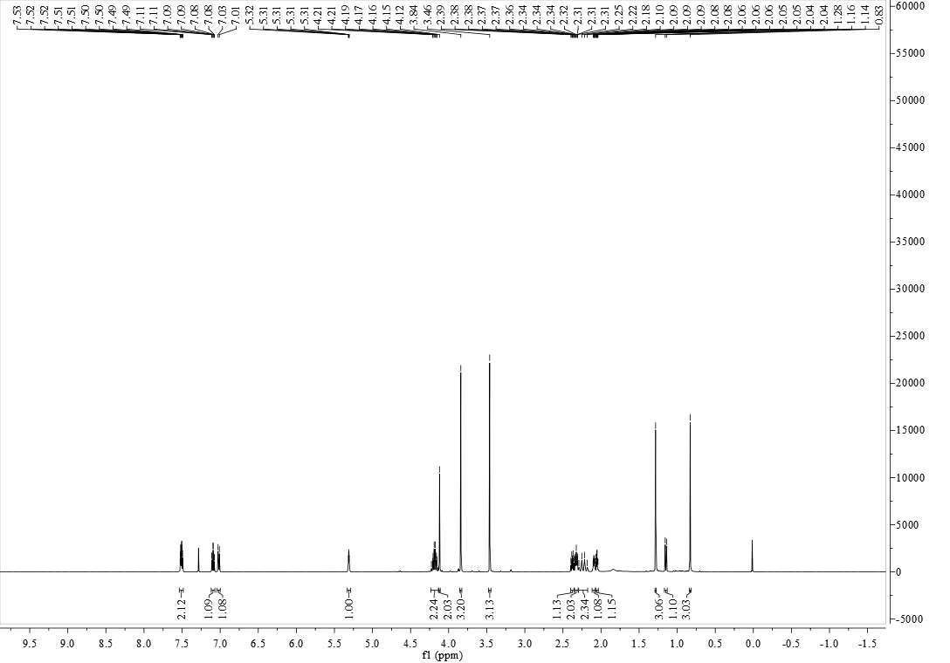

**FigureS13.** 1H NMR (500 MHz, CDCl3) of compound **5e**

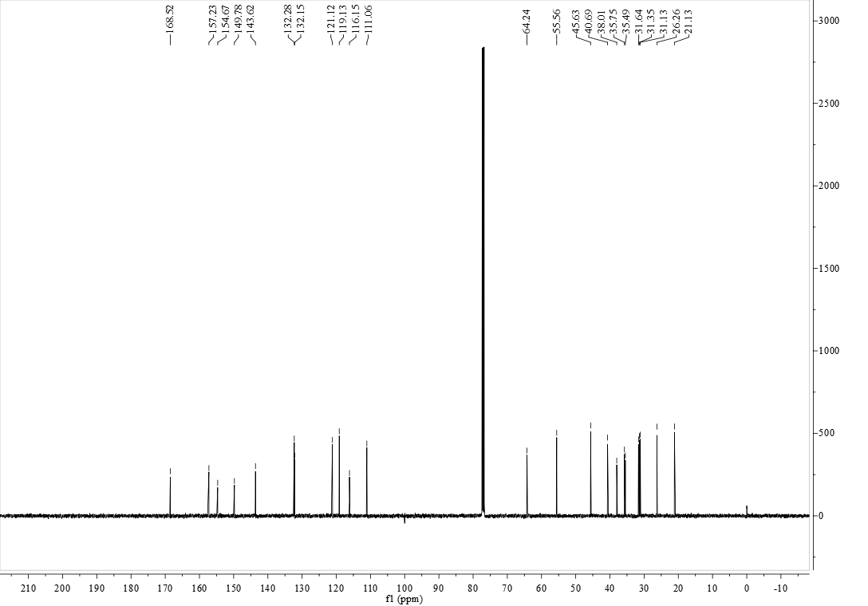

**FigureS14.** 13C NMR (125 MHz, CDCl3) of compound **5e**

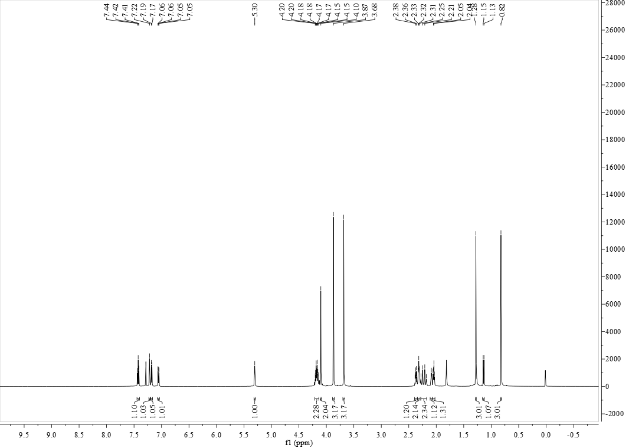

**FigureS15.** 1H NMR (600 MHz, CDCl3) of compound **5f**

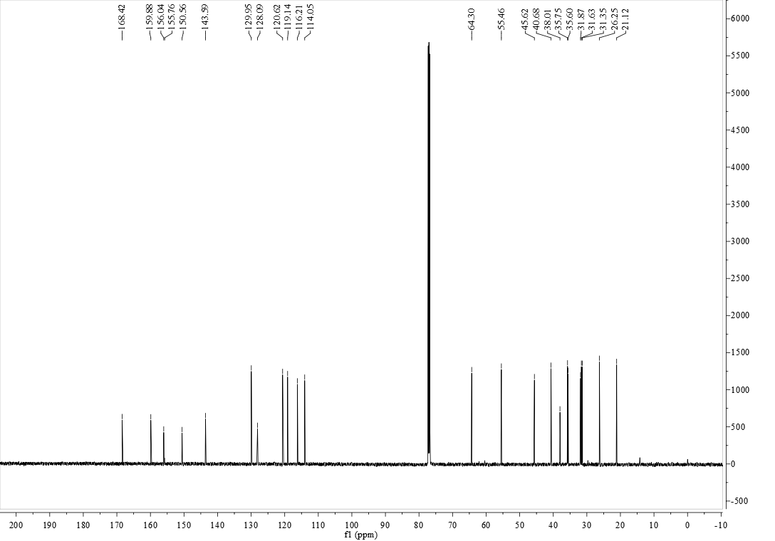

**FigureS16.** 13C NMR (150 MHz, CDCl3) of compound **5f**

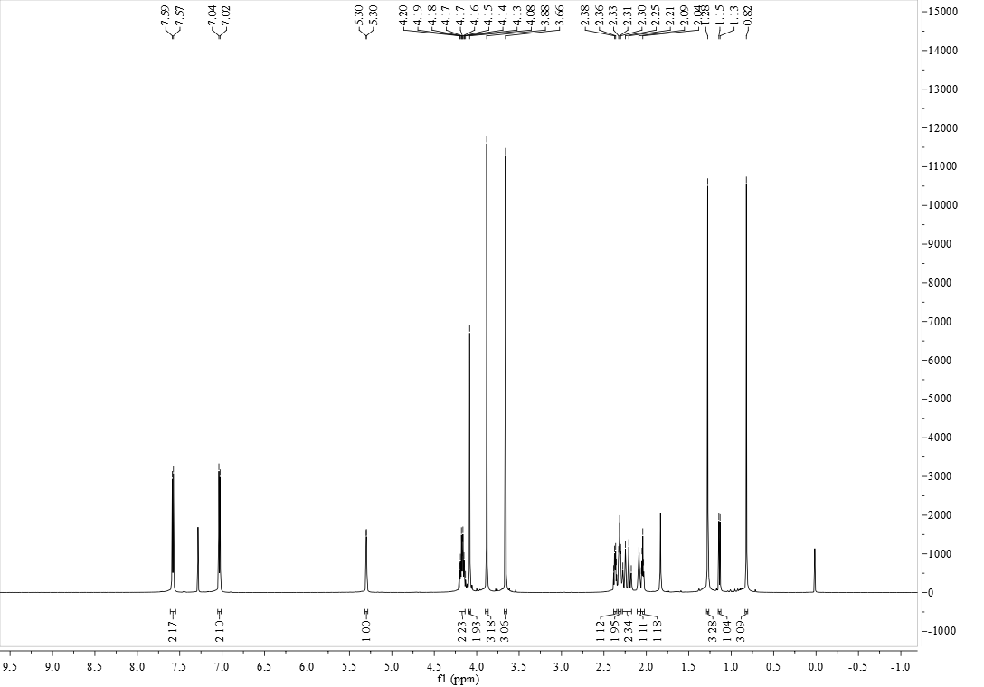

**FigureS17.** 1H NMR (600 MHz, CDCl3) of compound **5g**

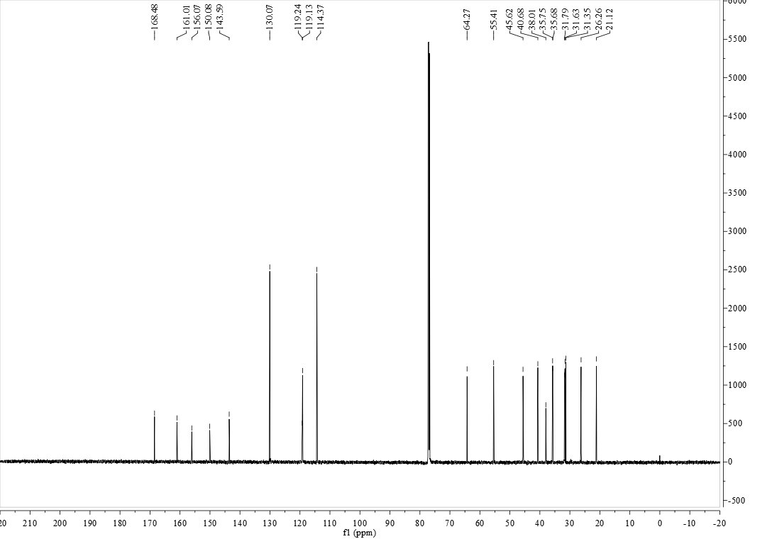

**FigureS18.** 13C NMR (150 MHz, CDCl3) of compound **5g**

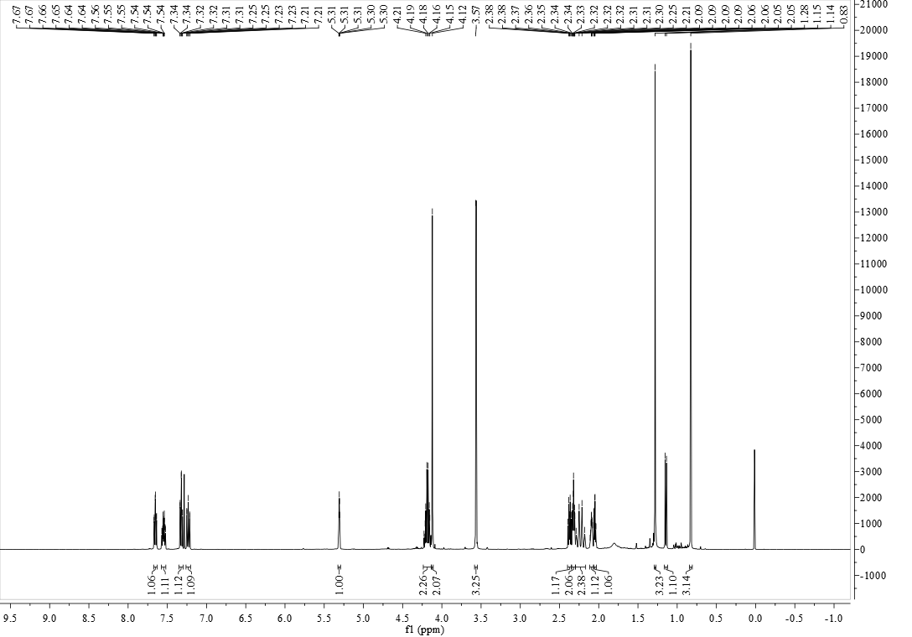

**FigureS19.** 1H NMR (500 MHz, CDCl3) of compound **5h**

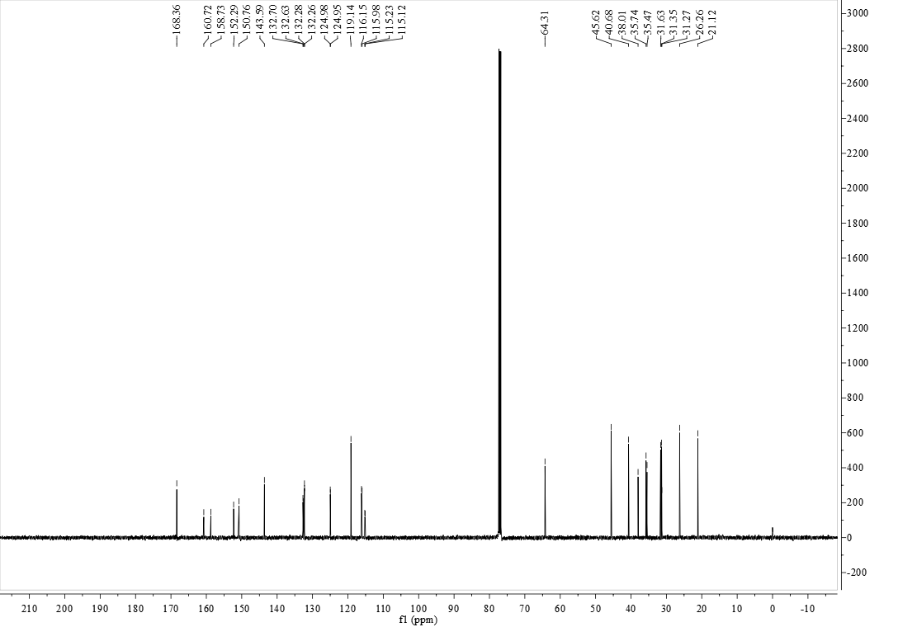

**FigureS20.** 13C NMR (125 MHz, CDCl3) of compound **5h**

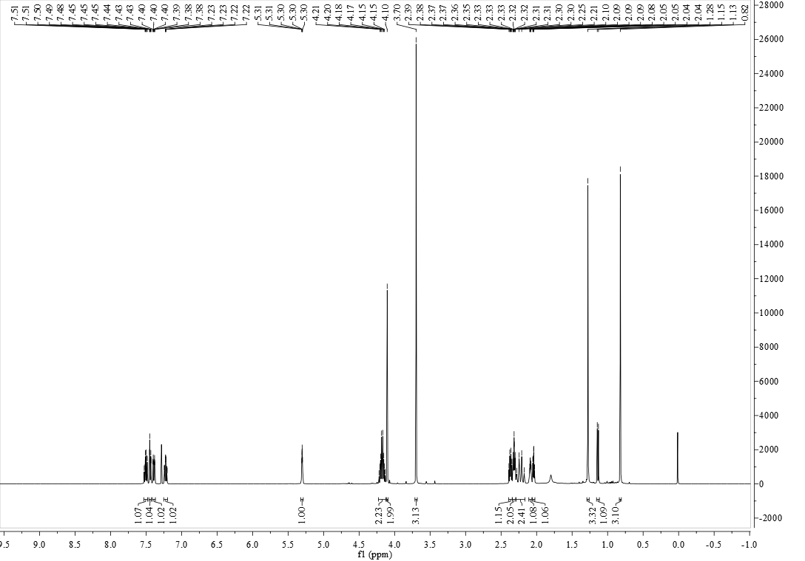

**FigureS21.** 1H NMR (500 MHz, CDCl3) of compound **5i**

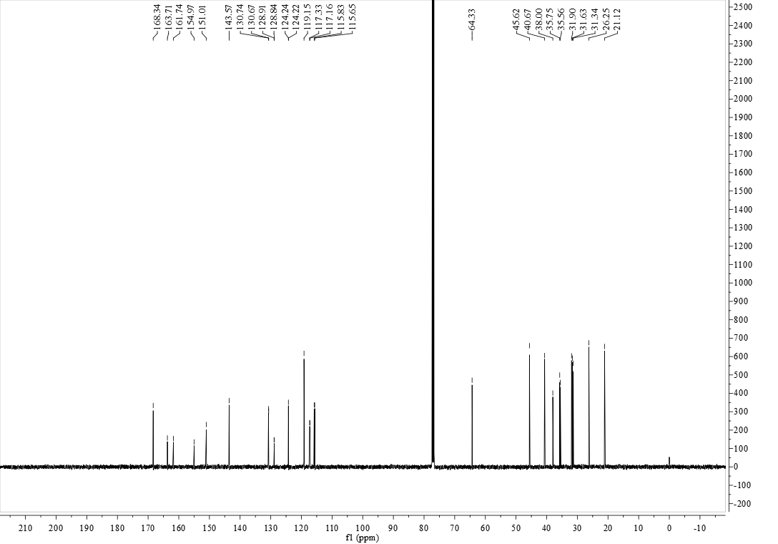

**FigureS22.** 13C NMR (125 MHz, CDCl3) of compound **5i**

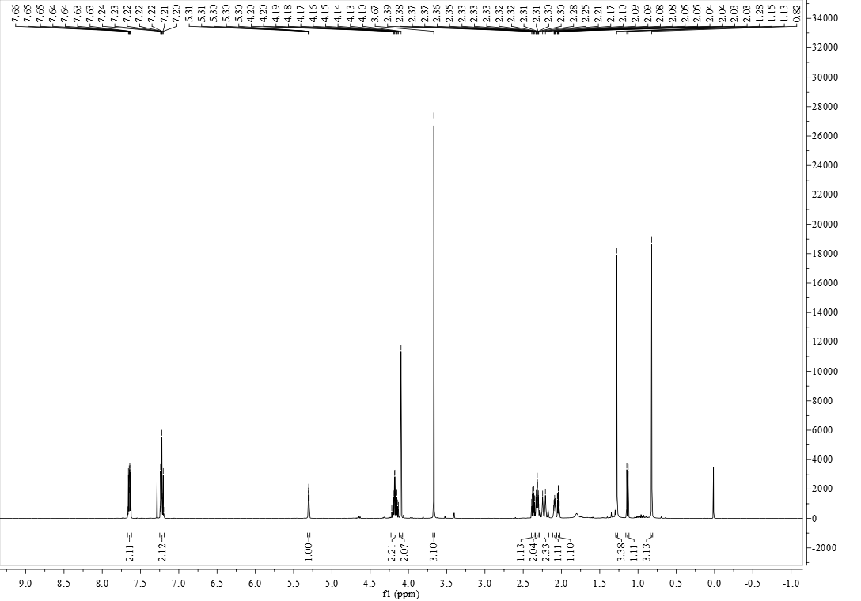

**FigureS23.** 1H NMR (500 MHz, CDCl3) of compound **5j**

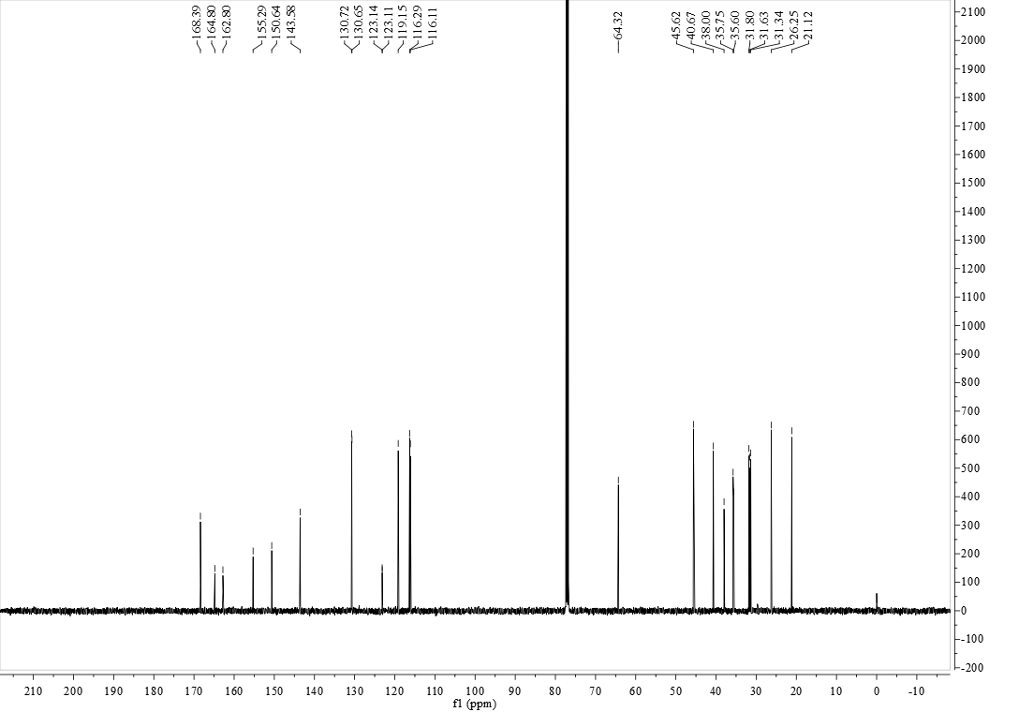

**FigureS24.** 13C NMR (125 MHz, CDCl3) of compound **5j**

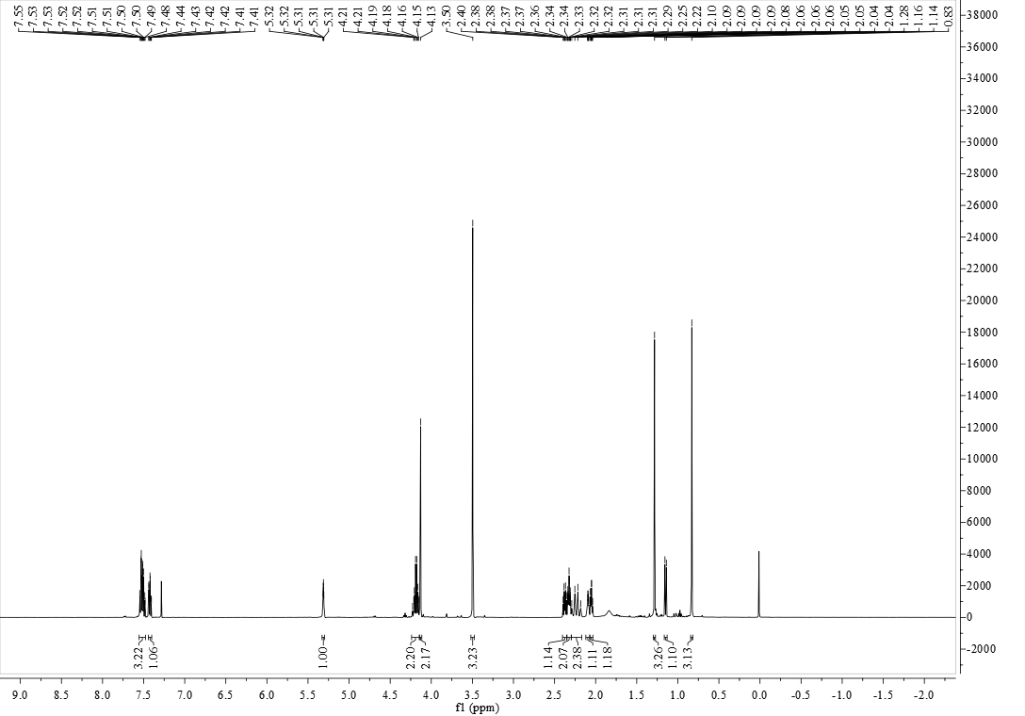

**FigureS25.** 1H NMR (500 MHz, CDCl3) of compound **5k**

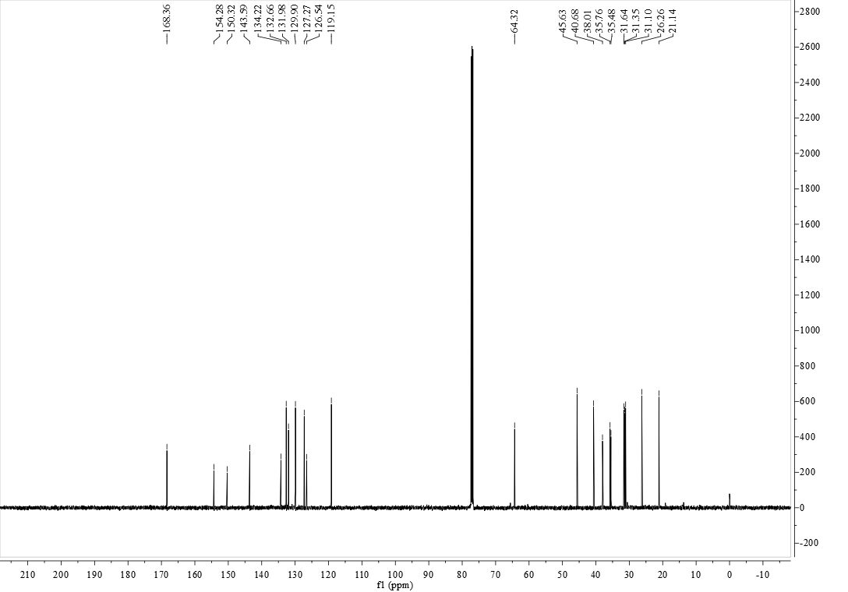

**FigureS26.** 13C NMR (125 MHz, CDCl3) of compound **5k**

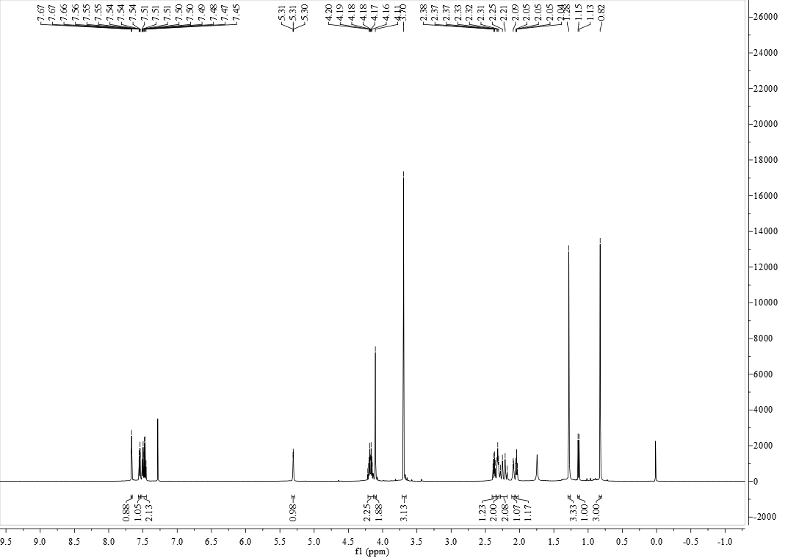

**FigureS27.** 1H NMR (600 MHz, CDCl3) of compound **5l**

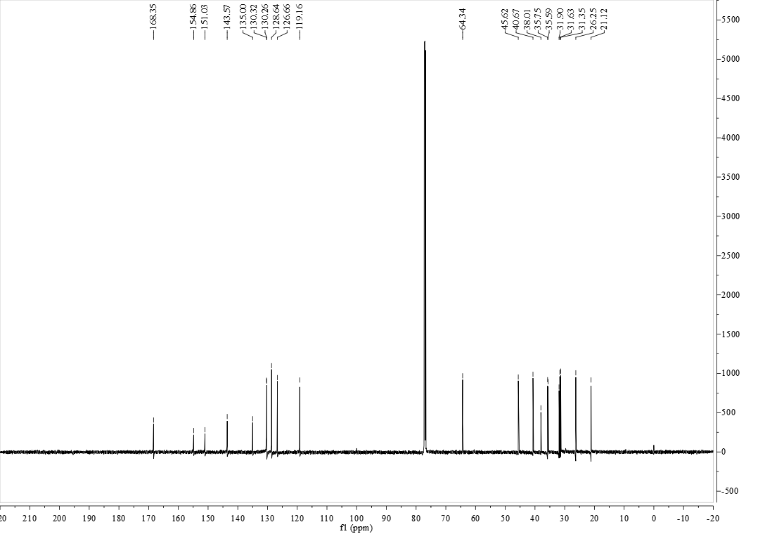

**FigureS28.** 13C NMR (150 MHz, CDCl3) of compound **5l**

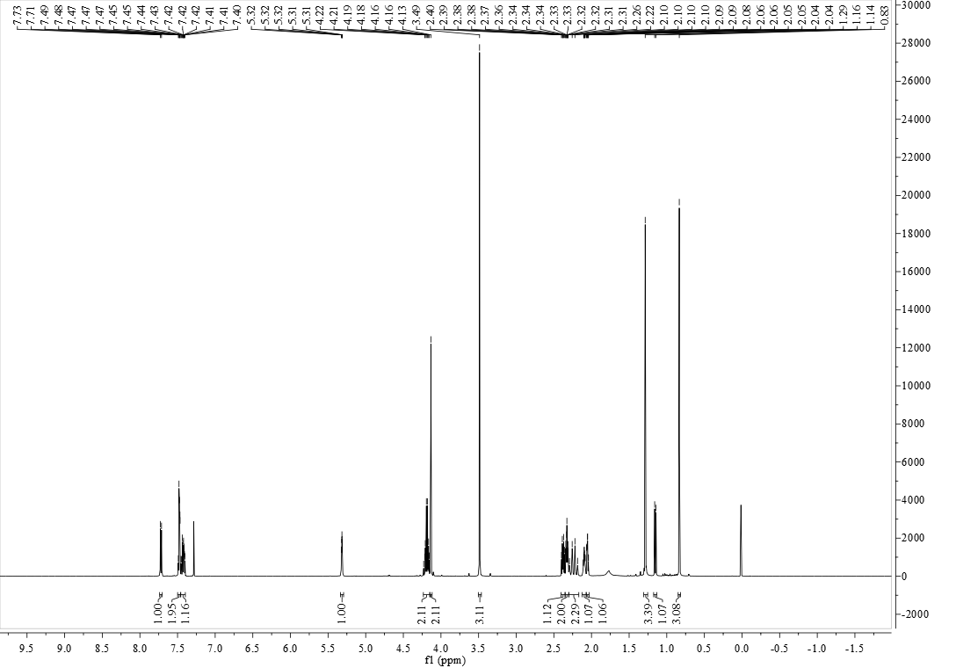

**FigureS29.** 1H NMR (500 MHz, CDCl3) of compound **5m**

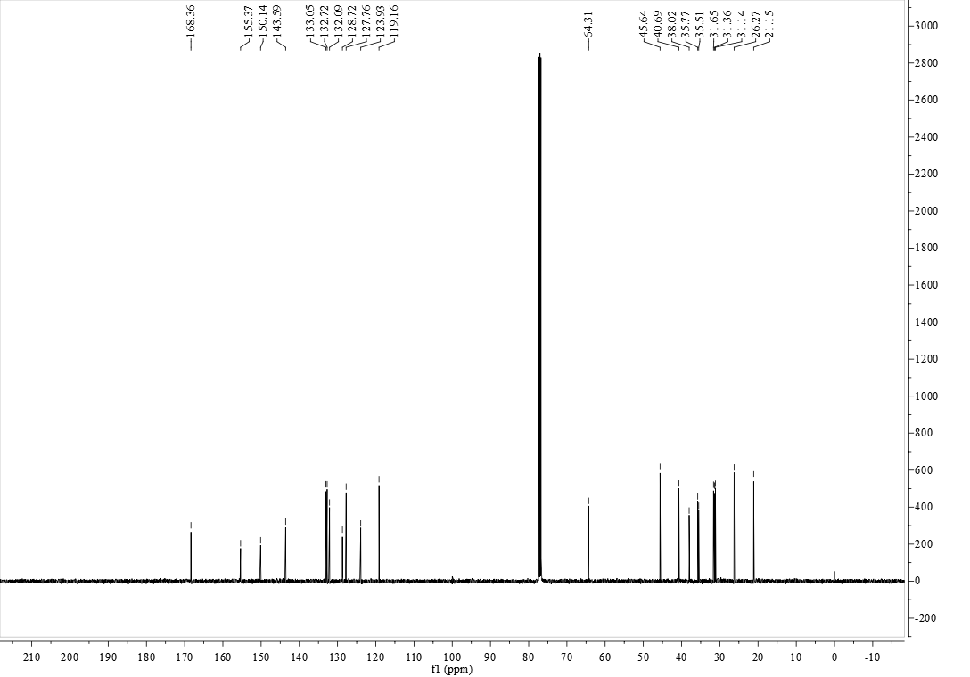

**FigureS30.** 13C NMR (125 MHz, CDCl3) of compound **5m**



**FigureS31.** 1H NMR (500 MHz, CDCl3) of compound **5n**

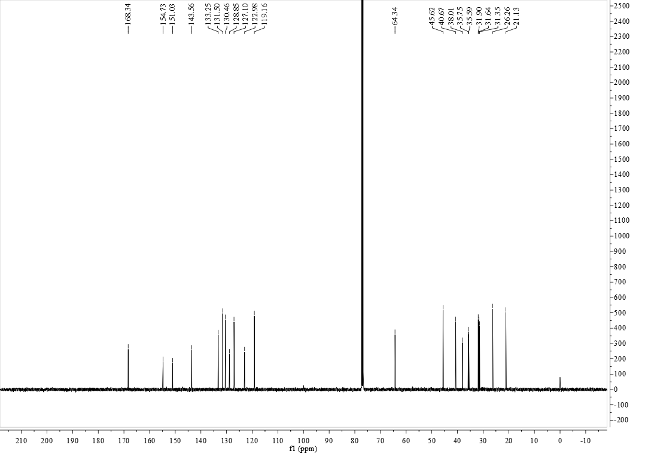

**FigureS32.** 13C NMR (125 MHz, CDCl3) of compound **5n**

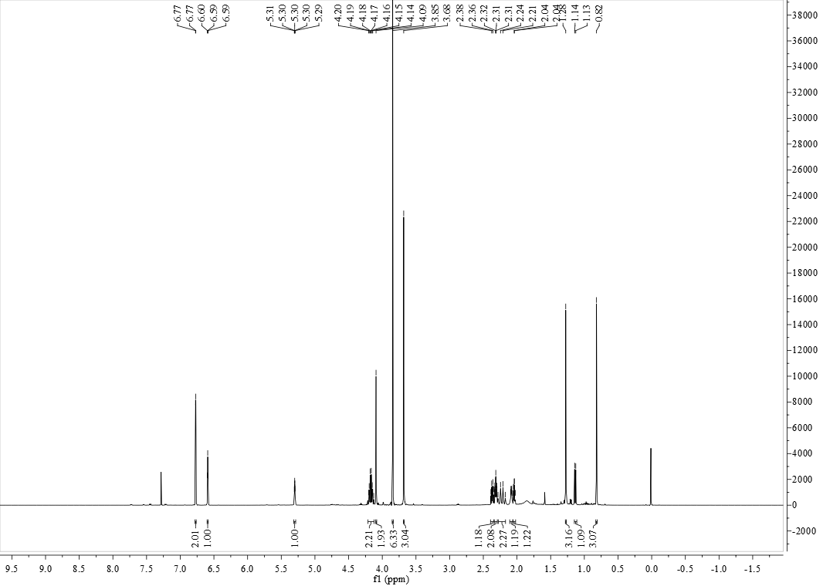

**FigureS33.** 1H NMR (500 MHz, CDCl3) of compound **5o**

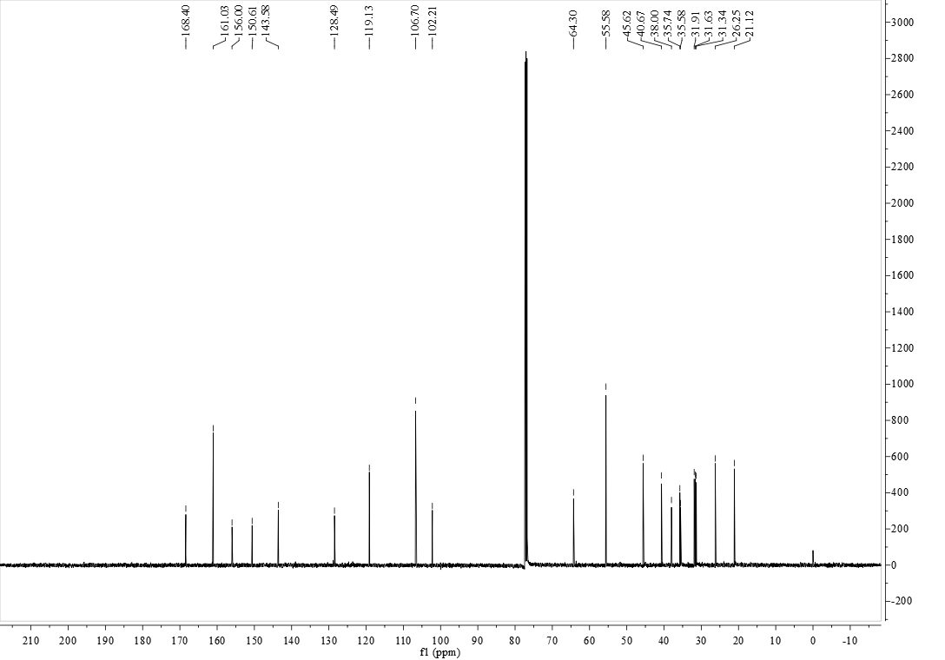

**FigureS34.** 13C NMR (125 MHz, CDCl3) of compound **5o**

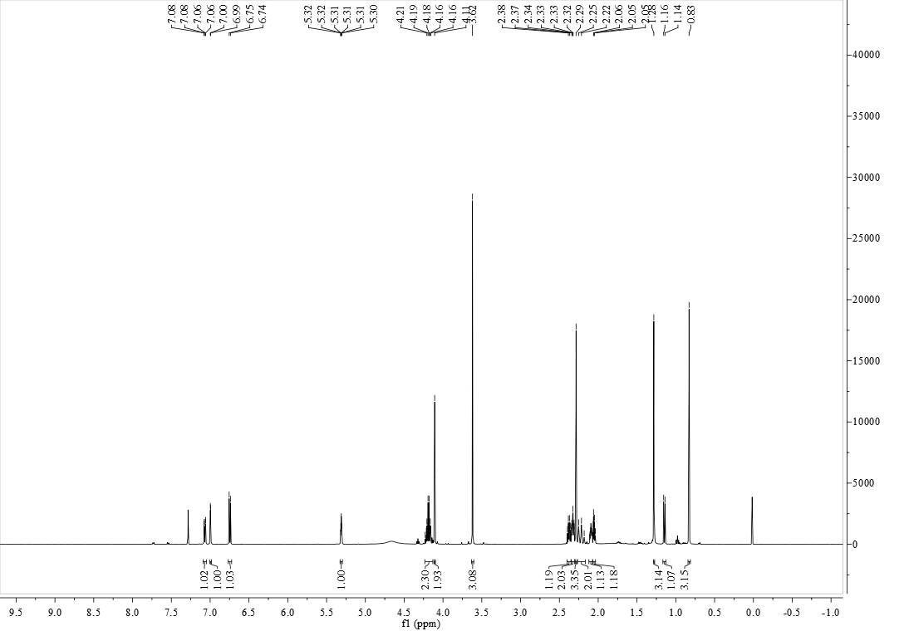

**FigureS35.** 1H NMR (500 MHz, CDCl3) of compound **5p**

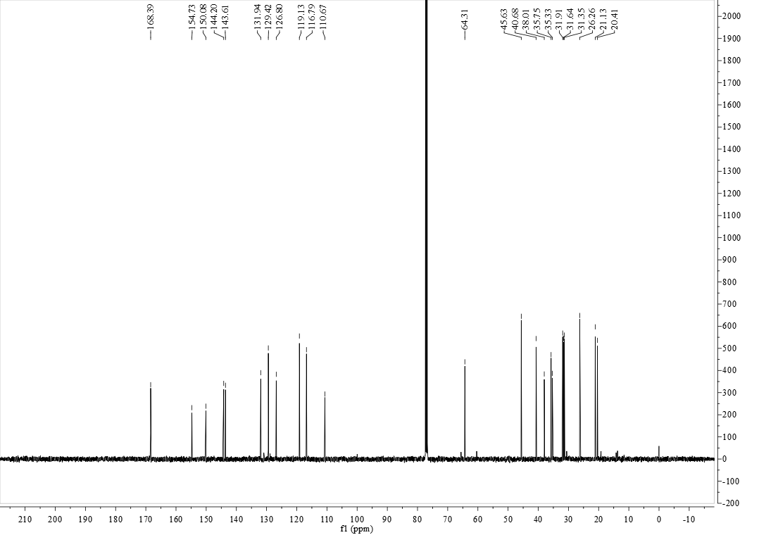

**FigureS36.** 13C NMR (125 MHz, CDCl3) of compound **5p**

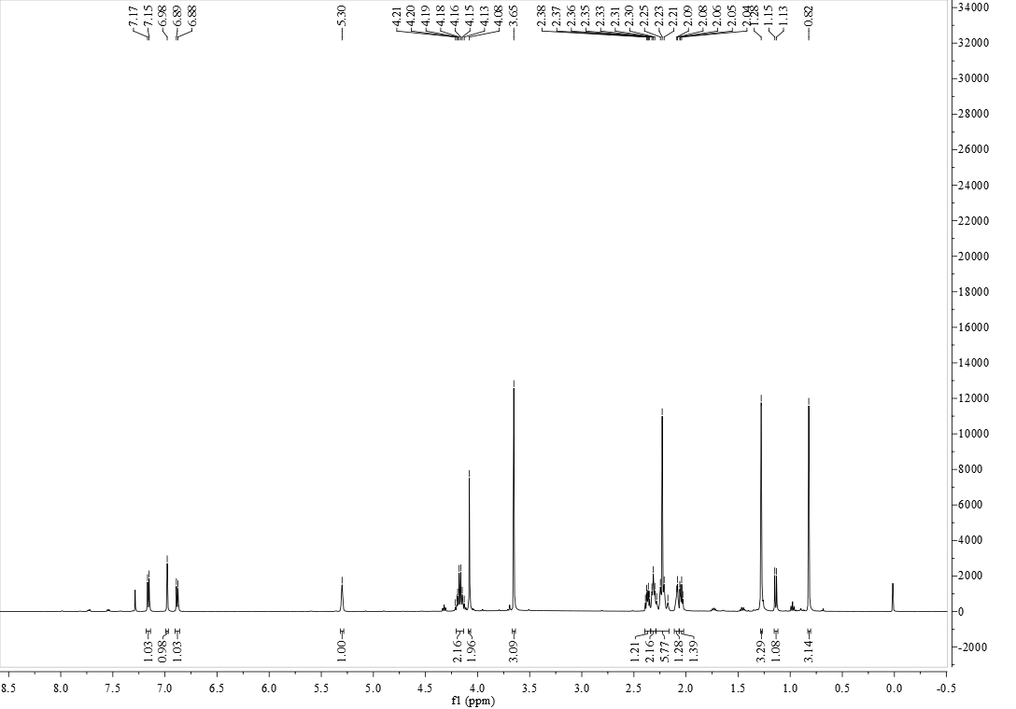

**FigureS37.** 1H NMR (500 MHz, CDCl3) of compound **5q**

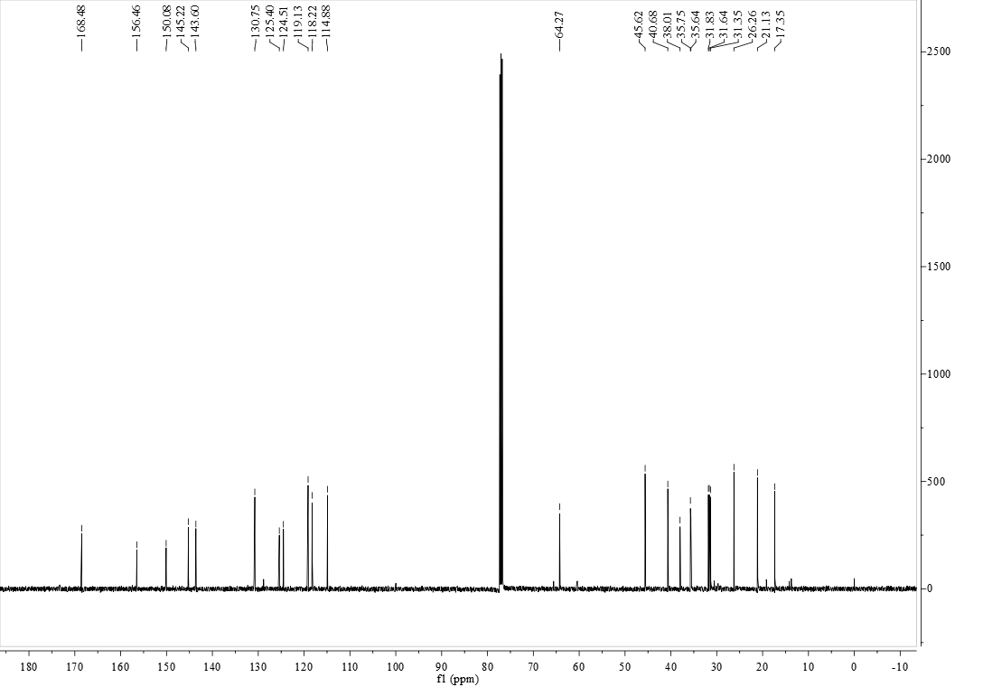

**FigureS38.** 13C NMR (125 MHz, CDCl3) of compound **5q**

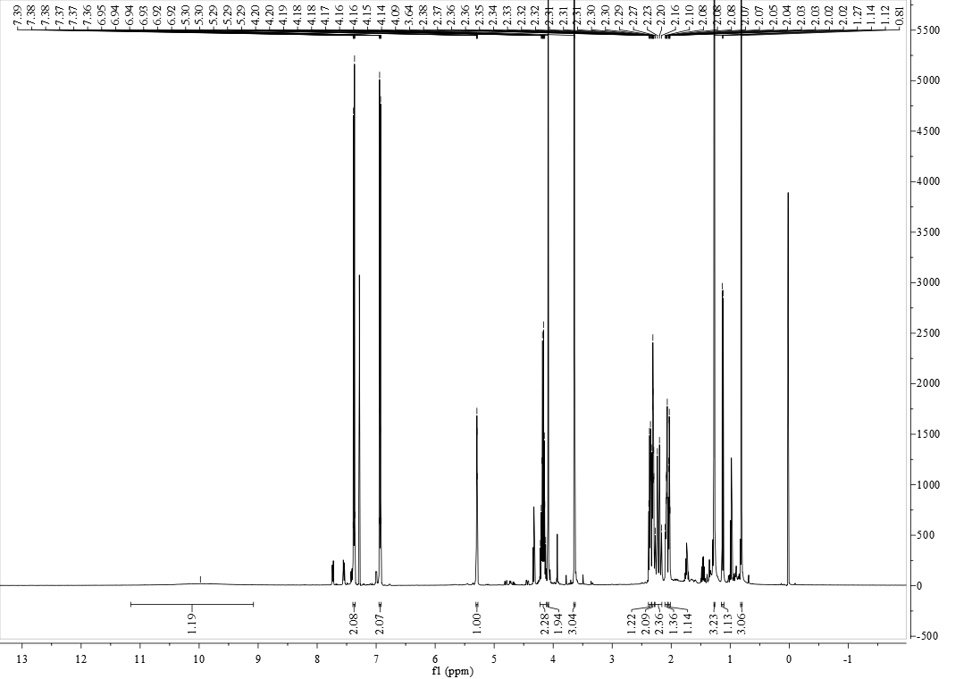

**FigureS39.** 1H NMR (500 MHz, CDCl3) of compound **5r**

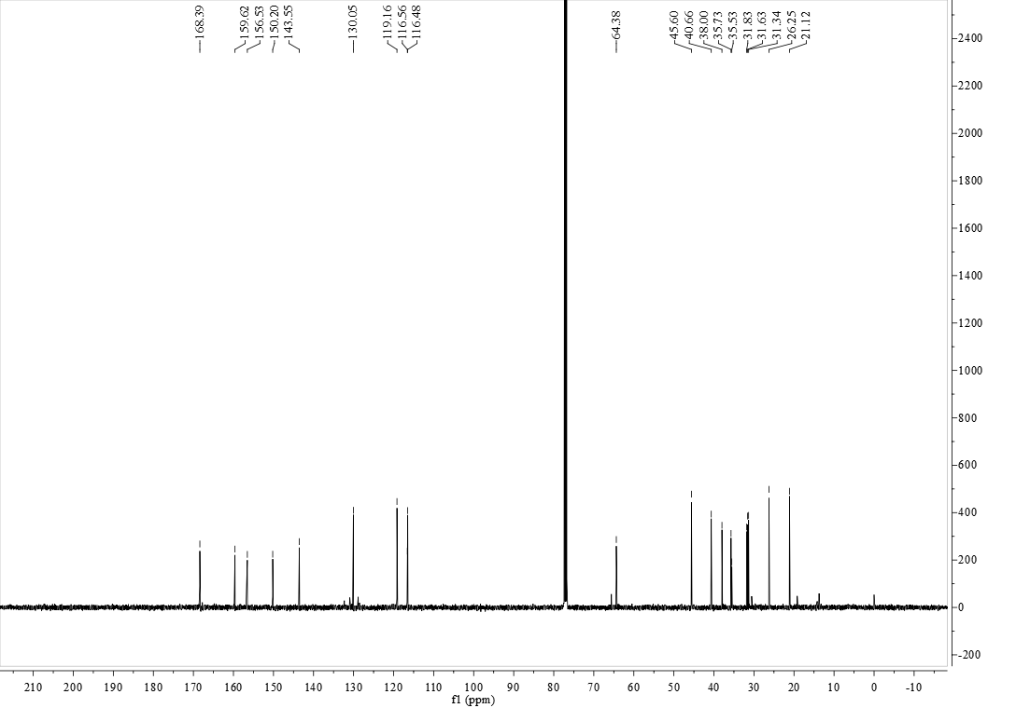

**FigureS40.** 13C NMR (125 MHz, CDCl3) of compound **5r**

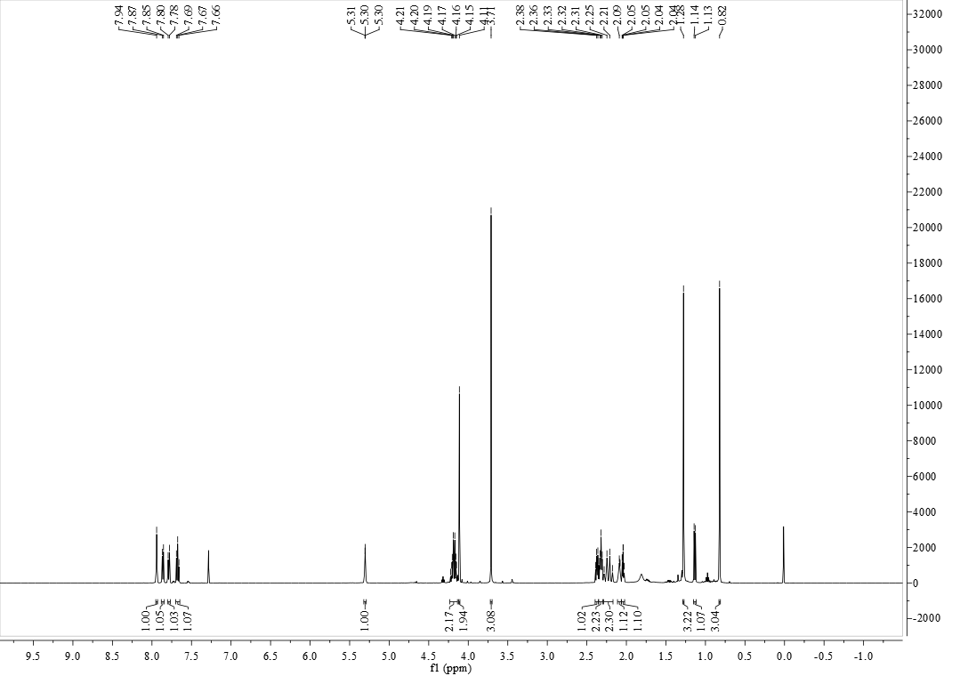

**FigureS41.** 1H NMR (500 MHz, CDCl3) of compound **5s**

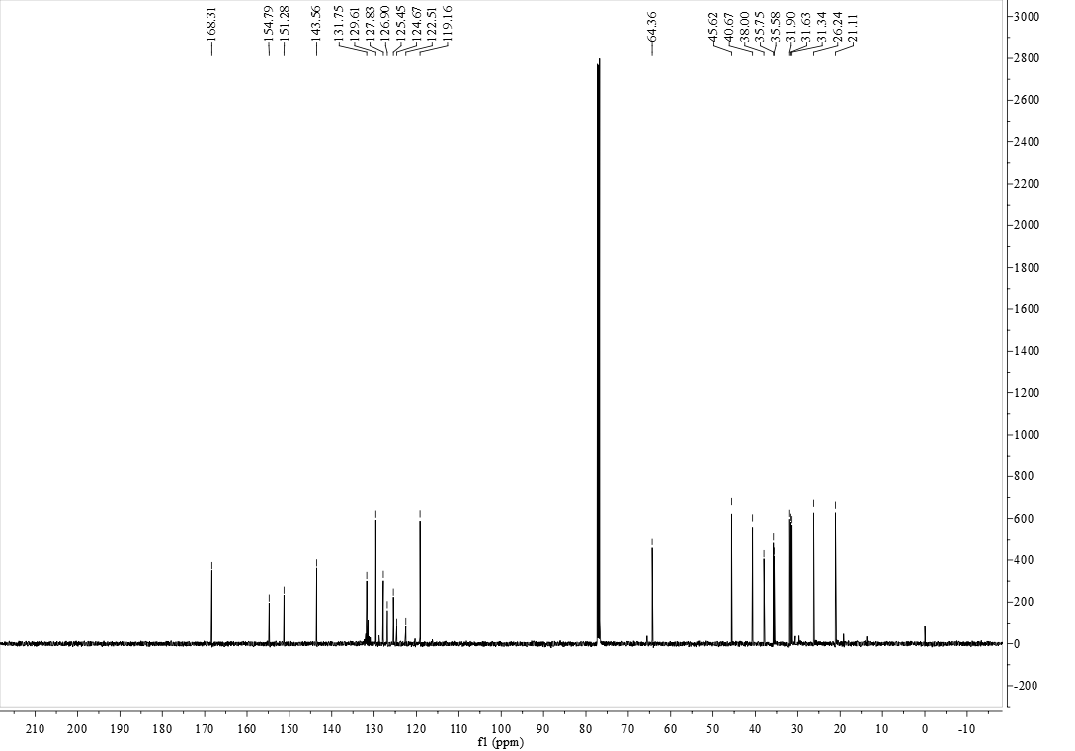

**FigureS42.** 13C NMR (125 MHz, CDCl3) of compound **5s**

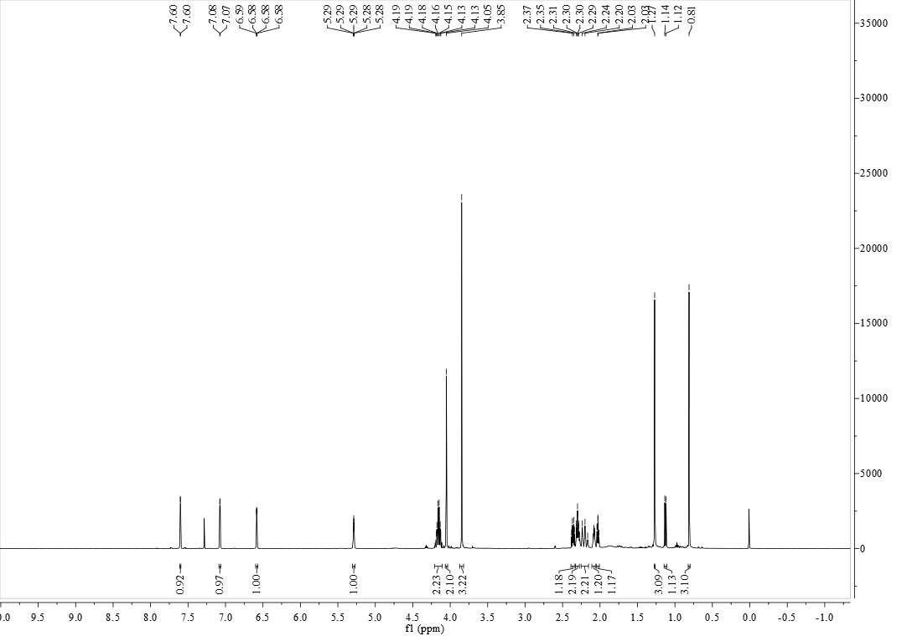

**FigureS43.** 1H NMR (500 MHz, CDCl3) of compound **5t**

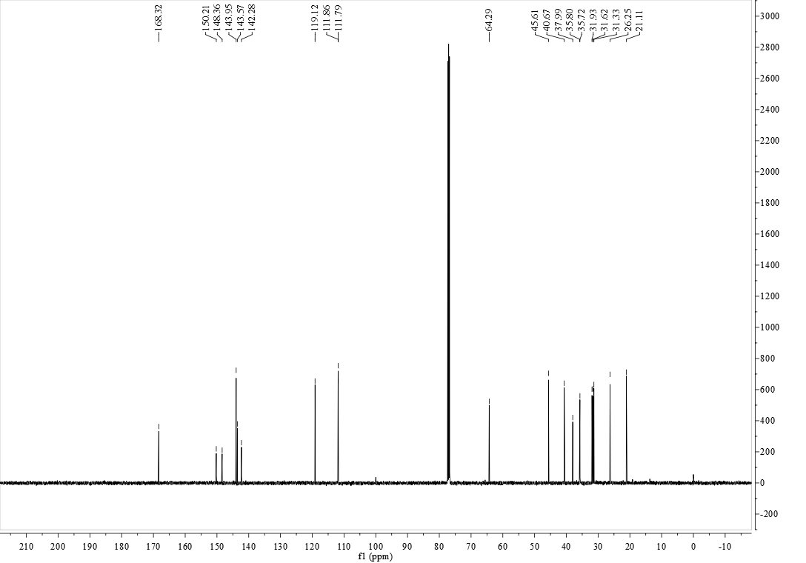

**FigureS44.** 13C NMR (125 MHz, CDCl3) of compound **5t**

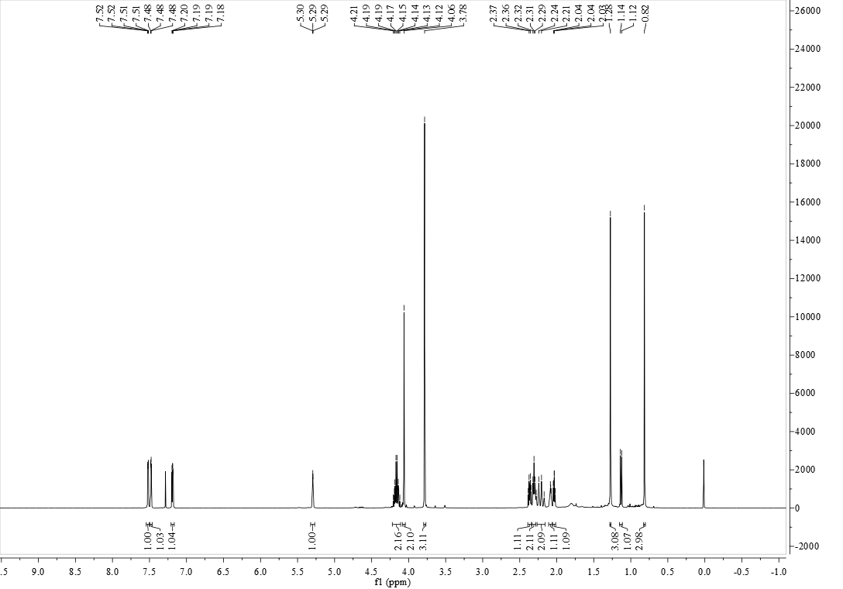

**FigureS45.** 1H NMR (500 MHz, CDCl3) of compound **5u**

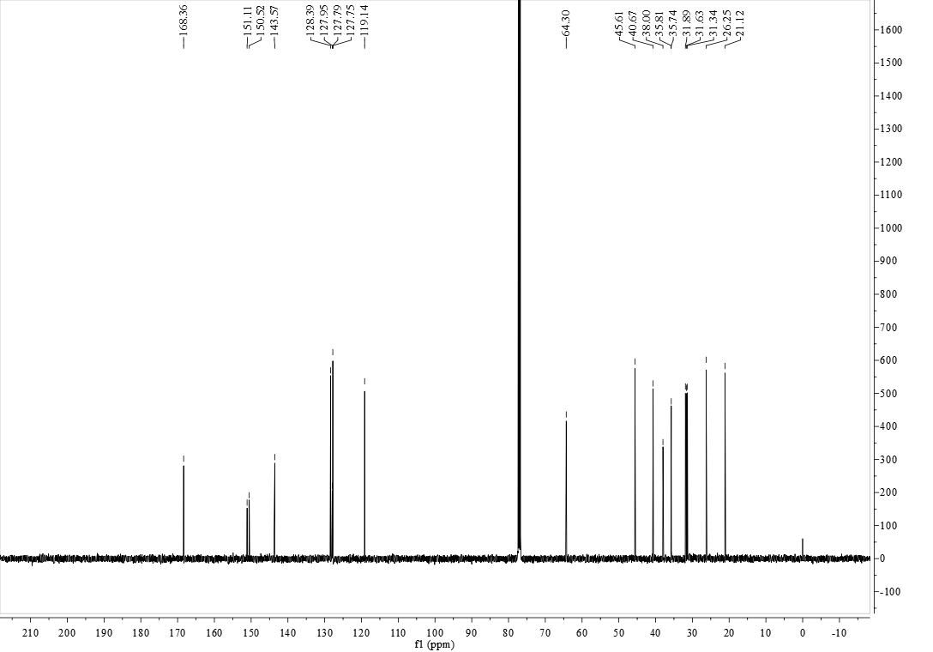

**FigureS46.** 13C NMR (125 MHz, CDCl3) of compound **5u**

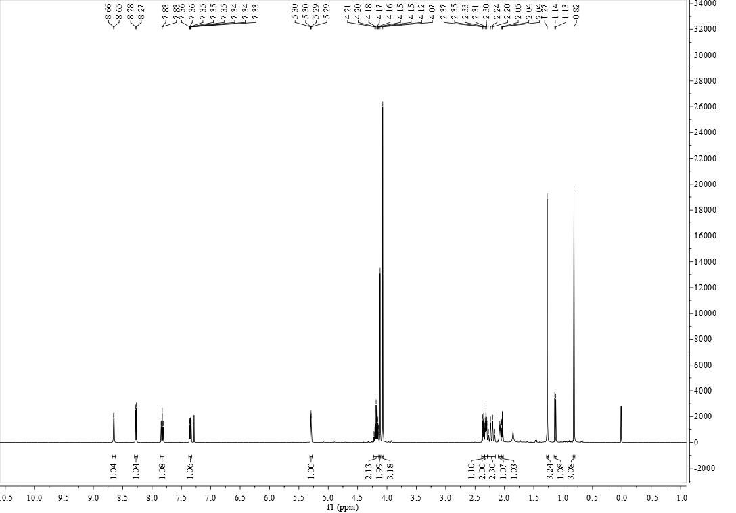

**FigureS47.** 1H NMR (500 MHz, CDCl3) of compound **5v**

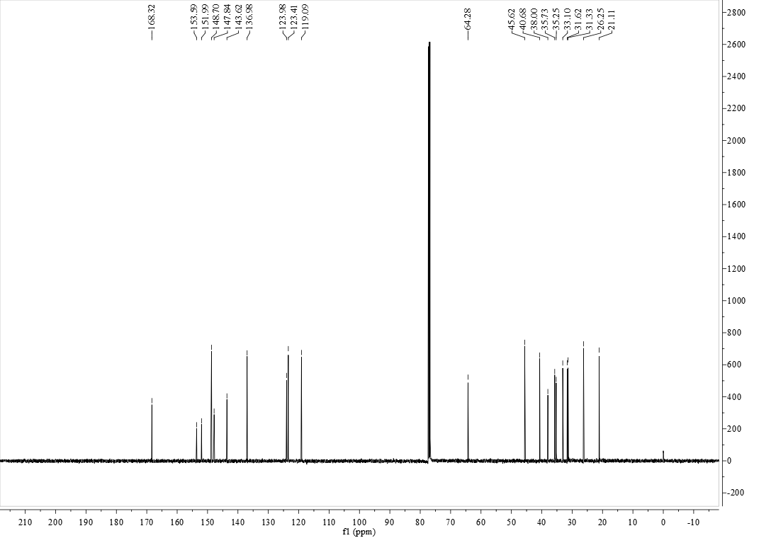

**FigureS48.** 13C NMR (125 MHz, CDCl3) of compound **5v**

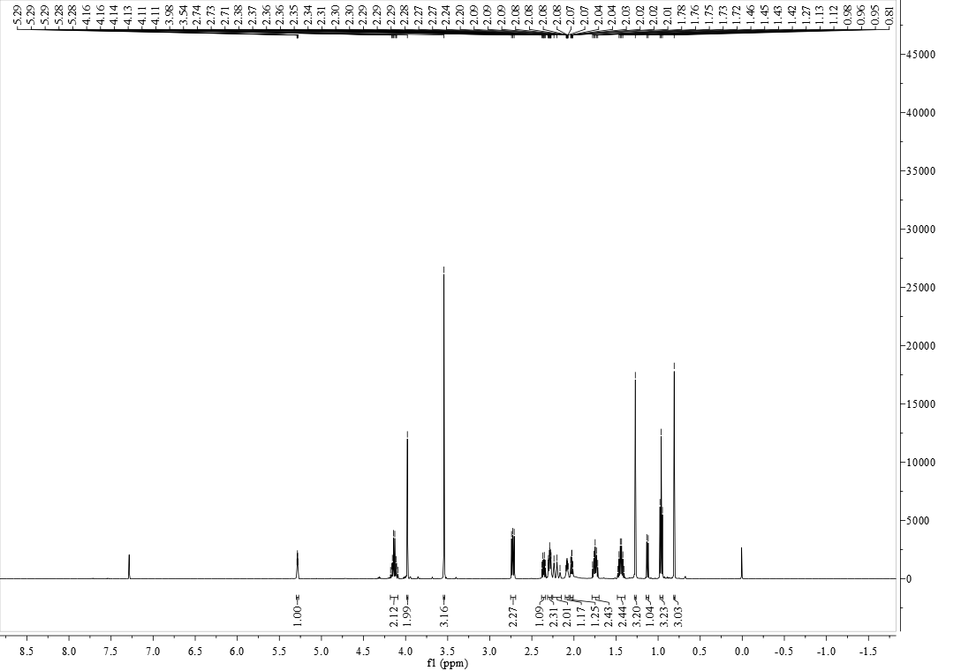

**FigureS49.** 1H NMR (500 MHz, CDCl3) of compound **5w**

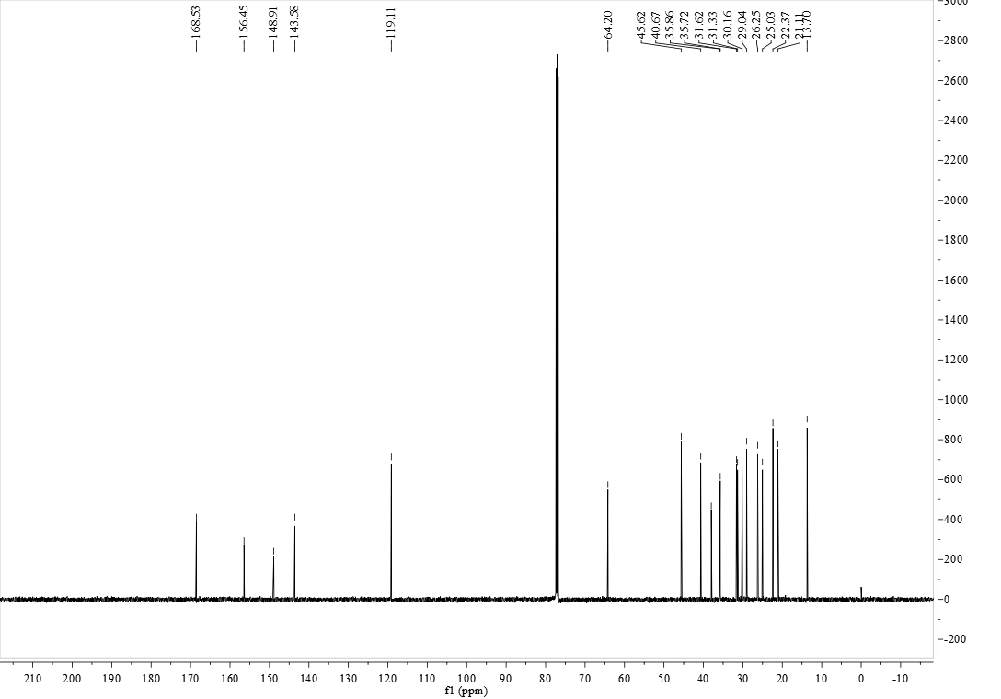

**FigureS50.** 13C NMR (125 MHz, CDCl3) of compound **5w**

**FT-IR-Spectra**

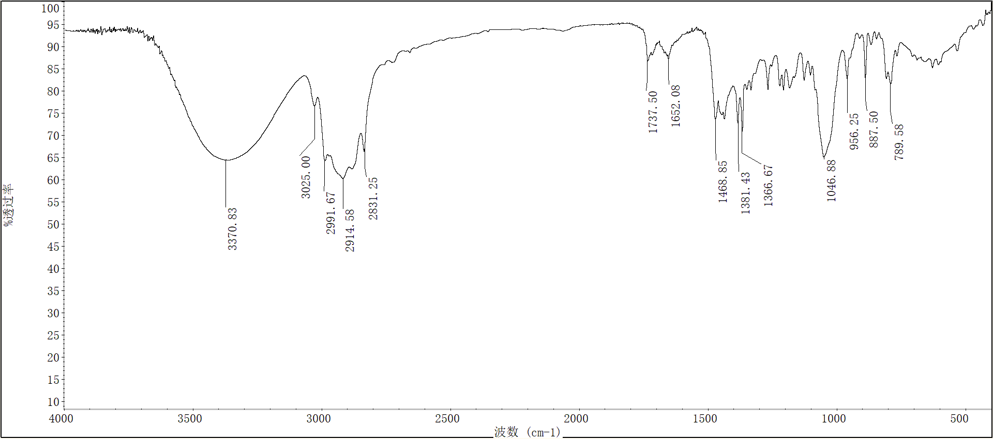

**FigureS51.** FT-IR spectra of compound **2**

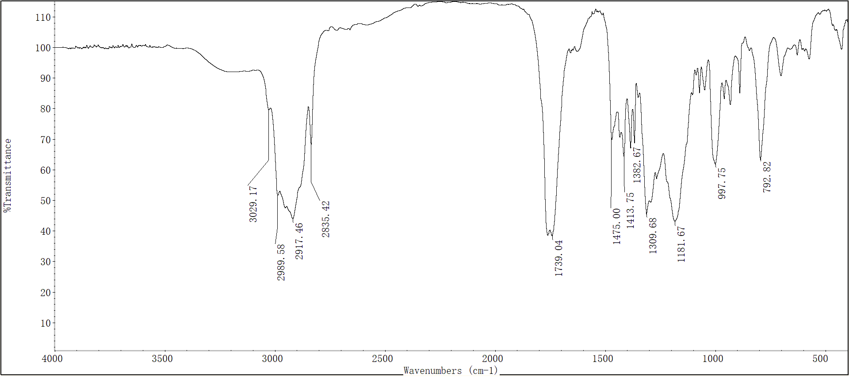

**FigureS52.** FT-IR spectra of compound **3**

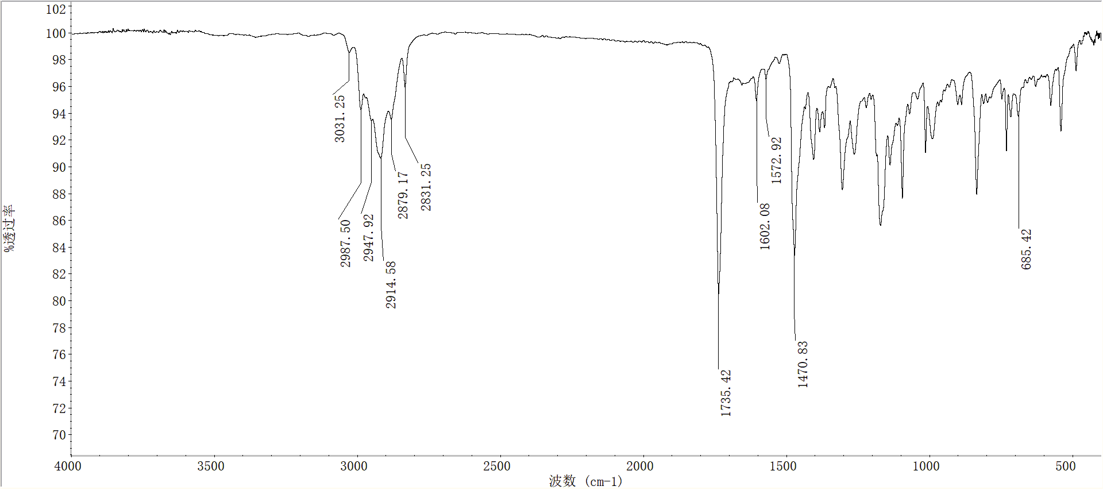

**FigureS53.** FT-IR spectra of compound **5a**

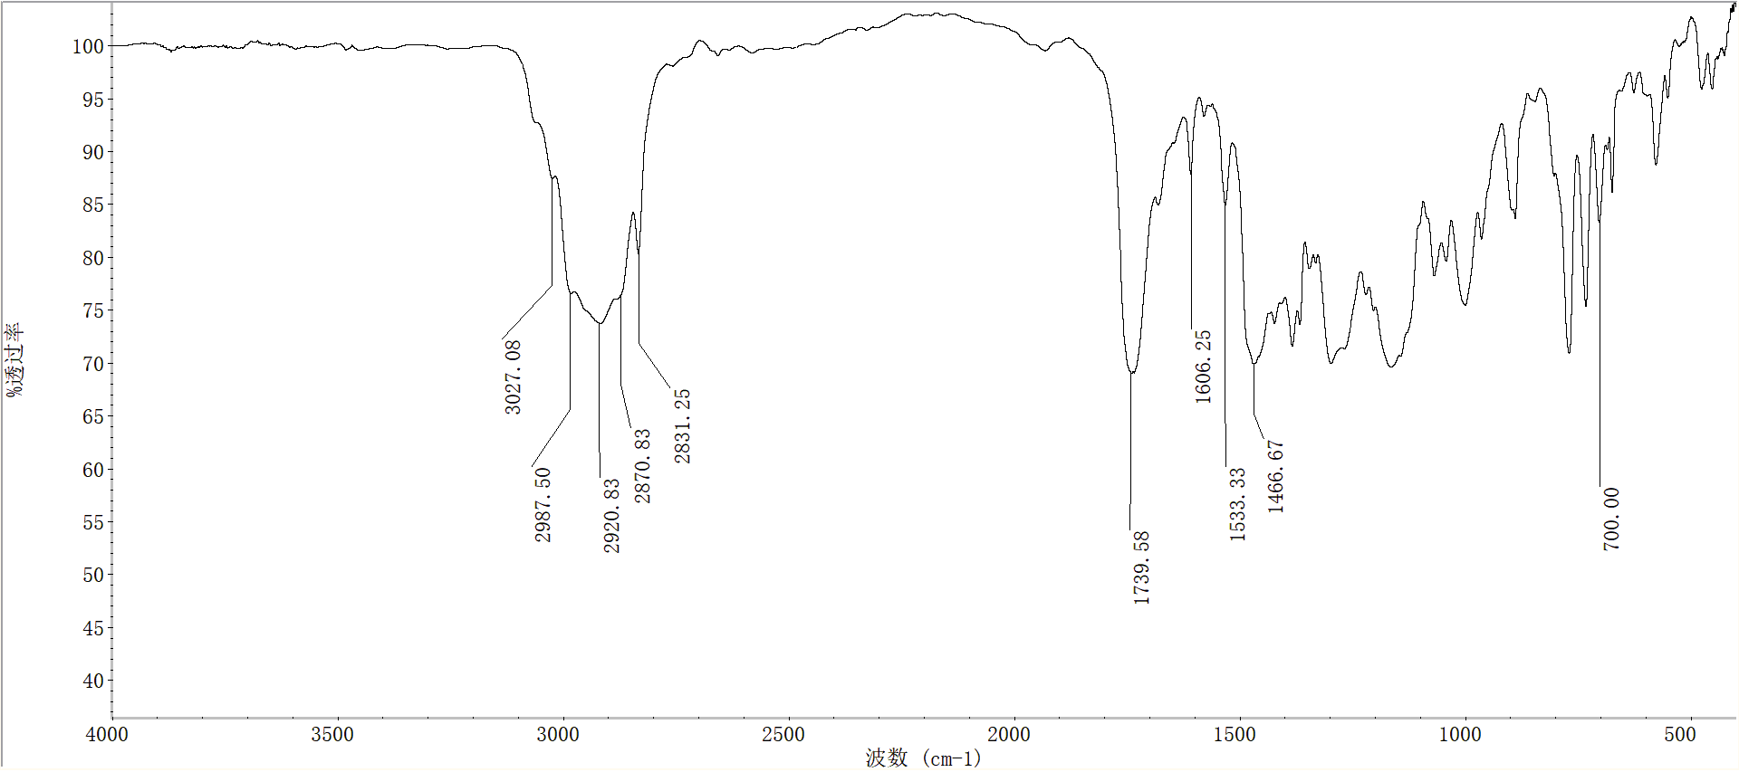

**FigureS54.** FT-IR spectra of compound **5b**

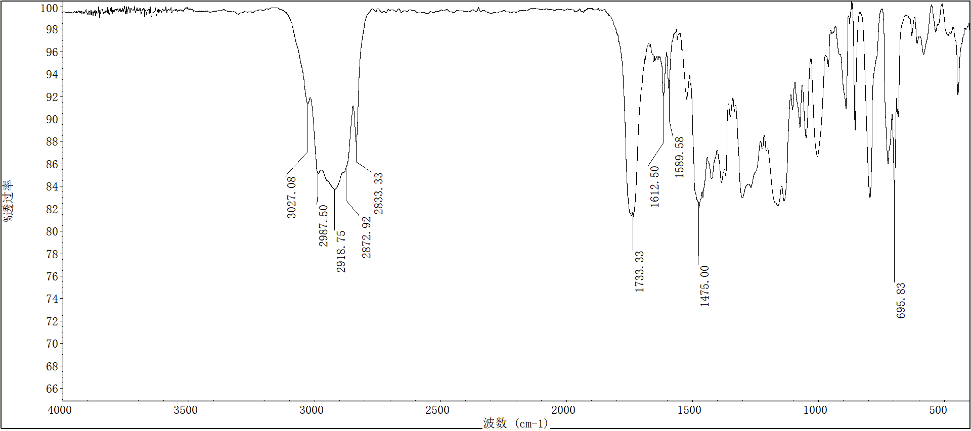

**FigureS55.** FT-IR spectra of compound **5c**

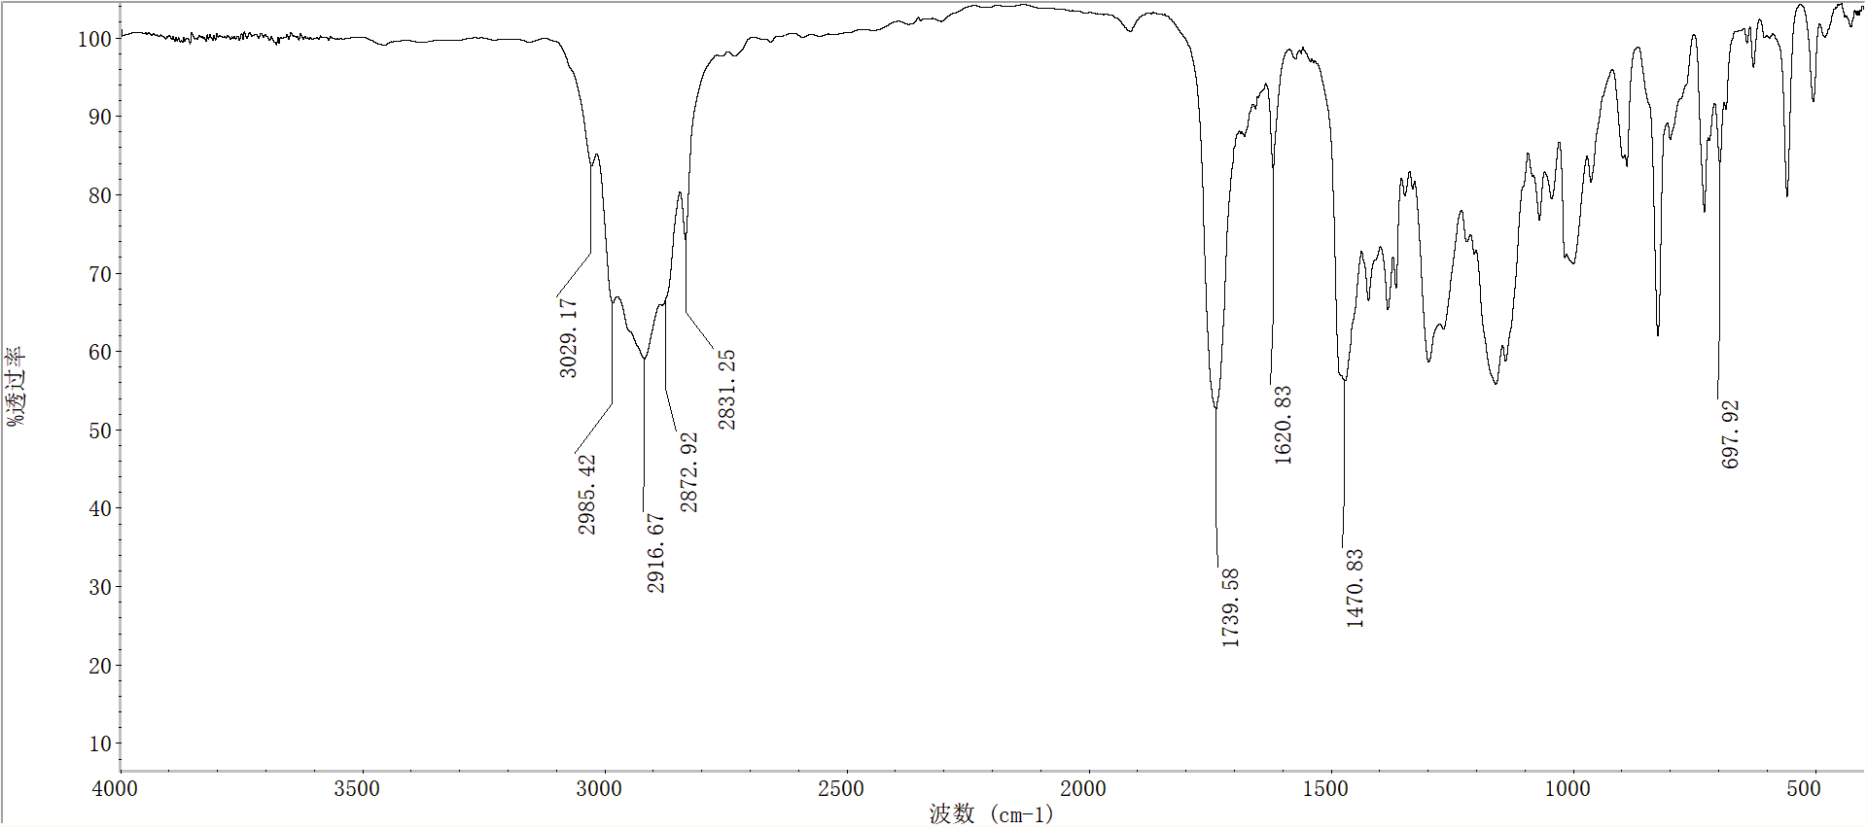

**FigureS56.** FT-IR spectra of compound **5d**

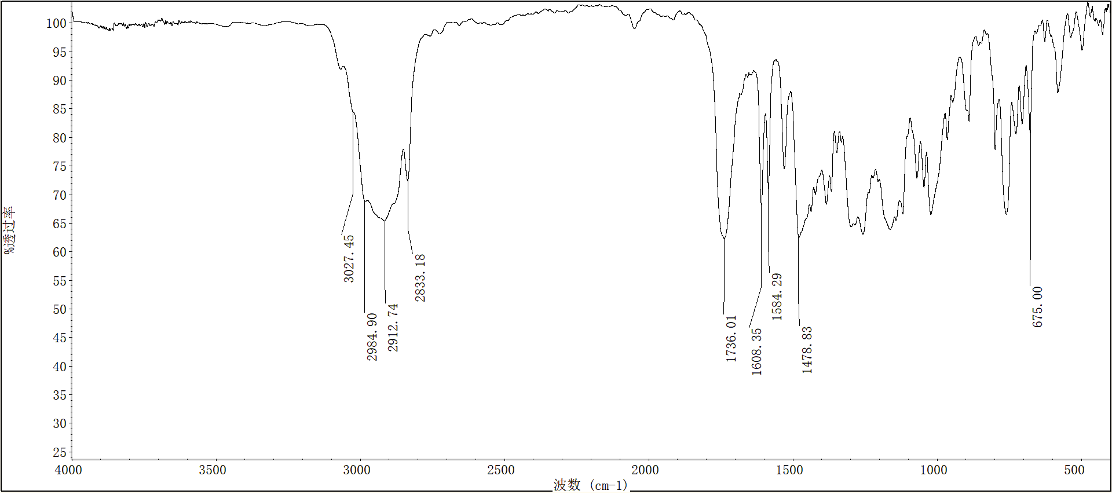

**FigureS57.** FT-IR spectra of compound **5e**

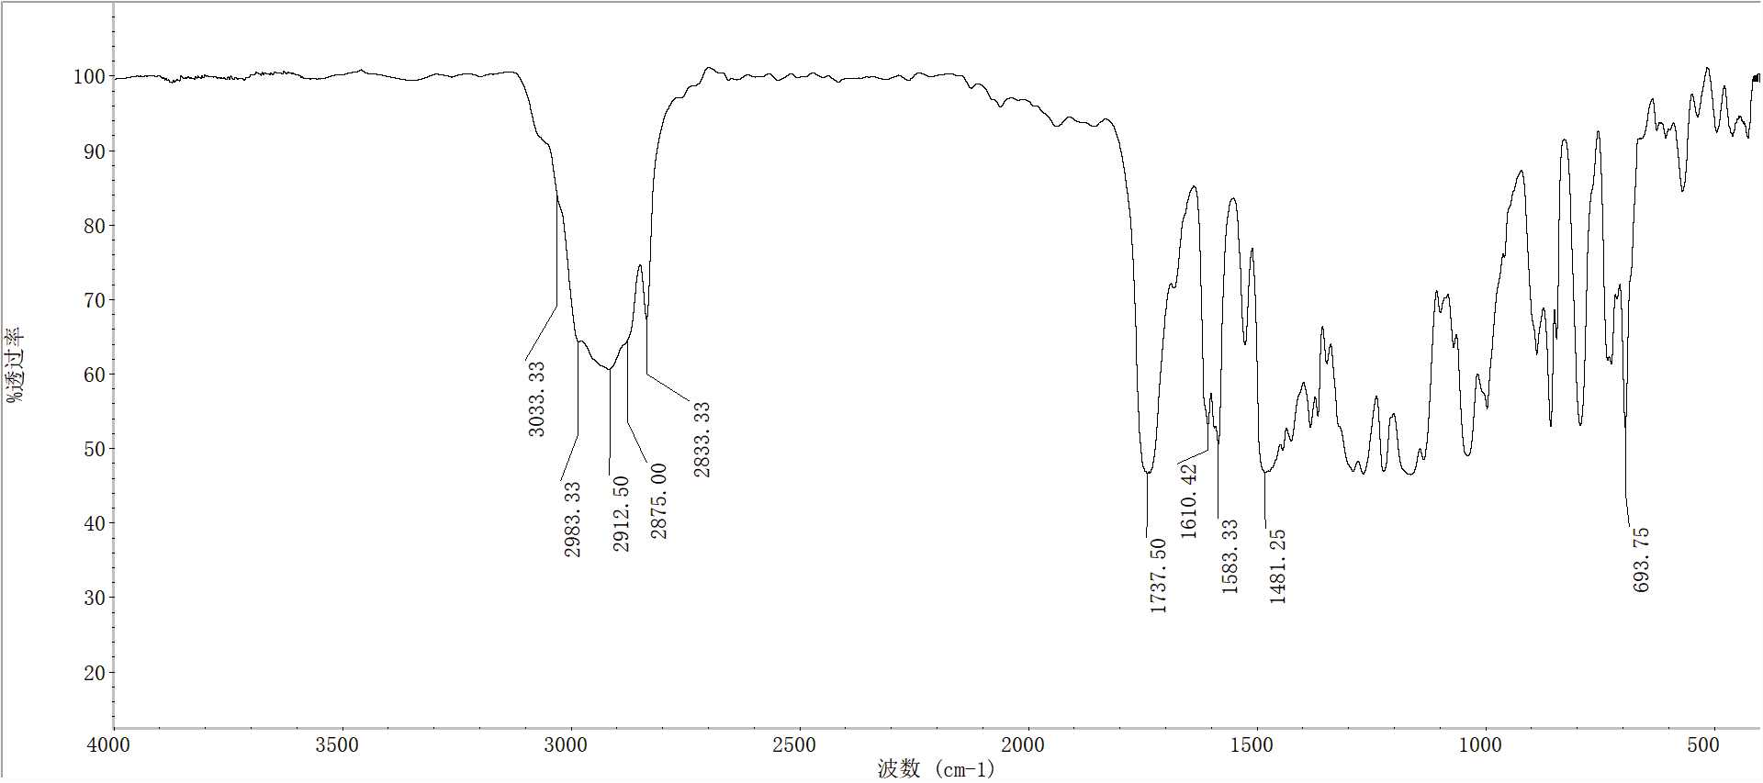

**FigureS58.** FT-IR spectra of compound **5f**

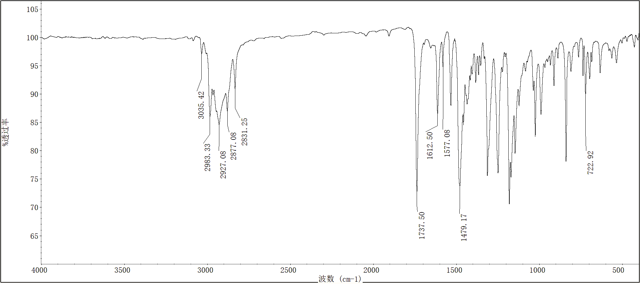

**FigureS59.** FT-IR spectra of compound **5g**

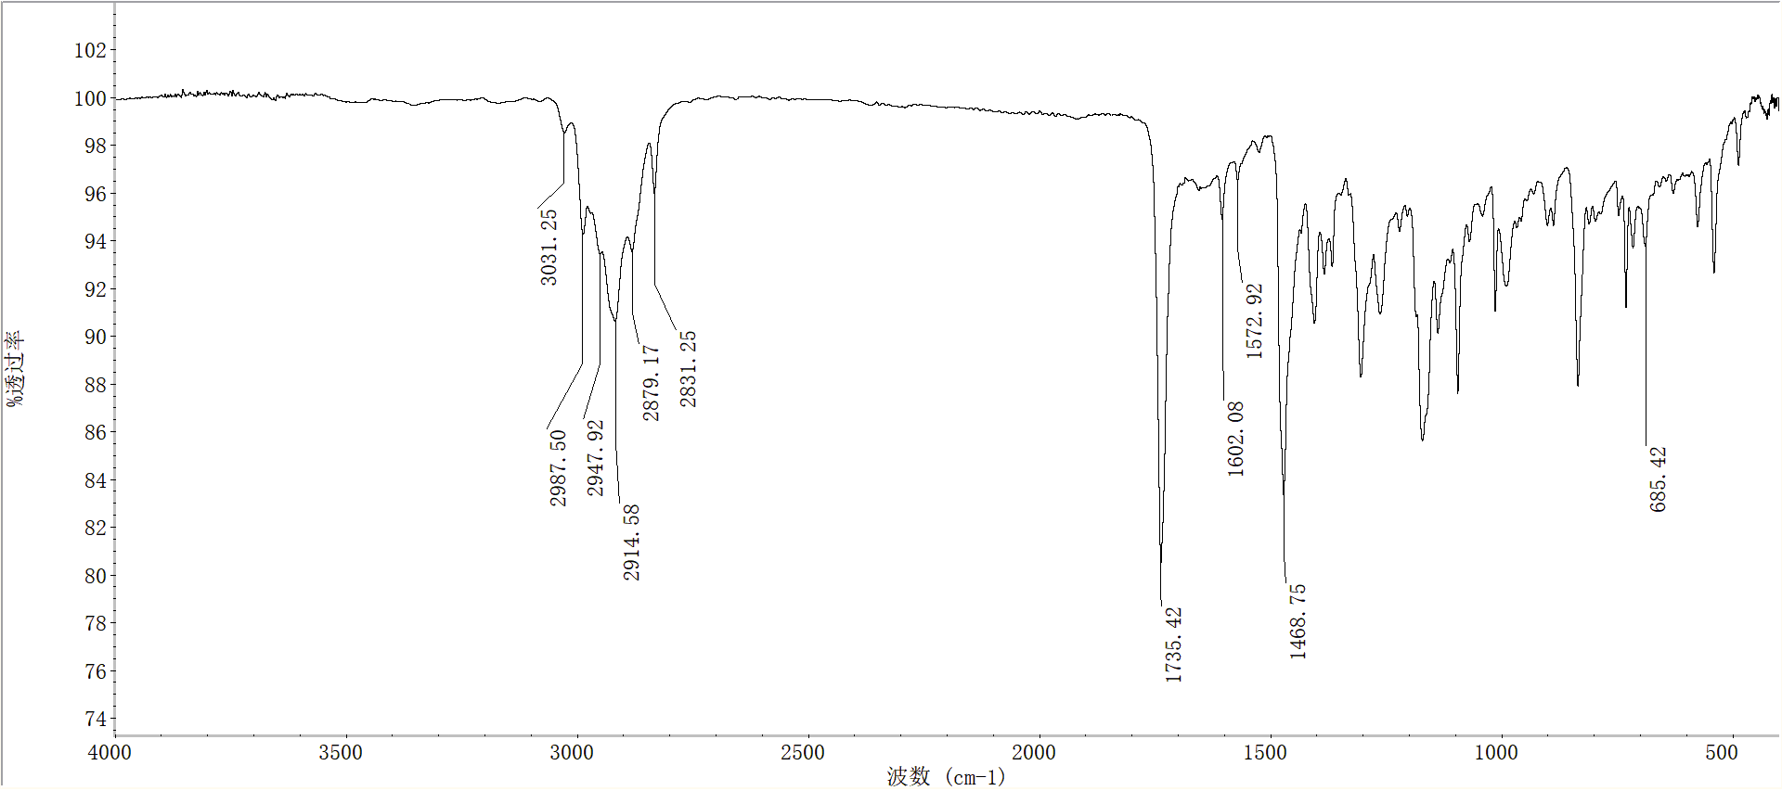

**FigureS60.** FT-IR spectra of compound **5h**

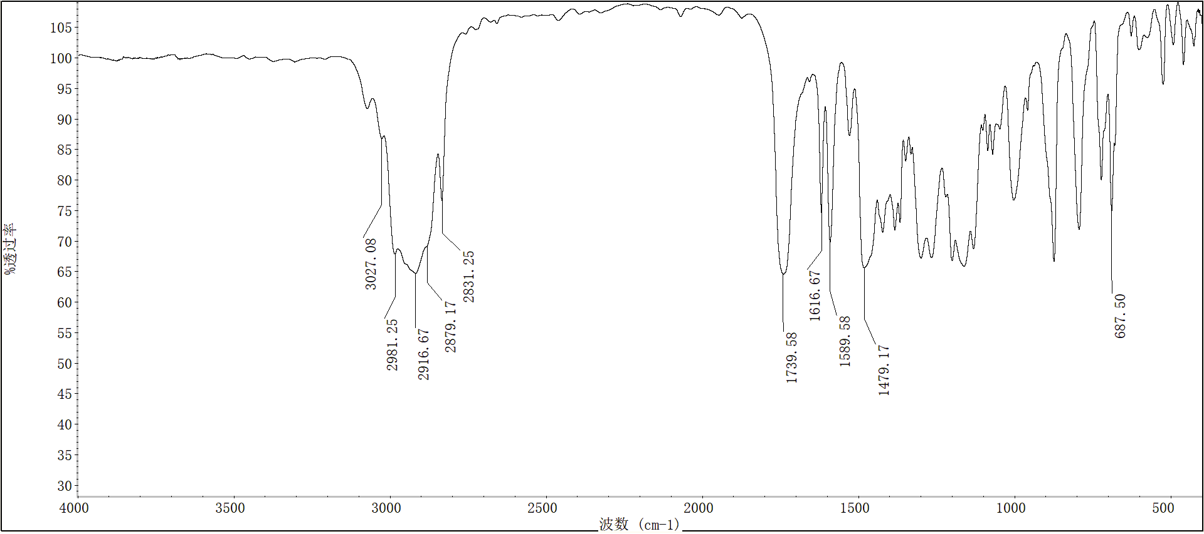

**FigureS61.** FT-IR spectra of compound **5i**

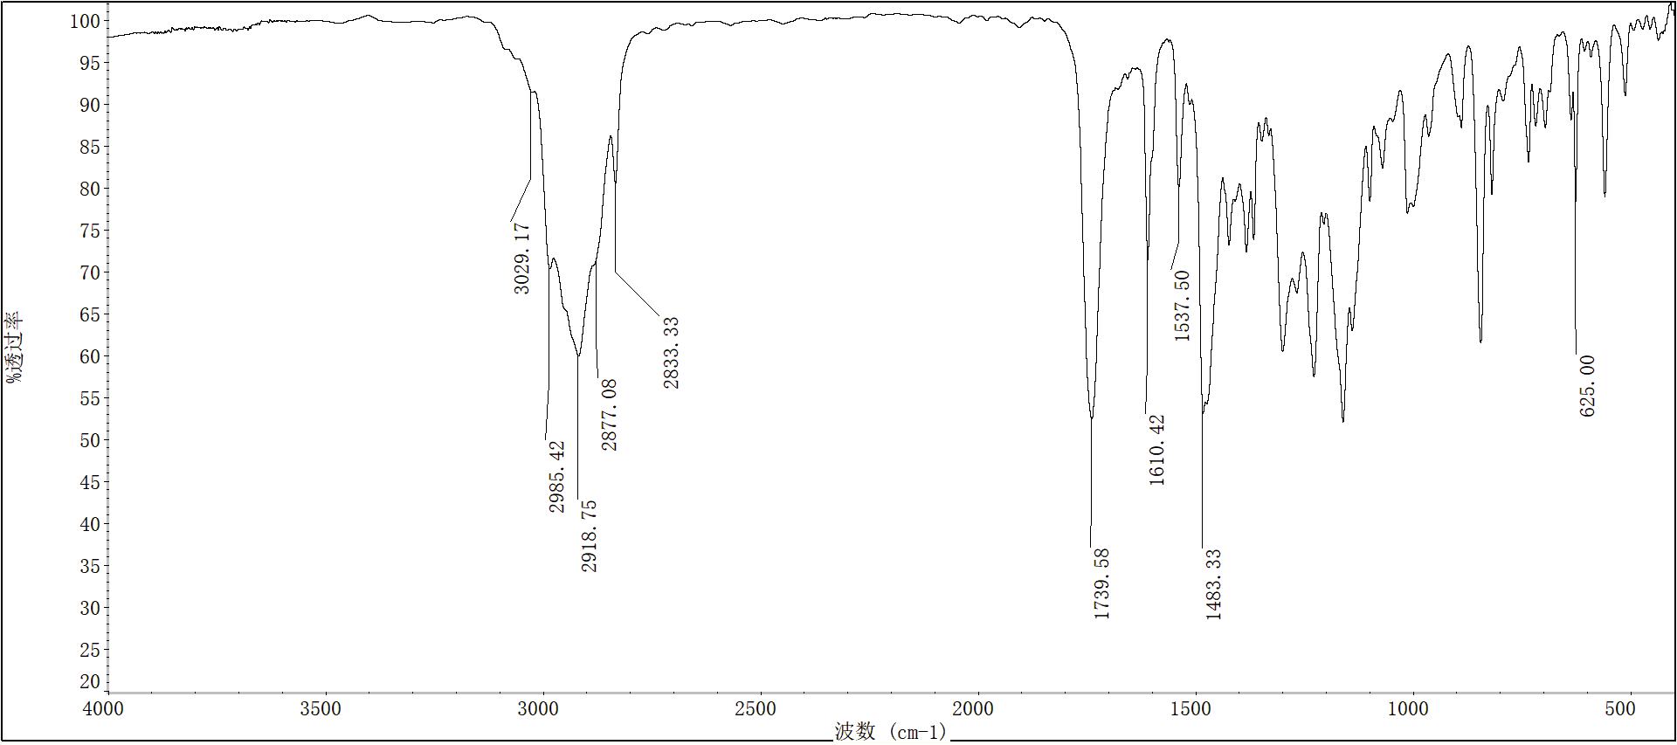

**FigureS62.** FT-IR spectra of compound **5j**

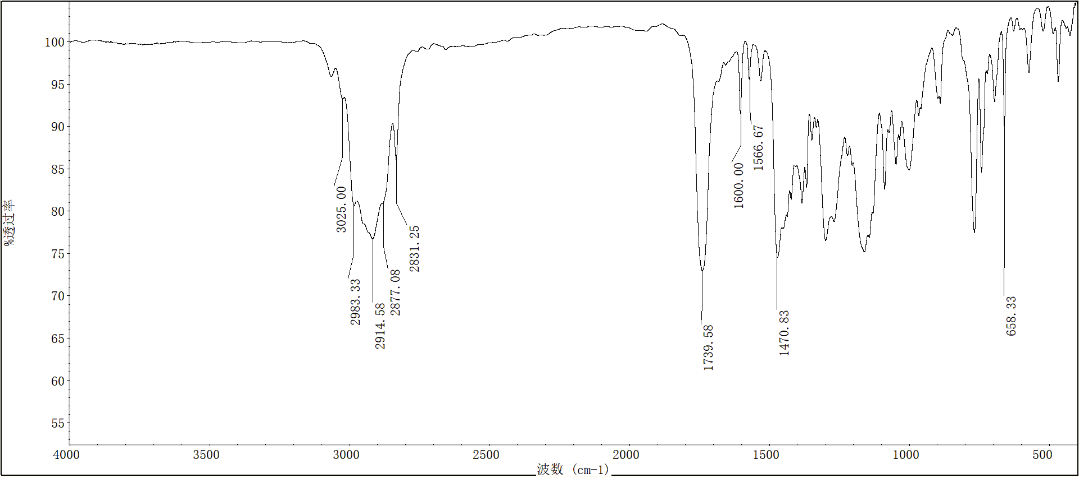

**FigureS63.** FT-IR spectra of compound **5k**

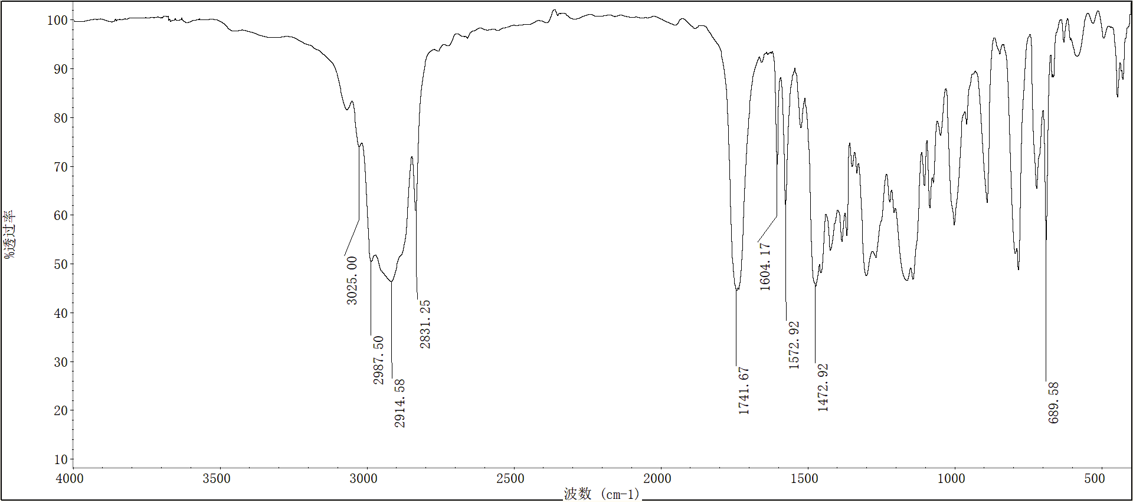

**FigureS64.** FT-IR spectra of compound **5l**

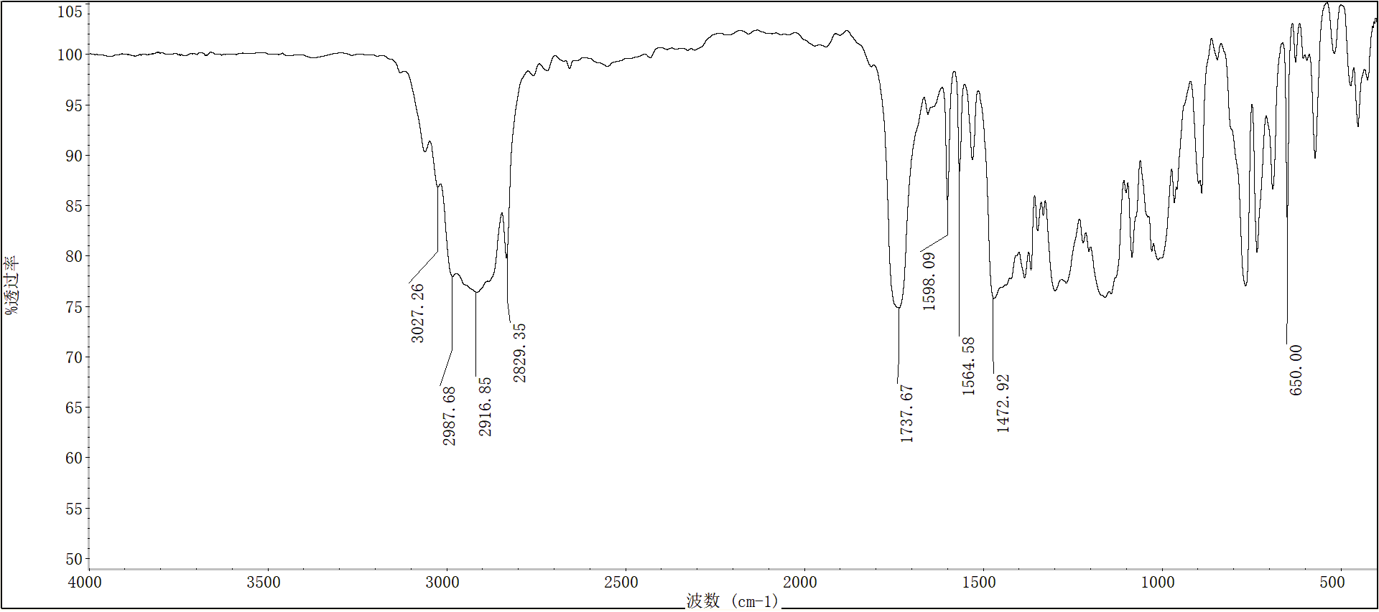

**FigureS65.** FT-IR spectra of compound **5m**

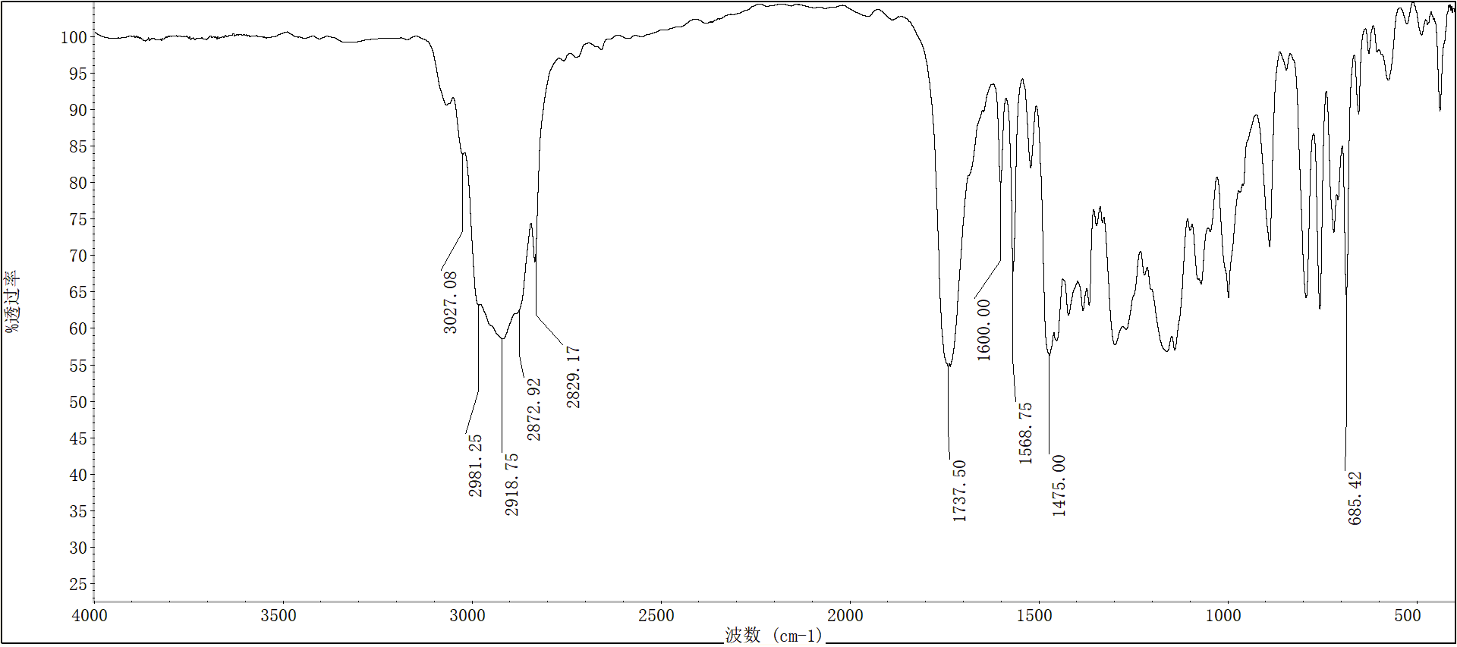

**FigureS66.** FT-IR spectra of compound **5n**



**FigureS67.** FT-IR spectra of compound **5o**

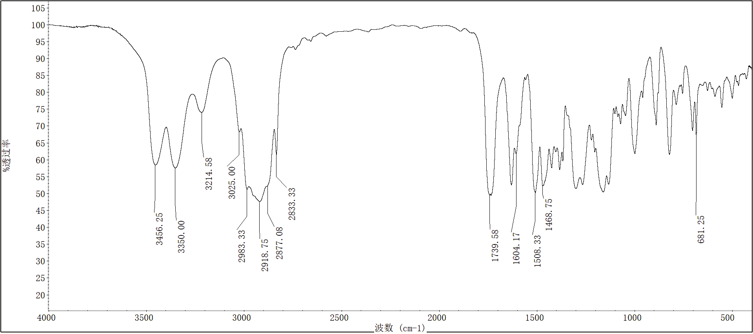

**FigureS68.** FT-IR spectra of compound **5p**

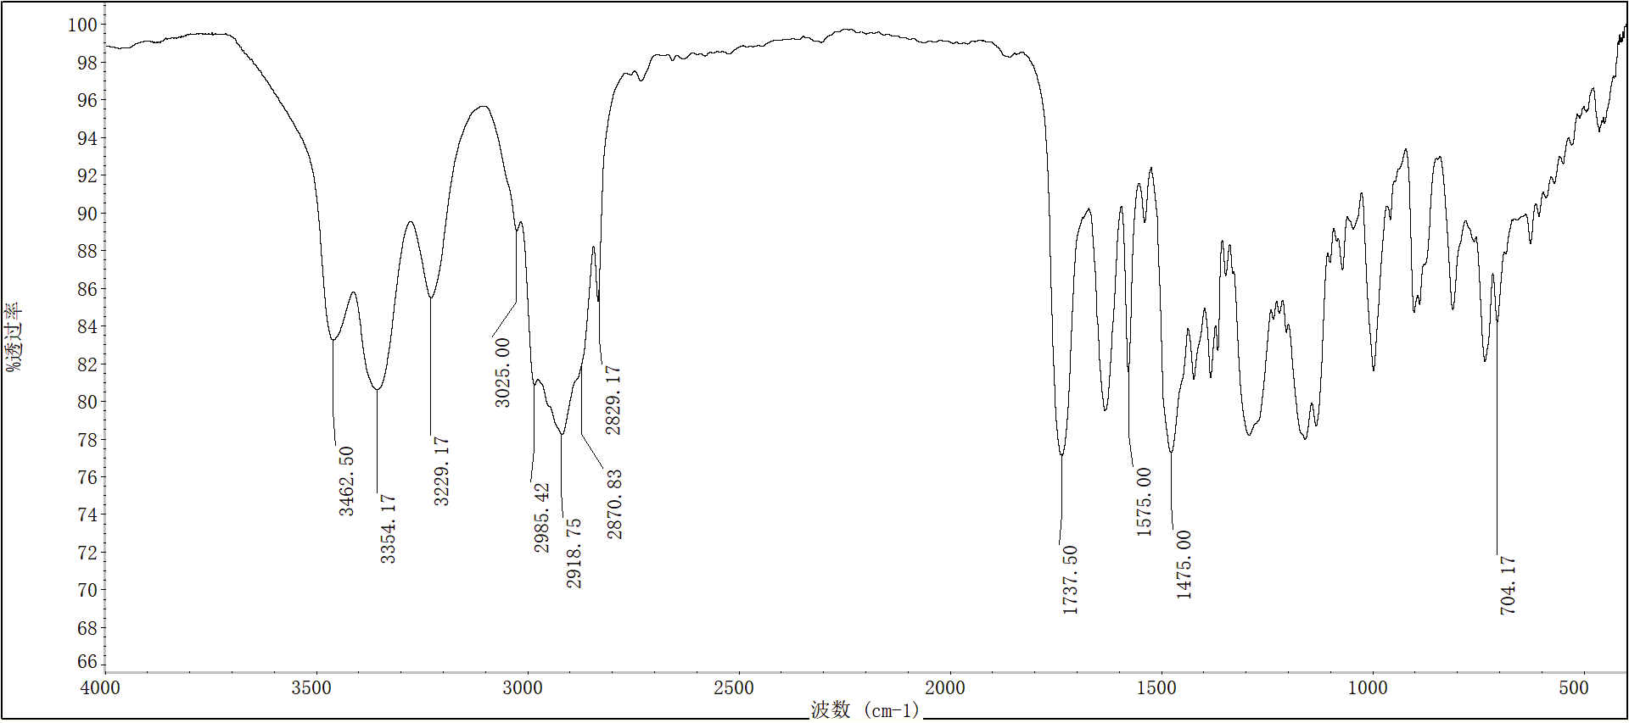

**FigureS69.** FT-IR spectra of compound **5q**

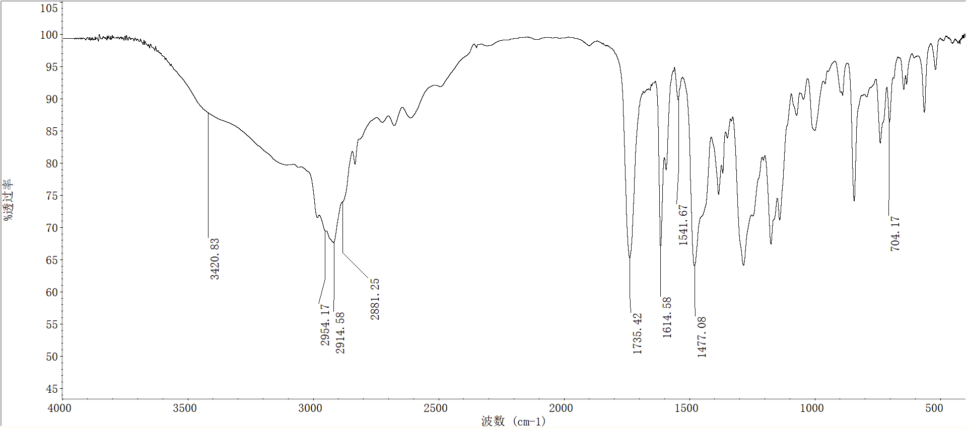

**FigureS70.** FT-IR spectra of compound **5r**

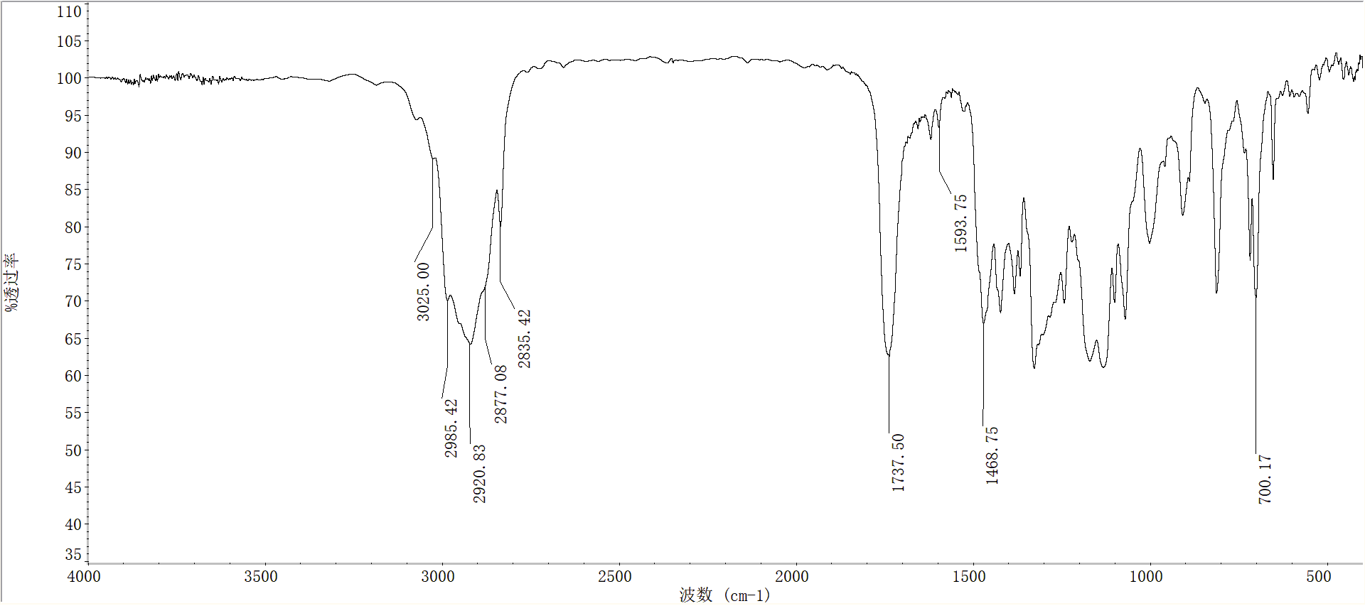

**FigureS71.** FT-IR spectra of compound **5s**

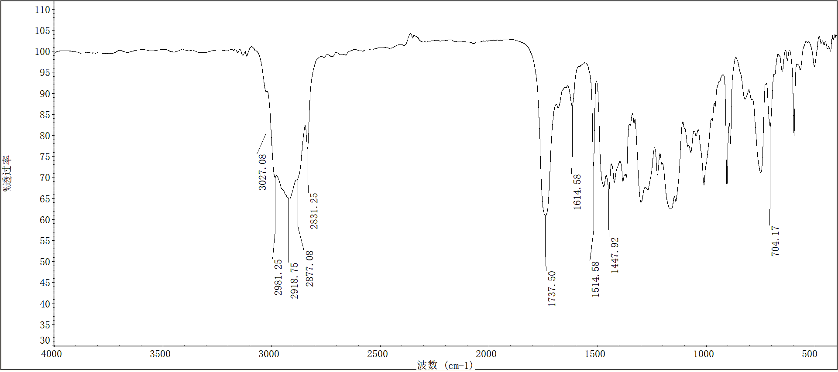

**FigureS72.** FT-IR spectra of compound **5t**

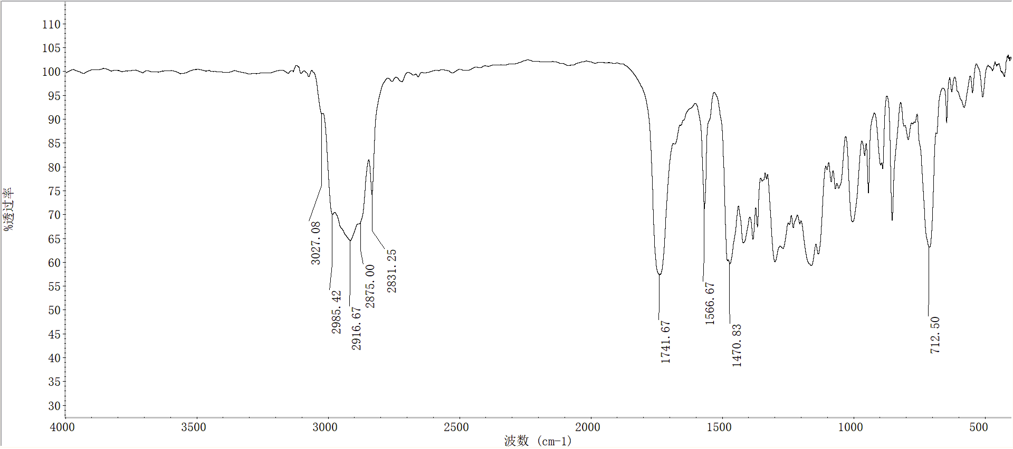

**FigureS73.** FT-IR spectra of compound **5u**

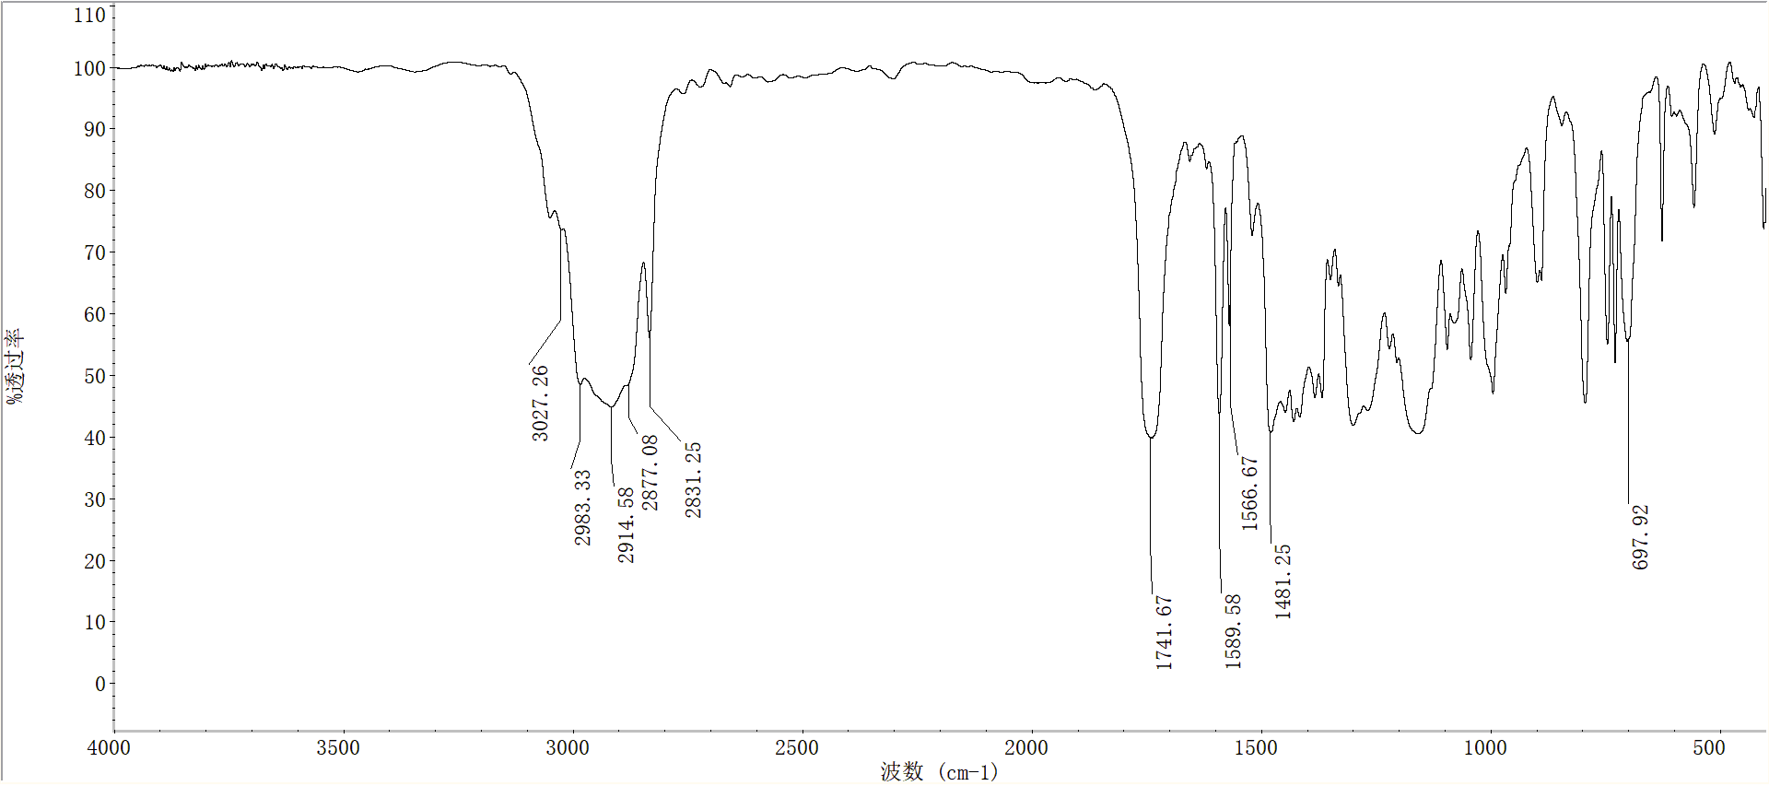

**FigureS74.** FT-IR spectra of compound **5v**

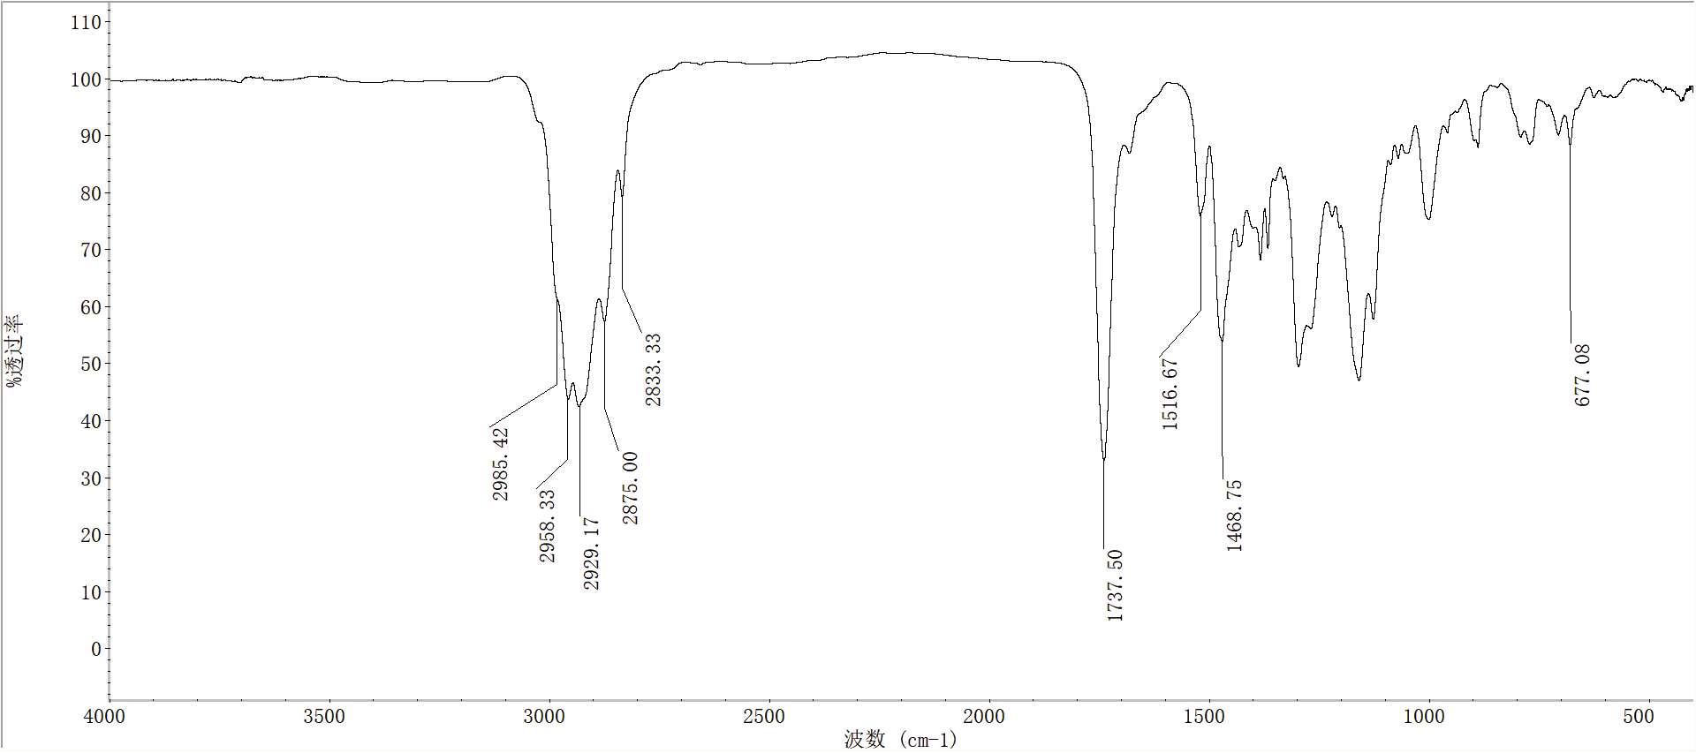

**FigureS75.** FT-IR spectra of compound **5w**

**MS-Spectra**



**FigureS76.** MSspectra of compound **5a**



**FigureS77.** MSspectra of compound **5b**



**FigureS78.** MSspectra of compound **5c**



**FigureS79.** MSspectra of compound **5d**



**FigureS80.** MSspectra of compound **5e**



**FigureS81.** MSspectra of compound **5f**



**FigureS82.** MSspectra of compound **5g**



**FigureS83.** MSspectra of compound **5h**



**FigureS84.** MSspectra of compound **5i**



**FigureS85.** MSspectra of compound **5j**



**FigureS86.** MSspectra of compound **5k**



**FigureS87.** MSspectra of compound **5l**



**FigureS88.** MSspectra of compound **5m**



**FigureS89.** MSspectra of compound **5n**



**FigureS90.** MSspectra of compound **5o**



**FigureS91.** MSspectra of compound **5p**



**FigureS92.** MSspectra of compound **5q**



**FigureS93.** MSspectra of compound **5r**



**FigureS94.** MSspectra of compound **5s**



**FigureS95.** MSspectra of compound **5t**



**FigureS96.** MSspectra of compound **5u**



**FigureS97.** MSspectra of compound **5v**



**FigureS98.** MSspectra of compound **5w**

