Supplementary Material

Supplementary Figures and Tables
For more information on Supplementary Material and for details on the different file types accepted, please see here. Figures, tables, and images will be published under a Creative Commons CC-BY licence and permission must be obtained for use of copyrighted material from other sources (including re-published/adapted/modified/partial figures and images from the internet). It is the responsibility of the authors to acquire the licenses, to follow any citation instructions requested by third-party rights holders, and cover any supplementary charges.

Supplementary Figures

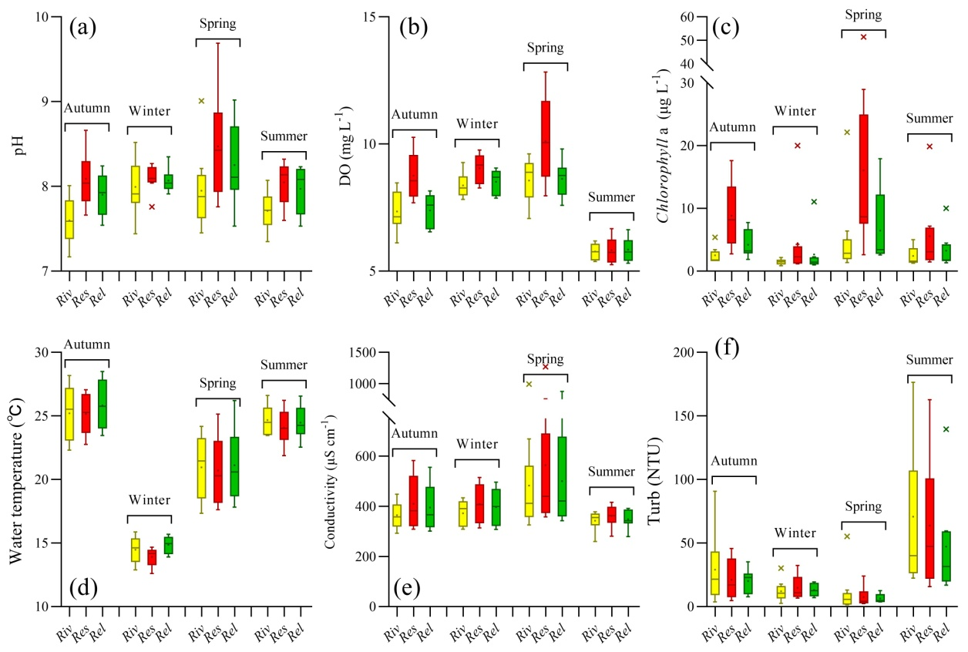
Supplementary Figure 1. Seasonal and spatial variability of the water temperature, pH, dissolved oxygen (DO), conductivity, turbidity (Turb) and chlorophyll a (chl-a) in the water samples of the river (Ri), reservoir (Res) and released (Rel) sections. Reservoir sections have a generally higher chl-a, DO and pH compare with river sections.
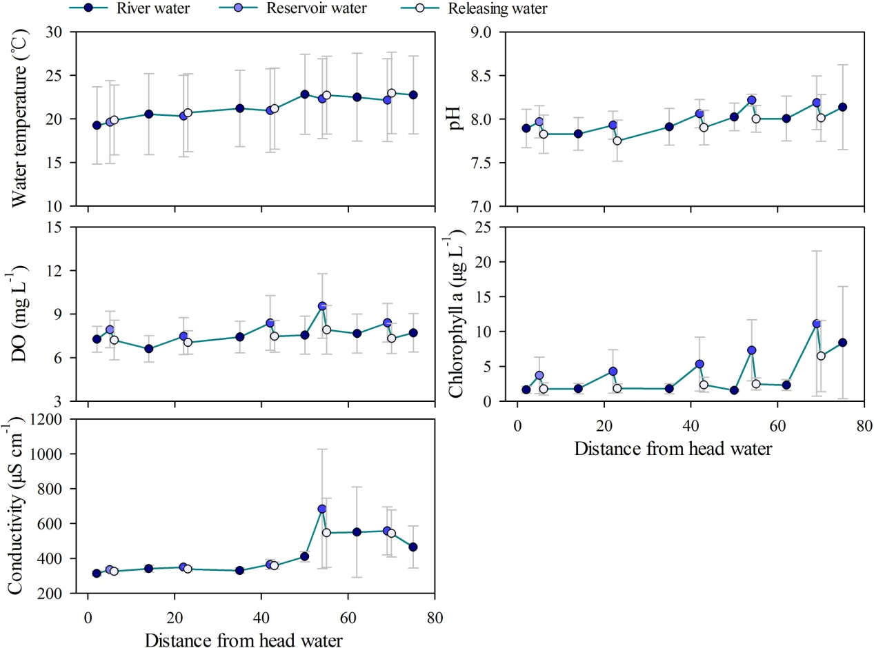
Supplementary Figure 2 The longitudinal spatial variations in water temperature, pH, DO, chl-a, and conductivity along Wubu River mainstream.

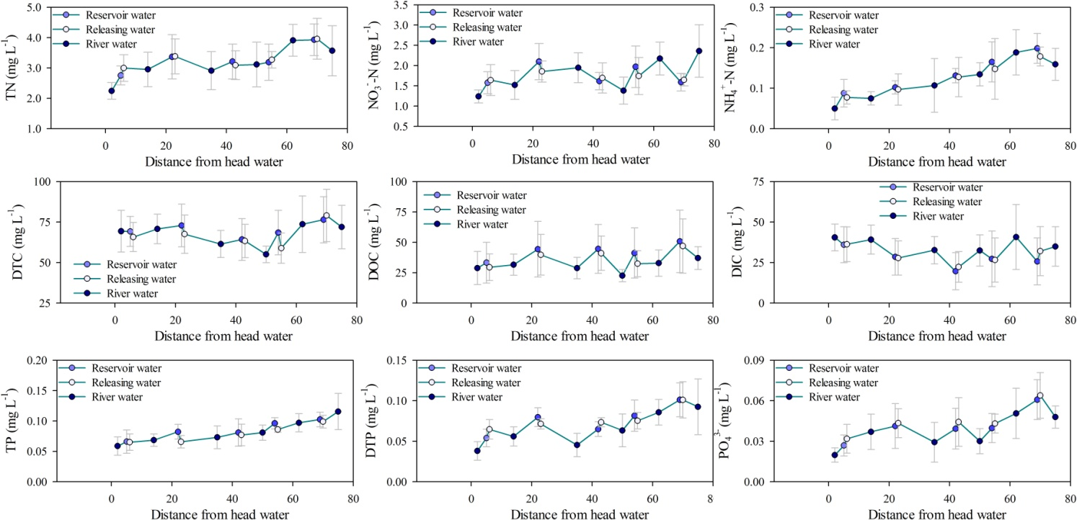
Supplementary Figure 3 The longitudinal spatial variations in TN, NO₃⁻-N, NH₄⁺-N, TP, DTP, PO₄³⁻, TOC, DOC, and TIC (c) in the water of the Wubu River mainstream.
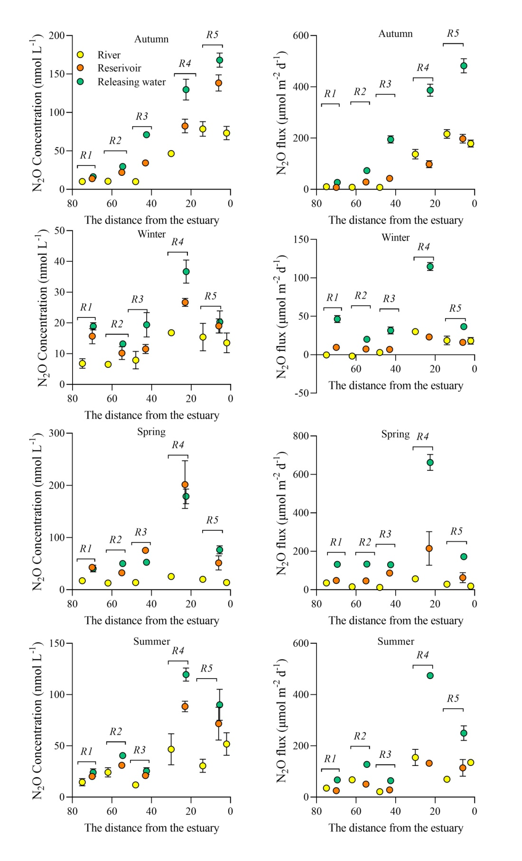
Supplementary Figure 4 The longitudinal spatial variation in water N₂O concentration and flux along the upstream section to estuary section of the Wubu River in different seasons.

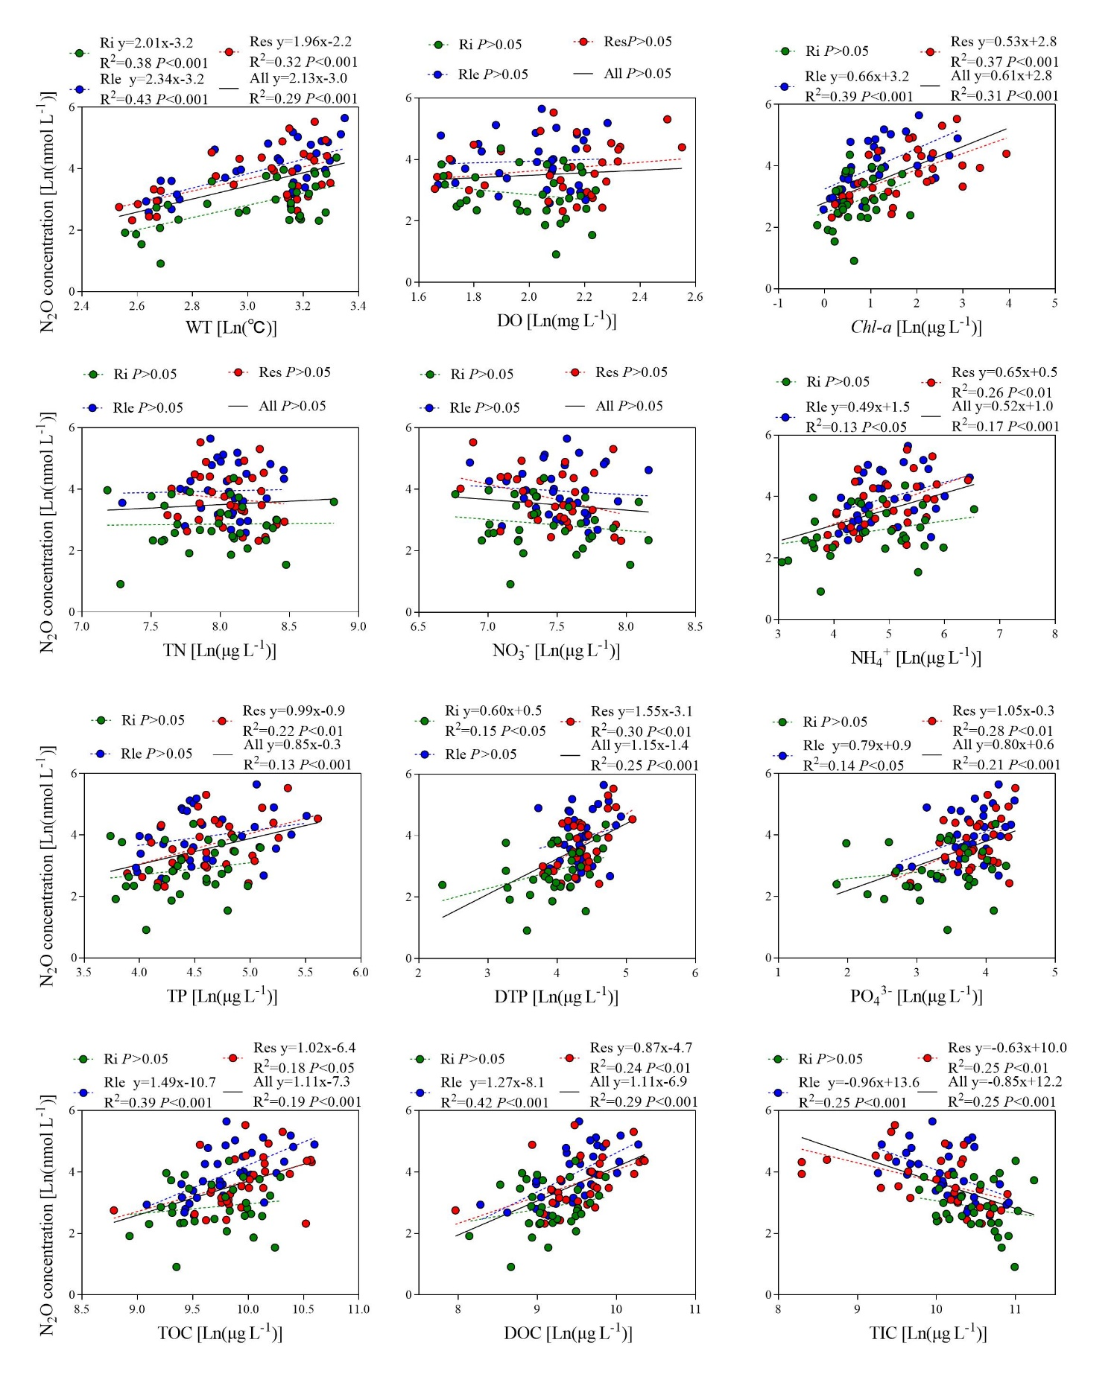
Supplementary Figure 5. Regression analysis of the N₂O concentrations with WT, DO, Chl-a, C, N and P measured in the river-reservoir-release system in Wubu River basin.
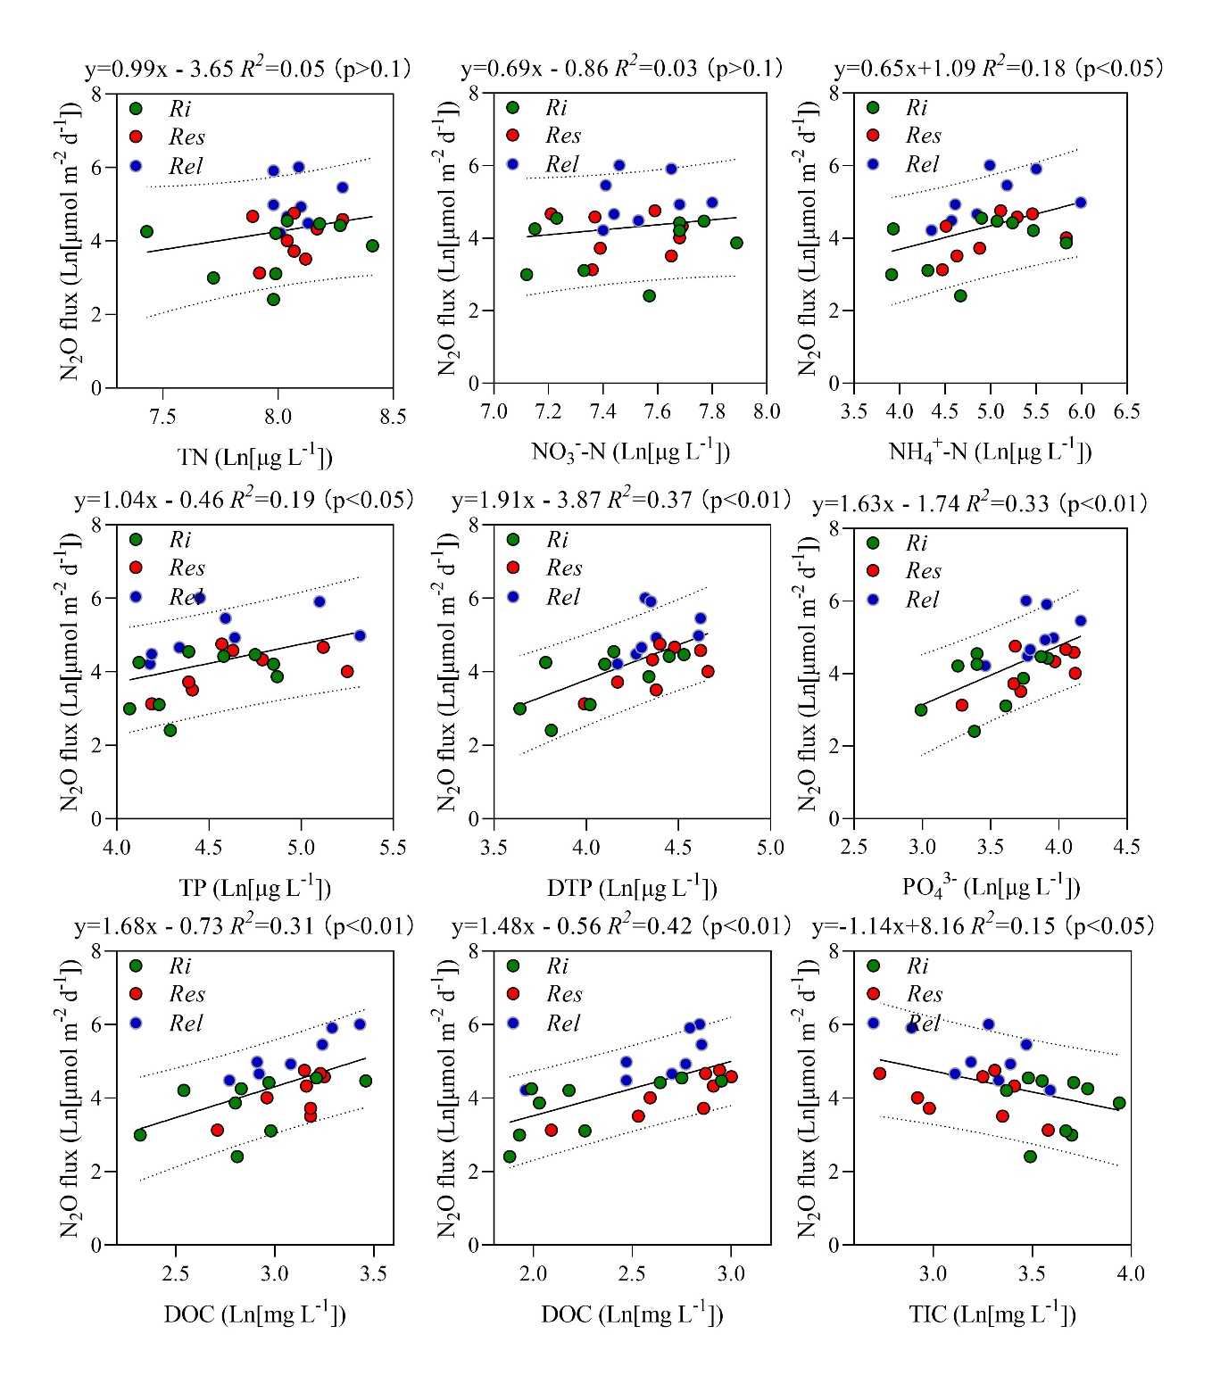
Supplementary Figure 6. Predict relationships of annual averaged N₂O fluxes and C, N and P measured in the river-reservoir-release system in Wubu River Basin.
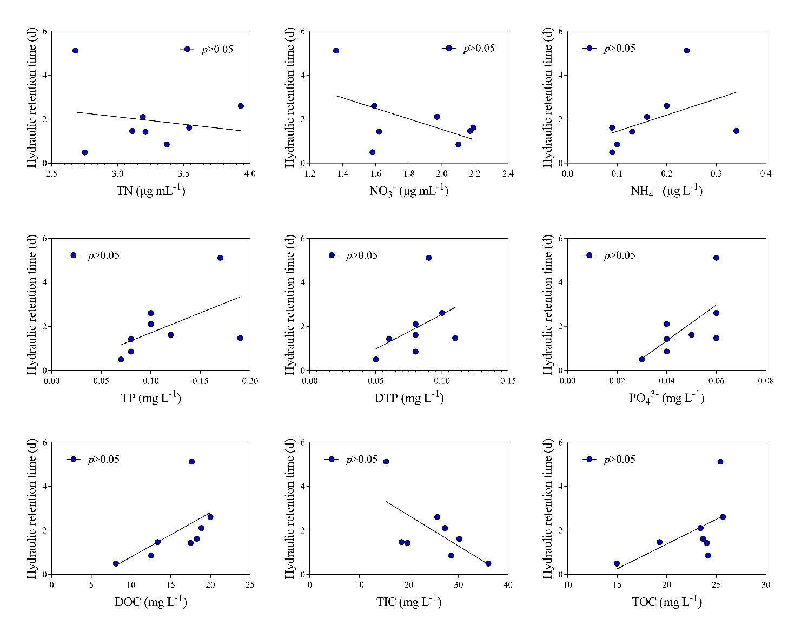
Supplementary Figure 7. relationships of hydraulic retention time and C, N and P measured in the reservoir sections in Wubu River Basin.

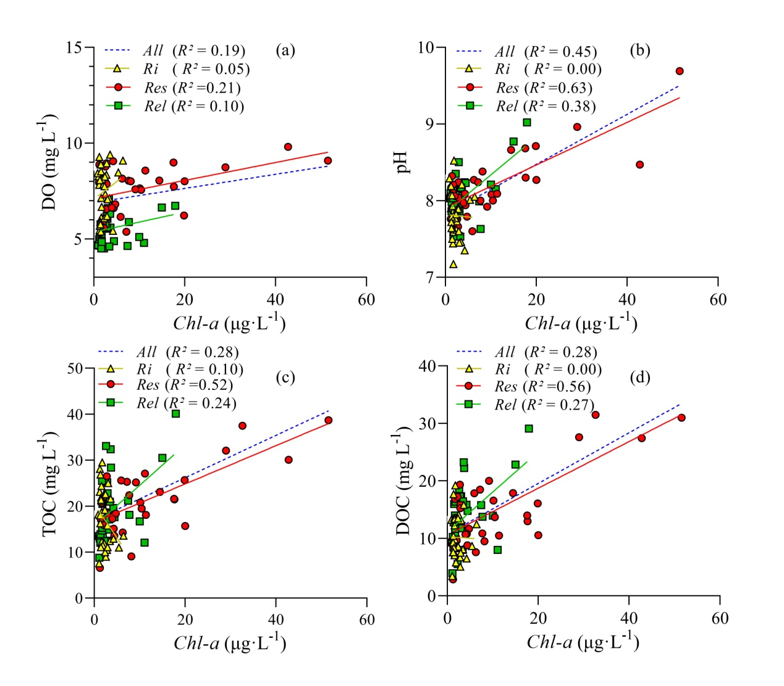
Supplementary Figure 8. Regression relationship of chl-a with DO, pH, TOC and DOC for river, reservoir and released water sections.

Supplementary Tables

Supplementary Table 1 Flow velocity, depth, riverway width, open water width, discharge and dominant sediment types of each sampling site.
Sampling sites | State | Flow velocity  (m s⁻¹) | Depth (m) | Riverway width (m) | Open water width (m) | Discharge (m³ s⁻¹) | Wind speed (m s⁻¹) |  |  |  | Air temperature (℃) |  |  |  | Sediment type
 |  |  |  |  |  |  | Sep-14 | Dec-14 | Mar-15 | Jun-15 | Sep-14 | Dec-14 | Mar-15 | Jun-15
w1 | River | 1.60 | 2.5 | 14 | 7.0 | 4.76 | 1.00 | 0.94 | 1.16 | 1.16 | 19.6 | 14 | 17.7 | 30.7 | boulder
w2 | Reservoir | 0.51 | 5.6 | 36 | 24.5 | 5.03 | 0.95 | 0.88 | 1.32 | 1.12 | 20.3 | 13.9 | 18.3 | 31.3 | fine sand
w3 | Released water | 1.30 | 1.7 | 11 | 17.8 | 4.84 | 0.92 | 0.93 | 1.20 | 1.02 | 21.20 | 14.20 | 18.60 | 32.00 | bed rock
w4 | River | 1.18 | 2.5 | 23 | 5.2 | 5.01 | 0.94 | 0.84 | 1.30 | 1.19 | 21.3 | 14.5 | 18.2 | 31.1 | fine sand
w5 | Reservoir | 0.63 | 3.4 | 50 | 71.5 | 6.14 | 1.09 | 0.94 | 1.33 | 1.16 | 22.30 | 15.90 | 18.20 | 30.10 | silt
w6 | Released water | 1.08 | 1.7 | 41 | 17.2 | 5.87 | 0.93 | 1.02 | 1.31 | 1.07 | 23.40 | 16.00 | 18.90 | 31.20 | cobble
w7 | River | 0.93 | 3.1 | 29 | 12.0 | 6.76 | 1.00 | 0.88 | 1.29 | 0.98 | 24.6 | 17.1 | 18.3 | 32.2 | grait
w8 | Reservoir | 0.56 | 5.0 | 65 | 52.8 | 6.63 | 0.98 | 0.98 | 1.31 | 1.07 | 25.40 | 17.60 | 19.30 | 32.20 | silt
w9 | Released water | 0.92 | 2.0 | 17 | 7.4 | 6.64 | 1.07 | 1.02 | 1.24 | 1.12 | 26.60 | 17.90 | 19.60 | 32.00 | fine sand
w10 | River | 1.70 | 3.0 | 54 | 11.8 | 7.11 | 1.10 | 0.98 | 1.26 | 1.03 | 29.7 | 18.50 | 21 | 31.9 | fine sand
w11 | Reservoir | 0.58 | 6.9 | 84 | 54.9 | 9.91 | 1.05 | 1.02 | 1.22 | 1.20 | 28.40 | 19 | 20.80 | 31.80 | silt
w12 | Released water | 0.99 | 1.3 | 43 | 17.5 | 9.19 | 1.05 | 1.07 | 1.28 | 1.06 | 29.00 | 17.60 | 20.30 | 32.70 | grait
w13 | River | 0.76 | 2.3 | 69 | 19.4 | 11.46 | 1.02 | 1.17 | 1.23 | 1.07 | 30.8 | 15 | 19.8 | 34.5 | bed rock
w14 | Reservoir | 0.51 | 4.6 | 90 | 90 | 14.05 | 1.10 | 1.12 | 1.29 | 1.10 | 29.30 | 14.50 | 19.80 | 33.70 | silt
w15 | Released water | 0.86 | 2.0 | 77 | 24.3 | 13.47 | 1.00 | 1.17 | 1.22 | 1.02 | 29.40 | 14.7 | 20.10 | 35.20 | silt
w16 | Estuary | 1.35 | 4.1 | 64 | 42.4 | 14.77 | 1.07 | 1.22 | 1.14 | 1.01 | 30.8 | 14.4 | 21.5 | 34 | silt
e1 | River | 0.85 | 1.4 | 31 | 2.9 | 1.72 | 0.83 | 0.54 | 1.26 | 1.03 | 28.5 | 15.7 | 21.7 | 32.3 | silt
e2 | Reservoir | 0.60 | 9.8 | 50 | 18.8 | 2.78 | 0.83 | 0.88 | 1.22 | 1.20 | 29.2 | 16.2 | 21.9 | 32 | silt
e3 | Released water | 1.15 | 2.2 | 15 | 4.9 | 2.59 | 0.97 | 0.86 | 1.28 | 1.06 | 29.70 | 20.3 | 21 | 32.1 | bed rock
y1 | River | 0.67 | 1.9 | 47 | 3.0 | 1.83 | 1.02 | 0.75 | 1.11 | 1.02 | 29.2 | 19.9 | 19.3 | 31.1 | silt
y2 | Reservoir | 0.58 | 5.0 | 66 | 37.7 | 2.66 | 0.91 | 0.71 | 1.08 | 1.11 | 29.30 | 18.50 | 19.50 | 31.30 | silt
y3 | Released water | 0.70 | 1.1 | 38 | 6.2 | 2.27 | 0.93 | 0.67 | 1.11 | 1.20 | 29.70 | 18.50 | 20.00 | 32.00 | bed rock
L1 | River | 0.56 | 1.0 | 27 | 4.2 | 1.15 | 0.85 | 0.68 | 1.16 | 1.00 | 29.7 | 14.7 | 21.3 | 32.3 | bed rock
L2 | Reservoir | 0.53 | 5.9 | 79 | 22.7 | 3.34 | 0.82 | 0.59 | 1.08 | 1.11 | 28.90 | 14.9 | 21.1 | 32.1 | fine sand
L3 | Released water | 0.59 | 3.3 | 49 | 3.0 | 2.80 | 1.01 | 0.59 | 1.08 | 1.20 | 28.90 | 14.20 | 21.50 | 32.00 | grait

Supplementary Table 2 The average and range of water temperature (℃), pH, conductivity (μS cm⁻¹), DO (mg L⁻¹), turbidity (NTU) and chl-a (μg L⁻¹) in the cascade river-reservoir system along the Wubu River. The average are presented as mean ± standard error.
Sampling  Rivers | State | Sampling  sites | Water temperature  (℃) | pH | Conductivity  (μS cm⁻¹) | DO  (mg L⁻¹) | Turbidity  (NTU) | chl-a  (μg L⁻¹)
Wubu River | River | w1 | 19.3±5.1  (12.9-23.5) | 7.9±0.2  (7.6-8.1) | 314±17  (293-329) | 7.3±1.0  (5.9-8.3) | 20.4±14.4  (7.7-40.1) | 1.7±0.6  (1.1-2.4)
 | Reservoir | w2 | 19.6±5.5  (12.6-24.0) | 8.1±0.2  (7.9-8.3) | 335±17  (318-358) | 7.9±1.4  (5.9-9.3) | 25.9±15.6  (4.9-42.2) | 3.7±3  (1.3-7.7)
 | Released water | w3 | 19.9±4.6  (13.9-23.6) | 7.9±0.3  (7.5-8.2) | 326±17  (302-342) | 7.2±1.6  (5.3-8.9) | 19.1±12.5  (4.7-35.2) | 2.3±1.2  (1.1-3.3)
 | River | w4 | 20.5±5.4  (13.4-25.0) | 7.6±0.2  (7.4-7.9) | 341±23  (312-360) | 6.6±1.0  (5.4-7.8) | 21.0±15.0  (5.7-40.5) | 1.8±0.9  (1.2-3.1)
 | Reservoir | w5 | 20.3±5.4  (13.2-25.0) | 7.9±0.1  (7.8-8.1) | 350±12  (341-368) | 7.5±1.5  (5.3-8.3) | 16.7±11.1  (2.9-27.3) | 4.3±3.6  (1.2-9.2)
 | Released water | w6 | 20.7±5.1  (14.0-24.8) | 7.9±0.1  (7.8-8.0) | 339±14  (322-355) | 7.1±0.9  (5.9-7.9) | 17.2±9.1  (3.8-23.9) | 1.8±0.7  (1-2.8)
 | River | w7 | 21.2±5.1  (14.6-26.0) | 7.9±0.3  (7.6-8.3) | 331±18  (315-356) | 7.4±1.3  (5.7-8.4) | 14.3±11.9  (2.1-30.4) | 1.8±0.8  (0.9-2.5)
 | Reservoir | w8 | 21.0±5.5  (14.1-27.1) | 8.2±0.1  (8.1-8.4) | 365±33  (335-411) | 8.4±2.2  (5.3-10.2) | 11.5±7.0  (3.9-19) | 5.3±4.5  (1.4-10.1)
 | Released water | w9 | 21.2±5.4  (14.5-27.0) | 8.0±0.2  (7.9-8.2) | 359±23  (341-390) | 7.5±1.3  (5.7-8.6) | 16.9±11.3  (3.7-28.2) | 3.1±1.4  (1.2-4.5)
 | River | w10 | 22.8±5.3  (15.0-26.7) | 7.8±0.2  (7.6-7.9) | 411±34  (368-452) | 7.6±1.5  (5.4-8.9) | 9.3±13.3  (1.8-29.2) | 1.6±0.2  (1.4-1.8)
 | Reservoir | w11 | 22.3±5.3  (14.7-26.7) | 8.2±0.2  (8.0-8.5) | 684±396  (416-1272) | 9.6±2.6  (6.0-12.2) | 9.8±7.5  (3.2-20.5) | 8.3±4.3  (2.8-12.8)
 | Released water | w12 | 22.7±5.2  (15.2-26.8) | 7.9±0.3  (7.5-8.2) | 547±229  (343-875) | 7.9±1.9  (5.4-9.8) | 11.1±6.3  (4.7-19.5) | 2.5±1.0  (1.5-3.6)
 | River | w13 | 22.5±5.8  (14.4-27.7) | 7.8±0.4  (7.2-8.2) | 551±300  (338-995) | 7.7±1.6  (6.1-9.4) | 31.2±53.2  (1.4-110.9) | 2.3±0.9  (1.6-3.6)
 | Reservoir | w14 | 22.2±5.5  (14.5-26.6) | 8.1±0.6  (7.6-9.0) | 558±159  (376-758) | 8.4±1.5  (6.7-10.2) | 20.1±29.6  (2.4-64.3) | 10.1±12.7  (2.8-29)
 | Released water | w15 | 23.0±5.4  (15.7-28.1) | 8.1±0.5  (7.5-8.8) | 543±156  (374-748) | 7.3±1.2  (6.1-8.7) | 17.1±14.2  (4.5-35.1) | 5.7±6.2  (1.7-15)
 | Estuary | w16 | 22.8±5.2  (15.9-28.2) | 7.9±0.8  (7.3-9.0) | 465±139  (356-668) | 7.7±1.5  (6.0-9.6) | 51.2±83.6  (7.1-176.4) | 7.6±9.8  (1.5-22.1)
Ersheng River | River | e1 | 22.2±4.5  (15.6-25.5) | 7.7±0.3  (7.3-8.0) | 322±44  (260-363) | 7.4±1.5  (5.4-9.1) | 39.9±42.1  (13.0-102.5) | 4.1±1.8  (2.2-6.4)
 | Reservoir | e2 | 21.7±5.2  (14.3-25.6) | 8.6±0.7  (8.2-9.7) | 324±49  (281-395) | 8.7±3.0  (5.5-12.8) | 66.2±65.0  (24.0-162.8) | 27.3±16.2  (17.6-51.5)
 | Released water | e3 | 23.0±6.1  (14.7-28.5) | 8.3±0.6  (7.6-9.0) | 319±42  (279-379) | 7.8±1.2  (6.2-9.1) | 43.3±64.2  (9.5-139.5) | 11.7±4.4  (7.7-17.9)
Yalu stream | River | y1 | 19.3±4.5  (13.7-23.5) | 7.9±0.2  (7.6-8.2) | 383±23  (358-412) | 8.2±1.4  (6.2-9.3) | 58.0±30.3  (30.2-100.8) | 3.1±1.7  (1.2-5.4)
 | Reservoir | y2 | 19.7±4.4  (14.5-23.6) | 8.3±0.3  (8.0-8.7) | 436±38  (397-480) | 8.9±1.7  (6.3-9.9) | 37.6±46.2  (14.0-106.9) | 7.6±4.9  (4.0-14.4)
 | Released water | y3 | 20.2±4.4  (15.2-24.0) | 8.2±0.2  (8.0-8.5) | 418±34  (389-458) | 8.2±1.1  (6.6-9.1) | 22.0±25.1  (7.8-59.6) | 3.6±2.6  (1.7-7.5)
Lugou stream | River | L1 | 21.4±5.0  (14.7-26.6) | 7.9±0.5  (7.5-8.5) | 395±16  (378-412) | 7.8±1.4  (5.8-8.9) | 30.5±41.1  (2.1-90.8) | 1.9±0.6  (1.5-2.8)
 | Reservoir | L2 | 20.9±5.4  (13.5-26.2) | 8.0±0.3  (7.8-8.3) | 434±31  (397-469) | 8.2±1.8  (5.5-9.2) | 25.9±37.3  (4.5-81.7) | 3.2±2.1  (1.7-6.3)
 | Released water | L3 | 21.9±4.7  (15.5-26.6) | 8.0±0.3  (7.6-8.2) | 426±27  (392-452) | 7.8±1.5  (5.6-8.8) | 26.7±21.6  (7.2-57.0) | 2.5±1.3  (1.4-4.2)

Supplementary Table 3 The average and range of N₂O concentration (nmol L⁻¹), k₀ (cm h⁻¹), and N₂O flux (μmol·m⁻²·d⁻¹) in the cascade river-reservoir system along the Wubu River. The average is presented as mean ± standard error.
Sampling  Rivers | State | Sampling  sites | N₂O concentration (nmol L⁻¹) |  | k₀ (cm h⁻¹) | N₂O (μmol·m⁻²·d⁻¹)
 |  |  | Average | Range |  | Average | Range
Wubu River | River | w1 | 12.3±4.5 | 5.5~19.2 | 14.2±0.4 | 20.1±15.6 | -0.2~35.4
 | Reservoir | w2 | 23.2±11.9 | 12.4~47.3 | 5.4±0.8 | 22.8±16.4 | 7.8~48.6
 | Released water | w3 | 25±10.2 | 15.2~49.8 | 15.6±0.8 | 68.2±39.4 | 27.5~132
 | River | w4 | 13.5±7 | 6~29.2 | 12±1.6 | 22.5±26.8 | -1.7~67.7
 | Reservoir | w5 | 24±9.2 | 7.4~36.1 | 7.7±0.2 | 33.4±17.1 | 7.5~50.8
 | Released water | w6 | 33.4±14 | 12.2~58.2 | 13.9±0.7 | 88.6±46 | 20.1~133.6
 | River | w7 | 11±3 | 4~15.1 | 9.6±1.9 | 11.1±6.7 | 2.9~21.2
 | Reservoir | w8 | 35.6±24.6 | 10.4~83.1 | 6±0.8 | 41.4±29.4 | 6.9~87.3
 | Released water | w9 | 42.2±21.3 | 16.4~74.3 | 12±1.1 | 105.2±62.8 | 31.5~194.9
 | River | w10 | 33.8±15.3 | 16.4~66.6 | 13.2±1.4 | 94.7±52.4 | 30.1~154.6
 | Reservoir | w11 | 99.7±67.7 | 25~262.5 | 5.3±0.8 | 117±68.9 | 23.1~214.9
 | Released water | w12 | 116.2±52.2 | 33.9~198.6 | 15.6±1.5 | 409.5±197.1 | 114.7~662.2
 | River | w13 | 36.2±25.9 | 10.1~88 | 10±1.8 | 83.4±79 | 18.6~216.2
 | Reservoir | w14 | 70.1±45.2 | 16.4~153 | 6.1±0.7 | 97.8±67.4 | 16.2~197.9
 | Released water | w15 | 88.7±53.6 | 15.4~178.5 | 11.6±0.9 | 235.2±161.9 | 36.5~482.4
 | Estuary | w16 | 38.2±26.6 | 8.9~82.2 | 10.5±1 | 87.8±70.8 | 18.1~178.7
Ersheng River | River | e1 | 25.9±17.2 | 8.8~57.8 | 0±0 | 67.7±53 | 14.4~133
 | Reservoir | e2 | 104.2±88.6 | 27.1~272 | 13.6±1.5 | 107.1±92.5 | 23.8~263.4
 | Released water | e3 | 131.2±95.9 | 33.6~325.6 | 4.6±0.3 | 369±266.4 | 99.8~805.6
Yalu stream | River | y1 | 25.2±15 | 4.3~45.1 | 12.8±1.2 | 47.7±36.2 | -4.5~90.8
 | Reservoir | y2 | 44.4±32 | 8.9~102 | 10.5±0.5 | 54.9±40.2 | 7.1~113.3
 | Released water | y3 | 51.7±35 | 12.4~128.5 | 6.1±0.7 | 144.8±94.3 | 28.5~286.4
Lugou stream | River | L1 | 28±20.9 | 2.4~55.7 | 14.1±1 | 71±64.9 | -11.8~148.3
 | Reservoir | L2 | 65.2±46.6 | 14.1~159.6 | 13.3±0.6 | 75.9±54.7 | 13.6~156.6
 | Released water | L3 | 80.4±62.3 | 17.2~204.7 | 5.4±0.3 | 138.1±109.8 | 26.2~269.9

Supplementary Table 4 Relations among environmental variables in Wubu River watershed, China (tested by Non-parametric correlations using Pearson).
 | TN | NO₃⁻ | NH₄⁺ | TP | DTP | PO₄³⁻ | DOC | TIC | TOC | WT | pH | Con | DO | Turb | Chl-a
TN | 1
NO₃⁻ | 0.658** | 1
NH₄⁺ | 0.433** | 0.46** | 1
TP | 0.165 | 0.378** | 0.653** | 1
DTP | 0.365** | 0.241* | 0.482** | 0.506** | 1
PO₄³⁻ | 0.094 | -0.031 | 0.259** | 0.345** | 0.738** | 1
DOC | 0.171 | 0.002 | 0.247* | 0.153 | 0.26** | 0.339** | 1
TIC | 0.106 | 0.174 | -0.276** | -0.318** | -0.249* | -0.463** | -0.515** | 1
TOC | 0.244* | 0.1 | 0.242* | 0.128 | 0.23* | 0.263** | 0.831** | -0.402** | 1
WT | -0.405** | -0.448** | -0.058 | 0.073 | 0.061 | 0.276** | 0.276** | -0.408** | 0.149 | 1
pH | 0.132 | 0.117 | 0.347** | 0.314** | 0.114 | 0.085 | 0.415** | -0.314** | 0.332** | -0.163 | 1
Con | 0.347** | 0.207 | 0.312** | 0.008 | 0.365** | 0.355** | 0.509** | -0.175 | 0.419** | 0.056 | 0.298** | 1
DO | 0.259** | 0.205* | 0.42** | 0.113 | 0.195* | 0.042 | 0.37** | -0.06 | 0.36** | -0.377** | 0.542** | 0.44** | 1
Turb | -0.297** | -0.209* | -0.131 | 0.206* | -0.024 | 0.161 | -0.153 | -0.125 | -0.141 | 0.241* | -0.119 | -0.287** | -0.268** | 1
Chl-a | -0.037 | -0.114 | 0.347** | 0.35** | 0.191 | 0.221* | 0.53** | -0.459** | 0.446** | 0.163 | 0.691** | 0.198* | 0.512** | 0.065 | 1

Supplementary Table 5 Relations between hydrodynamic conditions and environmental variables in reservoir sections of Wubu River watershed, China (tested by Non-parametric correlations using Pearson).
 | TN | NO₃⁻ | NH₄⁺ | TP | DTP | PO₄³⁻ | DOC | TIC | TOC | WT | pH | Con | DO | Turb | Chl-a | HRT | HL
HRT | -0.191 | -0.536 | 0.451 | 0.556 | 0.428 | 0.661 | 0.571 | -0.659 | 0.572 | 0.636 | 0.205 | 0.034 | 0.414 | 0.726* | 0.962** | 1
HL | -0.435 | 0.131 | -0.108 | -0.178 | -0.411 | -0.532 | -0.919** | 0.509 | -0.977** | -0.840** | -0.234 | -0.333 | -0.291 | -0.101 | -0.508 | -0.678 | 1

