Supplementary Material

Understanding the Differences between TOA and Surface Energy Budget Attributions of Surface Warming

Sergio A. Sejas¹*, Xiaoming Hu^{2,3}, Ming Cai⁴, and Hanjie Fan²

¹Science Systems and Applications Inc., Hampton, Virginia, USA

²School of Atmospheric Sciences, Sun Yat-sen University, Guangzhou, China

³Guangdong Province Key Laboratory for Climate Change and Natural Disaster Studies, Sun Yat-sen University, Guangzhou, China

⁴Department of Earth, Ocean & Atmospheric Sciences, Florida State University, Tallahassee, Florida, USA

Supplementary Table S1: A list of CMIP5 model simulations that are not analyzed in this study for the reason specified on the right column.
 | Model acronym | Institution | Reason why not used
1 | ACCESS1-0 | CSIRO and Bureau of Meteorology | not enough information to interpolate cloud data
2 | ACCESS1-3
3 | CNRM-CM5 | Centre National de Recherches M´et´eorologiques | no multi-level cloud data
4 | HadGEM2-CC | Met Office Hadley Centre | not enough information to interpolate cloud data
5 | HadGEM2-ES
6 | inmcm4 | Institute for Numerical Mathematics | missing cloud data
7 | FGOALS-s2 | Institute of Atmospheric Physics, Chinese Academy of Sciences | cloud data is extreme outlier

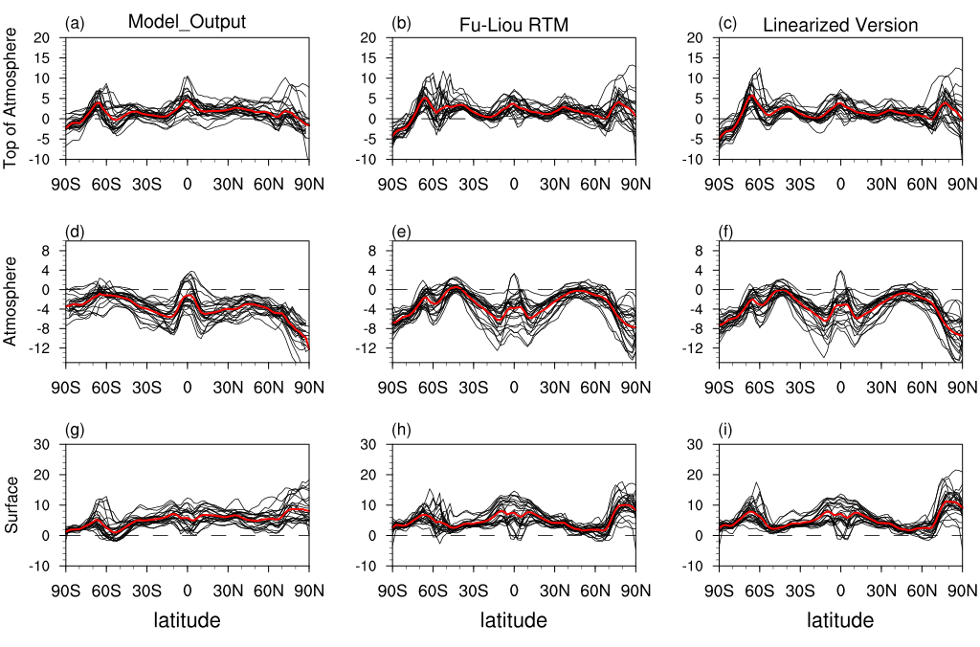
Figure S1. The zonal-mean net radiative flux changes (W*m⁻²) between the CMIP5 RCP8.5 and historical simulations given by the CMIP5 model outputs, the offline Fu-Liou radiative transfer model (RTM) calculations, the total sum of the linearized radiative fluxes given by the Fu-Liou RTM at the (a-c) TOA, (d-f) atmosphere, and (g-i) surface, respectively. Individual CMIP5 models (black lines); CMIP5 ensemble mean (red lines).

