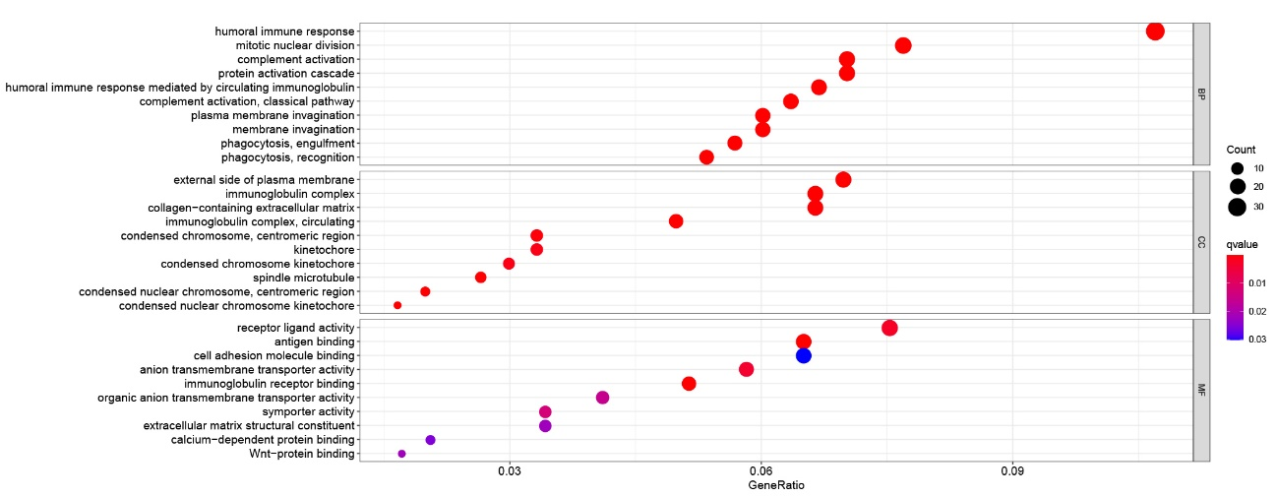
Figure S1 Bubble plot of GO analysis based on TCGA dataset.

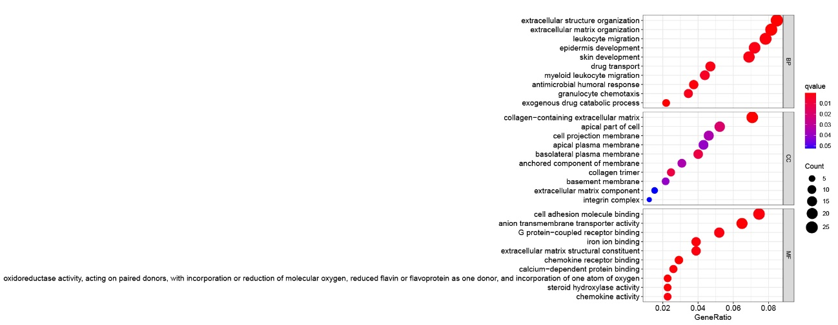
Figure S2 Bubble plot of GO analysis based on ICGC dataset.

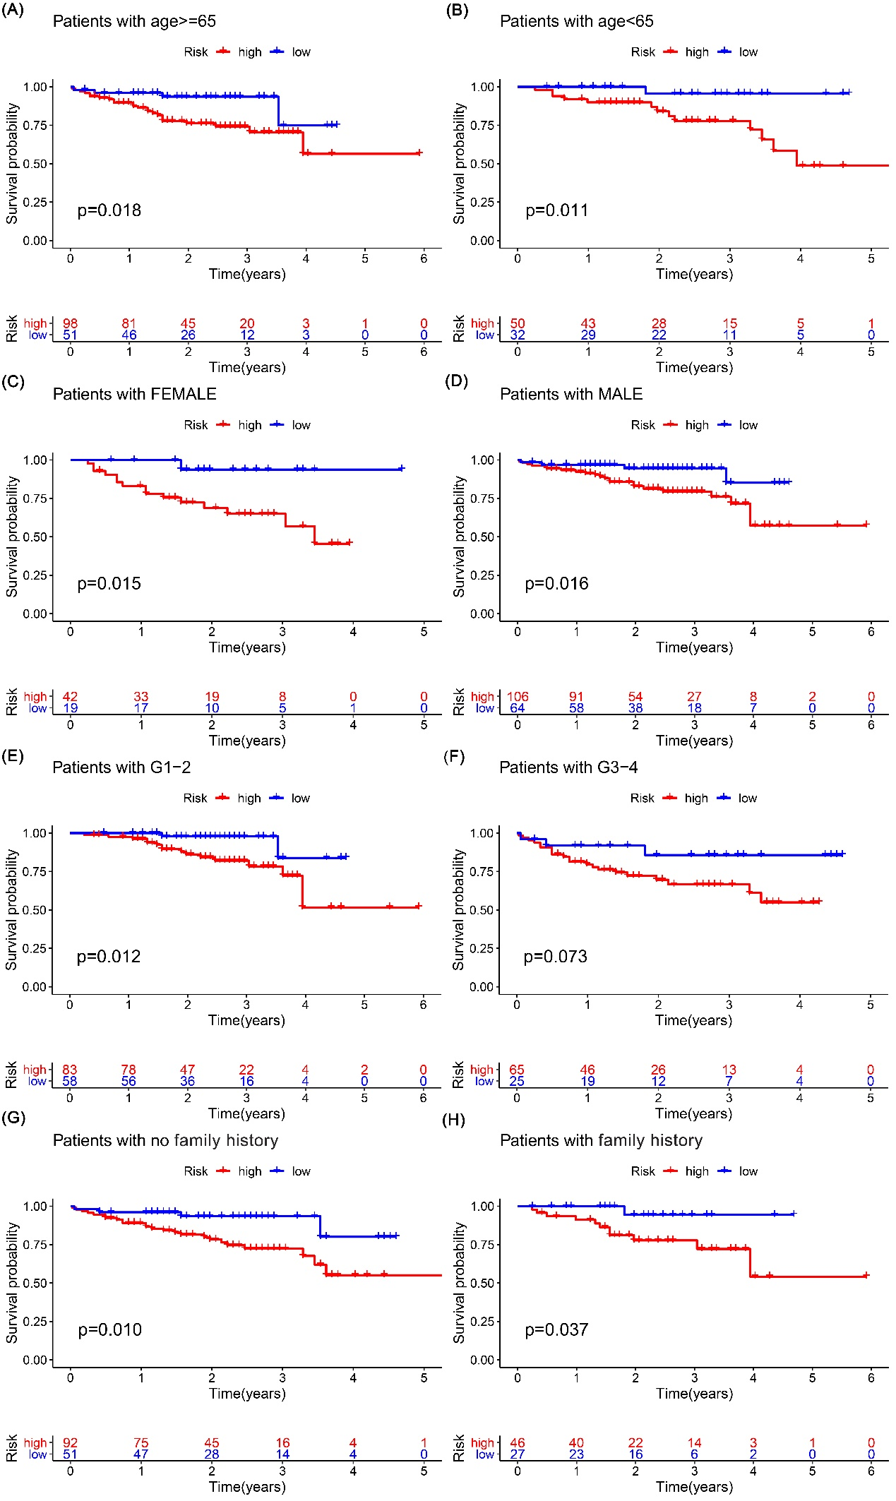
Figure S3 Stratified analysis validated by ICGC dataset.
Survival curves show higher survival probabilities of low risk group compared with high risk group stratified by (A) age≥65, (B)＜65, (C) female, (D) male, (E) G1-2, (G-H) Stage I-IV, while no significantly statistical difference was found after stratification by (F) G3-4.

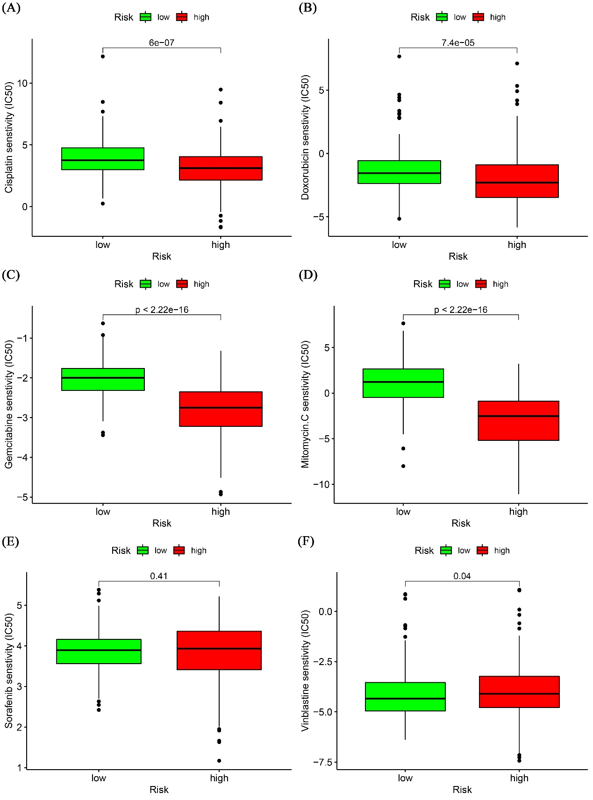
Figure S4 Predication of chemosensitivity based on risk model.
The model showed risk score was positively correlated with chemosensitivity of (A) Cisplatin, (B) Doxorubicin, (C) Gemcitabine, (D) Mitomycin C, but negatively associated with (E) Vinblastine and (F) Sorafenib.

