Supplemental File
Table A. Bivariate correlations between MVT, RTD at 50, 100, 200, 300 ms of the hip abductor and adductor muscles, and RoA at 50, 100, 200, 300 ms of the tensor fascia latae, gluteus medius and adductor magnus with the Four Square Step Test (FSST) and the two-leg side hop test.
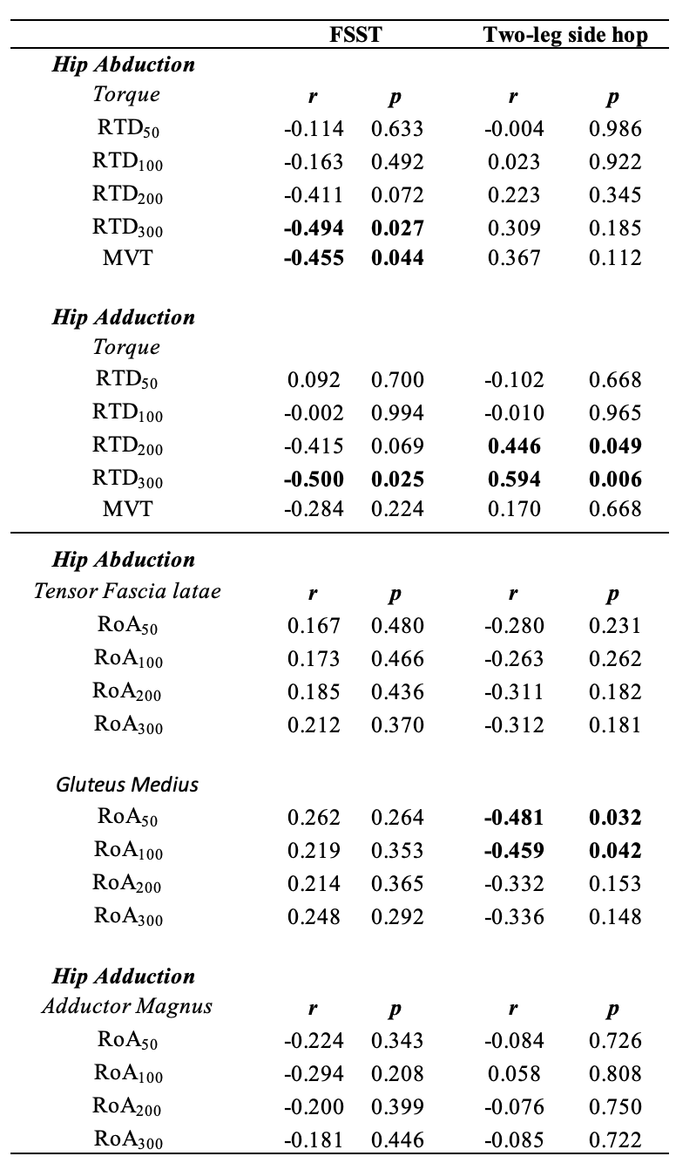
*
*
*
*
*
*
*
* Symbol indicates significant correlations.

